Additional file 2 - Survey

Scandinavian Neurotrauma Committee
presents
"Factors influencing implementation and guideline adherence"

A nationalwide cross-sectional survey

Thank you for your participation!

Regarding children with head trauma...

I regularly manage children with head trauma in the emergency department.
I do not regularly manage these patients but I know colleagues in my hospital that does.
I do not manage these patients and I do not know any colleagues in my hospital that does.

Click "Next" at the bottom of this page.

1. Background information

Any questions? Contact: info@shipp.se

1.1 Name of your hospital:

1.2 Gender:

Male
Female
Prefer not to respond

1.3 Career stage:

Early career (Intern, underläkare/AT-läkare)
Mid-career (Residency, ST-läkare)
Late career (Consultant, specialist)

1.4 In what field/specialty are you currently working?

Pediatric medicine
Surgery
Pediatric surgery
Emergency medicine
Neurology
Pediatric neurology
Neurosurgery
Internal medicine
Orthopedics
Pediatric orthopedics
Other

1.5 I believe that guidelines (in general) optimize health care delivery and outcomes by supporting patient-clinician communication and decision-making

Yes
No
Unsure

1.6 I have participated in the development of one or more guidelines

Yes
No

1.7 What category/-es of patients with head injury do you treat and assess at your emergency department?

Children only
Adults only
Both children and adults

The SNC-16 guideline

In 2016, SNC (Scandinavian Neurotrauma Committee) published management guidelines of children with minimal, mild and moderate headtrauma.

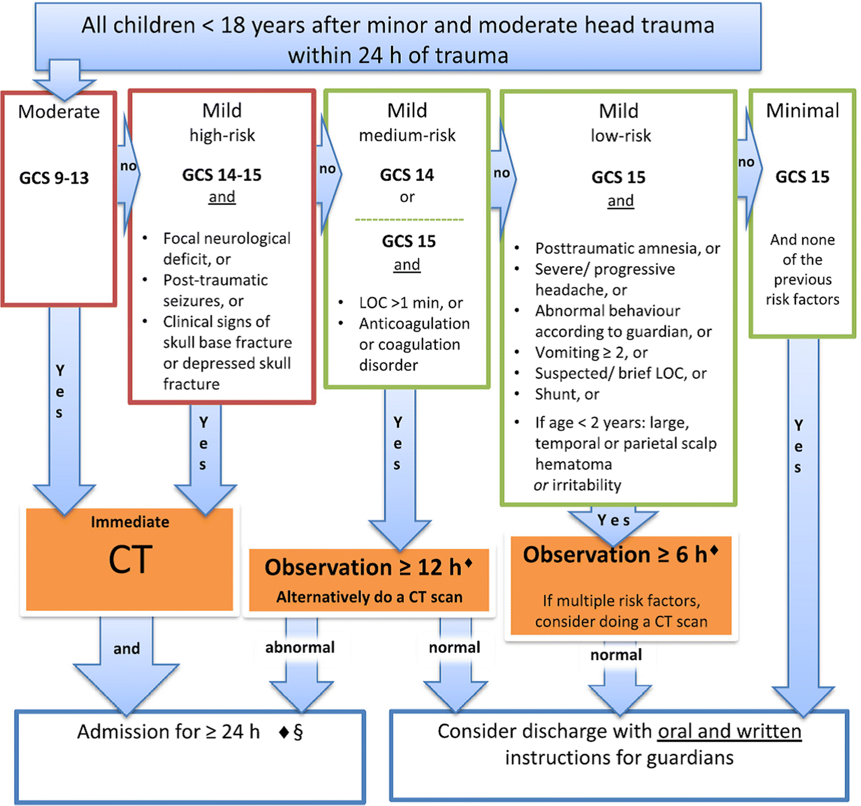
Astrand R, Rosenlund C, Unden J, Scandinavian Neurotrauma Committee (SNC). Scandinavian guidelines for initial management of minor and moderate head trauma in children. BMC Med 2016;14:33–016-0574

Further information:
Läkartidningen
PubMed
Any questions? Contact: info@shipp.se

2. Determinants of guideline use of the SNC-guidelines -16 (pediatric version)

Any questions? Contact: info@shipp.se

2.1 How often do you see pediatric patients with mild head injury?

Daily
Several times a week
1-3 times/month
5-10 times/year
1-4 times/year
Less then once a year

2.2 What is your level of awareness of/familiarity with the SNC-16 guideline?
Choose the response that best matches your scenario

I was not aware prior to this questionnaire
I am aware of the guideline but have not read it
I have read all or some of the guideline on one occasion then never again
I have read all or some of the guideline on multiple occasions
Other (specify):

2.3 What is your intended or actual use of the SNC-16 guideline?
Choose the response that best matches your scenario

I have never used the guideline and do not plan to
I have never used the guideline but will consider using it
I have never used the guideline but will use it
I have used the guideline once only
I have used the guideline a few times
I regularly use the guideline
Other (specify):

2.4 Others expect me to use the procedures, actions or activities recommended in this guideline
Choose all that apply

Patients
Colleagues
Managers or executives in my organization
Monitoring agency (Socialstyrelsen)
Government
Professional Society
Other (specify):

Attitude towards use of the SNC-16 guideline
To what extent do you agree with the following statements
1: Strongly disagree
7: Strongly agree

 | 1 - Strongly disagree | 2 | 3 | 4 | 5 | 6 | 7 - Strongly agree | Not sure
2.5 I agree with the content of the SNC-16 guideline
2.6 Following the guideline will improve care delivery
2.7 Following the guideline will improve patient outcomes
2.8 Following the guideline brings advantages to me, my practice or organization, or my patients (i.e. supports communication and decision-making, etc.)
2.9 Following the guideline brings disadvantages to me, my practice or organization, or my patients (i.e. time, costs, etc.)

Confidence in using the SNC-16 guideline
To what extent do you agree with the following statements
1: Strongly disagree
7: Strongly agree

 | 1 - Strongly disagree | 2 | 3 | 4 | 5 | 6 | 7 - Strongly agree | Not sure
2.10 I possess general knowledge about the clinical condition that is needed to use this guideline
2.11 I was trained in the skills (i.e. technical, procedural, cognitive, etc.) needed to use this guideline
2.12 I am confident that I possess the skills (i.e. technical, procedural, cognitive, problem-solving, etc.) needed to use this guideline
2.13 It is among my self-acknowledged professional responsibilities to follow the procedures, actions or activities recommended in this guideline
2.14 I have the autonomy to make changes needed to follow this this guideline

Support from peers and organization in use of the SNC-16 guideline
To what extent do you agree with the following statements
1: Strongly disagree
7: Strongly agree

 | 1 - Strongly disagree | 2 | 3 | 4 | 5 | 6 | 7 - Strongly agree | Not sure
2.15 Colleagues in my own organization use the guideline
2.16 Colleagues outside of my organization use the guideline
2.17 My organization provides support (leadership, resources, assistance, etc.) needed to use this guideline
2.18 The procedures, actions or activities recommended in this guideline is easy to incorporate in my practice

Patient and parents attitudes towards use of guideline
To what extent do you agree with the following statements
1: Strongly disagree
7: Strongly agree

 | 1 - Strongly disagree | 2 | 3 | 4 | 5 | 6 | 7 - Strongly agree | Not sure
2.19 The recommendations in this guideline are consistent with my patients’ values and preferences
2.20 My patients do, or are likely to accept and follow the recommendations in this guideline

Access and usability of the SNC-16 guideline
To what extent do you agree with the following statements
1: Strongly disagree
7: Strongly agree

 | 1 - Strongly disagree | 2 | 3 | 4 | 5 | 6 | 7 - Strongly agree | Not sure
2.21 It is easy to find information in this guideline because the format and layout is easy to navigate
2.22 The wording of this recommendation is clear and unambiguous
2.23 The guideline includes or is accompanied by implementation tools (clinician summary, patient summary, algorithm, medical record forms, etc.)
2.24 Implementation tools included in or with the guideline (clinician summary, patient summary, algorithm, chart forms, etc.) are helpful to me, my practice or organization, or my patients
2.25 The guideline is consistent with the available evidence
2.26 The guideline describes whether patient preferences were collected and influenced the guideline questions, methods or recommendations
2.27 The guideline clearly describes underlying evidence
supporting the recommendations

3. Other determinants

Any questions? Contact: info@shipp.se

Enablers

3.1 What is the single most important factor noted above that does/will enable your use of this guideline?

3.2 What is the single most important factor NOT noted above that does/will enable your use of this guideline?

Barriers

3.3 What is the single most important factor noted above that does/will challenge your use of this guideline?

3.4 What is the single most important factor NOT noted above that does/will challenge your use of this guideline?

4. Learning style

Any questions? Contact: info@shipp.se

4.1 What sources do you most often consult for knowledge to guide clinical decision making?
Choose all that apply

Colleagues
Patients
Medical literature
Electronic application or database
Internet
Guidance from government, regulatory agency (socialstyrelsen) or medical society
Educational meetings/conferences
Medical books
Systematic reviews
Guidelines
Other (specify):

4.2 How do you prefer to learn about guidelines?
Choose all that apply

Educational meetings/conferences
Guideline developer web site
Email from guideline developer
Medical journal publication
Other (specify):

4.3 What is your preferred format for guidelines, guideline summaries or guideline tools?
Choose all that apply

Mobile (telephone) application
Electronic version (software) on desk-top computer
Electronic version on developer web site
Print copy
Other (specify):

4.4 Did you understand the language of the present survey?

Yes
No (please comment below)

5.1 We kindly ask you to list 5-10 of your colleagues who also work with management of paediatric head trauma in the emergency setting. It could be colleagues from both your hospital or from other Swedish hospitals. We will use the adresses to send this questionnaire and ask them to respond.

Colleague 1- email
Colleague 2- email
Colleague 3- email
Colleague 4- email
Colleague 5- email
Colleague 6- email
Colleague 7- email
Colleague 8- email
Colleague 9- email
Colleague 10- email

