SUPPLEMENTAL INFORMATION

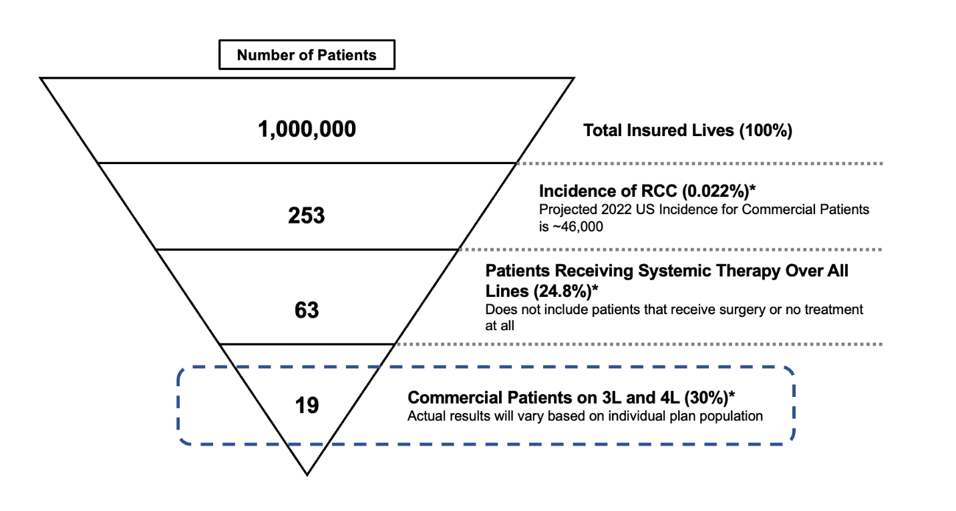

Supplemental Figure 1. Example of patient flow in a hypothetical 1-million-member plan. *Percentage was calculated using diagnostic-related group (DRG) data from Clarivate²³ and payer data from Managed Markets Insight & Technology (MMIT)²⁴.

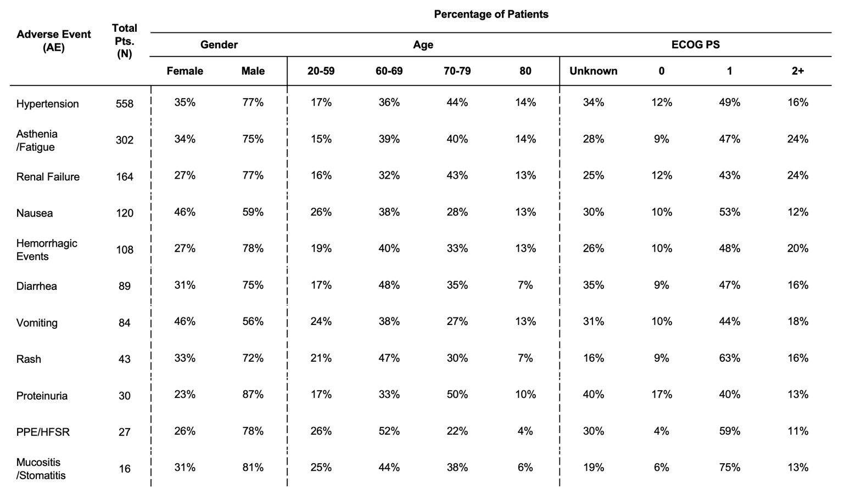

Supplemental Table 1. Patient demographic breakdown per adverse event type.

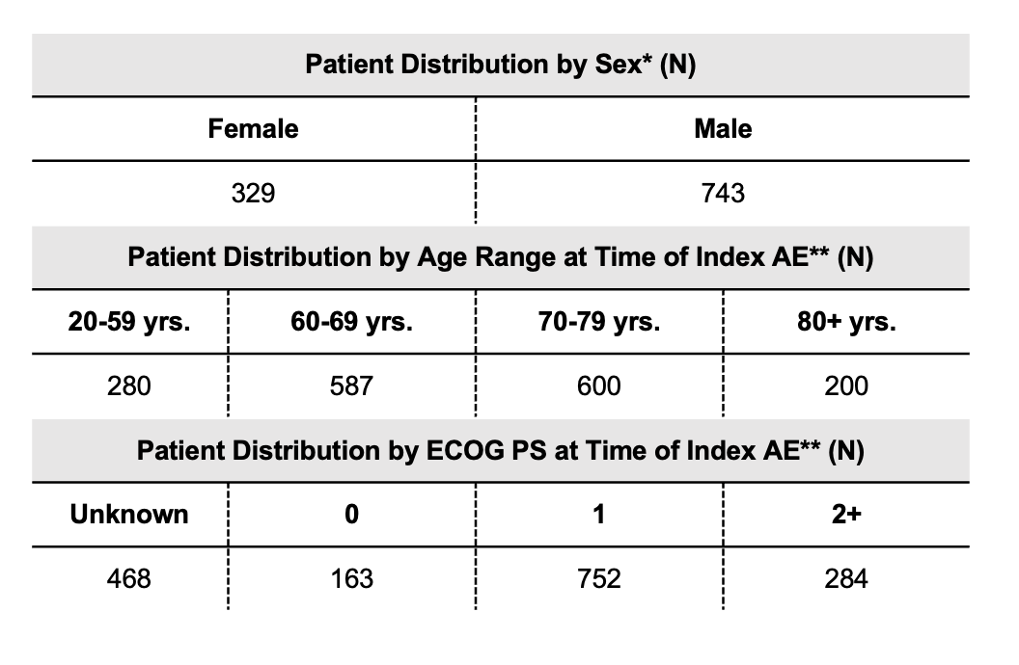
Supplemental Table 2. Study population demographics. *1,072 patients had a record of AE and cost data in time frame. **1,667 unique AEs with cost data in time frame.

