Additional file 2: Patient characteristics - Group 2

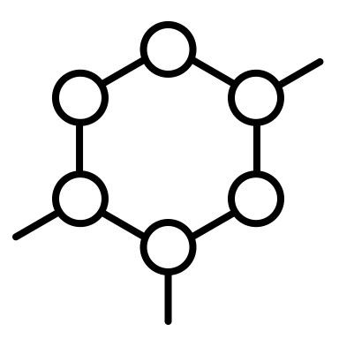
9
3
Sex: n=11
Age: median (range)
58 years (42)
Cancer stages: UICC n= 11
I: 1
IV: 10
II: 0
III: 0
No: 5
Occasionally: 3
Daily: 2
Lung: 2
Gastrointestinal: 3
Sarcoma: 1
Urinary tract: 2
Breast: 1
Other: 2

Sleeping pills/antidepressants: n= 10
Cancer entity: n= 11

