Supplementary Table 1. OWSA

Model input variables | Minimum input value | Maximum input  value | Minimum ICER | Maximum ICER | Spread
Probability of fibrosis (F2) to Fibrosis (F3) | 0.0127 | 0.117 | $79,977.98 | $65,162.31 | $14,815.67
Treatment success utility (SVR) | 0.0232 | 0.0348 | $85,201.02 | $70,343.37 | $14,857.65
Utility of fibrosis  (F0-F1) | 0.7878 | 0.8702 | $86,195.89 | $69,997.51 | $16,198.38
Probability of fibrosis (F2) to death | 0.0096 | 0.048 | $80,741.09 | $60,139.58 | $20,601.51
Probability of taking DAA treatment among linkage to care patients | 0.3878 | 0.8622 | $107,378.42 | $63,428.18 | $43,950.24
Probability of true negative  (HCR-RNA test) | 0.994 | 1 | $121,730.83 | $77,062.59 | $44,668.23
Probability of attend referral/linkage to care among HCV-RNA positive patients | 0.1323 | 0.3315 | $114,363.23 | $62,174.32 | $52,188.92
No fibrosis (F0)/fibrosis (F1) to death | 0.0102 | 0.048 | $74,213.46 | $133,187.16 | $58,973.70
Medical costs of F0-F3 with SVR | $0 | $5,056.01 | $61,820.13 | $156,046.26 | $94,226.13
Medical costs of F0-F3 | $0 | $7,949.12 | $85,877.20 | $(58,937.17) | $144,814.37
ª Yearly costs
^{b} After Wholesale Acquisition Cost (WAC) rebate conversion (33%)
* All costs converted to 2021 USD

Abbreviations: F = fibrosis stage; HCV = hepatitis C virus; HCC = hepatocellular carcinoma; OWSA = one-way sensitivity analysis

Supplementary Table 2. Years in HCC and Liver Transplant States

DAA Intervention in Untreated Groupª | Patient Group | Years in HCC and Liver Transplant
F1 | No HCV Screening | 0.005
F1 | ED-Based  HCV Screening | 0.004
F2 | No HCV Screening | 0.011
F2 | ED-Based  HCV Screening | 0.004
F3 | No HCV Screening | 0.061
F3 | ED-Based  HCV Screening | 0.004
F4 Comp. Cirrhosis | No HCV Screening | 0.190
F4 Comp. Cirrhosis | ED-Based  HCV Screening | 0.004
F4 Decomp. Cirrhosis | No HCV Screening | 0.483
F4 Decomp. Cirrhosis | ED-Based  HCV Screening | 0.004
ª Stage at which DAA intervention started in unscreened and untreated population

Supplementary Figure 1. OWSA Tornado Diagram

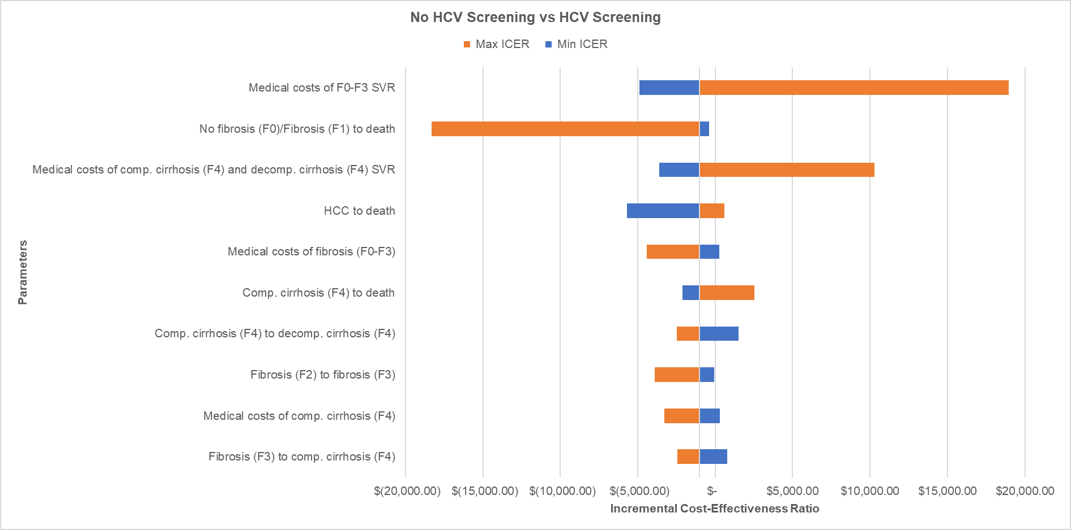
*DAA Intervention at F1 or Later Fibrosis Stages

