The Sixth National Health Service Surveys (NHSS)

Healthcare Workers Questionnaire

Table 1 Basic personal information ( Fill in the number in the blank on the right )
Questions and options |  | Answer
1 | Sex : (1) Male (2) Female
2 | Age ( years )
3 | Marital status :  (1) Unmarried (including unmarried, divorced and widowed) (2) Married
4 | Educational background:  (1) Doctor (2) Master (3) Bachelor (4) Junior college  (5) Technical secondary school (6) Technical school  (7) Senior high school (8) Junior high school and below
5 | Professional titles：  (1) Senior (consultant) (2) Deputy senior (associate consultant)  (3) Intermediate (4) Primary (resident) (5) Medical Assistant (6) None
6 | Professional qualification：  (1) Certified doctor (2) Certified Assistant doctor  (3) Professional traditional Chinese medicine doctor  (4) Professional Assistant traditional Chinese medicine doctor  (5) Registered nurse (6) Other
7 | The type of institution you are working in now:  (1) Hospital (2) Community health service center (3) Township health center
8 | Is it a formal staff member of this organization (BianZhi) :  (1) Yes (2) No (3) Don't know
9 | Administrative positions:  (1) Dean, center director (2) Vice Dean, center deputy director  (3) Department director (4) Deputy director of department  (5) Head nurse (6) None
10 | Years of working (years)
11 | What was your average monthly income last year? (Including salary, bonus, subsidies and all other income)
12 | Have you been promoted in the past 5 years (Administrative positions)?  (1) Yes (2) No
13 | Have you been promoted in the past 5 years (Professional titles)?  (1) Yes (2) No
14 | How many hours do you work per week on average?
15 | On average, how many times do you work the night shift at work each month (excluding those who work at home)?
16 | Currently mainly engaged in professional categories:  (1) Clinical medicine (2) Nursing (3) Public health  (4) Medical technology (5) Pharmacy

Table 2 Work experience (Circle the number that best describes you)
Please circle the following questions according to your own feelings.
1. Very inconsistent 2. Somewhat inconsistent 3. Somewhat inconsistent
4. Somewhat consistent 5. Somewhat consistent 6. Very consistent
Work stress
1 | Overall, I'm feeling great pressure from work | 1 | 2 | 3 | 4 | 5 | 6
2 | Overall, I'm experiencing a high level of tension from work | 1 | 2 | 3 | 4 | 5 | 6
3 | I have trouble falling asleep due to work | 1 | 2 | 3 | 4 | 5 | 6
4 | I'm feeling nervous due to work | 1 | 2 | 3 | 4 | 5 | 6
Turnover intention
1 | I often want to leave this hospital | 1 | 2 | 3 | 4 | 5 | 6
2 | I have often thought of leaving my present profession | 1 | 2 | 3 | 4 | 5 | 6
3 | Recently, I want to change my job | 1 | 2 | 3 | 4 | 5 | 6
4 | Next year, I will probably look for a new job | 1 | 2 | 3 | 4 | 5 | 6
Job satisfaction
1 | Overall, I am very satisfied with my current job | 1 | 2 | 3 | 4 | 5 | 6
2 | I am satisfied with my colleagues in the unit | 1 | 2 | 3 | 4 | 5 | 6
3 | Considering my skills and efforts, I am satisfied with my income level | 1 | 2 | 3 | 4 | 5 | 6
4 | I am satisfied with the leadership | 1 | 2 | 3 | 4 | 5 | 6
5 | I am satisfied with the working conditions and equipment configuration of the unit | 1 | 2 | 3 | 4 | 5 | 6
6 | I am satisfied with the prospects for promotion and career development in this job | 1 | 2 | 3 | 4 | 5 | 6
7 | I am satisfied with the management of the unit | 1 | 2 | 3 | 4 | 5 | 6
8 | I am satisfied with the benefits I receive at work | 1 | 2 | 3 | 4 | 5 | 6
9 | I am satisfied with the training opportunities I get at work | 1 | 2 | 3 | 4 | 5 | 6
10 | I am satisfied with the opportunity to display my abilities at work | 1 | 2 | 3 | 4 | 5 | 6

Table 3 Work Engagement (Circle the number that best describes you)
Please rate your feelings at work and decide whether you have the following feelings. If you have never had this feeling, please select the number "0". If you have had this feeling, please circle the number that best reflects the frequency or degree of agreement with the feeling.
0. Never/Totally Disagree - 6. Always/Totally Agree
1 | At my work, I feel bursting with energy | 0 | 1 | 2 | 3 | 4 | 5 | 6
2 | I find the work that I do full of meaning and purpose | 0 | 1 | 2 | 3 | 4 | 5 | 6
3 | Time flies when I'm working | 0 | 1 | 2 | 3 | 4 | 5 | 6
4 | At my job, I feel strong and vigorous | 0 | 1 | 2 | 3 | 4 | 5 | 6
5 | I am enthusiastic about my job | 0 | 1 | 2 | 3 | 4 | 5 | 6
6 | When I am working, I forget everything else around me | 0 | 1 | 2 | 3 | 4 | 5 | 6
7 | My job inspires me | 0 | 1 | 2 | 3 | 4 | 5 | 6
8 | When I get up in the morning, I feel like going to work | 0 | 1 | 2 | 3 | 4 | 5 | 6
9 | I feel happy when I am working intensely | 0 | 1 | 2 | 3 | 4 | 5 | 6
10 | I am proud on the work that I do | 0 | 1 | 2 | 3 | 4 | 5 | 6
11 | I am immersed in my work | 0 | 1 | 2 | 3 | 4 | 5 | 6
12 | I can continue working for very long periods at a time | 0 | 1 | 2 | 3 | 4 | 5 | 6
13 | To me, my job is challenging | 0 | 1 | 2 | 3 | 4 | 5 | 6
14 | I get carried away when I’m working | 0 | 1 | 2 | 3 | 4 | 5 | 6
15 | At my job, I am very resilient, mentally | 0 | 1 | 2 | 3 | 4 | 5 | 6
16 | It is difficult to detach myself from my job | 0 | 1 | 2 | 3 | 4 | 5 | 6
17 | At my work I always persevere, even when things do not go well. | 0 | 1 | 2 | 3 | 4 | 5 | 6

Table 4 Practice Environment ( Fill in the number in the blank on the right )
Questions and options |  | Answer
1 | How much do you feel patients respect you?  (1) Very respect (2)Somewhat respect (3) Average  (4) Somewhat disrespect (5) Very disrespect
2 | How much do you feel society as a whole respects your profession?  (1) Very respect (2)Somewhat respect (3) Average  (4) Somewhat disrespect (5) Very disrespect
3 | In your opinion, where on the scale does the current social status of medical personnel correspond? (0 is the lowest, 100 is the highest)  0 10 20 30 40 50 60 70 80 90 100
4 | How much do you feel patients trust you in providing services?  (1) Very high (2) Higher (3) Average (4) Lower (5) Very low
5 | What do you think of the current doctor-patient relationship?  (1) Very high (2) Higher (3) Average (4) Lower (5) Very low
6 | In most cases, patients will comment on the services you provide by saying that:  (1) Very satisfied (2) Somewhat satisfied (3) No comment  (4)Somewhat dissatisfied (5) Very dissatisfied

Supplementary Table 1 Testing the Moderated Mediation Effect in the Relationship between professional titles and turnover intention
 | Outcome variable：Work engagement |  |  |  | Outcome variable：Turnover intention
Variables | Coeff. | SE | t | P | Coeff. | SE | t | P
Constant | 0.945 | 0.463 | 2.04 | 0.042 | 4.398 | 0.483 | 9.098 | <0.001
X1(Primary title) | -1.071 | 0.468 | -2.289 | 0.022 | -1.829 | 0.489 | -3.744 | <0.001
X2(Intermediate title) | -0.982 | 0.466 | -2.109 | 0.035 | -1.793 | 0.486 | -3.689 | <0.001
X3(Senior/Deputy senior title) | -0.638 | 0.472 | -1.351 | 0.177 | -1.836 | 0.492 | -3.729 | <0.001
W(Monthly income) | 0.685 | 0.491 | 1.396 | 0.163 | 1.511 | 0.512 | 2.952 | 0.003
W × X1 | -0.663 | 0.494 | -1.343 | 0.180 | -1.515 | 0.514 | -2.945 | 0.003
W × X2 | -0.682 | 0.491 | -1.388 | 0.165 | -1.521 | 0.512 | -2.970 | 0.003
W × X3 | -0.630 | 0.494 | -1.276 | 0.202 | -1.600 | 0.515 | -3.106 | 0.002
M(Work engagement) |  |  |  |  | -0.479 | 0.032 | -14.929 | <0.001
W × M |  |  |  |  | 0.042 | 0.021 | 2.040 | 0.042
 | R2=0.024; F= 3.708; P=0.001 |  |  |  | R2=0.190; F= 27.434; P<0.001

Supplementary Table 2 Testing the Moderated Mediation Effect in the Relationship between administrative positions and turnover intention
 | Outcome variable：Work engagement |  |  |  | Outcome variable：Turnover intention
Variables | Coeff. | SE | t | P | Coeff. | SE | t | P
Constant | -0.004 | 0.034 | -1.128 | 0.898 | 2.599 | 0.036 | 72.617 | <0.001
X(Administrative positions) | 0.431 | 0.110 | 3.938 | <0.001 | -0.369 | 0.115 | -3.213 | 0.001
W(Monthly income) | 0.002 | 0.019 | 0.120 | 0.905 | 0.002 | 0.020 | 0.119 | 0.905
W × X | 0.041 | 0.041 | 1.010 | 0.313 | -0.074 | 0.053 | -1.415 | 0.157
M(Work engagement) |  |  |  |  | -0.457 | 0.032 | -14.262 | <0.001
W × M |  |  |  |  | 0.063 | 0.025 | 2.508 | 0.012
 | R2=0.139; F=6.957; P<0.001 |  |  |  | R2=0.189; F=49.068; P<0.001

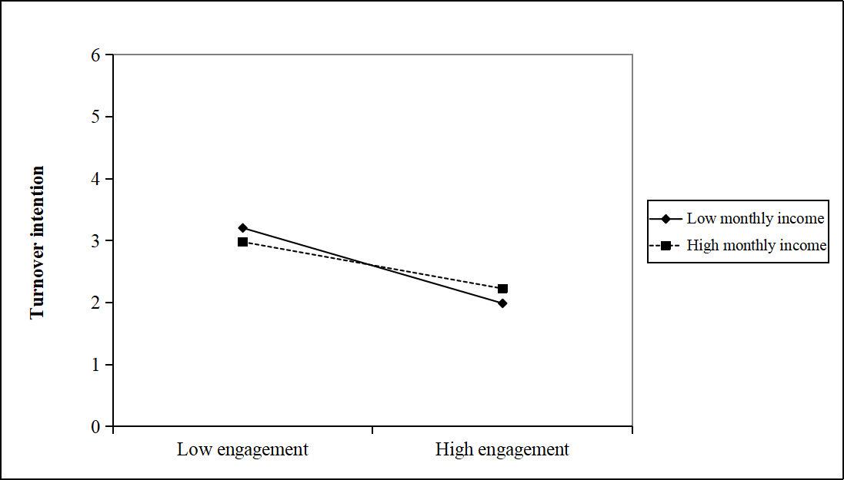
Supplementary Figure 1 Moderating effect of monthly income

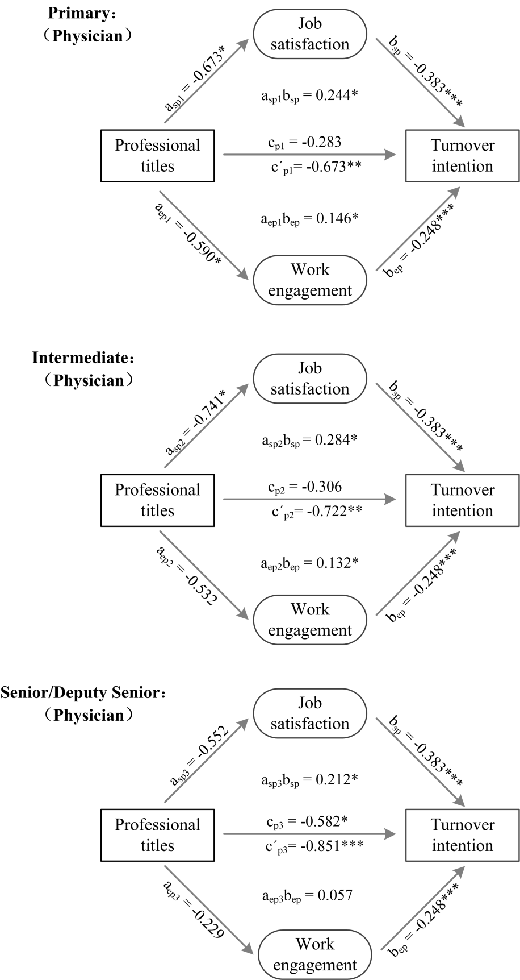
Supplementary Figure 2a The suppression model of professional titles and turnover intention in physicians

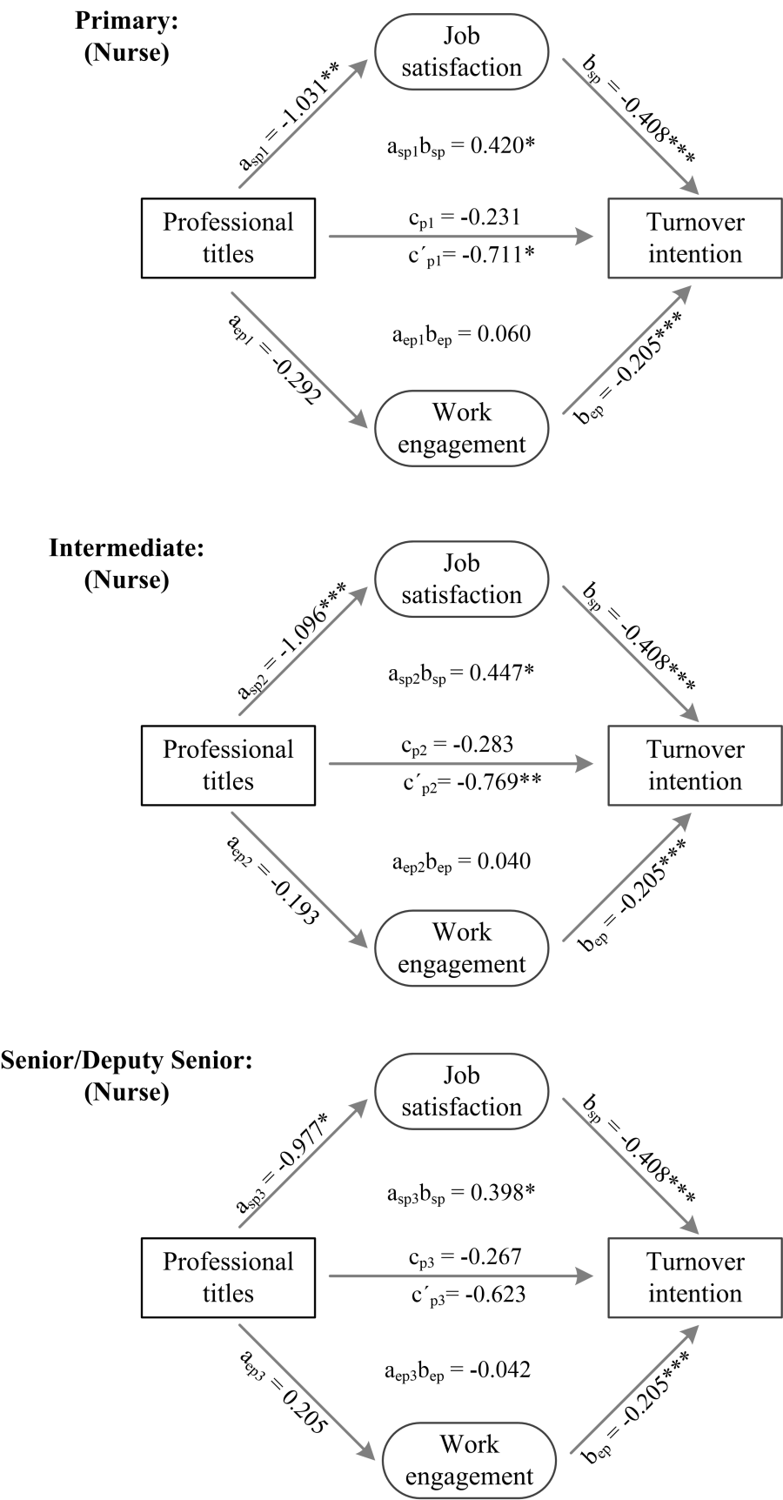
Supplementary Figure 2b The suppression model of professional titles and turnover intention in nurses

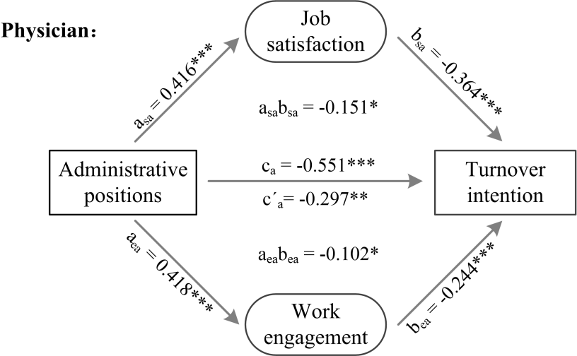
Supplementary Figure 3a The mediating model of administrative positions and turnover intention in physicians

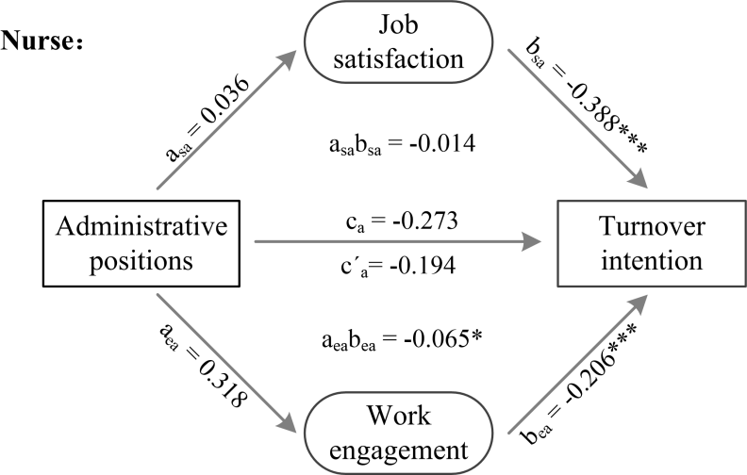
Supplementary Figure 3b The mediating model of administrative positions and turnover intention in nurses

