SUPPLEMENTARY FILE

Additional file 1: Figure showing Print Media Advertisement of eTB app as part of public information campaign to raise awareness

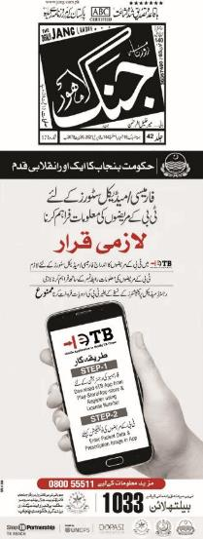

Additional file 2: Table showing Frequency of TB notifications by private pharmacies
Number of notifications during intervention period | Number of private pharmacies  N= 1580 (%) | Total number of TB notifications  N=15669(%)
1 PWT | 299 (19) | 299 (2)
2-10 | 1111(70) | 4988 (32)
11-20 | 98 (6) | 1378 (9)
21-40 | 32 (2) | 892 (6)
41-60 | 10 (0.6) | 505 (3)
61-100 | 10 (0.6) | 756 (5)
101-140 | 6 (0.4) | 728 (5)
>140 PWT | 14 (1) | 6123 (39)

Additional File 3: Table showing pharmacy contribution to additional and total district notifications
Districts | Notifications  Baseline period | Notifications  Intervention period | Additional notifications |  | Private pharmacy contribution  through e-TB
 | April 2019-  March 2020  n | April 2021-  March 2022  n | n | % | Total  n | Proportion of total  notifications  % | Proportion of additional cases  %
Faisalabad | 12931 | 19143 | 6212 | 48% | 5193 | 27% | 84%
Lahore | 19221 | 23346 | 4125 | 21% | 3931 | 17% | 95%
Multan | 9449 | 13370 | 3921 | 41% | 3301 | 25% | 84%
Rawalpindi | 9120 | 12324 | 3204 | 35% | 3244 | 26% | 101%
Total | 50721 | 68183 | 17462 | 34% | 15669 | 23% | 90%

