Supplementary information
Tables
Table S1. Background of Leprosy Focal Persons
Background characteristics | Number and % (95% CI) of focal persons (N = 31)
CMA or ANM (no academic course, but 1 year health training) | 18 (58%, 39-75%)
HA (completed 3 years academic training) | 13 (42%, 25-61%)
Leprosy specific training (either BLT or CLT) | 15 (48%, 30-67%)
Graduate degrees | 6 (19%, 7-37%)
Undergraduate degrees | 25 (81%, 63-93)

Table S2. Focal person’s knowledge on leprosy cardinal signs and skills on palpation of peripheral nerves
Details | Numbers (%, 95% CI, N=31) | Details | Numbers (%, 95% CI, N=31)
Persons who know 3 cardinal signs | 9 (29%, 14-48%) | Persons who palpate 4 peripheral nerves | 1 (3%, 0.1-17%)
Persons who know 2 cardinal signs | 8 (26%, 12-45%) | Persons who palpate 3 peripheral nerves | 0 (0%, 0-11%)
Persons who know only 1 cardinal sign | 13 (42%, 25-61%) | Persons who palpate 2 peripheral nerves | 1 (3%, 0.1-17%)
Persons who know no cardinal signs | 1 (3%, 0.1-17%) | Persons who palpate only 1 peripheral nerve | 4 (13%, 4-30%)
 |  | Persons who palpate no peripheral nerves | 25 (81%, 63-93%)

Table S3. Predictors of Leprosy Focal Person knowledge and skills
Tested predictor | Level of knowledge and Skills  Statistics |  | Statistics
 | # Health workers above the median | # Health workers below the median
Training status
Training taken | 12 | 3 | OR = 8.1 (95% CI, 1.4-66.3), p-value = 0.01
Training not taken | 5 | 11 | OR = 8.1 (95% CI, 1.4-66.3), p-value = 0.01
Job title
CMA, ANM or AHW | 12 | 6 | OR = 3.1 (95% CI, 0.6-18.3), p-value = 0.16
HA | 5 | 8 | OR = 3.1 (95% CI, 0.6-18.3), p-value = 0.16
Time since training
≤3 years | 3 | 6 | OR = 0.22 (95% CI, 0.01-2.45), p-value = 0.31
>3 years | 5 | 2 | OR = 0.22 (95% CI, 0.01-2.45), p-value = 0.31

Table S4. Distribution of cases treated in Health facilities as per place for diagnosis
Description | Number of cases (N=187) (%, 95% CI)
Lalgadh Leprosy Hospital (specialist hospital) | 145 (78%, 71-83%)
Government local health facilities | 32 (17%, 12-23)
Contact survey, LPEP –Active case detection | 9 (5%, 2-9%)
India | 1 (0.5%, <0.1-3%)

Table S5. The perception and practice of self-care in leprosy disabled persons after RFT
Counselling status | Patient status |  | Statistics
 | Believes self-care improves disability | Believes self-care does not improve disability
Provided | 23 | 2 | OR = 7.9 (95% CI, 1.3-89.1), p-value = 0.01
Not provided | 11 | 8 | OR = 7.9 (95% CI, 1.3-89.1), p-value = 0.01
 | Practiced self-care | Did not practice self-care
Provided | 25 | 0 | OR* = 46 (95% CI, 2.5-867%), p-value = <0.001
Not provided | 10 | 9 | OR* = 46 (95% CI, 2.5-867%), p-value = <0.001
*Note: OR and 95% CIs were calculated using the Haldane correction due a zero (see Supplementary information equation), fisher.test in R was used to calculate the p-value.

Equation
Equation S1 Odds ratio 95% confidence calculation with the Haldane correction:
$$e^{ln(OR)±1.96*\sqrt{1/(a+0.5)+1/(b+0.5)+1/(c+0.5)+1/(d+0.5)}}$$

Figures
Figure S1 Leprosy focal persons knowledge and skills score and time of training
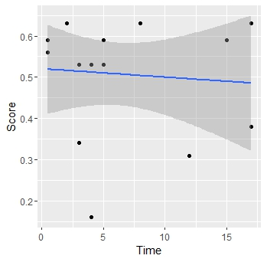
Figure S2 Time and EHF (A) and disability scores (B).
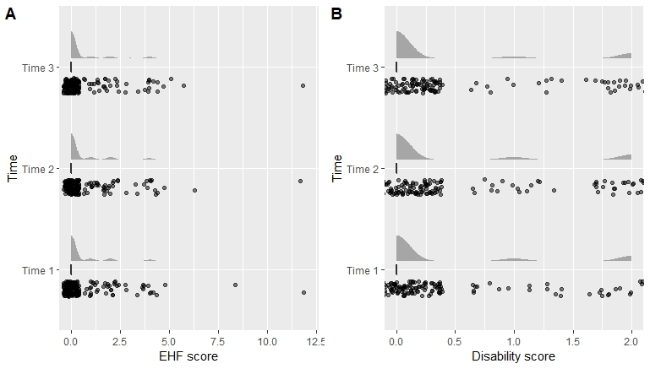

Figure S3 Self-care and disability and ear, hand and feet score data
