Appendix 1: Topics of the Quality Evaluation Questionnaire for Nursing Homes (QEQ-NH) (Triemstra et al, 2021)

Full questionnaire is available on request

Topics theme 1 (care outcomes): Person-centered care
Residents get enough attention
Jointly drawing up care plan
Care plan is available within six weeks
Care professionals know the resident
Care is delivered according to the care plan
Care professionals and therapists work well together
Care plan is discussed twice a year
Residents’ needs are the main focus
Topics theme 2 (care outcomes): Living and well-being
Attention to existential questions
Active involvement of family
Good personal care of residents
Clean room and spaces
Meaningful activities for residents
Good cooperation with volunteers
Satisfaction with meals
Living spaces are suitable for the target group
Topics theme 3 (care outcomes): Resident safety
Identifying risks
Reporting incidents
Following up incidents
Care professionals are authorized and competent for their actions
Medication safety agreements
Policy on restrictive measures and involuntary care
Employees work hygienically
Food safety agreements
Topics theme 4 (organizational conditions): Learning and improvement
Reflection on potential improvements
Sufficient time for consultation in teams
Care professionals can provide input for the quality plans
Quality management system that is supportive
Culture of learning and improvement
Care professionals have sufficient time to participate in a learning network

Topics theme 5 (organizational conditions): Leadership, management and governance
Clear, shared organizational vision
Board and management focus on quality of care
Board and management are involved with the facility
Board and management support the care professionals
Employees and residents (representatives) can influence the organizations’ policy
Topics theme 6 (organizational conditions): responsive workforce
Care professionals have the right skills and knowledge
Sufficient care professionals to provide care
At least two care professionals present during intensive care moments
Supervision in the living room or common area
Residents are usually helped by staff they know
Good teamwork
Training meets the needs of care professionals
Employees get enough time for training
Annual performance and development review
Absenteeism due to illness is not a problem
Staff turnover is not a problem
Care professionals enjoy going to work
Topics theme 7 (organizational conditions): use of resources
Evaluation of methods and practices on a regular basis
Materials and resources are available
Enough opportunities for using (innovative) technology
Facility services support the care professionals
Staff services support the care process
Topics theme 8 (organizational conditions): use of information
Client are surveyed at least once a year
Client feedback is used to improve care
Management information is available for learning and improvement
Few administrative burdens

Appendix 2: Type of support offered per theme

[Appendix 2 Figure 1]

Figure 1. Type of support offered per theme for Plus support trajectories (N= 104), in which typically one to three themes receive support of an expert coach during a period of nine months. The variable total count is because of data loss (improperly filled forms).

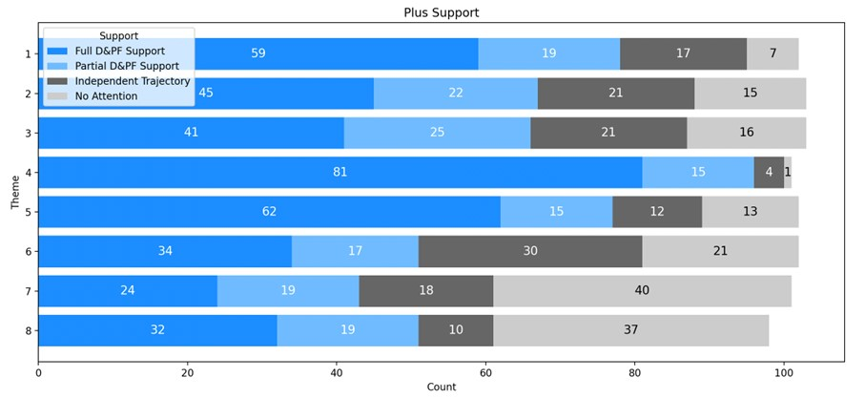

[Appendix 2 Figure 2]

Figure 2. Type of support offered per theme for Intensive support trajectories (N= 103), in which typically four to eight themes receive support of an expert coach during a period of 18 up to 24 months. The variable total count is because of data loss (improperly filled forms).

