Supplementary Material A:
LIST OF INDICATORS
INDICATOR | DIMENSION OF CARE
Presence of facility designated mobile phone | Safety
Availability of at least 6 hours of electricity daily | Safety
Availability of Ambulance | Effective
Presence of driver | Effective
Availability of external supervisor attached to facility | Effective
Water sorce to facility | Accessible
Availability of toilet | Patient Centered
Availability of soap and water | Patient Centered
Availability of hand wash | Safety
Adequacy of staff providing RMNCH services | Accessible
Traning of staff on BEoMNC | Effective
Training of staff on life saving skills | Effective
Availability of protocol for intrapartum care | Effective
Use of partographs | Effective
Privacy of partum care | Patient Centered
Satisfaction with care received | Patient Centered
Choice of receiving care with companion | Patient Centered
Use of uterotonics within one hour of birth | Effective
Knowledge of management of retained placenta | Effective
Knowledge of resuscitation in cases of PPH | Accessible
Knowledge of initial care for pre-eclampsia | Accessible
Monitoring of women in the post-partum period for danger signs | Effective
Apgar score assessment for newborns | Effective
Availability and Use of personal protecting equipment during labour | Safety
Availability of feedback box | Patient Centered
Monitoring newborn temperature for signs of hypothemria and fever | Effective
Waiting time of less than 30 mins | Accessible
Cleanliness of the facility | Safety
Newborn thoroughly dried after delivery | Effective
Skin to skin care for newborns for at least an hour | Effective
Availability of fetoscope | Accessible
Availability of thermometer | Accessible
Availability of sphygmomanometer | Accessible
Availability of Ambu bag | Accessible
Availability of oxytocin | Accessible
Availability of magnesium sulphate | Accessible
Availability of Amoxicillin | Accessible
Availability of Sepsis antibiotics | Accessible
Family planning counselling | Patient Centered
Check for proteinuria | Effective
Check for vital signs | Effective
Vagina examination | Effective
HIV screening | Effective
Anemia screening | Effective

SUPPLEMENTARY MATERIAL B: ANOVA OF FACILITY INDEX SCORES ACROSS STATES
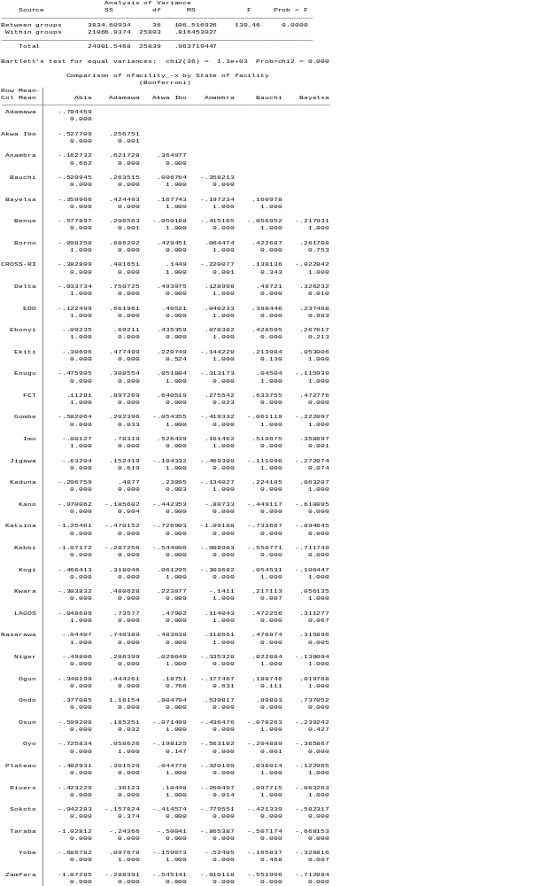
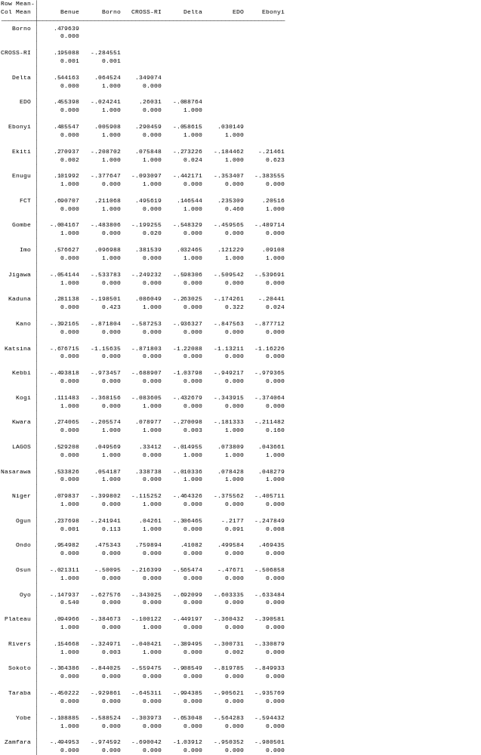
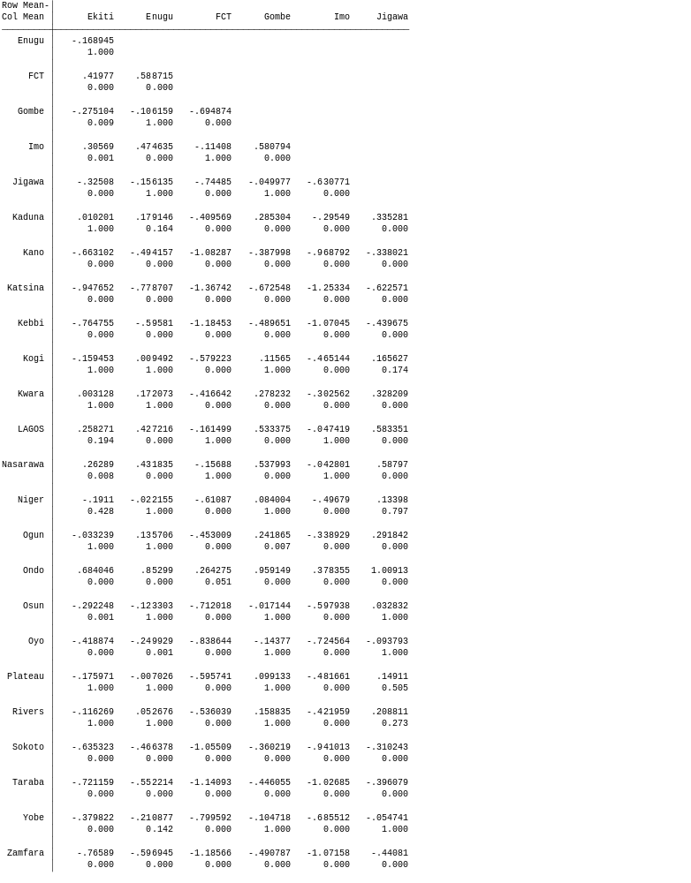
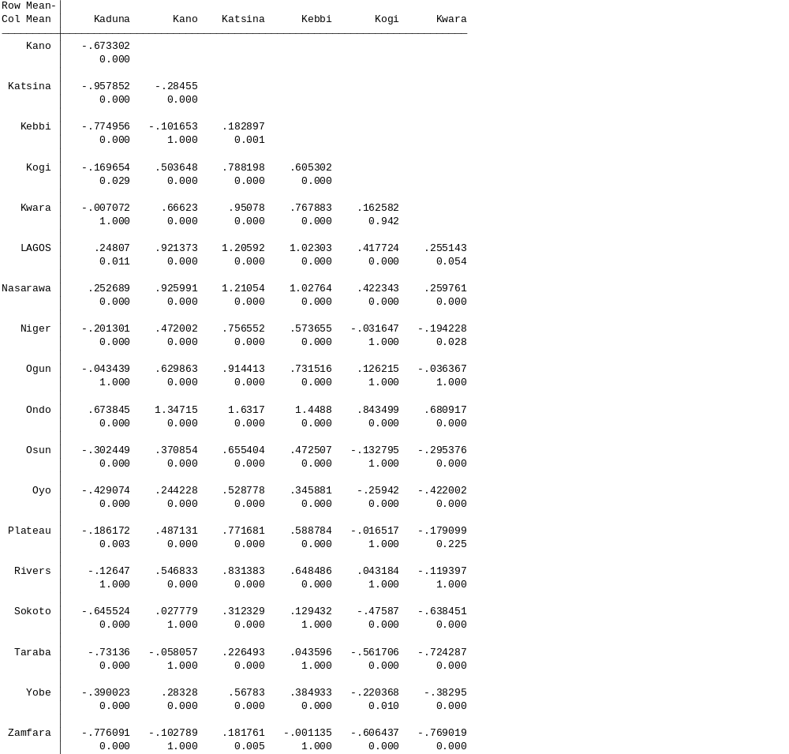

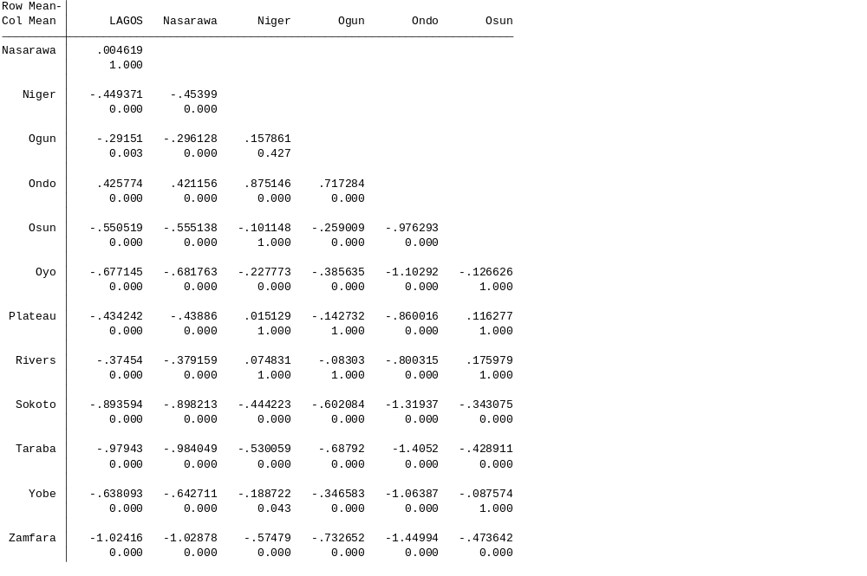

Supplementary Material C: Regression Model of effects of contextual variables on quality of care
