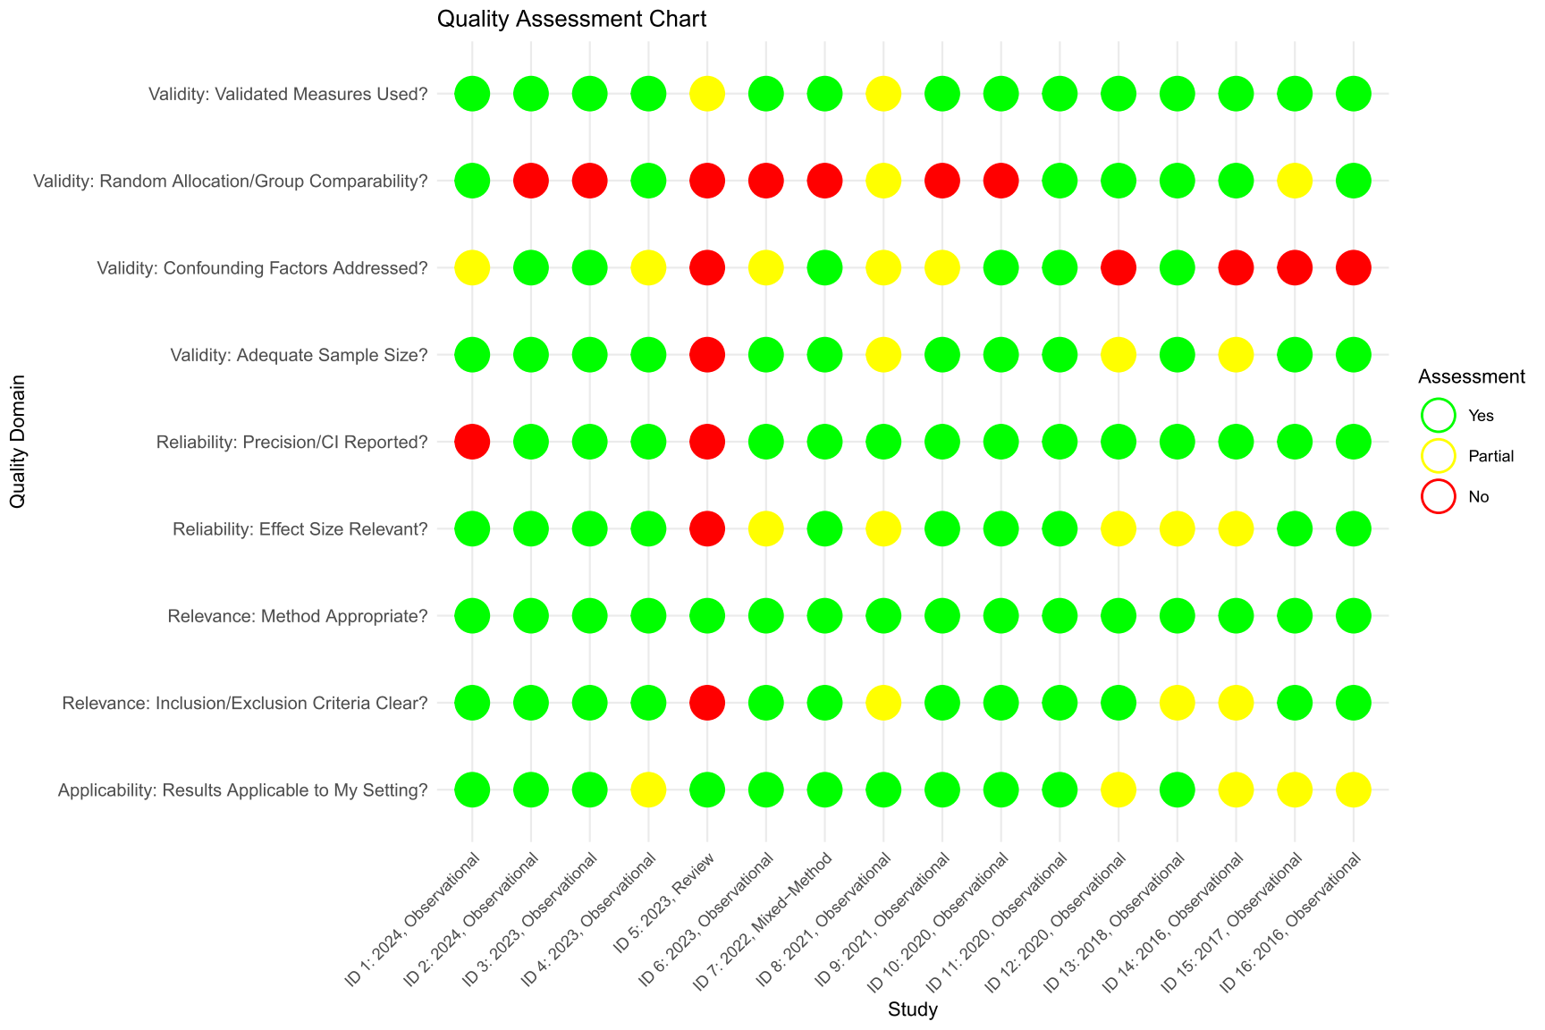
Figure 1A Quality Assessment of Eligible Studies adapted from Critical Appraisal Skills Program (CASP) for Systematic Review.
Critical Appraisal Skills Programme (2018). CASP (Systematic Review) Checklist. [online] Available at: https://casp-uk.net/casp-tools-checklists/systematic-review-checklist/ Accessed: May 25, 2025.

