Appendix
Supplemental Table 1: Characteristics of Medicare Beneficiaries living with Dementia (2000 - 2014, selected in-between years) ª
 | Traditional Medicare |  |  |  |  | Medicare Advantage
Characteristics | 2000 | 2006 | 2008 | 2014 | 2000 | 2006 | 2008 | 2014
 | 1,081 | 952 | 780 | 639 | 193 | 190 | 288 | 377
Age, yrs
65-74 | 243(23.3%) | 228(19.2%) | 184(20.7%) | 98(17.6%) | 47(25.8%) | 50(25.6%) | 70(20.5%) | 64(19.2%)
75-84 | 425(42.0%) | 334(40.6%) | 248(35.0%) | 251(34.1%) | 90(46.2%) | 81(46.1%) | 133(50.5%) | 182(44.9%)
>= 85 | 413(34.7%) | 390(40.2) | 348(44.2) | 290(48.3%) | 56(28.0%) | 59(28.2%) | 85(28.9%) | 131(35.9%)
Mean(SE) | 81.0(0.3) | 81.8(0.3) | 82.1(0.3) | 83.5(0.4) | 79.8(0.7) | 80.2(0.6) | 80.8(0.4) | 81.6(0.5)
Sex
Female | 679(64.0%) | 628(67.6%) | 502(65.6%) | 408(63.4%) | 119(62.2%) | 128(64.2%) | 181(62.7%) | 232(58.2%)
Race ^{b}
White non-Hispanic | 655(70.5%) | 584(71.3%) | 491(71.1%) | 409(70.5%) | 128(76.3%) | 105(65.0%) | 153(63.2%) | 202(60.3%)
Black non-Hispanic | 281(18.7%) | 250(17.7%) | 172(15.2%) | 130(14.4%) | 41(15.1%) | 46(16.2%) | 92(22.2%) | 97(20.0%)
Hispanic | 109(7.4%) | 96(8.5%) | 103(11.7%) | 82(11.7%) | 22(8.2%) | 36(16.4%) | 39(12.9%) | 74(18.2%)
Net worth ^{c}
≤ 32 000 | 559(48.8%) | 460(45.2%) | 377(45.4%) | 273(40.2%) | 71(35.0%) | 88(46.1%) | 112(37.7%) | 176(44.5%)
32 001-120 100 | 257(23.6%) | 212(22.1%) | 138(18.1%) | 129(18.5%) | 53(29.1%) | 39(20.9%) | 62(19.8%) | 63(16.6%)
120 101-300 500 | 148(15.2%) | 127(13.8%) | 108(13.9%) | 104(19.7%) | 50(25.7%) | 27(13.1%) | 55(19.7%) | 75(20.2%)
≥300 501 | 117(12.4%) | 153(18.9%) | 157(22.6%) | 133(21.7%) | 19(10.1%) | 36(19.8%) | 59(22.9%) | 63(18.7%)
Mean(SE) | 143,803.0(13,030.9) | 259542.9(40656.9) | 264847.3(26632.4) | 251441.5(24,125.2) | 132,855.8(16,845.0) | 175168.6(23502.7) | 245996.2(44216.2) | 344,060.4(108,561.6)
ADL Limitations ^{d}
0 | 403(35.9%) | 330(35.2%) | 269(35.1%) | 224(37.4%) | 89(43.6%) | 87(43.4%) | 135(47.1%) | 171(46.4%)
1-3 | 336(31.1%) | 288(29.3%) | 225(29.0%) | 179(37.4%) | 59(32.2%) | 54(29.6%) | 77(26.3%) | 105(27.5%)
4-6 | 342(33.0%) | 334(35.4%) | 286(35.9%( | 236(35.9%) | 45(24.2%) | 49(27.0%) | 76(26.7%) | 101(26.0%)
Mean(SE) | 2.3(0.1) | 2.4(0.1) | 2.4(0.1) | 2.4(0.1) | 1.9(0.2) | 2.0(0.2) | 1.9(0.1) | 1.9(0.1)
IADL Limitations ^{e}
0 | 275(24.8%) | 223(23.7%) | 191(26.5%) | 152(24.9%) | 65(32.1%) | 62(34.3%) | 88(31.0%) | 122(33.3%)
1-3 | 311(29.8%) | 249(28.3%) | 194(25.3%) | 140(25.5%) | 50(28.0%) | 41(21.5%) | 85(32.2%) | 97(28.6%)
4-5 | 442(45.4%) | 416(48.0%) | 350(48.2%) | 315(49.7%) | 66(39.9%) | 72(44.3%) | 93(36.8%) | 136(38.1%)
Mean(SE) | 2.7(0.1) | 2.8(0.1) | 2.8(0.1) | 2.8(0.1) | 2.3(0.2) | 2.5(0.2) | 2.3(0.1) | 2.3(0.1)
Cumulative Chronic Health Conditions (ever diagnosed)
0 | 57(5.7%) | 34(3.9%) | 33(5.1%) | 5(0.7%) | 26(14.0%) | 9(6.1%) | 9(3.2%) | 10(3.4%)
1-3 | 698(65.2%) | 524(58.4%) | 396(54.1%) | 286(49.2%) | 120(61.9%) | 121(67.2%) | 173(64.2%) | 205(56.1%)
4-5 | 174(16.8%) | 201(20.1%) | 153(20.4%) | 157(25.6%) | 20(9.7%) | 21(12.3%) | 44(15.7%) | 80(21.4%)
6-8 | 132(12.3%) | 158(17.6%) | 158(20.3%) | 151(24.5%) | 22(14.4%) | 26(14.5%) | 44(16.9%) | 66(19.2%)
Mean(SE) | 2.7(0.1) | 3.1(0.1) | 3.2(0.1) | 3.5(0.1) | 2.5(0.1) | 2.8(0.1) | 3.0(0.1) | 3.2(0.1)
Individual Chronic Health Conditions (ever diagnosed)
Stroke | 308(29.8%) | 305(31.4%) | 260(32.6%) | 212(30.9%) | 52(29.8%) | 189(31.6%) | 288(29.8%) | 100(27.5%)
Diabetes | 222(19.1%) | 248(24.7%) | 220(26.6%) | 226(33.7%) | 46(23.9%) | 50(23.1%) | 84(28.8%) | 145(38.4%)
Heart Disease | 444(41.4%) | 431(45.3%) | 354(44.1%) | 299(46.5%) | 71(39.7%) | 68(38.1%) | 114(40.5%) | 137(37.8%)
Hypertension | 643(58.4%) | 678(70.3%) | 574(72.6%) | 511(78.9%) | 100(49.9%) | 135(69.0%) | 200(69.4%) | 305(80.0%)
Cancer | 137(13.3%) | 153(17.5%) | 141(18.6%) | 164(25.6%) | 33(16.9%) | 37(17.2%) | 58(21.0%) | 82(20.5%)
Lung Disease | 134(13.3%) | 116(12.3%) | 116(14.7%) | 102(17.7%) | 16(9.2%) | 19(12.3%) | 34(11.9%) | 63(16.9%)
Psychiatric Problems | 279(26.7%) | 308(33.5%) | 263(34.8%) | 232(36.7%) | 36(20.8%) | 57(32.6%) | 76(29.0%) | 111(29.6%)
Arthritis | 754(67.9%) | 695(72.7%) | 590(74.9%) | 515(80.6%) | 111(58.2%) | 128(67.0%) | 204(70.9%) | 280(73.6%)
Live in Nursing Home During HRS Interview
yes | 282(29.9%) | 274(30.3%) | 253(31.9%) | 195(26.4%) | 33(20.9%) | 36(20.0%) | 48(17.0%) | 67(14.2%)
Respondent Type
Proxy | 557(54.1%) | 428(46.0%) | 373 (47.8% | 310(46.0%) | 77(43.1%) | 81(43.3%) | 104(38.5%) | 135(33.8%)
Dual Eligibility Status
Dually Eligible | NA | NA | NA | 408(34.4%) | NA | NA | NA | 130(28.8%)

Abbreviations: ADL, activities of daily living; IADL, instrumental activities of daily living
Annual Enrollment in Medicare Advantage: months enrolled in TM = 0 and months enrolled in MA >0
Annual Enrollment in Traditional Medicare: months enrolled in TM > 0 and months enrolled in MA =0
a, Percentages in parenthesis are weighted proportions derived using the survey sampling weights of the HRS
b, Due to small number of respondents (< 25) we exclude the count of the category “other” for Race/ethnicity
c Includes all wealth components minus all debt components assessed in HRS.
d, ADL Limitations: eating, transferring, toileting, dressing, bathing, and walking across a room.
e, IADL Limitations: preparing meals, grocery shopping, making phone calls, talking medications, managing money.

Supplemental Table 2: Clinical characteristics in 2000 and 2014 between TM and MA beneficiaries living with Dementia, stratified by age group

Panel A: Age group (65-74 years)

 | Traditional Medicare |  | Medicare Advantage
 | 2000 | 2014 | 2000 | 2014
Net worth^{c}
≤ 32,000 | 50.5%(43.5%,57.4%) | 44.3%(32.7%,56.5%) | 41.3%(26.6%,57.7%) | 28.4%(17.9%,41.8%)
32,001-120,100 | 29.9%(23.9%,36.6%) | 23.8%(14.9%,35.8%) | 36.4%(22.6%,53.0%) | 29.6%(18.9%,43.0%)
120,101-300,500 | 11.8%(7.9%,17.2%) | 19.1%(10.8%,31.3%) | 15.7%(7.7%,29.5%) | 26.6%(16.6%,39.8%)
≥300,501 | 7.8%(4.8%,12.5%) | 12.9%(7.0%,22.3%) | 6.6%(1.9%,20.2%) | 15.5%(8.2%,27.3%)
Mean(95%CI) | 90,430.7(61,667.3;119,194.2) | 163,790.1(100,268.2;227,312) | 91,409.8(51,932.5,;30,887.1) | 201,554.6(22,361.4;380,747.8)
Median(IQR) | 30,000(1,000;91,000) | 51,000(1900;180,500) | 53,000(1,500;114,000) | 25,000(400;13,4020)
ADL Limitations ^{d}
0 | 49.8%(42.8%,56.7%) | 56.9%(44.7%,68.2%) | 48.9%(33.4%,64.6%) | 48.2%(33.4%,63.2%)
1-3 | 28.5%(22.7%,35.1%) | 19.5%(11.8%,30.6%) | 26.7%(14.9%,43.2%) | 32.7%(19.6%,49.2%)
4-6 | 21.7%(16.3%,28.4%) | 23.6%(15.1%,35.0%) | 24.4%(12.9%,41.1%) | 19.1%(10.3%,32.7%)
Mean(95%CI) | 1.6(1.3,1.9) | 1.6(1.1,2.1) | 1.8(1,2.5) | 1.5(1,2.1)
IADL Limitations ^{e}
0 | 38.4%(31.7%,45.5%) | 40.1%(28.9%,52.5%) | 47.2%(31.3%,63.7%) | 43.7%(29.5%,59.0%)
1-3 | 31.6%(25.3%,38.6%) | 33.6%(22.8%,46.4%) | 20.9%(10.2%,37.8%) | 37.6%(23.9%,53.6%)
4-5 | 30.0%(23.6%,37.3%) | 26.3%(17.5%,37.6%) | 31.9%(18.1%,49.8%) | 18.7%(9.9%,32.6%)
Mean(95%CI) | 2(1.7,2.3) | 1.8(1.3,2.2) | 2(1.3,2.7) | 1.4(0.9,1.9)
Cumulative Chronic Health Conditions (ever diagnosed)
0 | 7.2%(4.4%,11.5%) | 0.5%(0.1%,3.4%) | 10.4%(3.8%,25.2%) | 6.9%(2.1%,20.3%)
1-3 | 66.7%(59.7%,73.1%) | 46.1%(34.0%,58.7%) | 61.2%(44.2%,75.8%) | 49.1%(33.9%,64.4%)
4-5 | 12.2%(8.2%,17.9%) | 26.2%(16.9%,38.3%) | 9.0%(3.0%,24.0%) | 27.1%(15.6%,42.7%)
6-8 | 13.8%(9.5%,19.6%) | 27.2%(17.6%,39.6%) | 19.4%(9.3%,36.1%) | 17.0%(8.8%,30.2%)
Mean(95%CI) | 2.6(2.4,2.8) | 3.6(3.3,4) | 3.1(2.5,3.7) | 3.3(2.8,3.7)
Live in Nursing Home During HRS Interview
no | 85.6%(78.7%,90.5%) | 87.3%(78.1%,93.0%) | 86.8%(67.9%,95.4%) | 92.5%(79.8%,97.4%)
yes | 14.4%(9.5%,21.3%) | 12.7%(7.0%,21.9%) | 13.2%(4.6%,32.1%) | 7.5%(2.6%,20.2%)

Panel B: Age group (75-84 years)

 | Traditional Medicare |  | Medicare Advantage
 | 2000 | 2014 | 2000 | 2014
Net worth^{c}
≤ 32,000 | 48.0%(42.8%,53.2%) | 38.2%(31.7%,45.1%) | 58.6%(44.8%,71.2%) | 44.0%(28.9%,60.3%)
32,001-120,100 | 20.7%(16.8%,25.2%) | 19.8%(15.2%,25.4%) | 12.1%(5.7%,23.9%) | 31.3%(18.8%,47.1%)
120,101-300,500 | 17.3%(13.5%,21.8%) | 19.8%(14.7%,26.2%) | 20.2%(11.1%,34.0%) | 13.4%(6.2%,26.6%)
≥300,501 | 14.1%(10.6%,18.4%) | 22.2%(16.9%,28.5%) | 9.0%(4.0%,19.0%) | 11.3%(4.5%,25.9%)
Mean(95%CI) | 152,454.4(119,451.5;185,457.2) | 219,386.2(161,823.7;276,948.6) | 176,176(114,456.3;237,895.6) | 229,821.6(146,288.9;313,354.3)
Median(IQR) | 40,000(500;157,000) | 80,000(1,500;244,000) | 94,755(33,200;193,000) | 66,000(2,000;237,002)
ADL Limitations ^{d}
0 | 36.2%(31.4%,41.2%) | 39.1%(32.6%,46.0%) | 50.2%(38.6%,61.7%) | 52.8%(44.7%,60.7%)
1-3 | 31.7%(27.0%,36.8%) | 32.3%(26.1%,39.1%) | 33.3%(23.0%,45.4%) | 24.2%(18.2%,31.4%)
4-6 | 32.2%(27.3%,37.4%) | 28.6%(22.8%,35.3%) | 16.6%(9.7%,27.0%) | 23.0%(17.0%,30.5%)
Mean(95%CI) | 2.3(2.1,2.5) | 2.1(1.8,2.4) | 1.5(1,1.9) | 1.6(1.3,2)
IADL Limitations ^{e}
0 | 25.6%(21.4%,30.4%) | 26.5%(20.8%,33.0%) | 31.9%(22.1%,43.6%) | 36.9%(29.4%,45.2%)
1-3 | 29.3%(24.7%,34.4%) | 23.4%(18.0%,29.9%) | 35.1%(24.4%,47.4%) | 25.3%(18.5%,33.5%)
4-5 | 45.0%(39.7%,50.5%) | 50.1%(43.0%,57.2%) | 33.1%(22.7%,45.4%) | 37.8%(30.1%,46.2%)
Mean(95%CI) | 2.7(2.5,2.9) | 2.8(2.5,3.1) | 2.1(1.6,2.5) | 2.2(1.9,2.6)
Cumulative Chronic Health Conditions (ever diagnosed)
0 | 6.4%(4.2%,9.6%) | 0.3%(0.0%,2.2%) | 14.3%(7.8%,24.7%) | 2.9%(1.1%,7.5%)
1-3 | 60.1%(54.8%,65.2%) | 39.9%(33.1%,47.0%) | 63.8%(51.8%,74.3%) | 58.5%(50.3%,66.2%)
4-5 | 19.9%(15.9%,24.6%) | 28.4%(22.3%,35.4%) | 6.5%(3.1%,13.0%) | 22.1%(16.3%,29.3%)
6-8 | 13.6%(10.3%,17.8%) | 31.4%(25.1%,38.5%) | 15.4%(8.2%,27.1%) | 16.4%(11.0%,23.8%)
Mean(95%CI) | 2.8(2.6,3) | 3.8(3.6,4) | 2.4(2,2.8) | 3.1(2.9,3.4)
Live in Nursing Home During HRS Interview
no | 71.5%(66.1%,76.3%) | 73.8%(66.9%,79.6%) | 83.1%(71.1%,90.7%) | 87.9%(81.5%,92.3%)
yes | 28.5%(23.7%,33.9%) | 26.2%(20.4%,33.1%) | 16.9%(9.3%,28.9%) | 12.1%(7.7%,18.5%)

Panel C: Age group ($≥$ 85 years)

 | Traditional Medicare |  | Medicare Advantage
 | 2000 | 2014 | 2000 | 2014
Net worth^{c}
≤ 32,000 | 48.7%(43.6%,53.9%) | 40.1%(34.0%,46.5%) | 35.3%(27.0%,44.7%) | 45.5%(36.3%,54.9%)
32,001-120,100 | 23.0%(18.8%,27.7%) | 15.7%(11.8%,20.5%) | 22.9%(16.1%,31.5%) | 13.7%(8.4%,21.5%)
120,101-300,500 | 14.9%(11.5%,19.1%) | 19.8%(14.3%,26.7%) | 15.2%(9.6%,23.2%) | 19.7%(13.3%,28.4%)
≥300,501 | 13.4%(10.2%,17.4%) | 24.5%(19.5%,30.3%) | 26.6%(19.1%,35.7%) | 21.1%(14.1%,30.4%)
Mean(95%CI) | 169,172.2(110,834;227,510.4) | 305,918.3(220,670.8;391,165.8) | 99,517.3(60,584.7;138,449.8) | 563,191.3(0.0;1129,054)
Median(IQR) | 38,000(500;142,000) | 75,800(1,500;295,629) | 46,900(500;152,300) | 68,900(1,000;283,000)
ADL Limitations ^{d}
0 | 26.3%(22.0%,31.2%) | 29.0%(23.5%,35.3%) | 27.8%(17.5%,41.1%) | 37.6%(28.7%,47.3%)
1-3 | 32.1%(27.4%,37.1%) | 25.5%(20.4%,31.3%) | 35.4%(23.0%,50.2%) | 28.9%(21.2%,38.2%)
4-6 | 41.6%(36.6%,46.8%) | 45.5%(39.0%,52.1%) | 36.8%(24.3%,51.2%) | 33.5%(25.5%,42.6%)
Mean(95%CI) | 2.8(2.6,3.1) | 2.9(2.6,3.2) | 2.6(2,3.2) | 2.3(1.9,2.8)
IADL Limitations ^{e}
0 | 14.8%(11.5%,18.8%) | 18.0%(13.5%,23.6%) | 19.0%(10.3%,32.4%) | 22.9%(15.7%,32.1%)
1-3 | 29.1%(24.5%,34.2%) | 23.8%(18.4%,30.2%) | 22.5%(12.9%,36.1%) | 27.6%(19.6%,37.3%)
4-5 | 56.1%(50.8%,61.3%) | 58.2%(51.4%,64.7%) | 58.5%(44.1%,71.7%) | 49.5%(39.8%,59.2%)
Mean(95%CI) | 3.2(3,3.4) | 3.2(2.9,3.4) | 3.1(2.5,3.6) | 2.9(2.5,3.3)
Cumulative Chronic Health Conditions (ever diagnosed)
0 | 3.9%(2.2%,6.6%) | 1.1%(0.3%,3.5%) | 16.8%(8.7%,29.9%) | 1.9%(0.5%,7.5%)
1-3 | 70.4%(65.4%,74.9%) | 56.8%(50.1%,63.3%) | 59.4%(44.9%,72.3%) | 56.8%(47.0%,66.1%)
4-5 | 16.2%(12.8%,20.4%) | 23.4%(18.3%,29.4%) | 15.4%(7.3%,29.6%) | 17.2%(11.2%,25.5%)
6-8 | 9.5%(6.9%,13.0%) | 18.7%(14.1%,24.4%) | 8.4%(3.3%,19.7%) | 24.1%(16.8%,33.3%)
Mean(95%CI) | 2.6(2.5,2.8) | 3.3(3.1,3.5) | 2.2(1.8,2.6) | 3.4(3.1,3.7)
Live in Nursing Home During HRS Interview
no | 58.0%(52.8%,63.0%) | 68.6%(62.7%,73.9%) | 65.5%(50.6%,77.8%) | 79.5%(72.4%,85.2%)
yes | 42.0%(37.0%,47.2%) | 31.4%(26.1%,37.3%) | 34.5%(22.2%,49.4%) | 20.5%(14.8%,27.6%)
Abbreviations: ADL, activities of daily living; IADL, instrumental activities of daily living
Annual Enrollment in Medicare Advantage: months enrolled in TM = 0 and months enrolled in MA >0.
Annual Enrollment in Traditional Medicare: months enrolled in TM > 0 and months enrolled in MA =0.
a, Percentages in parenthesis are weighted proportions derived using the survey sampling weights of the HRS.
b, Due to small number of respondents (< 25) we exclude the count of the category “other” for Race/ethnicity.
c Includes all wealth components minus all debt components assessed in HRS.
d, ADL Limitations: eating, transferring, toileting, dressing, bathing, and walking across a room.
e, IADL Limitations: preparing meals, grocery shopping, making phone calls, talking medications, managing money.

Supplemental Table 3: Dementia Prevalence 2000-2014 (HRS years)
Population |  | 2000 | 2002 | 2004 | 2006 | 2008 | 2010 | 2012 | 2014
Overall Medicare Population | n | 10,395 | 10,482 | 10,590 | 10,778 | 10,620 | 10,065 | 9,753 | 9,244
Overall Medicare Population | cases | 1,310 | 1,175 | 1,160 | 1,201 | 1,120 | 1,158 | 1,147 | 1,058
Overall Medicare Population | (%) | 12% | 11% | 10% | 11% | 10% | 10% | 9% | 9%
Overall Medicare Population | [95% CI] | [.113,.127] | [.101,.113] | [.096,.109] | [.1,.113] | [.0895,.101] | [.0916,.104] | [.088,.1] | [.0835,.0955]
Traditional Medicare Population | n | 8,037 | 8,585 | 8,701 | 8,296 | 7,519 | 6,935 | 6,424 | 5,765
Traditional Medicare Population | cases | 1,081 | 998 | 975 | 952 | 780 | 826 | 784 | 639
Traditional Medicare Population | (%) | 13% | 11% | 11% | 11% | 9% | 10% | 10% | 9%
Traditional Medicare Population | [95% CI] | [.12,.14] | [.1,.12] | [.099,.11] | [.1,.12] | [.085,.099] | [.094,.11] | [.089,.1] | [.078,.093]
Medicare Advantage Population | n | 2,109 | 1,711 | 1,669 | 2,000 | 2,754 | 2,896 | 3,117 | 3,217
Medicare Advantage Population | cases | 193 | 160 | 156 | 190 | 288 | 295 | 330 | 377
Medicare Advantage Population | (%) | 8% | 9% | 8% | 9% | 10% | 9% | 9% | 10%
Medicare Advantage Population | [95% CI] | [.072,.097] | [.074,.1] | [.071,.099] | [.077,.1] | [.087,.11] | [.076,.097] | [.079,.1] | [.085,.11]
Abbreviations: MA, Medicare Advantage; TM, Traditional Medicare
Annual Enrollment in Medicare Advantage: months enrolled in TM = 0 and months enrolled in MA > 0
Annual Enrollment in Traditional Medicare: months enrolled in TM > 0 and months enrolled in MA = 0
a, Values in squared brackets are weighted proportions derived using the survey sampling weights of the HRS.
b, Due to small number of respondents (< 25) we exclude the count of the category “other” for Race/ethnicity.

Supplemental Table 4: Plan Switching 2012-2013, by Cognitive Function (Dementia, CIND, Normal) and Dual Eligibility ª
 |  | 2013
2012 | Cognitive Function | Enrolled in MA 2013 and Alive | Enrolled in TM 2013 and Alive | Died between 2012-2013 | Row Total
 |  | No.(row %) | No.(row %) | No.(row %) | No.
All
Enrolled in MA 2012 and Alive | Normal | 2102(94%) | 56(2.5%) | 79(3.5%) | 2237
Enrolled in MA 2012 and Alive | CIND | 669(89.8%) | 29(3.9%) | 47(6.3%) | 745
Enrolled in MA 2012 and Alive | Dementia | 253(74.2%) | 17(5%) | 71(20.8%) | 330
Enrolled in TM 2012 and Alive | Normal | 197(4.1%) | 4405(92.2%) | 176(3.7%) | 4778
Enrolled in TM 2012 and Alive | CIND | 63(4.1%) | 1283(92.2%) | 138(3.7%) | 1484
Enrolled in TM 2012 and Alive | Dementia | 27(3.3%) | 607(73.2%) | 195(23.5%) | 829
Non-dual eligible population
Enrolled in MA 2012 and Alive | Normal | 1928(94.3%) | 49(2.4%) | 68(3.3%) | 2045
Enrolled in MA 2012 and Alive | CIND | 539(89.4%) | 23(3.8%) | 41(6.8%) | 603
Enrolled in MA 2012 and Alive | Dementia | 181(72.4%) | 14(5.6%) | 55(22%) | 250
Enrolled in TM 2012 and Alive | Normal | 166(3.8%) | 4088(92.6%) | 159(3.6%) | 4413
Enrolled in TM 2012 and Alive | CIND | 44(3.8%) | 1009(86.7%) | 111(9.5%) | 1164
Enrolled in TM 2012 and Alive | Dementia | 14(2.6%) | 387(72.6%) | 132(24.8%) | 533
Dual eligible population
Enrolled in MA 2012 and Alive | Normal | 174(90.6%) | 7(3.6%) | 11(5.7%) | 192
Enrolled in MA 2012 and Alive | CIND | 130(91.5%) | 6(4.2%) | 6(4.2%) | 142
Enrolled in MA 2012 and Alive | AD/ADRD | 72(79.1%) | 3(3.3%) | 16(17.6%) | 91
Enrolled in TM 2012 and Alive | Normal | 31(8.5%) | 317(86.8%) | 17(4.7%) | 365
Enrolled in TM 2012 and Alive | CIND | 19(5.9%) | 274(85.6%) | 27(8.4%) | 320
Enrolled in TM 2012 and Alive | AD/ADRD | 13(4.4%) | 220(74.3%) | 63(21.3%) | 296
Abbreviations: MA, Medicare Advantage; TM, Traditional Medicare; CIND, cognitive impairment not dementia, AD/ADRD, Alzheimer’s disease and Alzheimer’s related Dementia
ª Dually eligible: Medicare beneficiaries identified to be eligible to receive Medicaid benefits for at least one month during 2012.

Supplemental Figure 1: MA Enrollment between 2000-2014, by Cognitive Function and Race ^{a, b}
Cognitive Function Categories (Dementia, CIND, Normal)
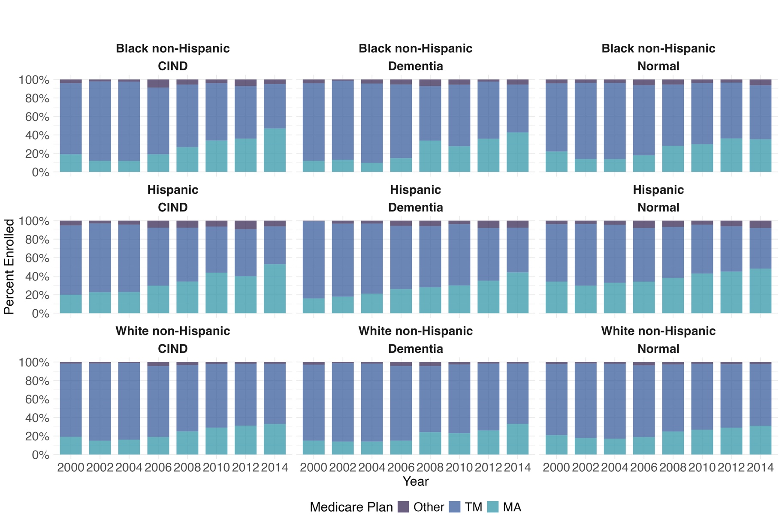

Abbreviations: MA, Medicare Advantage; TM, Traditional Medicare
Annual Enrollment in Medicare Advantage: months enrolled in TM = 0 and months enrolled in MA >0
Annual Enrollment in Traditional Medicare: months enrolled in TM > 0 and months enrolled in MA =0
“Other” refers to cases that were not classified as TM or MA based on the criteria for enrollment.
a, Percentages are weighted proportions derived using the survey sampling weights of the HRS.
b, Due to small number of respondents (< 25) we exclude the count of the category “other” for Race/ethnicity.
Supplemental Figure 2: MA Enrollment between 2000-2014, by Cognitive Function and Race ^{a, b}
Sensitivity to Enrollment Criteria (12 months in a year); Cognitive Function Categories (AD/ADRD, Normal)
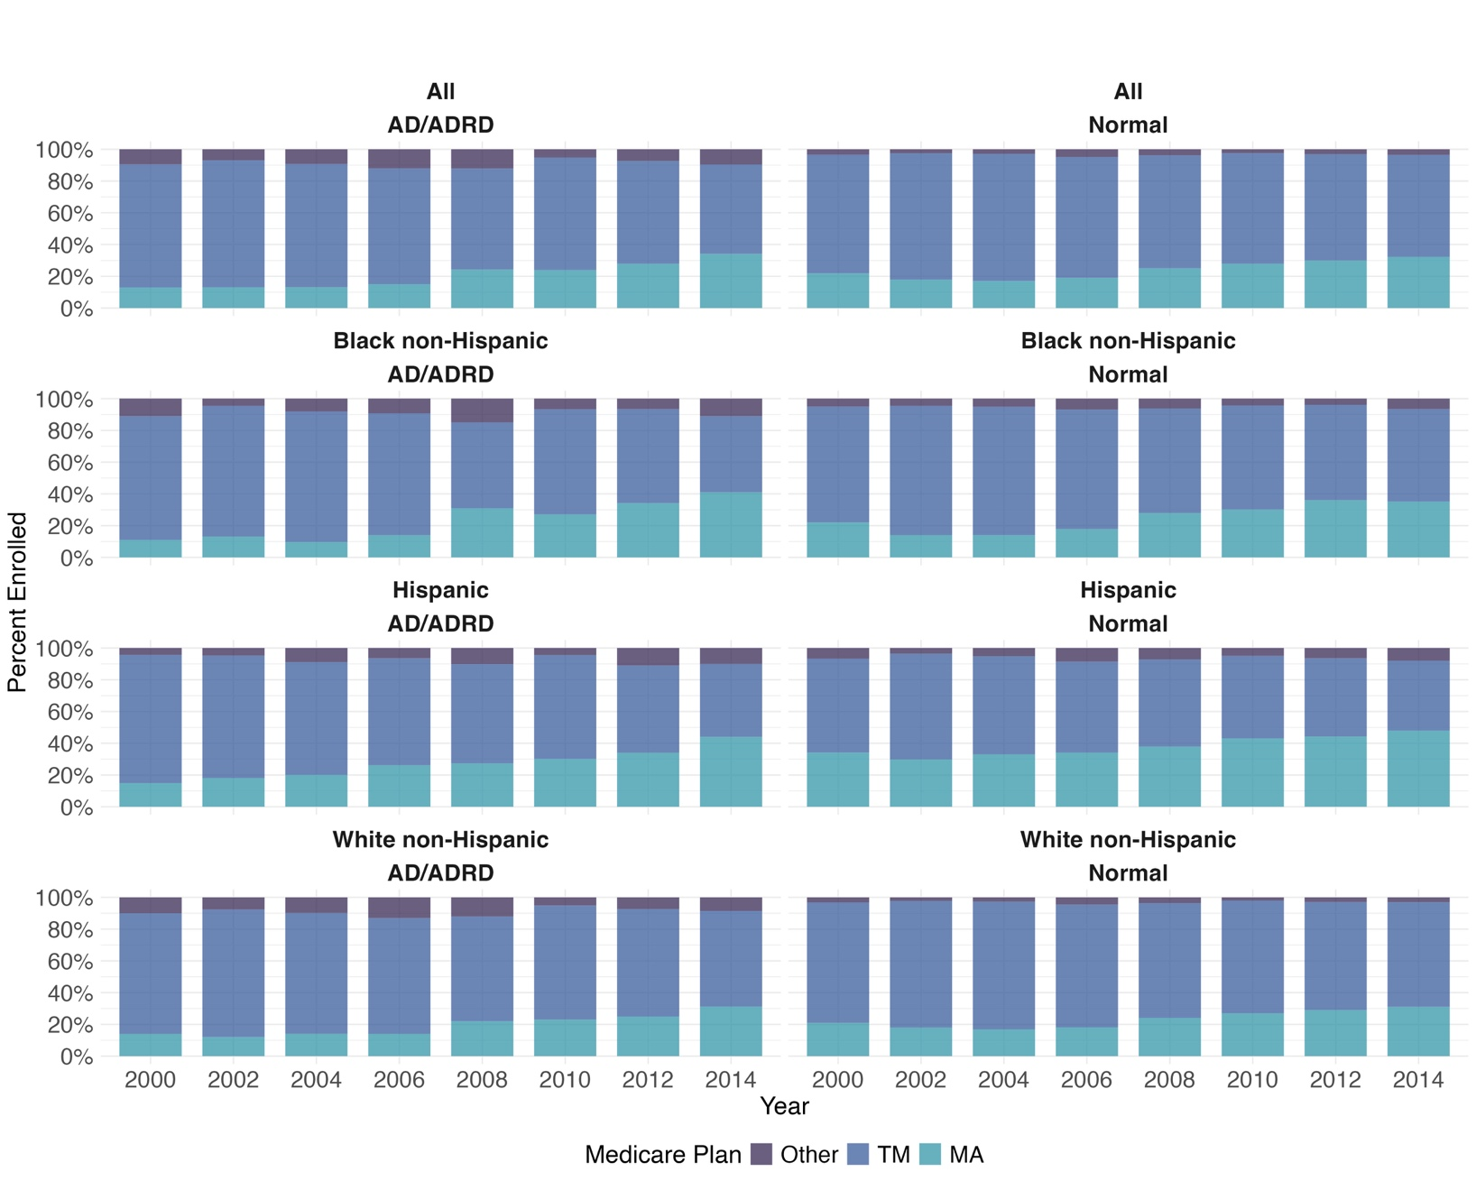

Abbreviations: MA, Medicare Advantage; TM, Traditional Medicare
Annual Enrollment in Medicare Advantage: months enrolled in TM = 0 and months enrolled in MA =12
Annual Enrollment in Traditional Medicare: months enrolled in TM = 12 and months enrolled in MA =0
“Other” refers to cases that were not classified as TM or MA based on the criteria for enrollment.
a, Percentages are weighted proportions derived using the survey sampling weights of the HRS.
b, Due to small number of respondents (< 25) we exclude the count of the category “other” for Race/ethnicity.

