Supplementary material

Goodness of fit
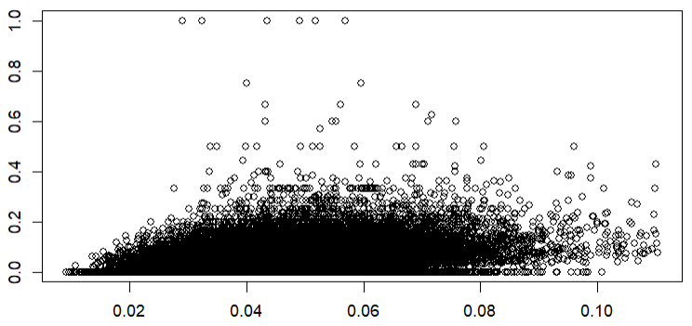
Figure S1. Plot of observed (Y-axis) versus predicted (X-axis) values based on the multivariate regression in M1.

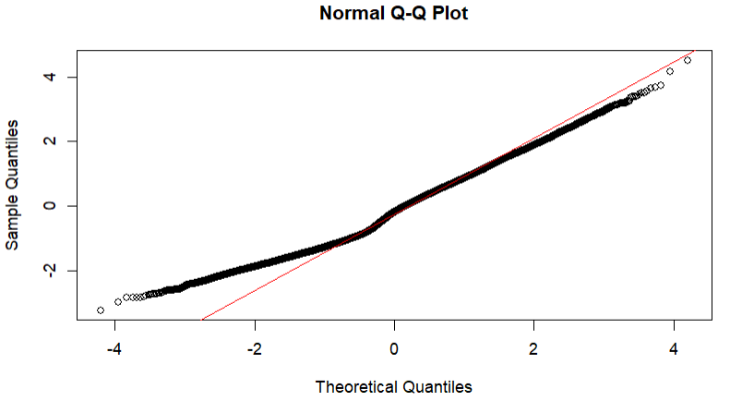
Figure S2. Q-Q plot of residuals based on the multivariate regression in M1

Supplementary table S1. Data sources
Data | Registry (source) | Variable
Living in NH | Swedish Social Service Register (NBHW) | Boform
Age | RTB (SCB)
Sex | RTB (SCB)
ED-visit | National Patient Registry. Specialized outpatient care (NBHW) | VERKS_AKUT
Main diagnosis at ED-visit | National Patient Registry. Specialized outpatient care (NBHW) | HDIA
Morbidity | National Patient Registry. Inpatient and specialized outpatient care (NBHW)  Swedish Drug Prescription Registry (NBHW) | HDIA, DIAGNOS  ATC (dementia = N06D)
Education | LISA (SCB)
Civil status | LISA (SCB)
Country of Birth | LISA (SCB)
Addresses of NH-residents | SCB | Folkbokföringsadress
Addresses of NHs | Business register (SCB)  Unit survey (NBHW)
NH characteristics data | Unit Survey (NBHW)

Example of model specification (M4)
glmer(cbind(ED visit, no ED visit) ~ (private + profile + size + urbanity + nurse weekday + nurse weekend + mean ED risk score + proportion born in Sweden + proportion married + proportion highest education) * pandemic + (1| nursing home) + (1|month), family = binomial, control = glmerControl(optimizer = “bobyqa”, optCtrl = list(maxfun = 1e5)

Description of dataset

Supplementary Table S2. Characteristics of NH-residents.
 | Included (matched to NH) | Excluded (Not matched to NH)
N (% of total) | 74, 327 (%) | 68,273 (%)
Mean age (SD) | 86.12 (7.76) | 84.73 (7.97)
Female (%) | 51,531 (69.3) | 40,343 (59.1)
Dementia (%) | 30,045 (40.4) | 29,103 (42.6)
Share of NH-residents with at least one ED-visit (%) | 32,229 (43.4) | 29,729 (43.5)
Mortality (%) | 29,106 (39.2) | 32,010 (46.9)
SES – civil status | Married = 8,537 (11.5)  Divorced = 14,755 (19.9)  Unmarried = 7,940 (10.7)  Widow/widower = 43,095 (58.0) | Married = 19,044 (28.5)  Divorced = 11,102 (16.6)  Unmarried = 7141 (10.7)  Widow/widower = 29,648 (44.3)
SES Born in Sweden | Sweden = 65,737 (88.4)  Outside of Sweden =  8587 (11.6) | Sweden = 60,264 (88.3)  Outside of Sweden = 8008 (11.7)
SES highest education | Primary = 38,288 (51.5)  Secondary = 25,799 (34.7)  Tertiary = 10,197 (13.7) | Primary = 31,262 (46.7)  Secondary = 23,925 (35.8)  Tertiary = 11,703 (17.5)
Most common disease chapter of primary diagnosis at ED visit (% of total)
Symptoms, signs and abnormal clinical and laboratory findings not elsewhere classified | 14,935 (27.0) | 15,757 (27.3%)
Injury, poisoning and certain other consequences of external causes | 13,039 (23.6) | 12,051 (20.8)
Diseases of the circulatory system | 3642 (6.6) | 4068 (7.0)
Diseases of the respiratory system | 2801 (5.1) | 2945 (5.1)
Diseases of the musculoskeletal system and connective tissue | 2751 (5.0) | 2769 (4.8)
Certain infectious and parasitic diseases | 2728 (4.9) | 2803 (4.8)
Factors influencing health status and contact with health services | 2505 (4.5) | 2929 (5.1)
Diseases of the genitourinary system | 2221 (4.0) | 2460 (4.3)
Covid-19 | 502 (0.9) | 530 (0.9)

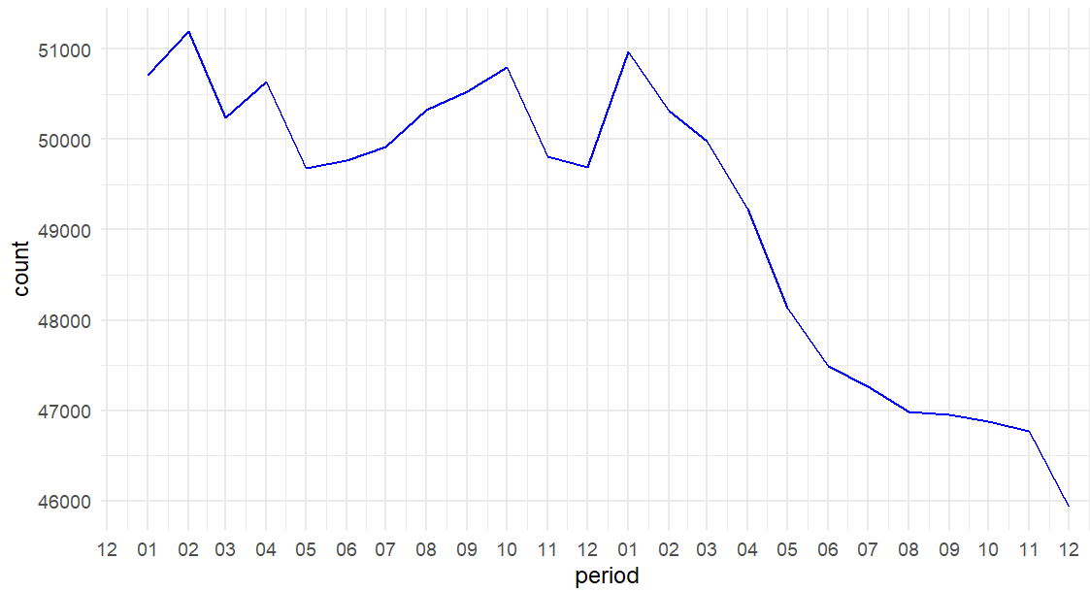
Supplementary figure S3. Number of NH-resident observations per month

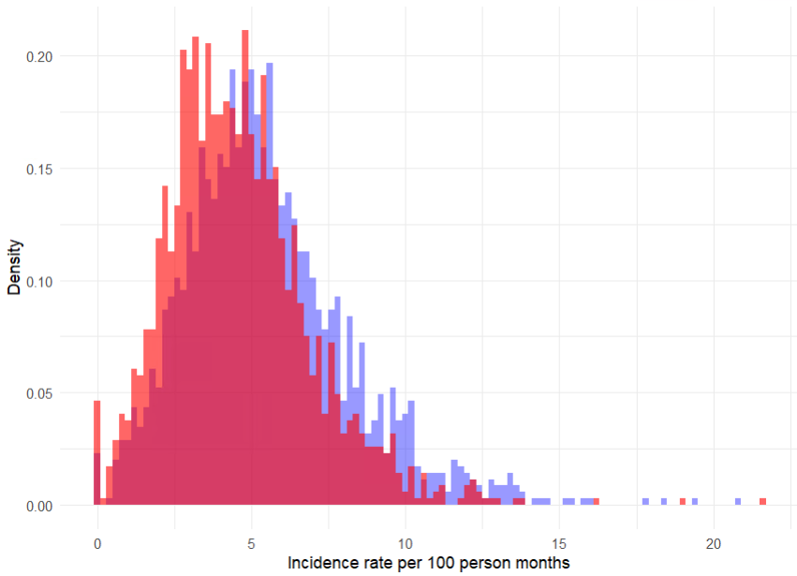
Supplementary Figure S4. Overlapping density ploy of ED incidence rate from nursing homes in 2019 (blue) and 2020 (red) per 100 person months.

Supplementary table S3. M1-M3 including the effects of the socioeconomic variables and the ED risk prediction score used in M3 and M4.
 | BIVARIATE (95% CI) | M1 (95% CI) | M2 (95% CI) | M3 (95% CI)
Intercept |  | 0,04 (0,04-0,05) | 0,05 (0,04-0,05) | 0,05 (0,04-0,06)
Private ownership (ref = public) | 1,06 (1,01-1,11) | 1,04 (1,00-1,10) | 1,03 (0,98-1,09) | 1,04 (0,99-1,10)
Dementia profile (ref = somatic) | 0,91 (0,88-0,95) | 0,89 (0,85-0,92) | 0,88 (0,85-0,92) | 0,9 (0,87-0,94)
Medium size (ref = small) | 0,98 (0,94-1,03) | 0,97 (0,93-1,03) | 0,97 (0,93-1,02) | 0,97 (0,93-1,02)
Large size | 1,00 (0,95-1,05) | 0,99 (0,94-1,04) | 0,99 (0,94-1,04) | 0,98 (0,94-1,03)
Urbanity 2 (ref = most urban) | 1,04 (0,99-1,11) | 1,03 (0,99-1,08) | 1,03 (0,98-1,09) | 1,06 (1,00-1,11)
Urbanity 3 | 0,96 (0,90-1,04) | 0,94 (0,87-1,01) | 0,94 (0,87-1,02) | 0,97 (0,89-1,06)
Urbanity 4 | 0,90 (0,85-0,97) | 0,89 (0,83-0,95) | 0,89 (0,83-0,96) | 0,91 (0,85-0,98)
Urbanity 5 | 0,93 (0,88-1,01) | 0,9 (0,84-0,97) | 0,9 (0,83-0,96) | 0,93 (0,86-1,00)
Urbanity 6 | 0,51 (0,41-0,63) | 0,5 (0,42-0,61) | 0,51 (0,41-0,61) | 0,54 (0,44-0,65)
Medium number of nurses on weekdays (ref = low) | 0,97 (0,93-1,02) |  | 0,95 (0,91-1,00) | 0,95 (0,92-1,00)
High number of nurses on weekdays | 0,99 (0,94-1,05) |  | 0,95 (0,90-1,01) | 0,96 (0,91-1,01)
Medium number of nurses on weekends (ref = low) | 0,93 (0,90-0,98) |  | 0,97 (0,92-1,01) | 0,97 (0,93-1,01)
High number of nurses on weekends | 1,01 (0,96–1,07) |  | 1,04 (0,99-1,10) | 1,04 (0,99-1,10)
ED prediction score |  |  |  | 1,06 (1,04-1,08)
Born in Sweden (proportion) |  |  |  | 0,84 (0,71-0,98)
Married (proportion) |  |  |  | 1,03 (0,84-1,26)
Tertiary education (proportion) |  |  |  | 0,81 (0,66-0,99)
 | AIC | NH Variance | NH VPC | Pseudo-R2 total (fixed effects)
M0 | 107080 | 0,111 | 3,3%
M1 | 106985 | 0,102 | 3,0% | 55,5% (4,9%)
M2 | 106981 | 0,101 | 3,0% | 55,5% (5,3%)
M3 | 106931 | 0,0897 | 2,7% | 55,1% (7,4%)

