Appendix 2.

Card game for Workshops

Type of cards | Description
Domain cards:  Physical domains - where adolescents experience pain | At school  At home  During leisure time  - With friends  - During sports participation  At healthcare providers  Blank cards
Problem cards:  Problems or challenges | The pain experience  Communication  Low health literacy  Understanding of pain  - Fear of pain (serious injury/condition)  - Theories and beliefs about the pain  - Pain triggers and pain relievers  Motivation  Information from external sources, Dr. Google?  Consequences for participation  - School  - Friends  - Activities  Isolation  Mental health challenges  - Identity, future dreams  - Hopelessness, frustration, energy level, tiredness, psychological distress  Blank cards
Solution cards:  Place possible solutions alongside the problem card + domain cards | School-healthcare  - School nurse  - School physiotherapist  School system  General practitioners  Physiotherapist -examination and follow-up  Help from a multidisciplinary team  Examination  Pain neuroscience education – information on what causes pain  - Recognizing patterns of pain  - Learn about load management (total workload)  Psychological therapies (Cognitive Behavioral Therapy)  Relaxation techniques (help to relax - for instance Yoga, mindfulness, breathing exercises)  Exercise instructions or activity plans  Patient stories or support groups, description of adolescents with pain and how they manage their pain condition  Digital solutions (apps, website)  A logbook or a diary for tracking their pain  Co-developing an action plan with healthcare providers  Thorough examination  Nature exposure  Blank cards
Examples from group works | 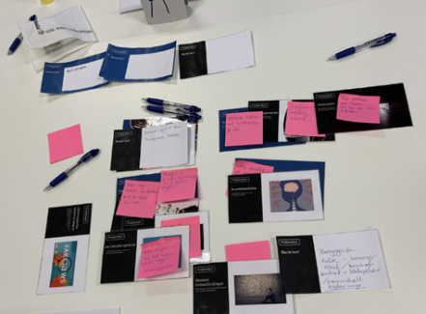  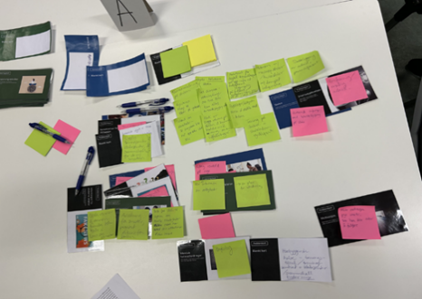
Procedure and use of cards in the workshop phases
Phase | Procedure and use of cards
Critique phase | Participants used Domain and Problem cards to identify and discuss challenges across different contexts.
Fantasy phase | Participants brainstormed solutions by adding Solution cards to the identified challenges.
Implementation phase | Participants refined and prioritized ideas from the Fantasy phase using Solution cards, focusing on actionable steps.

