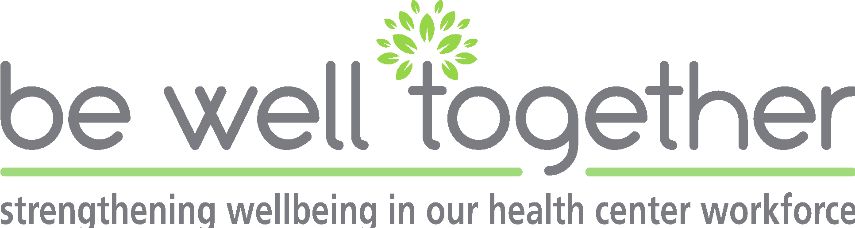

Follow Up Listening Sessions Suggested Questions

- Introductions
  - Thank you for joining today to share your thoughts and ideas regarding the Be Well Together project. Please note you are not required to answer a question that you don’t want to. This session will be recorded via zoom. None of the information shared or used from this session will be identifiable. Themes identified will be shared in aggregate and per health center as with the previous sessions.

- Housekeeping
  - Review purpose of the project
  - Review objectives of listening session
  - Goal: to understand the impact the Be well together program has had on you personally as well as your Community Health Center.

- Overarching questions:
  - What is your perception of the impact of the Be Well Together Program on you personally?
  - How do think the Be Well Together Program impacted the Community health center? The Wellness Culture?
  - Since participating in the Be Well Together program, what does wellbeing mean to you?
    - Did the BWT program improve wellbeing, hope?

Branching Questions (if needed):
- Status and causes of health center employees’ burnout
  - Do you currently observe burnout/ compassion fatigue in health center staff?
    - What are you seeing among fellow health center colleagues that is impacting wellbeing?
    - What if any changes have you noticed related to expressions or manifestation of burnout in health center staff [health center]?
  - How did these compare to before the COVID pandemic? Have they changed?

- Current resources and programs at the CHCs/ BWT Implementation
  - How have you observed increased resources for wellness programs at your Community Health Center. Can you give some examples?
    - Please describe programming activities that were helpful.
    - What were barriers to staff engaging in programming activities or resources? What was done to overcome these barriers?
    - What were the barriers to implementation of wellness activities? What was done to overcome these barriers?
  - Did you attend a BWT sponsored program?
  - If you did not attend, what were the barriers?
  - Describe what you have found helpful, supportive etc. from BWT
  - What could we improve upon for:
    - Attendance
    - Communication
    - Content
  - What BWT tools will you continue to use (tailored to the CHC)
  - How did the tool (s) improve your wellbeing

- Preparing the environment
  - So far we have prepared flyers, email language, and a slide deck to help promote this initiative at your health center.
  - How else can we support staff at your health center in completing a post wellness survey?

- System Change and Measuring Hope
  - How did the BWT program improve your perception of how leadership/the CHC prioritizes your wellbeing?
  - Do up think that employees/leaders are prioritizing wellness initiatives?" "Do you find that there is more opportunity, or greater access, to engage in wellness initiatives?"
  - As the grant comes to an end: How do you see your health center working to sustain supportive programming activities that promote a culture of wellness at your Community Health Center?
    - Leadership role in leading and supporting these efforts
  - How can we support you in sustainability? Any recommendations?

