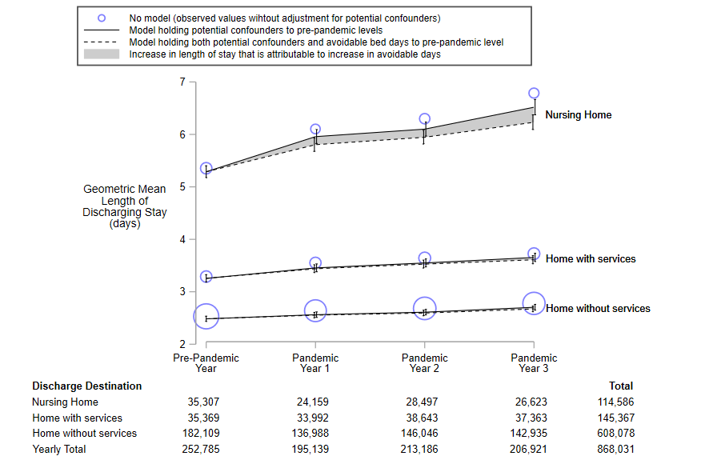
The area of the blue circles is proportional to the number of annual discharges.

