List of supplementary materials

Supplementary Material 1. Topic guide template for interviews with HCPs 2
Supplementary Material 2. Topic guide template for interviews with patients and informal carers 6
Supplementary Material 3. Number and type of interviews per country 10
Supplementary Material 4. Sociodemographic characteristics of participants 11
Supplementary Material 5. Validated care trajectory maps 12
5.1. Belgium, Pneumology, Inpatient and outpatient units. 12
5.2. Belgium, Geriatrics, Outpatient unit. 13
5.3. Greece, Internal Medicine, Inpatient unit. 14
5.4. Norway, Geriatrics, Outpatient unit. 15
5.5. Norway, Geriatrics, Inpatient unit. 16
5.6. Poland, Neurology and Psychiatry, Outpatient units. 17
5.7. Spain, Geriatrics and intermediate care centre, Inpatient unit. 18
5.8. Spain, Geriatrics, Outpatient unit. 19
5.9. Switzerland, General Internal Medicine, Inpatient unit. 20

Supplementary Material 1. Topic guide template for interviews with HCPs
_______________________________________________________________________________
Interview number: Date: Interviewer:
Interview via (Teams, Zoom, phone…): Name of the interviewee:
Health profession / Medical specialty: Healthcare organisation:
Country: Other comments: …………………………………………………………
_______________________________________________________________________________________
INTRODUCTION (5 min)
Good morning,
Thank you for your time. We will start by introducing ourselves (Brief introduction of interviewer’s).
As you may know, the goal of the BE-SAFE project is to improve patient safety by reducing the use of benzodiazepine and sedative-hypnotics (BZRAs) for sleep problems. To do so, we will ask you to describe the current chain of care for patients over 65 years of age taking sleeping pills (i.e. Benzodiazepines and Sedative-Hypnotics (BZRAs), such as Alprazolam, Diazepam or Zolpidem) in your context.

During the interview today, we will cover 3 aspects: 1) we will ask you some general questions about your organisation; 2) we will ask you questions about the care trajectory ; 3) we will ask you what you think could be improved in the chain of care to make BZRA deprescribing successful.

Do you have any questions? Is it ok if we record the interview?
- DESCRIPTION OF CARE TRAJECTORIES (40 min)
To start with, please could you introduce yourself? Could you tell us about your current work and your position in the X healthcare organisation?
We would like to ask you some general questions about your work and the X healthcare organisation:
- Could you please summarise your training or professional trajectory?
- Do you work only in the X department? Or also in other departments of the hospital?
- Do you work in inpatient and outpatient units?
- The X department is part of the X? Do you have hospital day in your department? Do you have other specialized consultations?
- How many professionals are working in the clinic? Are residents working there?
- Do you have a guideline or internal protocol in your department for BZRA deprescribing?

Now, we would like to show you a graph that summarises the information about the care trajectory of deprescribing in your institution. We will ask you some questions to detail the chain of care. Before starting, I would like to remind you that we are interested in knowing “the usual care” of patients.
About the type of patients that you see normally in your ward:
- How would you describe the typical profile of patients that you see at the Department X? What other kinds of patients are referred to the Department X?
- Are all patients referred by the general practitioner? Can they be referred by other doctors or come from other institutions?
- In your department, do you have an idea of the proportion of patients over 65 years old taking BZRA for sleep problems?
- Of this number, in which proportion do you initiate deprescribing in usual care?

Setting (Where) | Steps of the deprescribing process | Dimensions | Questions
GPs’ office | Medication history + Identify inappropriate BZRA | Behaviour | - Do you think that GPs usually try to deprescribe themselves first?
GPs’ office | Medication history + Identify inappropriate BZRA | Communication among HCPs | - How do GPs communicate with your clinic to refer the patient?  - Do primary care and hospitals share the same EHR?
Hospital department | Medication history  +  Identify potentially inappropriate BZRA | Behaviour | - Do you have a unified electronic prescription in X?  - How do you do the medication review at the X?  - How do you identify inappropriate prescriptions, such as Benzodiazepines? Do you use a set of criteria such as START / STOPP?
Hospital department |  | Stakeholders identification | - Who does the medication review? Are resident physicians working in the X?  - Are clinical pharmacists working in the X? May they have any role in medication review and identification of PIP?  - In your department, is the patient visited only by the physicin? Do other healthcare providers play a role in medication history?
Hospital department |  | Communication among HCPs | - Do you have multidisciplinary meetings?  - In case different persons contribute to deprescribing care, how do you communicate with each other?
Hospital department |  | 6’s Ws | - What is the average duration of a consultation at the X? When is the medication history done?
Hospital department | Determine whether medication can be ceased and prioritization  +  Plan and initiate medication  withdrawal | Behaviour | - Once you have identified an inappropriate BZRA prescription, what would you do next?  - How do you communicate to the patient the identification of a potentially inappropriate prescription?  - How do you communicate to the family and caregivers the identification of a potentially inappropriate prescription?  - How do you involve the patients in the decision to stop BZRA?  - How do you involve families/caregivers in the decision to stop BZRA?
Hospital department |  | Stakeholders identification | - Who decides to discontinue BZRA?  - Who makes the tapering plan? How do you make the tapering plan?  - Would you offer other alternatives to the patient?  - Do you involve psychologists or psychiatrists in BZRA deprescribing?  - With what type of patients are you most likely to initiate BZRA deprescribing in the hospital? What does it depend on?
GP’s office | Step 5: monitoring, support and documentation | Communication with GPs | - How do you communicate with GPs to inform them about the start of the patient’s deprescribing process?  - How do you consider the relationship between hospital specialists and GPs? (Do you think that the GPs support the medication changes proposed by the specialists?)  - If the patient is not discharged home, how do you communicate with other institutions that will care for the patient after discharge (e.g. nursing homes)?
GP’s office | Step 5: monitoring, support and documentation | Stakeholders | - Usually, are GPs working alone or working with other HCPs?
GP’s office | Step 5: monitoring, support and documentation | Behaviour | - How do you see the role of the GPs in the follow-up?  - How do you consider the role of other HCPs of the community (e.g. nurses, community pharmacists) in the follow-up of the discontinuation process?
Hospital department | Step 5: monitoring, support and documentation | Behaviour | - What is the role of physicians in your department during the follow-up?  - Do you usually see the patients again for follow-up?  - What would you do in this follow-up visit about BZRA deprescribing?
Hospital department | Step 5: monitoring, support and documentation | 6 W’s | - How many visits do you usually have with the same patient during the follow-up?  - How long does it take from one visit to the next?

ANALYSIS OF ACTORS (5 min)
Now we would like you to think about who are the stakeholders who play a key role in patient care during BZRA deprescribing in your contex.
- First, we would like you to look at the list and think of any stakeholders missing from the list.
- We want you to order by relevance from the centre out, being the centre the most relevant stakeholder. According to you, which stakeholder is the most relevant for BZRA deprescribing? Where would you place the rest?
- As a X, with which of these stakeholders do you have the most important relationship? And what are they like?
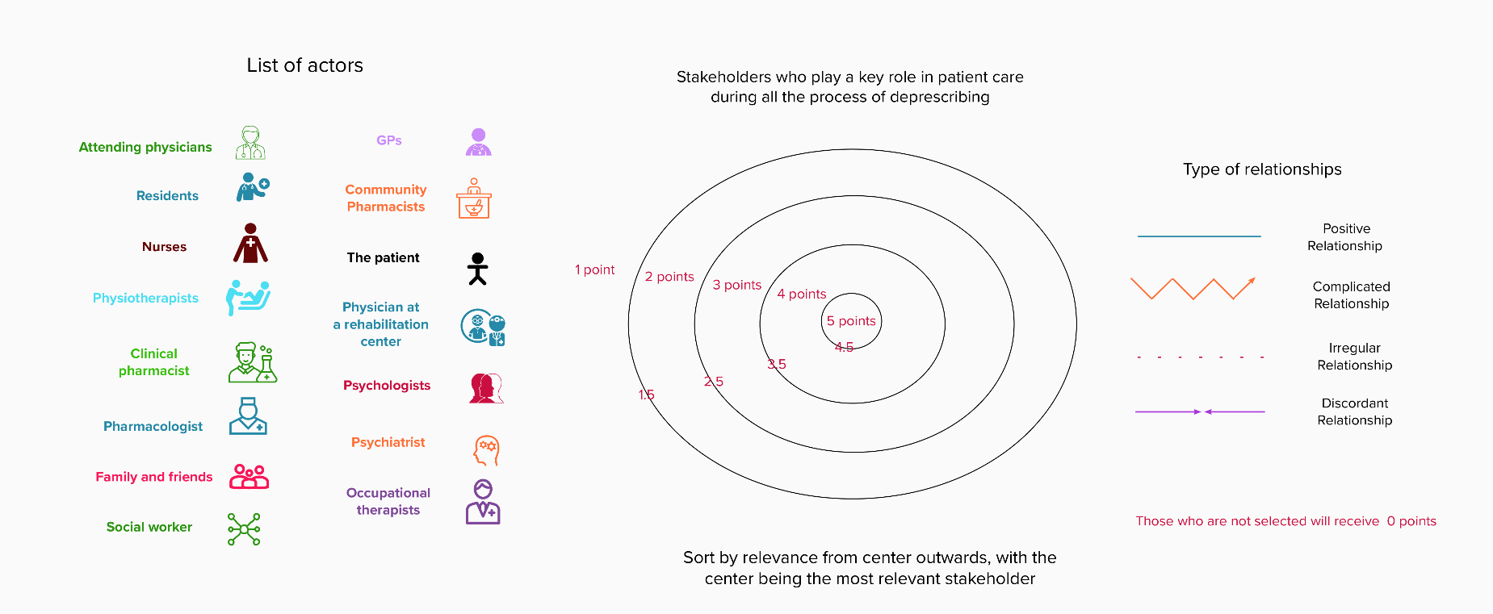

ADAPTATION OF THE CARE TRAJECTORY FOR INTERVENTION IMPLEMENTATION (15 min)
Now we would like you to think about what improvements in the chain of care you would implement for BZRA discontinuation to be successful. These 5 steps have been described in the literature as necessary steps for deprescribing. We would like you to think about these steps and tell us: what do you think is working well?; what do you think can be improved in your context?; Which step do you consider key to success?
DEPRESCRIBING PROCESS
STEP 5
STEP 3
STEP 4
STEP 2
STEP 1
Plan and initiate BZRA withdrawal
Medication history
Identify potentially inappropriate BZRA
Determine whether BZRA can be ceased, involving the patient in the decision

Follow-up monitoring, and support

CLOSURE (1 min)
Thank you for your time and availability. In the following months, we will organise a meeting with healthcare professionals to validate the analysis. I would like to invite you to participate (explain phase 4).

Supplementary Material 2. Topic guide template for interviews with patients and informal carers

Interview number: ………… Date: ………………………
Interviewer: ……………………………… Interview via (Teams, Zoom, phone…): …………………………………………………….
Name of the interviewee: …………………………………………………… Sex: ……………….
Age: ………………………………………......................... Country: ……………
Undergone BZRA discontinuation: …………… Other comments: …………………………………………………………
Thank you for participating in this interview.
This study is part of the BE-SAFE project which aims at reducing the use of sleeping pills, specifically benzodiazepine and sedative-hypnotics (BZRAs), for sleep problems among adults over 65 years of age. In this interview, we would like to cover three aspects:
- Firstly, we would like you to describe the care that you have received recently in the healthcare organisation when you were admitted or attended outpatient consultations.
- Secondly, we would like you to tell us the information and recommendations that you have received about sleeping pills, if any when you were admitted/attended outpatient consultations in this healthcare organisation.
- Finally, I would like to ask you what you think could be improved in the care you received in relation to the information and recommendations about sleeping pills.

This interview will last a maximum of 1 hour. Everything you say will remain strictly anonymous. The interview will be recorded and afterwards transcribed literally.
You don’t need to answer questions that you’re uncomfortable with and you can withdraw from the interview whenever you wish. There are no right or wrong answers, we are interested in your personal opinion. Do you have any questions before we begin? Can you confirm that you are happy for the interview to be recorded?
INTRODUCTION (10 min)
- How long ago did you start taking sleeping pills?
  - Prompts: In what context did you start taking them? Who prescribed them to you?
- Have you been taking sleeping pills continuously until now?
  - Prompts: Some people try to stop sleeping pills, have you ever tried to stop taking sleeping pills? How it was?

DESCRIPTION OF CARE TRAJECTORIES (25 min)
Now, we would like to talk about the admission/visits that you had in the department of X in the healthcare organisation:
- Could you briefly explain the care that you received the last time that you were admitted or visited outpatient consultations in the healthcare organisation?
  - Prompts: Why did you go to the Hospital? How long were you there? When did it happen? Who treated you?
Thinking about the admission/visits that you had in the department of X in the healthcare organisation:
- Did any health professionals review and discuss with you your medications during your last admission or visits to this healthcare organisation?
  - Prompts: How was this medication reviewed? Who did it? In which circumstances? Did your family participate in this review? In which moment?
- Did any healthcare professional, such as doctors or nurses, give you information about sleeping pills?
  - Prompts: What type of information did you receive? Was there any written information provided? Were you or your family informed about the potential side effects of taking sleeping pills in the long term? Who provided this information? In which circumstances? What was your opinion on that? In which moment?
- Did the healthcare professionals of this healthcare organisation advise you to stop taking sleeping pills or inform you of alternatives to reduce the use of sleeping pills?
  - Prompts: How was this advice? Who provided the information? In which circumstances? What was your opinion on that? In which moment?
- Do you remember if the healthcare providers proposed/implemented changes in your sleeping pills during hospitalisation/visits?
- If yes Did healthcare professionals involve you in the decision of changing or reducing your sleeping pills?
  - Prompt: How was this decision taken? Was your family involved in the decision?
- At discharge, did you receive any information about changes in sleeping pills?
  - Prompt: Can you tell me about it? What type of information did you receive? Who provided it (medical doctors, nurses, pharmacists…)? Was your family informed about these changes?
- After discharge, did you discuss the changes in sleeping pills with other healthcare professionals (GPs, pharmacists..)?
  - Prompt: Were your GP aware of the medication changes done at the hospital?
- Do you think that your GP had any role in the follow-up of your sleeping pill changes?
  - Prompt: What was the GP’s perception about the sleeping pill changes done by specialists at the hospital, if there were any changes?
- Should you have any questions or concerns about the changes in your sleeping pills, who would you talk to?
- What other people in your environment besides healthcare professionals are important to you in the management of your sleeping pills? (such as family or friends)

ANALYSIS OF ACTORS (5 min)
Now we would like you to imagine that you would like to stop taking sleeping pills. If you decided to stop taking sleeping pills, who do you think would be the key people in this process? I'll share the screen.

- Here, we have listed some actors who can play a role in helping you to reduce sleeping pills. First of all, we would like you to look at the list and think if anyone is missing from this list.
- On this side, you can see a series of circles, a kind of target. We would like you to sort the actors in order of relevance, from the centre outwards, the centre being the most important actor. We go from the centre to the periphery, from the most important to the least important. Which stakeholder do you think is the most relevant to help you reduce sleeping pills? Where would you place the others? (You don’t need to use all the people in the list, only those who you would consider relevant in the process).
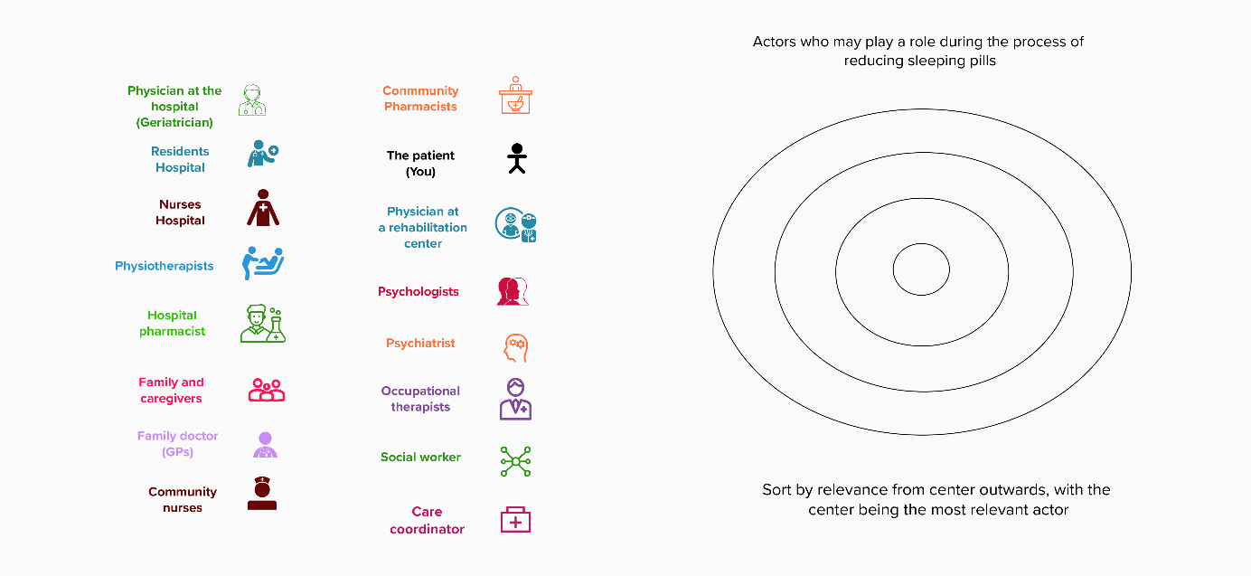
- Which of these stakeholders do you have the most important relationship with?

ADAPTATION OF THE CARE TRAJECTORY FOR INTERVENTION IMPLEMENTATION (20 min)

- For some patients, it could be recommended to stop taking sleeping pills and sometimes this process could be difficult. Now we would like you to imagine that you could change the way information and recommendations about sleeping pills are given to patients in the hospital. What would you change to improve the care that you received about sleeping pills?
- Some prompt questions to guide the conversation:
  - How would you react if a physician suggested you start a process to stop taking sleeping pills during your admission/visits to this healthcare organization? Would you be afraid of anything (e.g. bother your family if you have insomnia)?
  - What kind of information would you like to receive in relation to sleeping pills during your admission or visits?
  - Who should provide this information? When do you think it would be the best time to receive this information? Would you like your family or partner to receive also this information?
  - If you were willing to stop taking sleeping pills, what kind of information would you need to engage in the process?
  - If you were willing to stop taking sleeping pills, when do you think that would be the best time to get advice on stopping sleeping pills? And when do you think it would be the best time to start reducing them?
  - How would you like to be involved in the decision of changing or stopping sleeping pills? What could healthcare professionals do to involve you in the decision to reduce the sleeping pills? Would you like your family or partner to be involved in this decision?
  - How would you feel if healthcare professionals recommended other approaches for treating insomnia, such as psychological therapy (CBT-I)?
  - If you were willing to stop taking sleeping pills, who would you trust to help you in the process? (Which healthcare professionals, family, others?)
  - How would you improve the information given to you about the changes in your sleeping pills at discharge?
  - How could healthcare professionals support you in reducing sleeping pills?
  - What could others around you (family, friends, caregivers…) do to support you in reducing sleeping pills?

CLOSURE (5 min)
- Is there anything else you would like to add that we did not cover during the interview?
Thank you for your time and collaboration

Supplementary Material 3. Number and type of interviews per country

Country | Interviews conducted | Type and number of participants |  |  |  |  |  |  | Languages used in interviews
Country | Interviews conducted | Resident physicians¹ | Attending physicians¹ | GPs | Hospital nurses | Managers | Other HCPs | Patient or informal caregiver | Languages used in interviews
Belgium | 8 | 1 | 1 | 1 | 1 | 1 | 1 psychologist | 2 | French
Greece | 8 | - | 2 | 1 | 1 | 1 | 1 psychiatrist | 2 | English and Greek
Poland | 7 | 1 | 2 | 1 | - | 1 | - | 2 | English and Polish
Norway | 9 | 1 | 2 | 1 | 2 | 1 | - | 2 | English and Norwegian
Spain | 7 | - | 2 | 1 | 1 | 1 | 1 clinical pharmacist | 1 | Spanish
Switzerland | 8 | 1 | 1 | 1 | 1 | 1 | 1 clinical pharmacist | 2 | English and French
Table 3.1. Number and type of interviews conducted per country (Phases 2 and 3)
¹ Hospital physicians working in the department under study.

Country | Type and number of participants in validation meetings |  |  |  |  |  |  |  |  | Languages used in group interviews
Country | Resident physicians¹ | Attending physicians¹ | GPs | Hospital nurses | Managers | Other HCPs | Patients or informal caregivers | Local researchers | Total participants | Languages used in group interviews
Belgium | 1 | 1 | 1 | - | - | 1 clinical pharmacist | 4 | - | 4 HCPs &  4 patients | French
Greece | - | 2 | 1 | 1 | - | 1 psychiatrist | - | 2 | 7 | English and Greek
Poland | 1 | 2 | 1 | - | 1 | - | - | 1 | 6 | English
Norway | - | 2 | - | 1 | 1 | - | - | 1 | 5 | English
Spain | - | 1 | 1 | - | 1 | 2 clinical pharmacists | - | 1 | 6 | Spanish
Switzerland | 1 | 1 | 1 | 1 | - | 1 clinical pharmacist | - | - | 6 | English
Table 3.2. Number and type of participants in group validation interviews per country (Phase 4)
¹ Hospital physicians working in the department under study

Supplementary Material 4. Sociodemographic characteristics of participants
Table 4.1. Socio-demographic characteristics of HCPs (Phases 2 and 3 of data collection)
 | Healthcare professionals (N=36)
Demographics
Age in years, median (min-max) | 45 (31 - 64)
Gender, n (%)  Men  Women | 15 (41.7)  21 (58.3)
Profiles, n (%)  Hospital physicians  Resident physicians  Attending physicians  Nurses  GPs  Managers (HCPs with a role of responsibility in the organisation)  Other types of HCPs¹ | 4 (11.1)  10 (27.7)  6 (16.7)  6 (16.7)  6 (16.7)  4 (11.1)
Years of professional experience, median (min-max) | 18 (4 - 39)
Years of professional experience in the healthcare organisation under study, median (min-max) | 7 (1 - 26)
¹ This category includes clinical pharmacists, psychologists and psychiatrists.

Table 4.2. Socio-demographic characteristics of patients and informal caregivers (Phase 3)
 | Patients and informal caregivers (N=11)
Demographics
Age in years, median (min-max) | 79 (67 - 86)
Gender, n (%)  Men  Women | 4 (36.4)  7 (63.6)
Highest educational level achieved, n (%)  Primary School  Secondary School  Postsecondary education | 2 (18.2)  4 (36.4)  4 (45.5)
Medical history
Type of BZRA use, n (%)  Benzodiazepines  Z-drugs | 5 (45.5)  6 (54.5)
Years taking BZRA, Median (min-max) | 15 (0-47)
Tried to stop BZRA before, n (%) | 8 (72.7)
Months from discharge or last consultation, Median (min-max) | 1 (0-8)

Supplementary Material 5. Validated care trajectory maps

Belgium, Pneumology, Inpatient and outpatient units.
Legend: Rounded blocks with a dashed border indicate interprofessional communication activities.

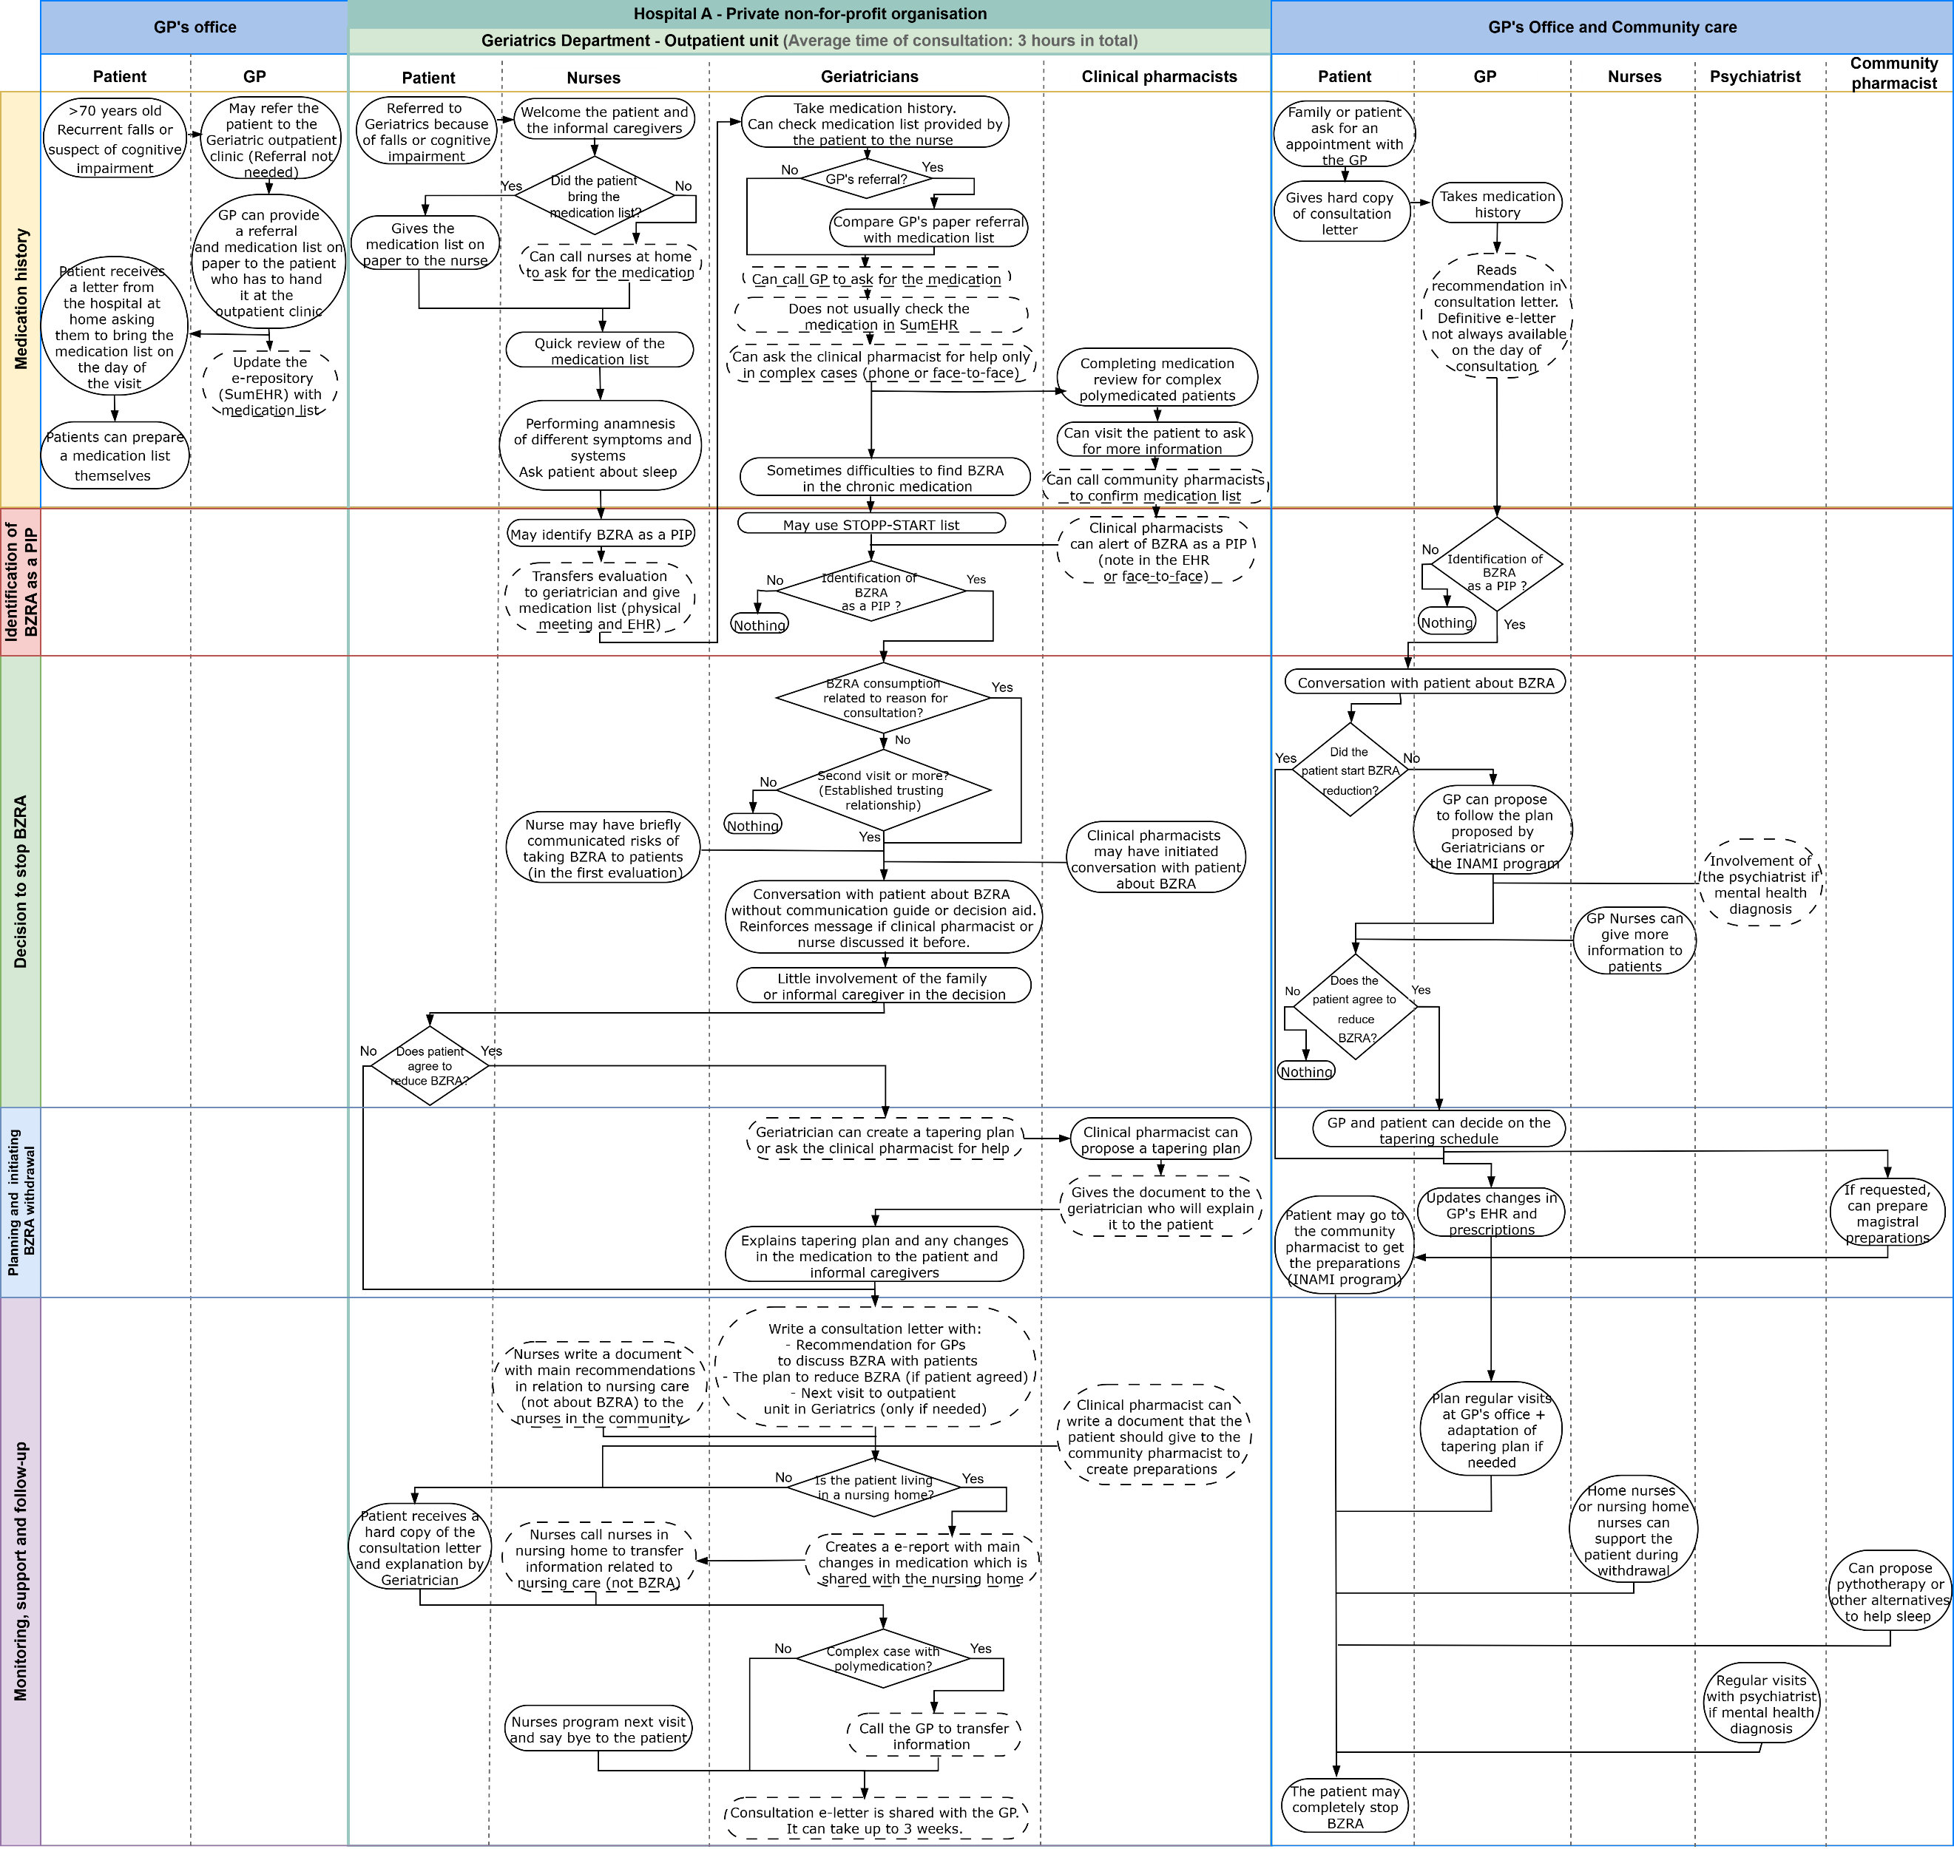
Belgium, Geriatrics, Outpatient unit.

Legend: Rounded blocks with a dashed border indicate interprofessional communication activities

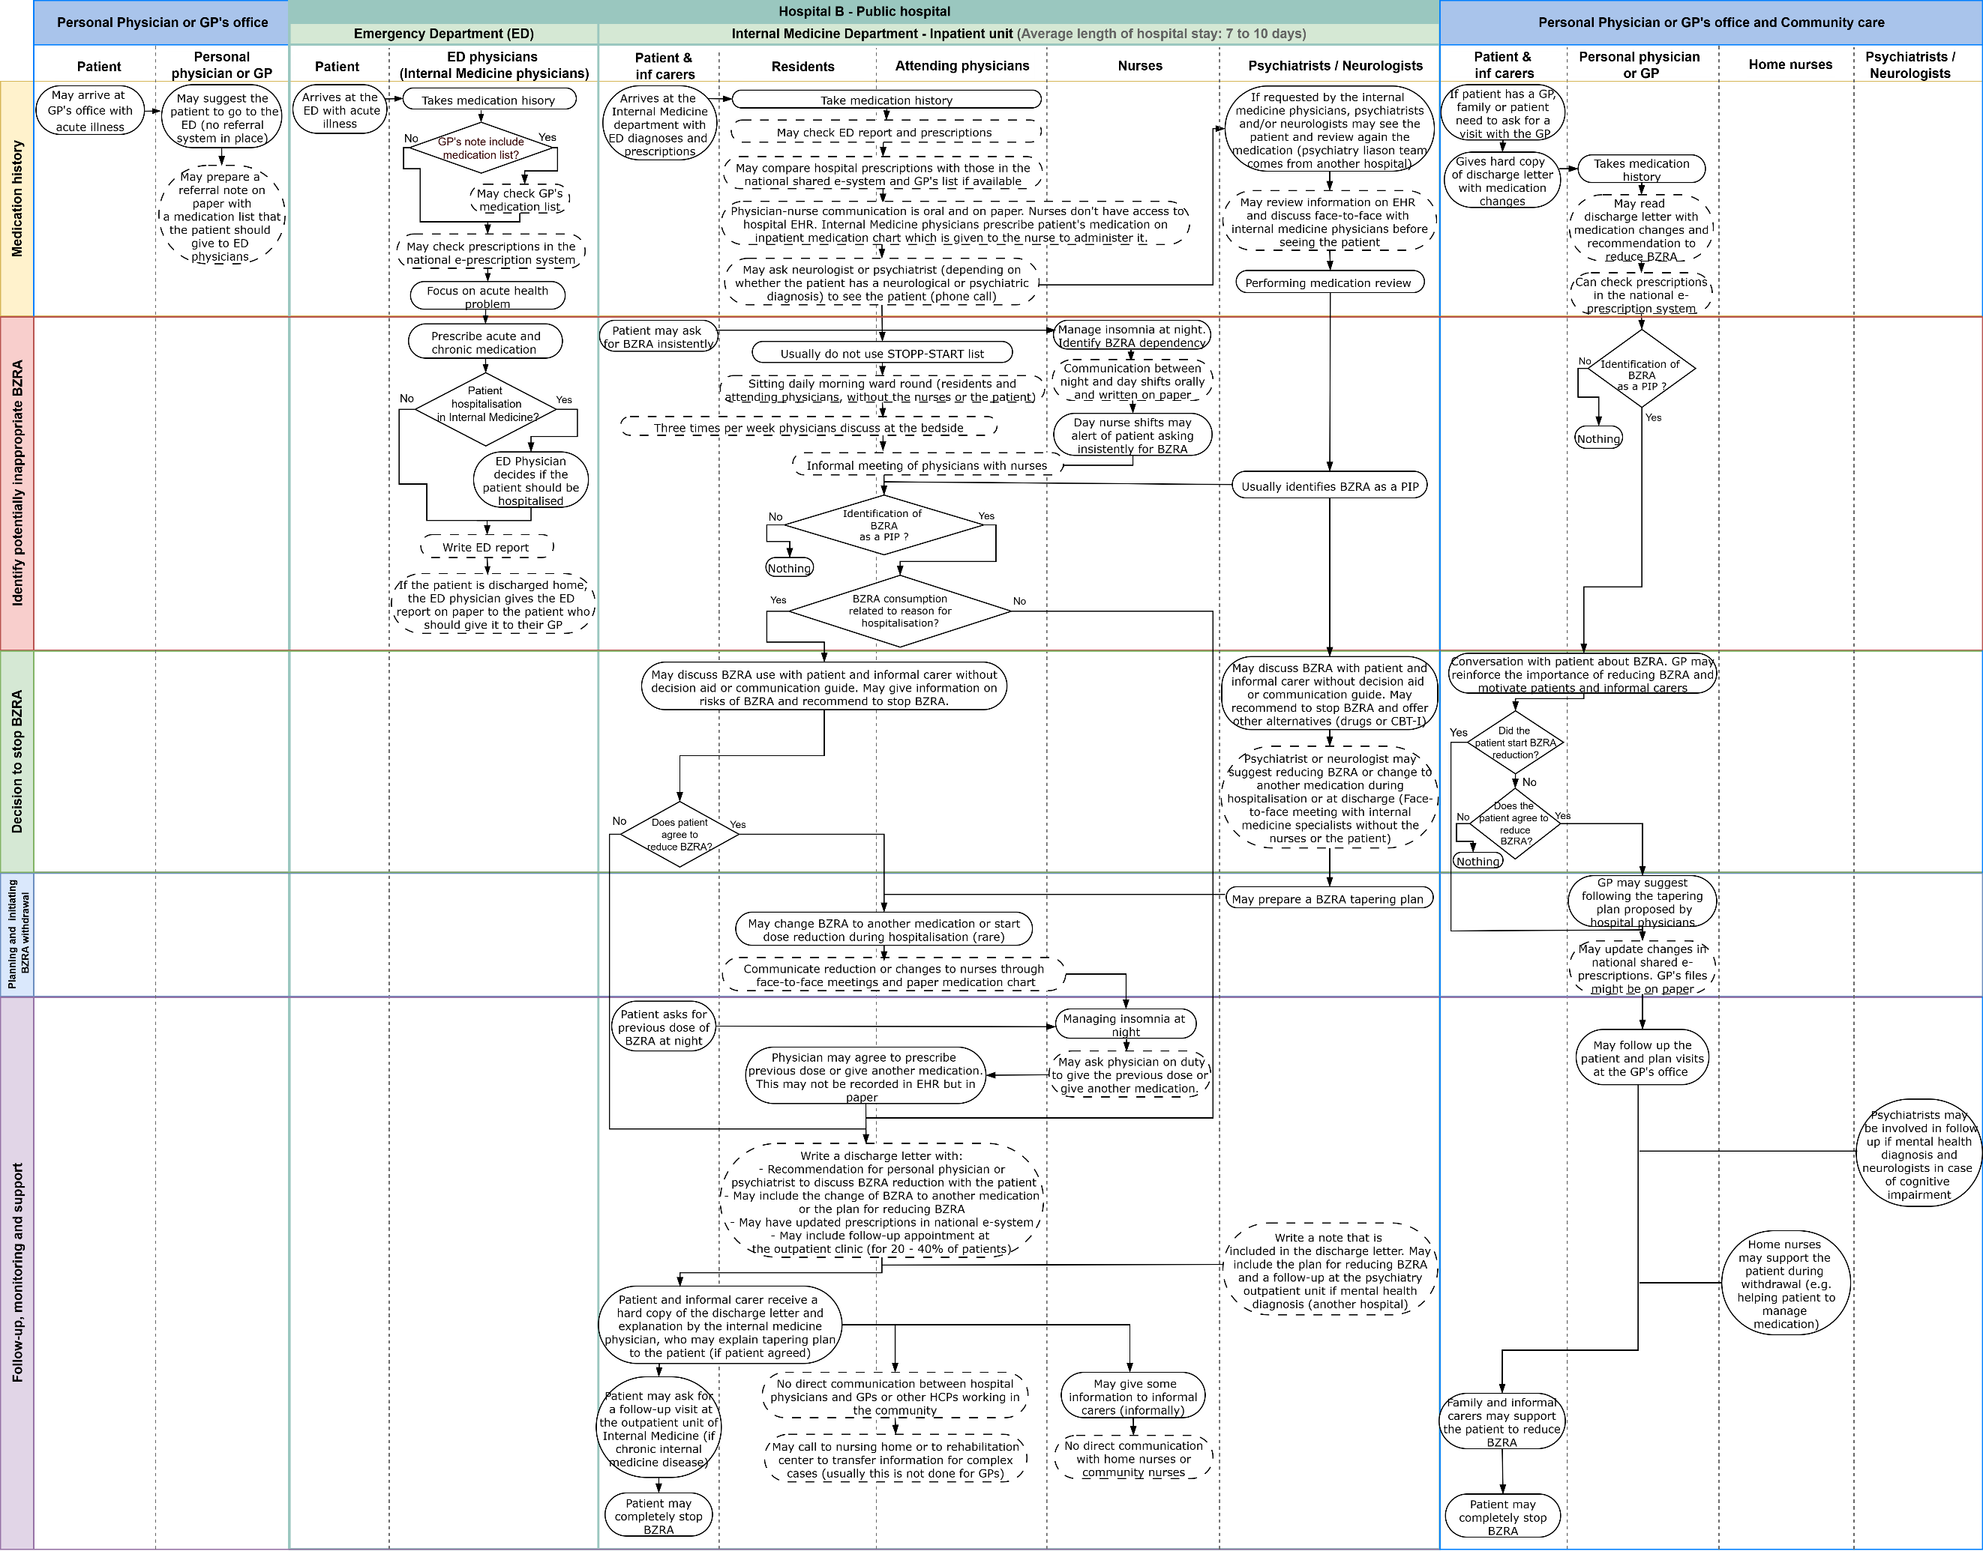
Greece, Internal Medicine, Inpatient unit.
Legend: Rounded blocks with a dashed border indicate interprofessional communication activities.

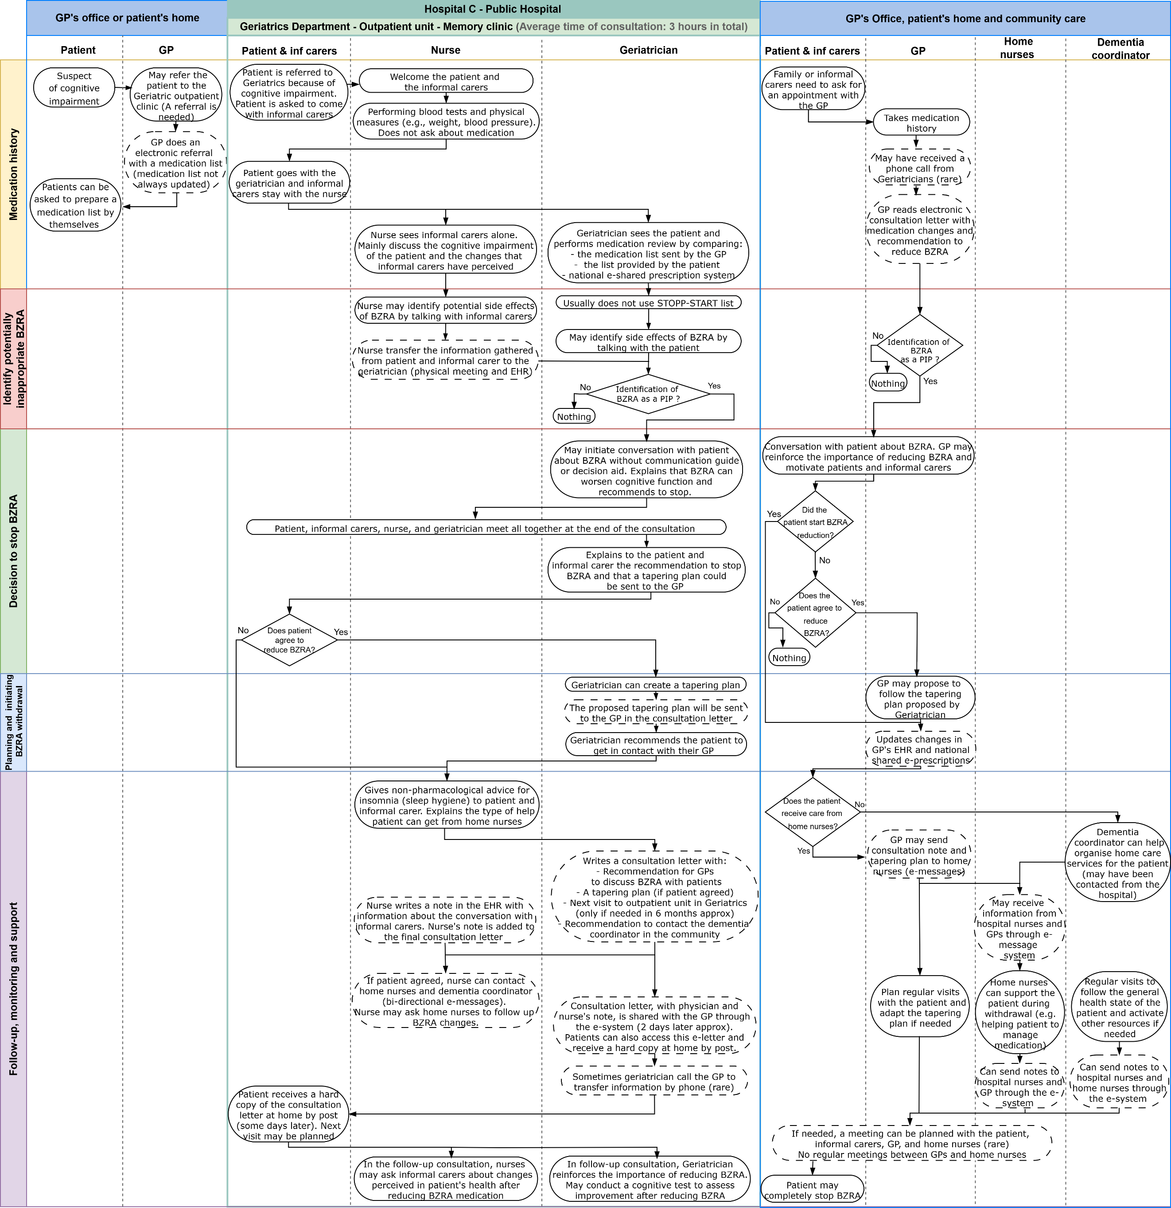
Norway, Geriatrics, Outpatient unit.

Legend: Rounded blocks with a dashed border indicate interprofessional communication activities.

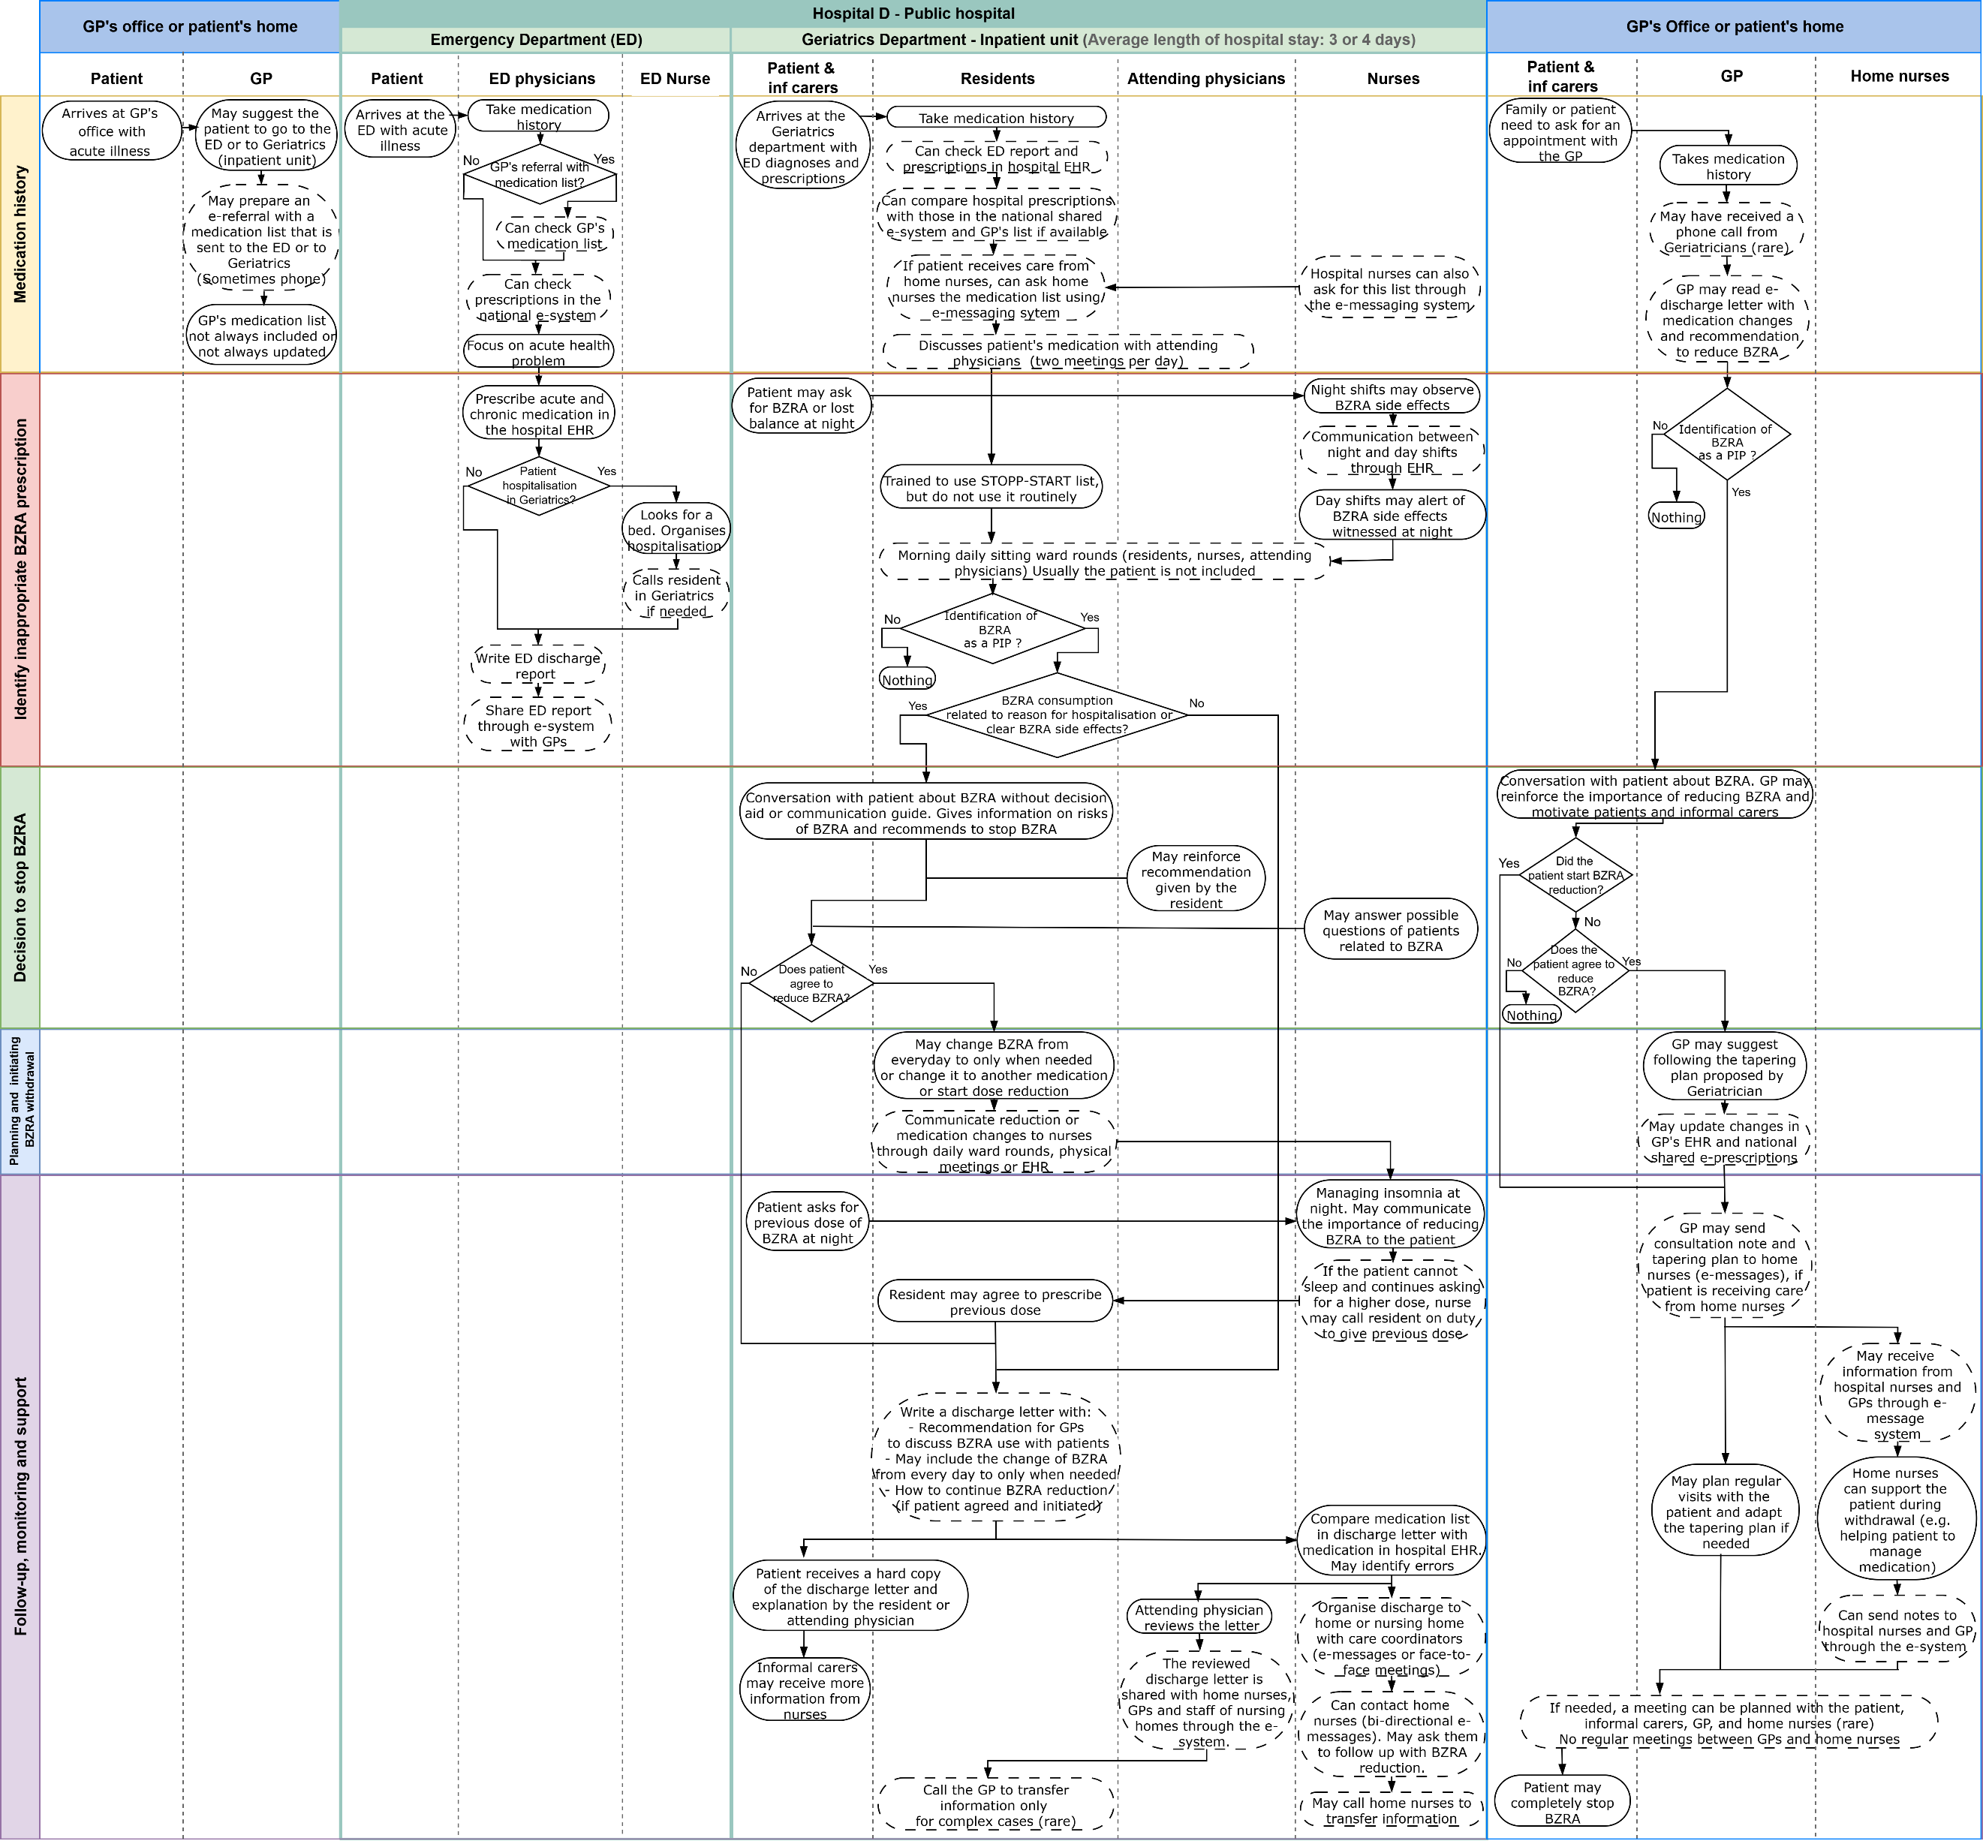
Norway, Geriatrics, Inpatient unit.

Legend: Rounded blocks with a dashed border indicate interprofessional communication activities.

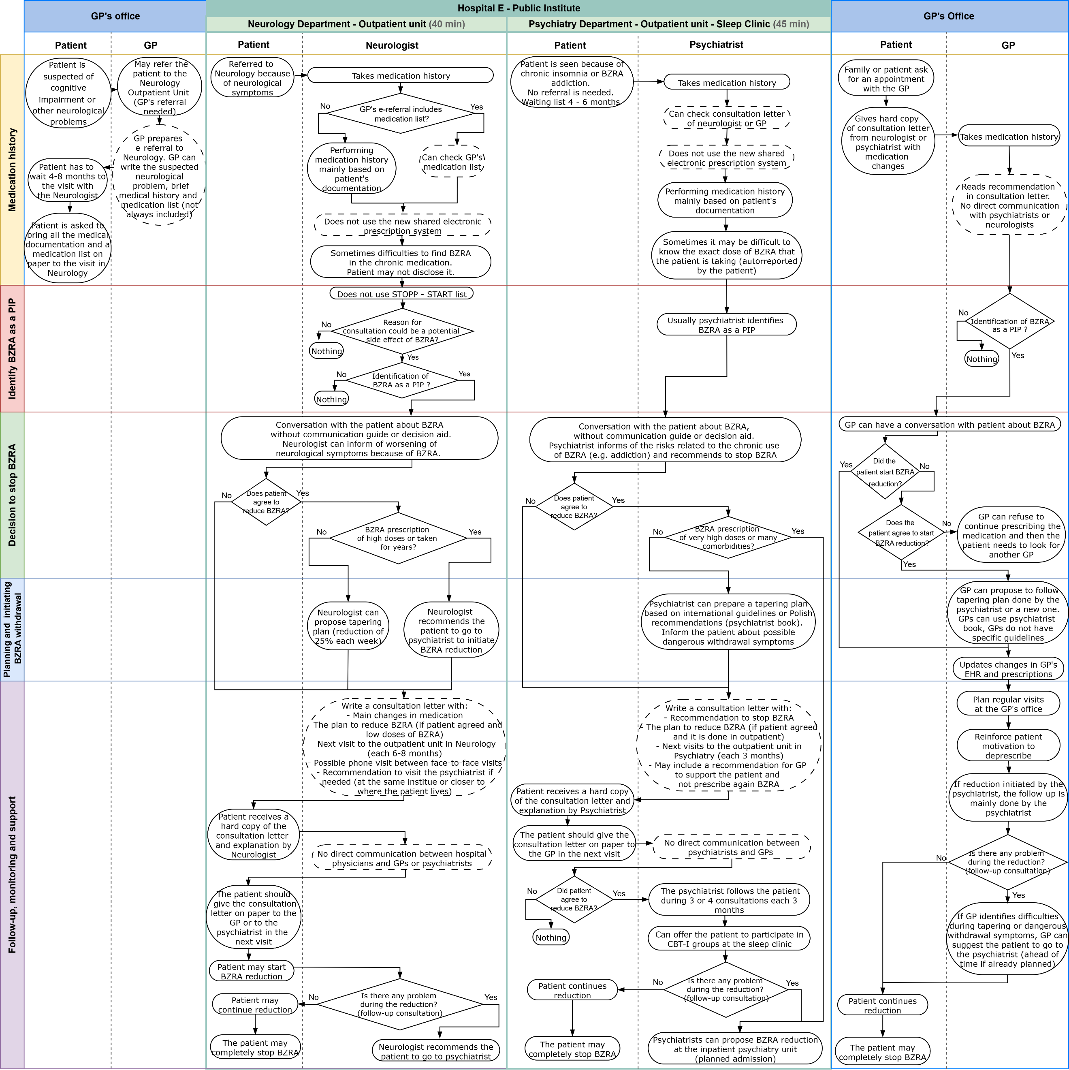
Poland, Neurology and Psychiatry, Outpatient units.

Legend: Rounded blocks with a dashed border indicate interprofessional communication activities.

Spain, Geriatrics and intermediate care centre, Inpatient unit.

Legend: Rounded blocks with a dashed border indicate interprofessional communication activities.

Spain, Geriatrics, Outpatient unit.

Legend: Rounded blocks with a dashed border indicate interprofessional communication activities.

Switzerland, General Internal Medicine, Inpatient unit.
Legend: Rounded blocks with a dashed border indicate interprofessional communication activities

Reeve, E et al. (2014). Review of deprescribing processes and development of an evidence-based, patient-centred deprescribing process. British Journal of Clinical Pharmacology, 78(4), 738–747

