Supplementary information

Figure S1. Model Structure.
Figure S2. Kaplan-meier curve fitting and extrapolation for overall survival (A) and disease-free survival (B).
Figure S3. Probability Sensitivity Analysis Scatter Plot.
Table S1. Details of Treatment Strategy and Unit Costs.
Table S2. The CHEERS 2022 checklist.
Table S3. Summary of Statistical Goodness-of-fit of K-M Curve.

Figure S1. Model Structure.

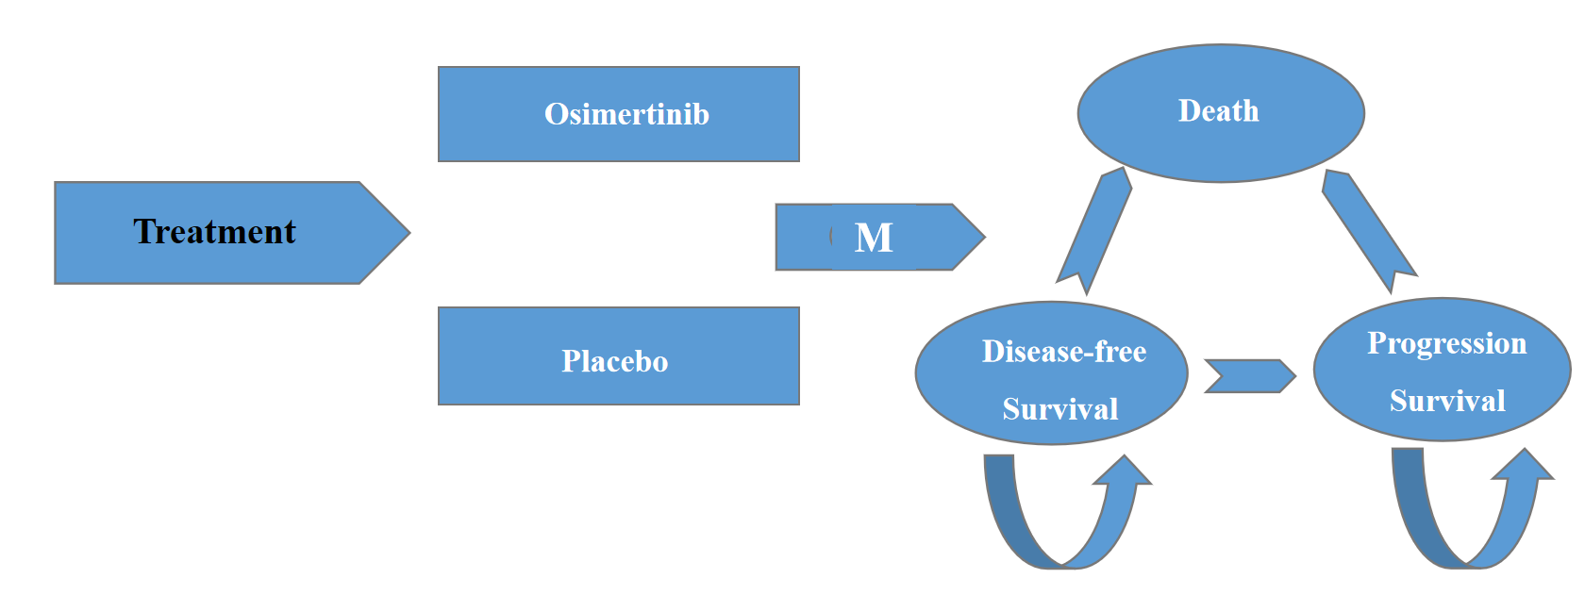

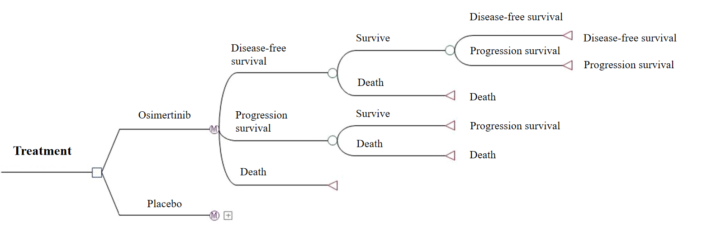

Abbreviation: M, Markov.

Figure S2. Kaplan-meier curve fitting and extrapolation for overall survival (A) and disease-free survival (B)

A.
B.
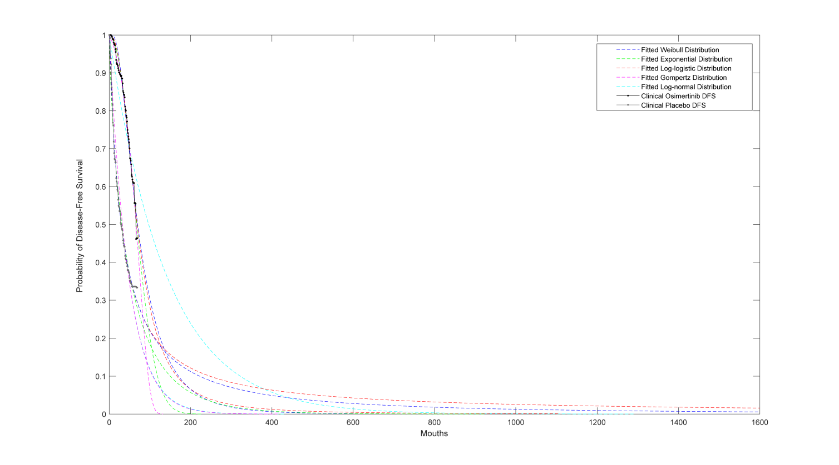
Abbreviation: OS, overall survival; DFS, disease-free survival

Figure S3. Probability Sensitivity Analysis Scatter Plot.

Abbreviation: ICE,incremental cost-effectiveness; WTP, willingness-to-pay.

Each point represents one iteration from the 10,000 Monte Carlo simulations. The dotted line denotes the WTP threshold of $150,000/QALY. The points below this line (green) correspond to the probability that osimertinib will be cost-effective.

Table S1. Details of Treatment Strategy and Unit Costs.
Treatment Strategy | Dose |  | Time | Unit costs, $
Osimertinib group | Osimertinib, 80 mg |  | Administered osimertinib 80 mg once daily | 567
Placebo group | Placebo, 80 mg |  | Administered placebo 80 mg once daily | 0
Subsequent therapy | Osimertinib, 80 mg |  | Administered placebo 80 mg once daily | 567
Subsequent therapy | Chemotherapy | Cisplatin, 75 mg/m | Administered intravenously every 3 weeks | 0.3172
Subsequent therapy | Chemotherapy | Pemetrexed, 500 mg/m2 | Administered intravenously every 3 weeks | 0.7933
Subsequent therapy | Radiotherapy |  | Administered radiotherapy | 1,605

Table S2. The CHEERS 2022 checklist.

Section/item | Item No | Recommendation | Reported?
Title and abstract
Title | 1 | Identify the study as an economic evaluation and specify the interventions being compared. | Yes
Abstract | 2 | Provide a structured summary that highlights context, key methods, results, and alternative analyses. | Yes
Introduction
Background and objectives | 3 | Give the context for the study, the study question, and its practical relevance for decision making in policy or practice. | Yes
Methods
Health economic analysis plan | 4 | Indicate whether a health economic analysis plan was developed and where available. | Yes
Study population | 5 | Describe characteristics of the study population (such as age range, demographics, socioeconomic, or clinical characteristics). | Yes
Setting and location | 6 | Provide relevant contextual information that may influence findings. | Yes
Comparators | 7 | Describe the interventions or strategies being compared and why chosen. | Yes
Perspective | 8 | State the perspective(s) adopted by the study and why chosen. | Yes
Time horizon | 9 | State the time horizon for the study and why appropriate. | Yes
Discount rate | 10 | Report the discount rate(s) and reason chosen. | Yes
Selection of outcomes | 11 | Describe what outcomes were used as the measure(s) of benefit(s) and harm(s) | Yes
Measurement of outcomes | 12 | Describe how outcomes used to capture benefit(s) and harm(s) were measured. | Yes
Valuation of outcomes | 13 | Describe the population and methods used to measure and value outcomes. | Yes
Measurement and valuation of resources and costs | 14 | Describe how costs were valued. | Yes
Currency, price date, and conversion | 15 | Report the dates of the estimated resource quantities and unit costs, plus the currency and year of conversion. | Yes
Rationale and description of model | 16 | If modelling is used, describe in detail and why used. Report if the model is publicly available and where it can be accessed. | Yes
Analytics and assumptions | 17 | Describe any methods for analysing or statistically transforming data, any extrapolation methods, and approaches for validating any model used. | Yes
Characterizing heterogeneity | 18 | Describe any methods used for estimating how the results of the study vary for subgroups. | Yes
Characterizing distributional effects | 19 | Describe how impacts are distributed across different individuals or adjustments made to reflect priority populations. | Yes
Characterizing uncertainty | 20 | Describe methods to characterise any sources of uncertainty in the analysis. | Yes
Approach to engagement with patients and others affected by the study | 21 | Describe any approaches to engage patients or service recipients, the general public, communities, or stakeholders (such as clinicians or payers) in the design of the study. | Not applicable
Results
Study parameters | 22 | Report all analytic inputs (such as values, ranges, references) including uncertainty or distributional assumptions. | Yes
Summary of main results | 23 | Report the mean values for the main categories of costs and outcomes of interest and summarise them in the most appropriate overall measure. | Yes
Effect of uncertainty | 24 | Describe how uncertainty about analytic judgments, inputs, or projections affect findings. Report the effect of choice of discount rate and time horizon, if applicable. | Yes
Effect of engagement with patients and others affected by the study | 25 | Report on any difference patient/service recipient, general public, community, or stakeholder involvement made to the approach or findings of the study. | Not  applicable
Discussion
Study findings, limitations, generalizability, and current knowledge | 26 | Report key findings, limitations, ethical or equity considerations not captured, and how these could affect patients, policy, or practice. | Yes
Other
Source of funding | 27 | Describe how the study was funded and any role of the funder in the identification, design, conduct, and reporting of the analysis | Yes
Conflicts of interest | 28 | Report authors conflicts of interest according to journal or International Committee of Medical Journal Editors requirements. | Yes

Reference:
Husereau D, Drummond M, Augustovski F, de Bekker-Grob E, Briggs AH, Carswell C, et al. Consolidated Health Economic Evaluation Reporting Standards 2022 (CHEERS 2022) Statement: Updated Reporting Guidance for Health Economic Evaluations. Value Health. 2022;25(1):3-9.

Table S3. Summary of Statistical Goodness-of-fit of K-M Curve.
 | Exponential | Weibull | Gompertz | Log-logistic | Log-normal
Osimertinib OS curve
AIC | 16.4748 | 15.3216 | 16.6453 | 15.4223 | 16.3875
BIC | 21.083 | 17.6257 | 21.2535 | 19.7304 | 20.9956
Placebo OS curve
AIC | 34.9885 | 34.5588 | 35.6719 | 35.355 | 34.6978
BIC | 39.9203 | 37.0247 | 40.6037 | 40.2868 | 39.6296
Osimertinib DFS curve
AIC | 36.6003 | 35.5152 | 37.2139 | 36.3262 | 36.0731
BIC | 40.5701 | 38.7637 | 41.7109 | 40.8232 | 41.0973
Placebo DFS curve
AIC | 105.0808 | 103.8388 | 107.0254 | 104.8113 | 104.616
BIC | 109.1129 | 106.0873 | 111.5224 | 109.3083 | 109.5778

Abbreviation: OS, overall survival; DFS, disease-free survival; AIC, Akaike’s information criterion; BIC, Bayesian information criterion.

According to the AIC and BIC value of the distributions and the visual fitting of the curves (Figure S2) showed that the Weibull distribution is probably the most reasonable parametric survival model. Weibull distribution is flexible and widely used for matching patients with three statesover time, because it can monotonously increase or decrease risk functions, and it is suitable for estimating events occurring during early follow-up work.

