Figure A: histograms with density curves for each subscale and for the overall score. The distributions clearly show a right-skewed pattern, providing empirical justification for the use of Gamma regression.

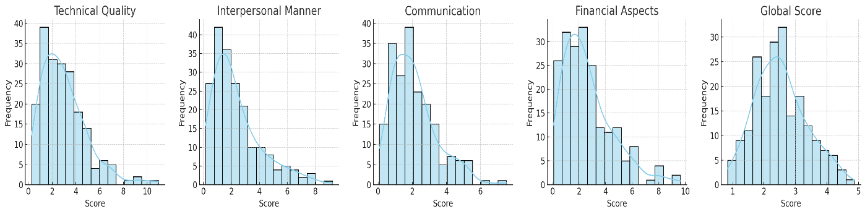
As shown in Table C, sensitivity analyses (robust OLS, beta regression, and ordinal models) confirmed consistent results and indicated a superior fit for the Gamma model
Table C. Sensitivity analyses (robust OLS, beta regression, and ordinal models)
Model | Coefficient | 95% CI | p-value | Fit Comment
Gamma regression | 0.42 | 0.28–0.56 | <0.001 | Optimal fit
Robust OLS | 0.41 | 0.27–0.55 | <0.001 | Consistent
Beta regression | 0.40 | 0.26–0.54 | <0.001 | Good consistency
Ordinal logistic model | 0.43 | 0.29–0.57 | <0.001 | Consistent

