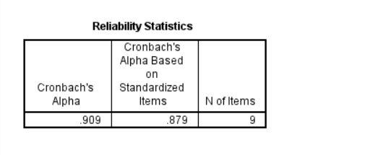

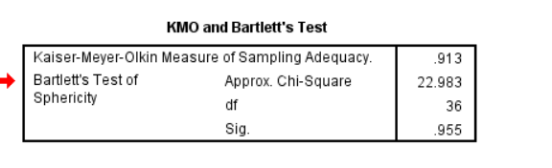

Table 4. Multivariable Logistic Regression Analysis of Factors Associated with Burnout​ (Cut-off: Total Score ≥17)
Variable | B | SE | Wald | P-value | OR | 95%CI
 |  |  |  |  |  | Lower Limit (LL) | Upper Limit (UL)
Professional Title
Resident Physician |  |  |  |  | 1.000
Attending Physician | 0.652 | 0.202 | 10.386 | 0.001 | 1.919 | 1.291 | 2.851
Associate Chief Physician | 0.254 | 0.21 | 1.473 | 0.225 | 1.29 | 0.855 | 1.945
Chief Physician | -0.134 | 0.28 | 0.229 | 0.632 | 0.875 | 0.505 | 1.514
Average Weekly Working Hours
<50h |  |  |  |  | 1.000
50-60h | 0.049 | 0.33 | 0.022 | 0.881 | 1.051 | 0.55 | 2.007
61-70h | -0.169 | 0.357 | 0.224 | 0.636 | 0.844 | 0.419 | 1.701
71-80h | 0.527 | 0.396 | 1.777 | 0.182 | 1.695 | 0.78 | 3.68
>80h | 1.249 | 0.435 | 8.232 | 0.004 | 3.488 | 1.486 | 8.188
Geographic Region
Eastern |  |  |  |  | 1.000
Central | -0.787 | 0.235 | 11.218 | 0.001 | 0.455 | 0.287 | 0.721
Western | -0.489 | 0.241 | 4.106 | 0.043 | 0.614 | 0.382 | 0.984
Northeastern | -1.31 | 0.267 | 24.039 | <0.001 | 0.27 | 0.16 | 0.455
Average Weekly Viewing Time
<1h |  |  |  |  | 1.000
1-3h | -0.097 | 0.233 | 0.174 | 0.677 | 0.907 | 0.574 | 1.433
3-5h | -1.522 | 0.196 | 60.011 | <0.001 | 0.218 | 0.149 | 0.321
>5h | -0.537 | 0.288 | 3.474 | 0.062 | 0.585 | 0.332 | 1.028
Prefers Football | 0.563 | 0.161 | 12.176 | <0.001 | 1.756 | 1.28 | 2.409
Prefers Basketball | 0.409 | 0.158 | 6.72 | 0.01 | 1.505 | 1.105 | 2.051
Constant | 0.174 | 0.511 | 0.116 | 0.733 | 1.19
Table 6. Ordinal Logistic Regression Analysis of Factors Associated with Burnout Severity (Cut-offs: Burnout ≥17, Severe Burnout ≥44)
Variable | OR | P | 95%CI
Variable | OR | P | Lower Limit (LL) | Upper Limit (UL)
Average Weekly Working Hours
<50h
50-60h | 1.732 | 0.197 | 0.751 | 3.987
61-70h | 1.246 | 0.566 | 0.589 | 2.638
71-80h | 2.226 | 0.051 | 0.997 | 4.973
>80h | 1.896 | 0.033 | 1.123 | 4.371
Professional Title​
Resident Physician | 1.000
Attending Physician | 1.433 | 0.045 | 1.039 | 2.786
Associate Chief Physician | 1.254 | 0.342 | 0.787 | 1.996
Chief Physician | 1.502 | 0.233 | 0.77 | 2.93
Geographic Region​
Eastern
Central | 0.64 | 0.031 | 0.427 | 0.961
Western | 0.664 | 0.046 | 0.437 | 0.951
Northeastern | 0.575 | 0.040 | 0.34 | 0.974
​​Average Weekly Viewing Time​
<1h
1-3h | 0.943 | 0.769 | 0.634 | 1.401
3-5h | 0.358 | <0.001 | 0.232 | 0.55
>5h | 0.706 | 0.236 | 0.397 | 1.255
Prefers Football | 0.459 | <0.001 | 0.327 | 0.645
Prefers Basketball​ | 0.397 | <0.001 | 0.285 | 0.553

Table 4. Multivariable Logistic Regression Analysis of Factors Associated with Burnout​ (Categorical Coding of Weekly Working Hours)
Variable | B | SE | Wald | P-value | OR | 95%CI
 |  |  |  |  |  | Lower Limit (LL) | Upper Limit (UL)
Professional Title
Resident Physician |  |  |  |  | 1.000
Attending Physician | 0.467 | 0.205 | 5.183 | 0.023 | 1.595 | 1.067 | 2.384
Associate Chief Physician | 0.102 | 0.212 | 0.231 | 0.631 | 1.107 | 0.730 | 1.679
Chief Physician | -0.212 | 0.283 | 0.564 | 0.453 | 0.809 | 0.464 | 1.408
Average Weekly Working Hours
<50h |  |  |  |  | 1.000
50-60h | 0.103 | 0.330 | 0.097 | 0.755 | 1.108 | 0.580 | 2.118
61-70h | -0.084 | 0.358 | 0.054 | 0.816 | 0.920 | 0.456 | 1.856
71-80h | 0.638 | 0.399 | 2.555 | 0.110 | 1.893 | 0.866 | 4.142
>80h | 1.212 | 0.435 | 7.767 | 0.005 | 3.362 | 1.433 | 7.887
Geographic Region
Eastern |  |  |  |  | 1.000
Central | -0.906 | 0.242 | 14.046 | <0.001 | 0.404 | 0.251 | 0.649
Western | -0.541 | 0.249 | 4.727 | 0.030 | 0.582 | 0.358 | 0.948
Northeastern | -1.463 | 0.273 | 28.702 | <0.001 | 0.231 | 0.136 | 0.395
Average Weekly Viewing Time
<1h |  |  |  |  | 1.000
1-3h | -0.123 | 0.237 | 0.270 | 0.603 | 0.884 | 0.555 | 1.408
3-5h | -1.550 | 0.199 | 60.569 | <0.001 | 0.212 | 0.144 | 0.314
5h | -0.556 | 0.292 | 3.620 | 0.057 | 0.574 | 0.324 | 1.017
Prefers Football | 0.540 | 0.163 | 10.979 | 0.001 | 1.716 | 1.247 | 2.361
Prefers Basketball | 0.395 | 0.16 | 6.143 | 0.013 | 1.485 | 1.086 | 2.030
Constant | 0.465 | 0.515 | 0.815 | 0.367 | 1.592 |  | 0.465

Table 6. Ordinal Logistic Regression Analysis of Factors Associated with Burnout Severity (Categorical Coding of Weekly Working Hours)
 | OR | P | 95%CI
 | OR | P | 下限 | 上限
Average Weekly Working Hours
<50h
50-60h | 1.990 | 0.100 | 0.877 | 4.513
61-70h | 1.192 | 0.641 | 0.569 | 2.499
71-80h | 1.889 | 0.114 | 0.858 | 4.158
>80h | 1.747 | 0.034 | 1.071 | 3.959
Professional Title​
Resident Physician | 1.000
Attending Physician | 1.840 | 0.004 | 1.218 | 2.779
Associate Chief Physician | 1.436 | 0.119 | 0.911 | 2.261
Chief Physician | 1.557 | 0.179 | 0.815 | 2.974
Geographic Region​
Eastern
Central | 0.549 | 0.003 | 0.371 | 0.815
Western | 0.537 | 0.003 | 0.357 | 0.807
Northeastern | 0.599 | 0.048 | 0.361 | 0.996
​​Average Weekly Viewing Time​
<1h
1-3h | 0.941 | 0.755 | 0.641 | 1.380
3-5h | 0.337 | <0.001 | 0.220 | 0.515
>5h | 0.749 | 0.310 | 0.428 | 1.309
Prefers Football | 0.419 | <0.001 | 0.300 | 0.584
Prefers Basketball​ | 0.410 | <0.001 | 0.296 | 0.567
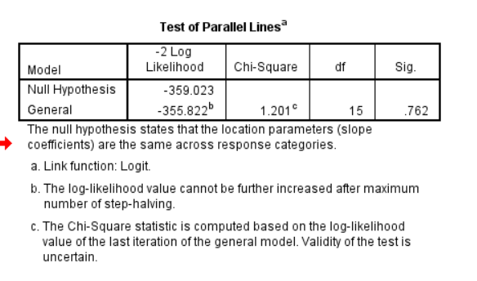

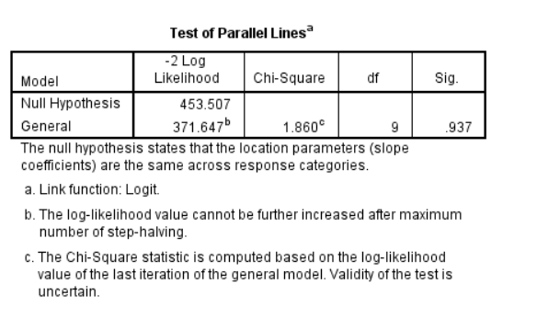

Table 4. Multivariable Logistic Regression Analysis of Factors Associated with Burnout​ (Including Interaction Term: Professional Title × Viewing Time)
Variable | B | SE | Wald | P-value | OR | 95%CI
 |  |  |  |  |  | Lower Limit (LL) | Upper Limit (UL)
Professional Title
Resident Physician |  |  |  |  | 1.000
Attending Physician | 0.467 | 0.205 | 5.183 | 0.023 | 1.595 | 1.067 | 2.384
Associate Chief Physician | 0.102 | 0.212 | 0.231 | 0.631 | 1.107 | 0.730 | 1.679
Chief Physician | -0.212 | 0.283 | 0.564 | 0.453 | 0.809 | 0.464 | 1.408
Average Weekly Working Hours
<50h |  |  |  |  | 1.000
50-60h | 0.103 | 0.330 | 0.097 | 0.755 | 1.108 | 0.580 | 2.118
61-70h | -0.084 | 0.358 | 0.054 | 0.816 | 0.920 | 0.456 | 1.856
71-80h | 0.638 | 0.399 | 2.555 | 0.110 | 1.893 | 0.866 | 4.142
>80h | 1.212 | 0.435 | 7.767 | 0.005 | 3.362 | 1.433 | 7.887
Geographic Region
Eastern |  |  |  |  | 1.000
Central | -0.906 | 0.242 | 14.046 | <0.001 | 0.404 | 0.251 | 0.649
Western | -0.541 | 0.249 | 4.727 | 0.030 | 0.582 | 0.358 | 0.948
Northeastern | -1.463 | 0.273 | 28.702 | <0.001 | 0.231 | 0.136 | 0.395
Average Weekly Viewing Time
<1h |  |  |  |  | 1.000
1-3h | -0.123 | 0.237 | 0.270 | 0.603 | 0.884 | 0.555 | 1.408
3-5h | -1.550 | 0.199 | 60.569 | <0.001 | 0.212 | 0.144 | 0.314
5h | -0.556 | 0.292 | 3.620 | 0.057 | 0.574 | 0.324 | 1.017
Prefers Football | 0.540 | 0.163 | 10.979 | 0.001 | 1.716 | 1.247 | 2.361
Prefers Basketball | 0.395 | 0.16 | 6.143 | 0.013 | 1.485 | 1.086 | 2.030
Professional Title * Viewing Time | 0.487 | 0.169 | 8.360 | 0.004 | 1.628 | 1.170 | 2.265
Constant | 0.465 | 0.515 | 0.815 | 0.367 | 1.592 |  | 0.465

Table 6. Ordinal Logistic Regression Analysis of Factors Associated with Burnout Severity (Including Interaction Term: Professional Title × Viewing Time)
 | OR | P | 95%CI
 | OR | P | 下限 | 上限
Average Weekly Working Hours
<50h
50-60h | 1.990 | 0.100 | 0.877 | 4.513
61-70h | 1.192 | 0.641 | 0.569 | 2.499
71-80h | 1.889 | 0.114 | 0.858 | 4.158
>80h | 1.747 | 0.034 | 1.071 | 3.959
Professional Title​
Resident Physician | 1.000
Attending Physician | 1.840 | 0.004 | 1.218 | 2.779
Associate Chief Physician | 1.436 | 0.119 | 0.911 | 2.261
Chief Physician | 1.557 | 0.179 | 0.815 | 2.974
Geographic Region​
Eastern
Central | 0.549 | 0.003 | 0.371 | 0.815
Western | 0.537 | 0.003 | 0.357 | 0.807
Northeastern | 0.599 | 0.048 | 0.361 | 0.996
​​Average Weekly Viewing Time​
<1h
1-3h | 0.941 | 0.755 | 0.641 | 1.380
3-5h | 0.337 | <0.001 | 0.220 | 0.515
>5h | 0.749 | 0.310 | 0.428 | 1.309
Prefers Football | 0.419 | <0.001 | 0.300 | 0.584
Prefers Basketball​ | 0.410 | <0.001 | 0.296 | 0.567
Professional Title * Viewing Time | 1.448 | 0.018 | 1.064 | 1.970

