Supplementary file -1
The scenarios used in simulating the participants for role-play sessions in the skill improvement sessions of the V-BIS intervention.
Scenario No – 1

A – Background of the problem
Baby is 9 Months, Weight 3.8 kg at birth, healthy, difficulty feeding solid food, not drinking breast milk, growth chart descends for three months.
B - Growth monitoring chart of the child.
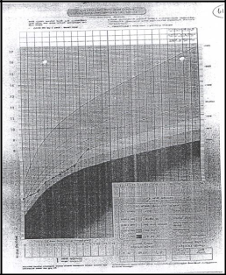

C – The 24 hour dilatory recall of the baby
- Early morning - Cow’s milk $1/2$ a cup, $1/2$ a cup of thin porridge added with 1 teaspoon sugar.
- Around 10 am – Half a banana - (half smashed), and half a cup of fruit juice.
- Afternoon – half a cup of thinly prepared soup, one spoon of rice and $1/2$ a spoon of stanched beans, half a cup of water.
- Around 2 – 3 pm – 1 Sweet biscuit, half a cup of cow’s milk.
- Evening – 2 Spoon of rice, one spoon of vegetables of family food (Carrot and green leaves), $1/2$ cup water.
- Before Sleep - $1/4$ piece of bread without any spread, $1/2$ a cup of cow’s milk and water during the night.

D - Mother’s perception regarding the problem
- Thinking meat is hard to digest for the baby.
- Her mother has made her aware of this.

E – Mother’s behaviors
- Showing disappointment about the baby’s weight loss.
- Not respecting the advice that the provider gives.

Scenario No – 2

A – Background of the problem
Baby is eight months, healthy, and not that liking to eat food

B - Growth monitoring chart of the child
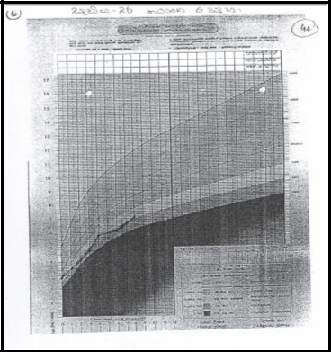

C – The 24-hour dietary recall of the baby
- Early Morning – Breast milk, three tablespoons of thin porridge added with sugar and milk
- Around 10 am – Breast milk
- Afternoon – 1 Spoon of rice from family food, $1/2$ a teaspoon of smashed beans, smashed green leaves and $1/2$ a teaspoon of water.
- Around 2-3 pm – Breast milk, one sweet biscuit
- Evening – Breast milk, Butter speeded lig piece of bread
- Before Sleep – Breast milk
- During the night – Breast milk

D – Mother’s perception
- Small babies should be fed full stomachs with porridge.
- Eggs should not be fed because of flem.
- Babies are less weighted because that’s the way of our family generation.

E – Mother’s behavior
- Thinks her baby’s weight is acceptable.
- Comes out with contradictory opinions to what is being advised.
- Expresses feelings of anger.

