Supplementary File 4: Sensitivity analysis and publication bias assessment
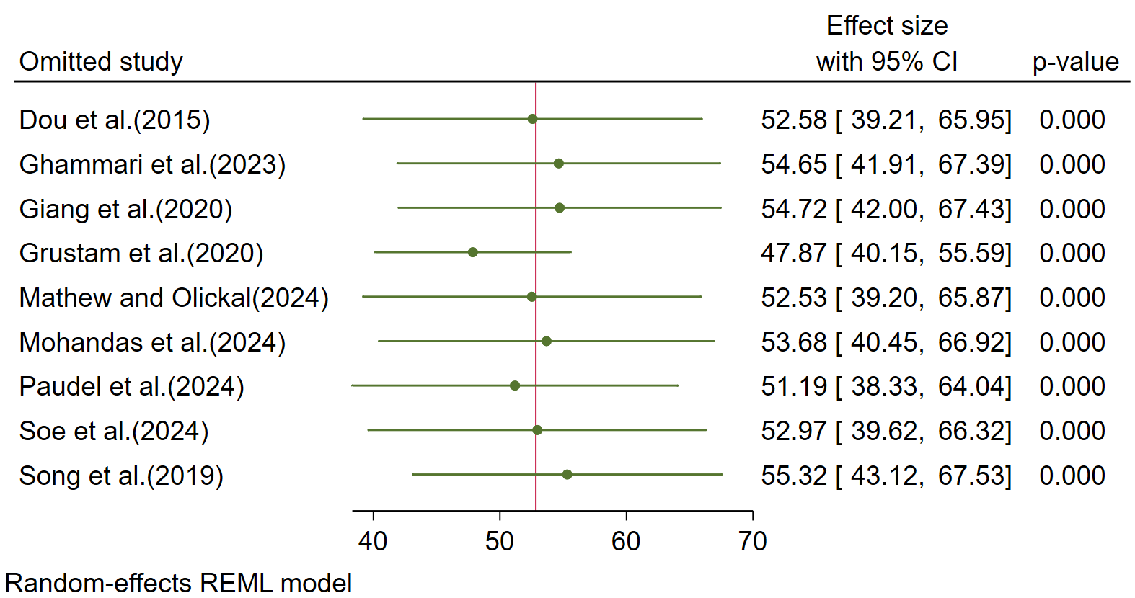
Figure S4-a: Sensitivity analysis for pooled proportion of NCD service utilization
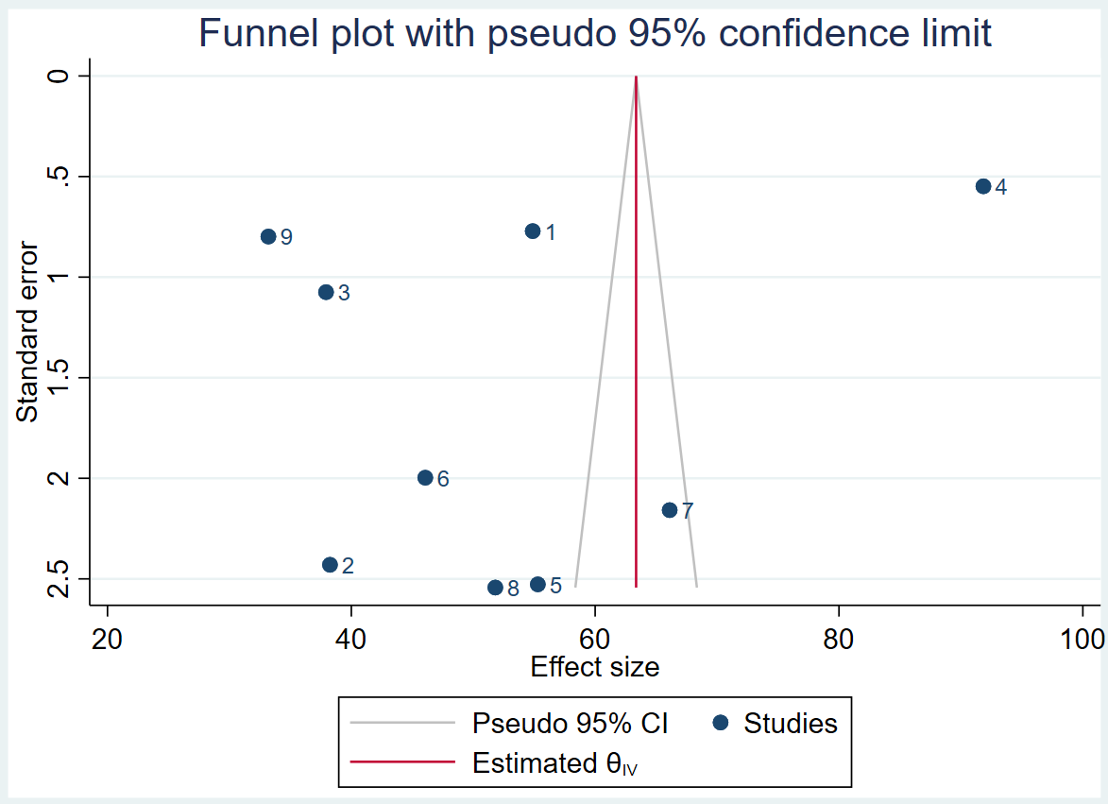
Figure S4-b: Publication bias assessment for included studies with funnel plot

