Supplementary Materials
Table S2 Summary of medication ratios, dosages and wastage.
Drugs | Proportion receiving relevant treatment in Lu group | Proportion receiving relevant treatment in Ate group | Usage | Minimum bottle size (mg) | Waste rate | Wastage outcome of US dollar ($/patient-cycle) | Wastage outcome of milligrams (mg/patient-cycle)
Lurbinectedin | - | - | 3.2 mg/m², iv, 1/21d, Q3W | 4 | 27.2% | 4488.00 | 2.18
Atezolizumab ª | - | - | 1200 mg, iv, 1/21d, Q3W | 1200 | 0.0% | - | -
Carboplatin | 0.16 | 0.11 | AUC 5mg/mL/min, iv, 1/21d, Q3W | 50 | 5.0% | 3.14 | 25.00
Etoposide | 0.14 | 0.1 | 100mg/m², iv, d1-3/21d, Q3W | 100 | 9.0% | 5.56 | 54.00
Topotecan | 0.1 | 0.16 | 1.5 mg/m², iv 30 min, d1-5/21d, Q3W | 4 | 9.0% | 222.25 | 6.35
Irinotecan | 0.1 | 0.14 | 350mg/m², iv, 1/21d, Q3W | 100 | 9.0% | 19.10 | 63.00
Atezolizumab ^{b} | 0.08 | 0.04 | 1200 mg, iv, 1/21d, Q3W | 1200 | 0.0% | - | -
Abbreviations: AUC: area under curve; iv: intravenous; Q3W: every 3 weeks; d: day.
a: atezolizumab as first-line treatment
b: atezolizumab as a subsequent anti-tumor treatment

Table S3 Summary of follow-up methods.
Time horizon | Examination items | Follow-up frequency
First year | Functional MRI,  Pet image w/ct full body,  Blood test,  Breathing capacity test | once every 3 cycles
Second to third year |  | once every 6 cycles
Fourth to fifth year |  | once every 9 cycles
After the sixth year |  | once every 18 cycles

Table S4 : Incidence of grade 3-4 adverse events included in the model.
Types of adverse events (grade 3-4, %) | Lurbinectedin | Atezolizumab
Anaemia | 8 | 1
Decreased neutrophil count | 7 | 0
Decreased platelet count | 7 | 0
Neutropenia | 5 | 0.4
Thrombocytopenia | 5 | 0.4

Table S5 Goodness-of-fitness results.
 | OS of lurbinectedin |  |  | OS of atezolizumab |  |  | PFS of lurbinectedin |  |  | PFS of atezolizumab
Distribution | LnL | Params | AIC | LnL | Params | AIC | LnL | Params | AIC | LnL | Params | AIC
Exponential | -64.9326 | 1 | 131.8652 | -73.74224 | 1 | 149.4845 | -73.11102 | 1 | 148.222 | -100.2436 | 1 | 202.4872
Weibull | -55.32906 | 2 | 114.6581 | -63.94705 | 2 | 131.8941 | -69.5377 | 2 | 143.0754 | -100.2636 | 2 | 204.5273
Gamma | -55.79695 | 2 | 115.5939 | -62.99519 | 2 | 129.9904 | -67.6196 | 2 | 139.2392 | -100.0782 | 2 | 204.1564
Log-Normal | -62.40493 | 2 | 128.8099 | -64.8047 | 2 | 133.6094 | -60.57218 | 2 | 125.1444 | -71.32409 | 2 | 146.6482
Gompertz | -57.10274 | 2 | 118.2055 | -68.56009 | 2 | 141.1202 | -72.70253 | 2 | 149.4051 | -91.83485 | 2 | 187.6697
Log-Logistic | -56.64063 | 2 | 117.2813 | -62.47519 | 2 | 128.9504 | -63.37605 | 2 | 130.7521 | -72.35862 | 2 | 148.7172
Generalized Gamma | -55.30379 | 3 | 116.6076 | -62.69351 | 3 | 131.387 | -60.37074 | 3 | 126.7415 | -55.86631 | 3 | 117.7326
FP1-1 | -62.3943 | 2 | 128.7886 | -73.12037 | 2 | 150.2407 | -74.19513 | 2 | 152.3903 | -99.95616 | 2 | 203.9123
FP1-2 | -56.89317 | 2 | 117.7863 | -62.96378 | 2 | 129.9276 | -66.68311 | 2 | 137.3662 | -106.3866 | 2 | 216.7732
FP2-1 | -53.9573 | 3 | 113.9146 | -64.75239 | 3 | 135.5048 | -73.47652 | 3 | 152.953 | -98.41306 | 3 | 202.8261
FP2-2 | -54.01484 | 3 | 114.0297 | -63.95382 | 3 | 133.9076 | -72.43917 | 3 | 150.8783 | -96.43435 | 3 | 198.8687
RCS1 | -54.15056 | 3 | 114.3011 | -63.99856 | 3 | 133.9971 | -71.88557 | 3 | 149.7711 | -94.59211 | 3 | 195.1842
RCS2 | -54.13809 | 4 | 116.2762 | -63.58003 | 4 | 135.1601 | -65.62191 | 4 | 139.2438 | -55.78045 | 4 | 119.5609
RP-hazard-1 | -55.329 | 2 | 114.658 | -62.74878 | 3 | 131.4976 | -59.06833 | 5 | 128.1367 | -55.33787 | 3 | 116.6757
RP-hazard-2 | -55.14685 | 3 | 116.2937 | -63.94708 | 2 | 131.8942 | -61.61085 | 6 | 135.2217 | -57.51266 | 4 | 123.0253
RP-odds-1 | -54.57954 | 3 | 115.1591 | -62.47532 | 2 | 128.9506 | -59.94056 | 5 | 129.8811 | -54.91691 | 3 | 115.8338
RP-odds-2 | -56.64109 | 2 | 117.2822 | -62.44085 | 3 | 130.8817 | -61.81198 | 6 | 135.624 | -57.1243 | 4 | 122.2486
RP-normal-1 | -54.82059 | 3 | 115.6412 | -62.58929 | 3 | 131.1786 | -60.57219 | 2 | 125.1444 | -54.33705 | 3 | 114.6741
RP-normal-2 | -54.81796 | 4 | 117.6359 | -64.80475 | 2 | 133.6095 | -60.38609 | 3 | 126.7722 | -54.27943 | 4 | 116.5589
Abbreviations: OS: Overall survival; PFS: Progression-free survival; LnL: Log-likelihood; Params: Parameters; AIC: Akaike information criterion; FP: Fractional polynomial; RCS: Restricted cubic spline models; RP: Royston-Parmar models. Bold data means that this model is the model we finally selected.

Table S6 Summary results of scenario analysis.
Incremental Cost ($) | Incremental QALYs | ICER ($/QALY)
Base: RCS1 for OS; RP-hazard-1 for PFS
229,342.16 | 0.30 | 773,428.44
Scenario (a): Log-logistic for OS; RP-hazard-1 for PFS
224,978.19 | 0.21 | 1,061,316.86
Scenario (b): RCS2 for OS; RP-hazard-1 for PFS
237,269.44 | 0.45 | 527,445.14
Scenario (c): RP-odds-2 for OS; RP-hazard-1 for PFS
224,967.98 | 0.21 | 1,062,241.92
Scenario (d): RCS1 for OS; Gen-gamma for PFS
245,470.25 | 0.30 | 822,898.30
Scenario (e): RCS1 for OS; RP-odds-1 for PFS
271,571.36 | 0.30 | 901,724.73
Scenario (f): RCS1 for OS; RP-normal-2 for PFS
243,541.51 | 0.30 | 817,013.24
Abbreviations: OS: Overall survival; PFS: Progression-free survival; QALY: Quality-adjusted life year

(a)
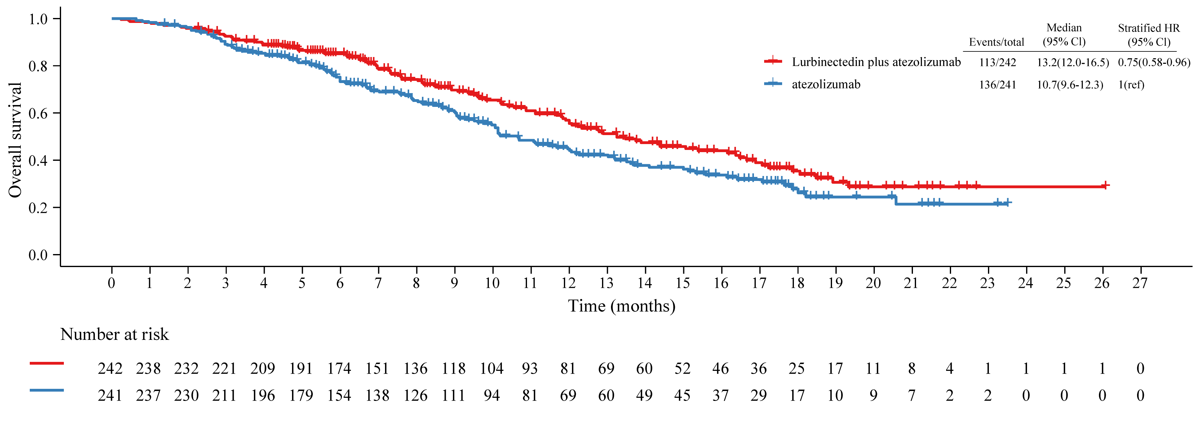 (b)
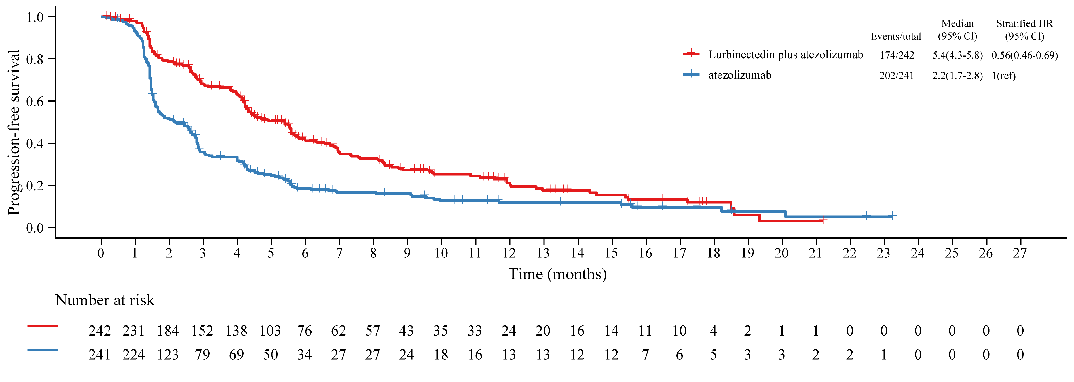 Figure S1 Reconstruction of Kaplan Meier survival curve. OS curve (a). PFS curve (b).
OS, overall survival; PFS, progression-free survival.

(a)
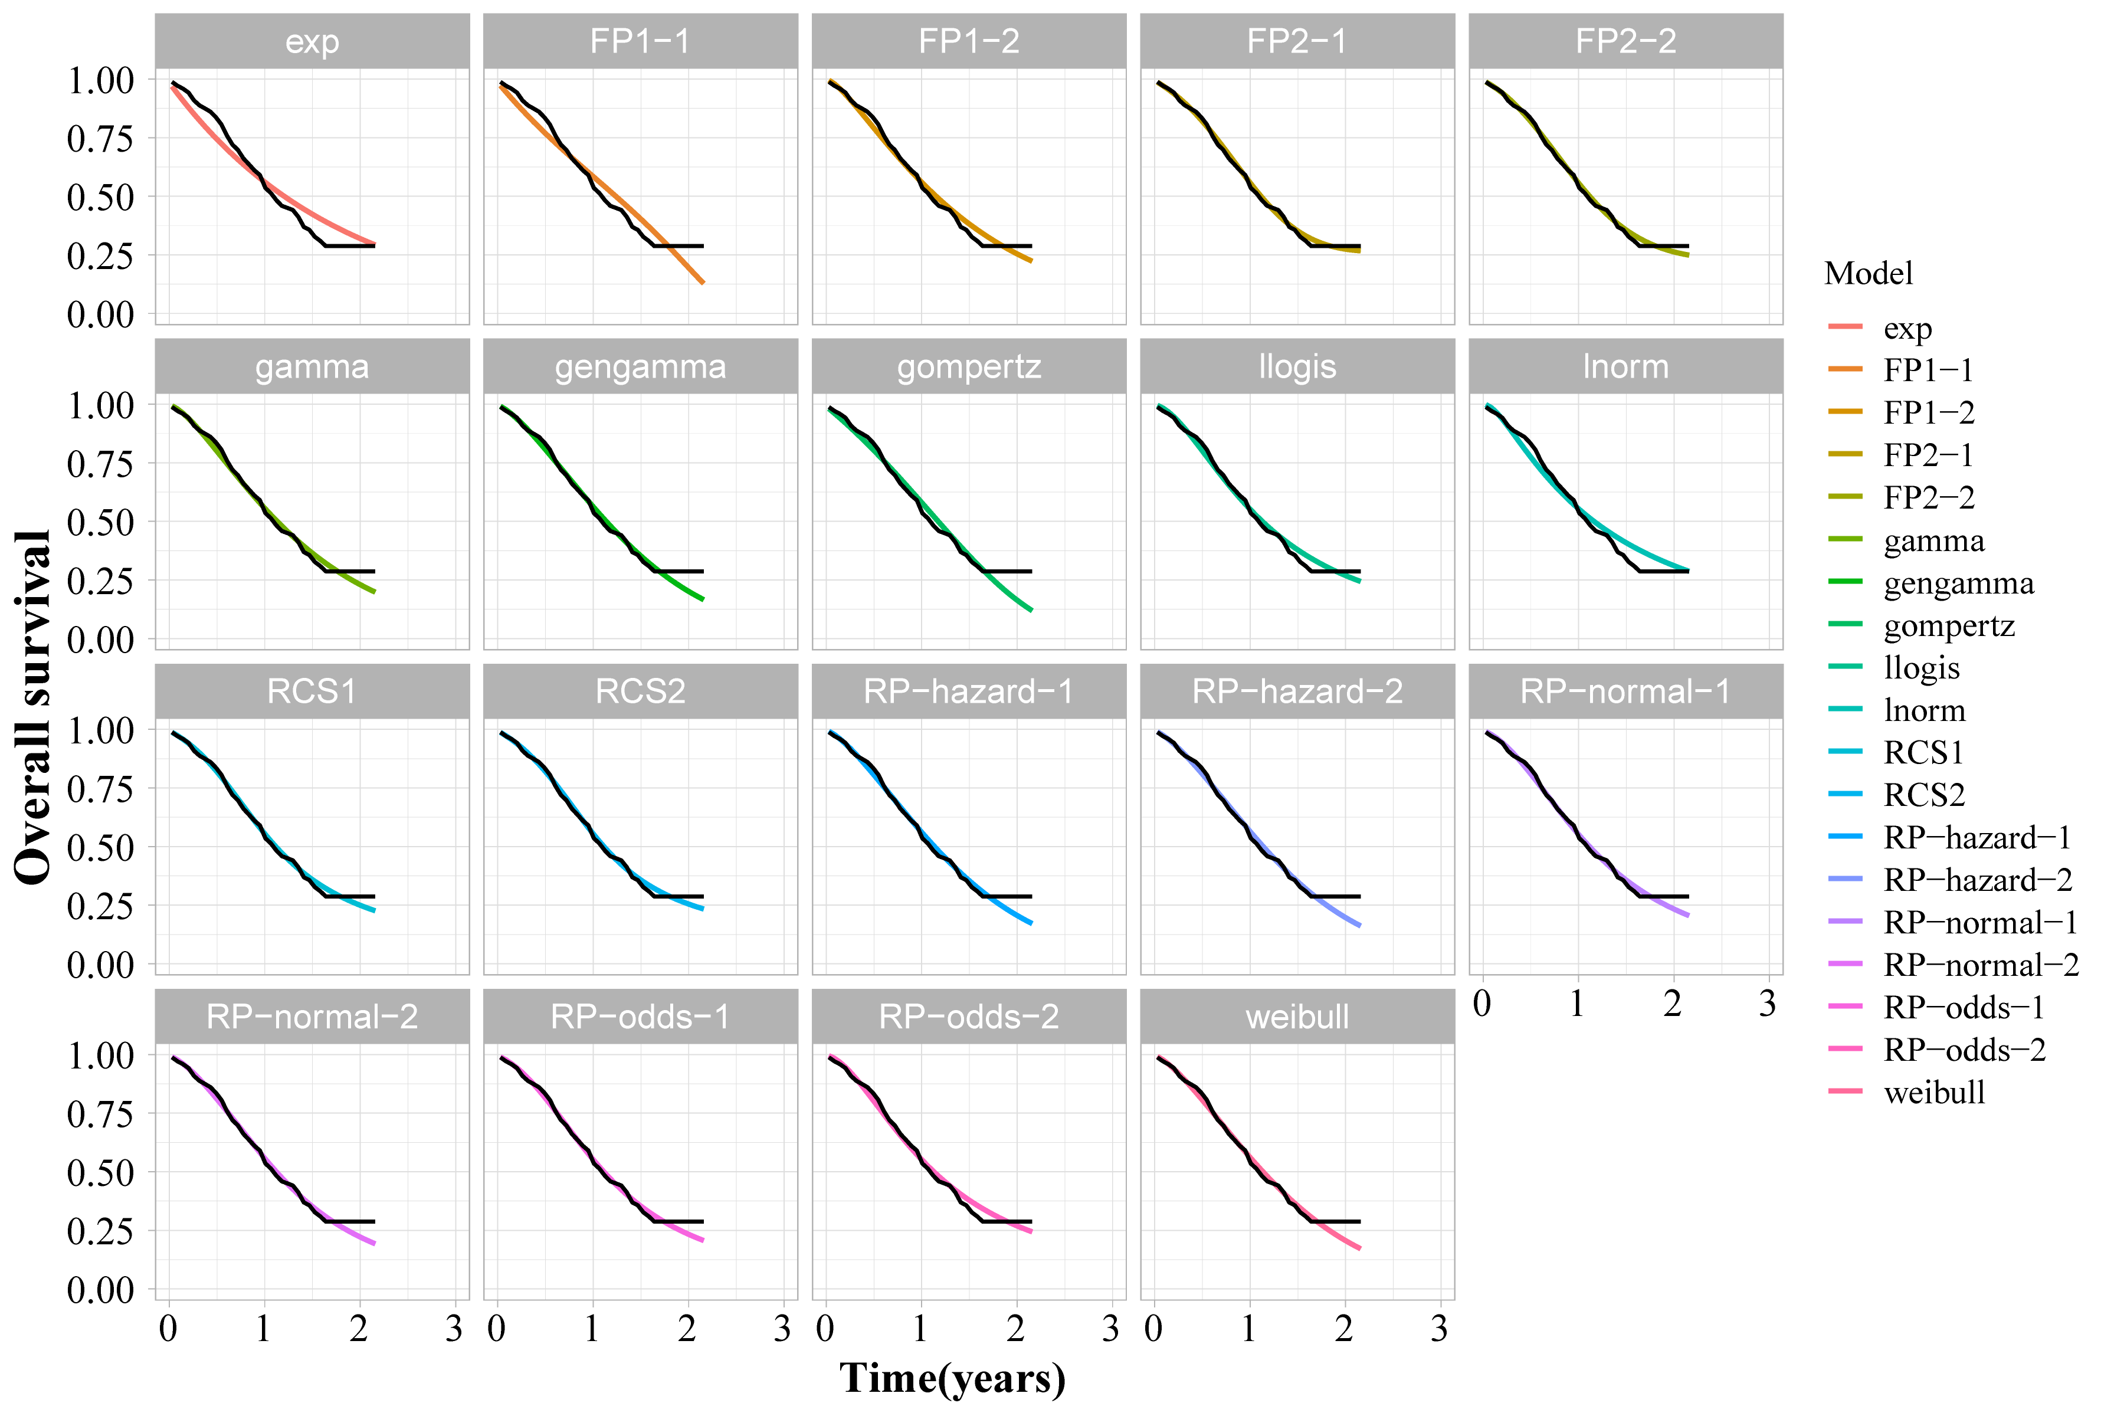

(b)
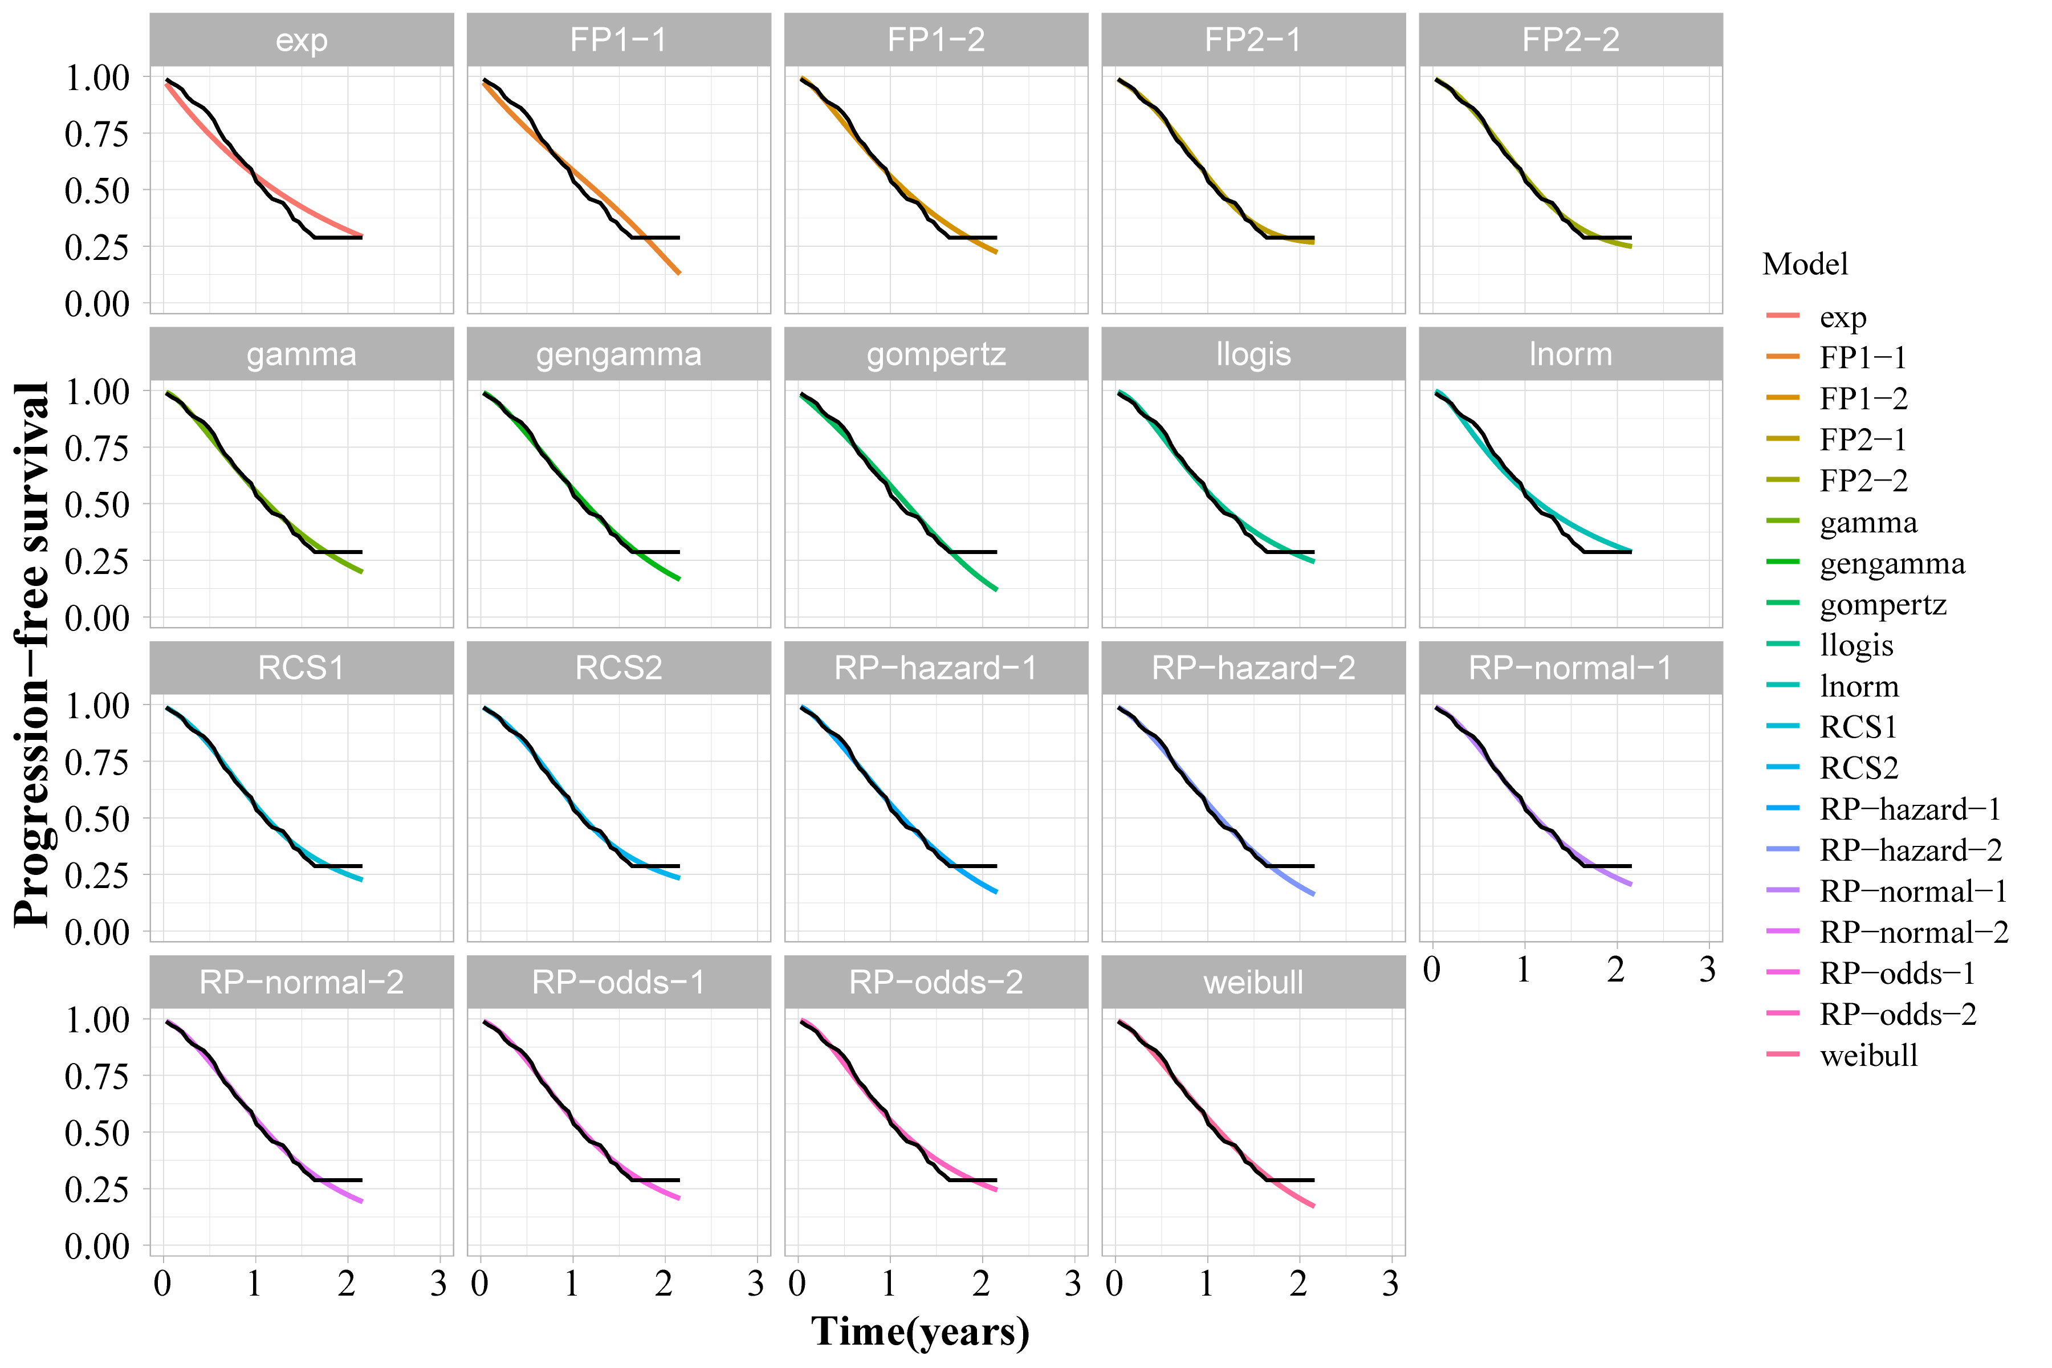

(c)
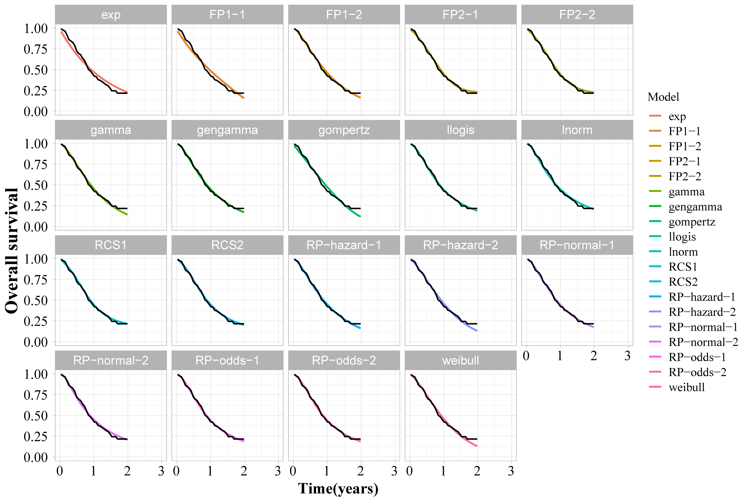
(d)
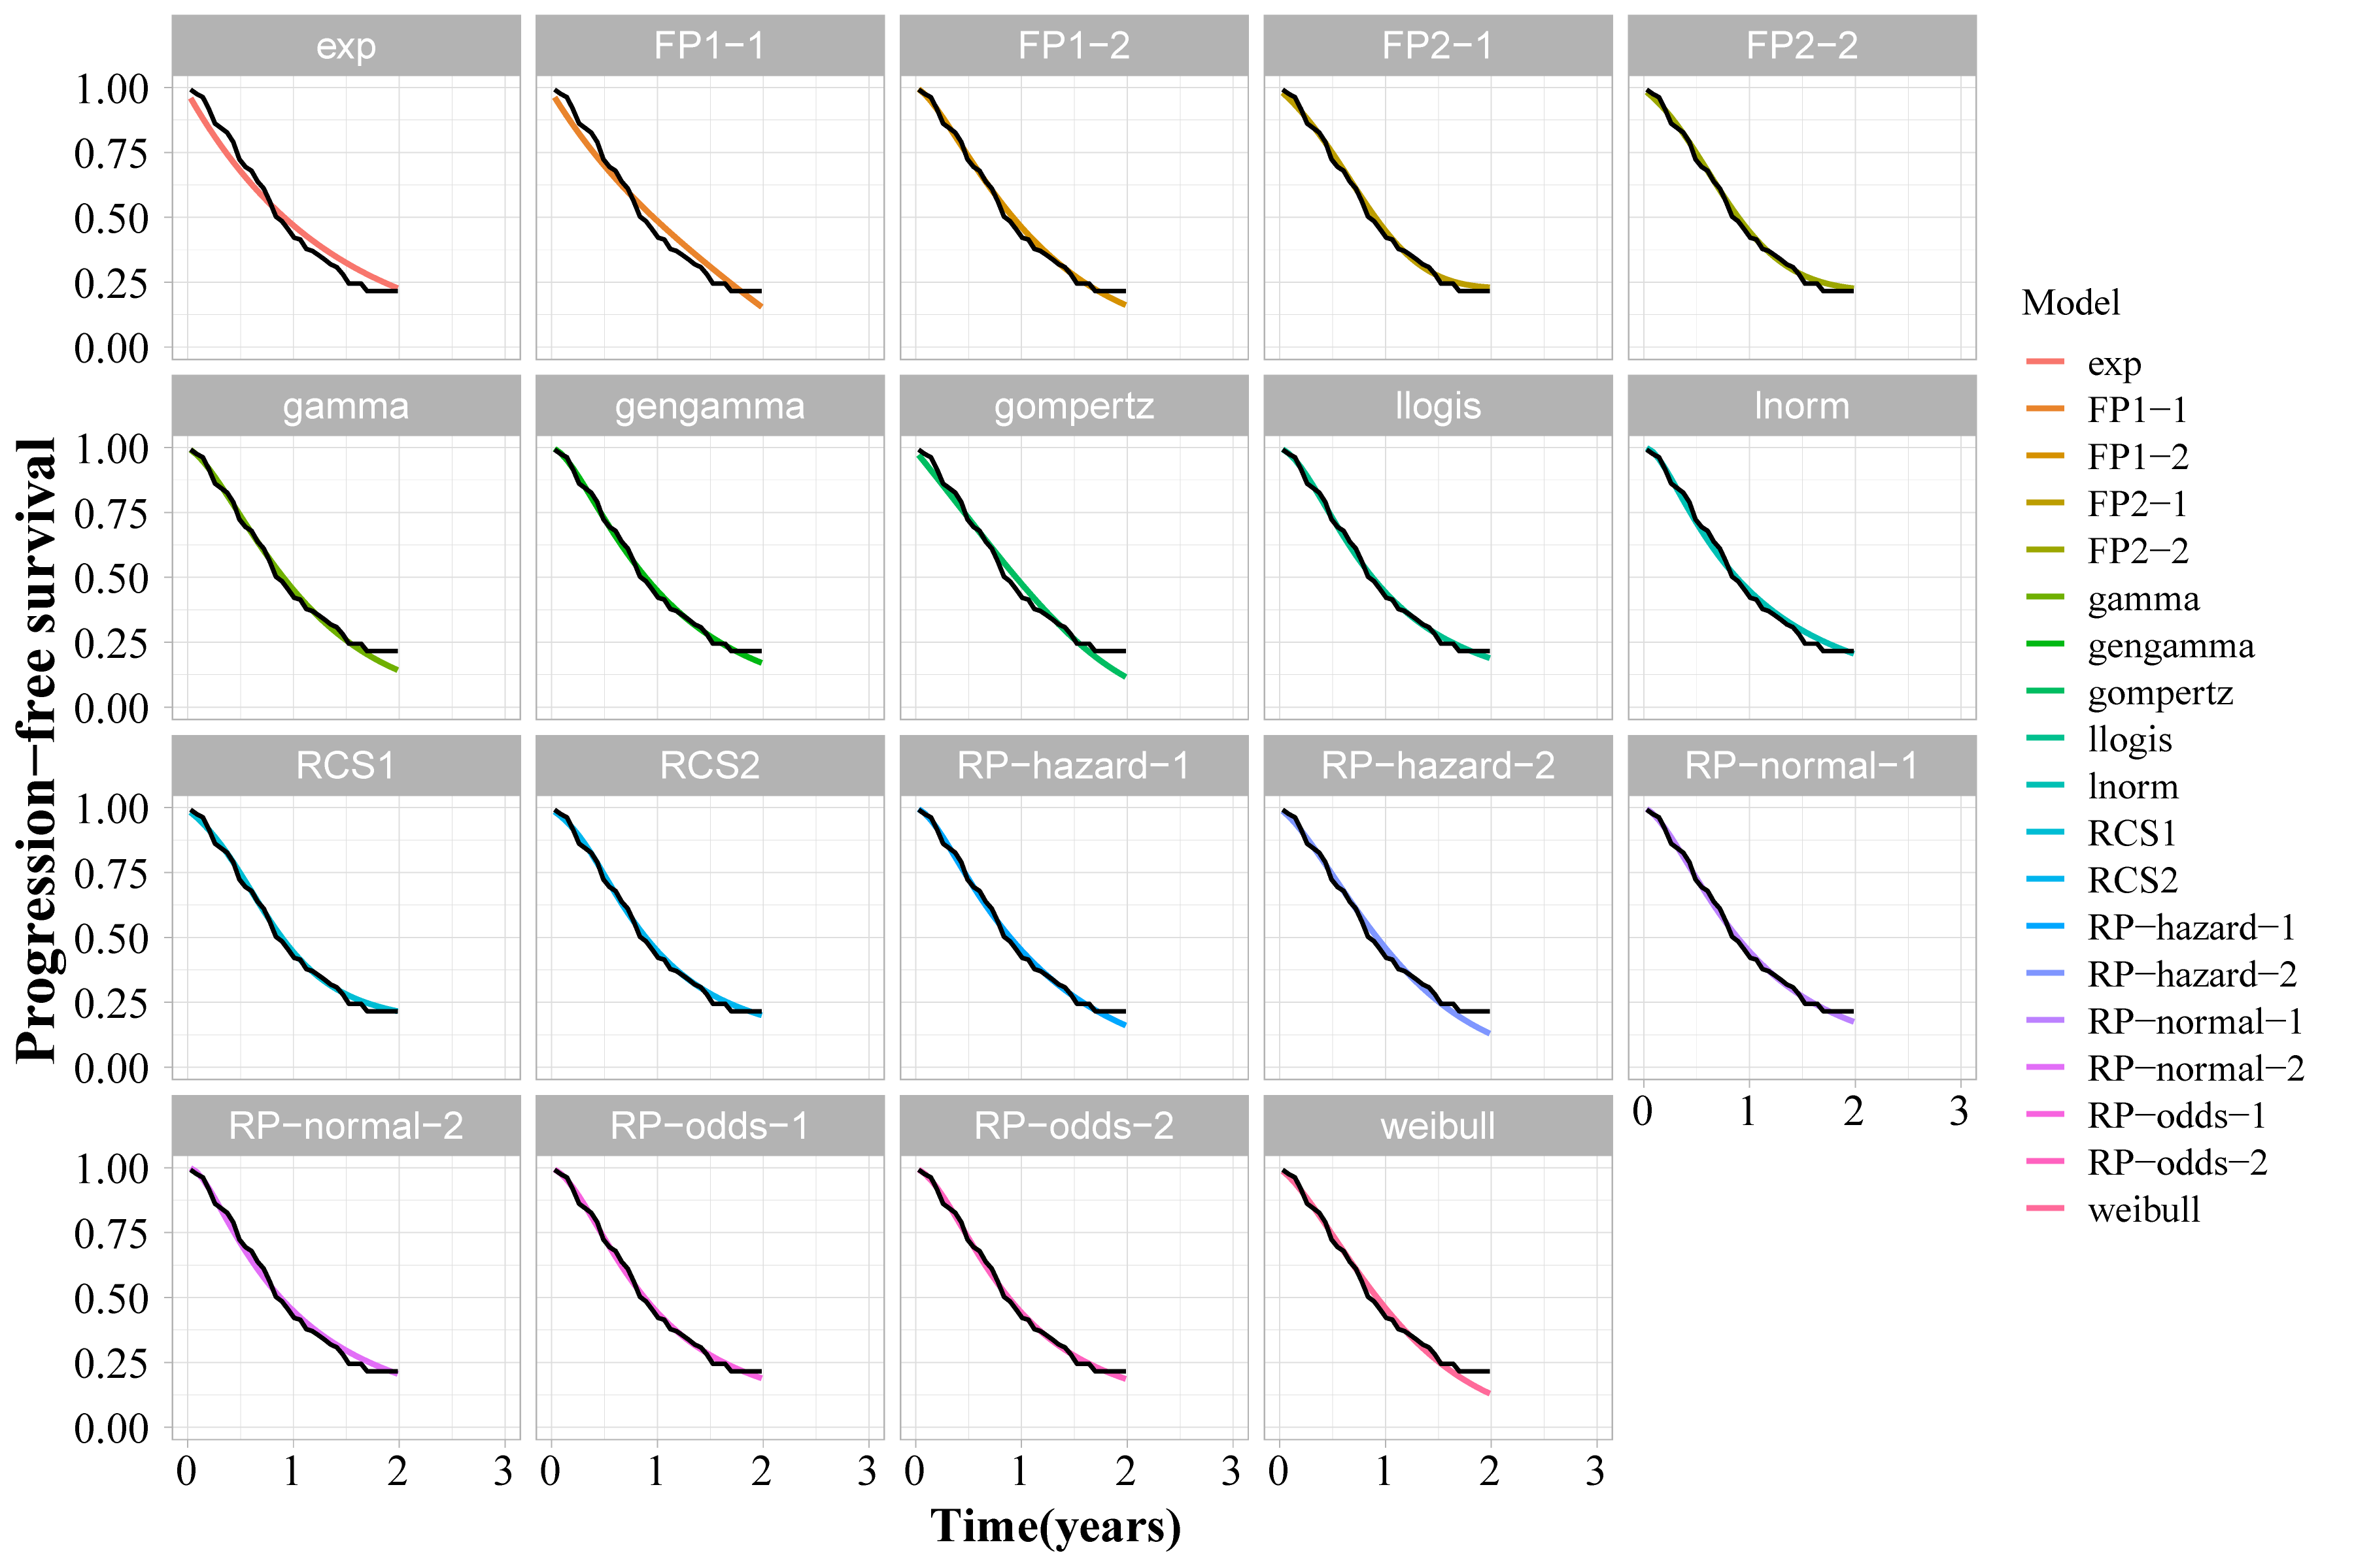
Figure S2 Survival plots showing the goodness-of-fit. OS of lurbinectedin. (a), OS of atezolizumab (b), PFS of lurbinectedin (c), PFS of atezolizumab (d) Abbreviations: OS: overall survival; PFS: progression-free survival; Black line shows the original KM curves
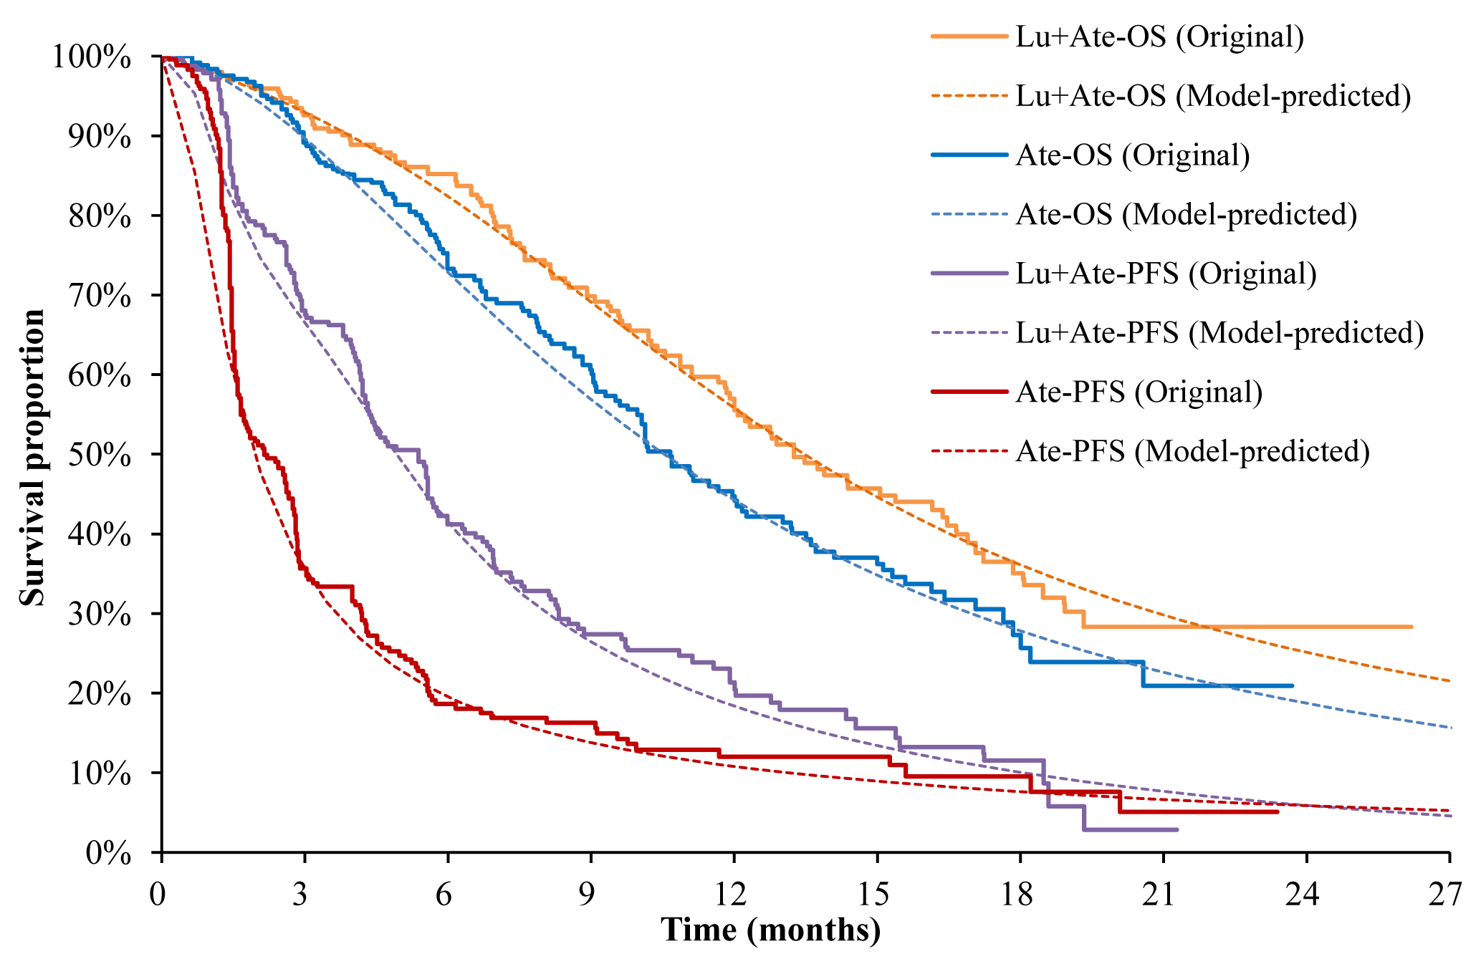
Figure S3 Kaplan-Meier Curves for OS and PFS with Model-Predicted Fits in Lu+Ate and Ate Groups.
OS, overall survival; PFS, progression-free survival; Lu+Ate, lutetium plus atezolizumab; Ate, atezolizumab

(a)
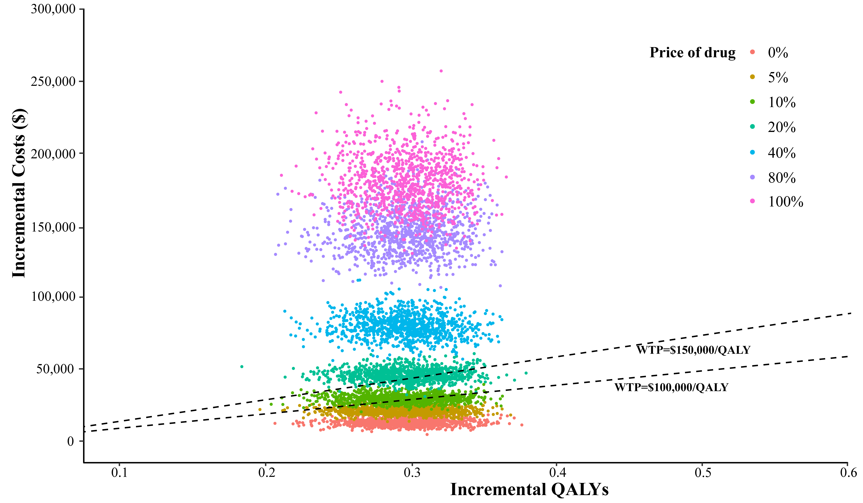
(b)
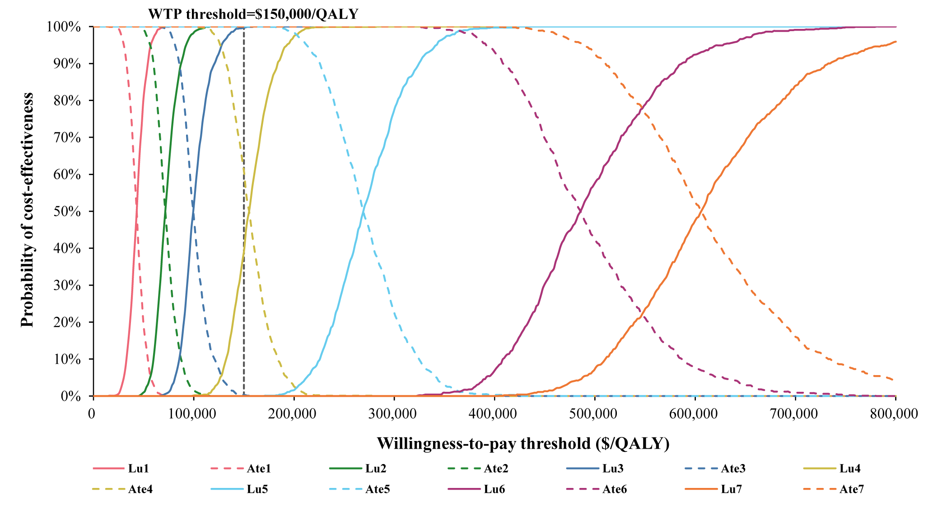
Figure S4 Probabilistic sensitivity analysis for ignoring drug wastage. Scatter plots for probabilistic sensitivity analysis (a), Cost-effectiveness acceptability curves (b).
Abbreviations: WTP: willingness-to-pay; QALY: Quality-adjusted life year; Lu: lurbinectedin; Ate: atezolizumab; 0-7 refers to the price of lurbinectedin and atezolizumab change from 0%, 5%, 10%, 20%, 40%, 80% to 100%.

