Supplementary material for: Political and institutional determinants of the Colombian health system financing fragmentation: An exploratory qualitative study of stakeholders’ and policymakers’ perspectives

Appendix A. Thematic guide for interviews 2
Appendix B. Tables 3
Table B1. Analysis matrix structure 3
Table B2. Distribution of interviewees according to positions held 7
Table B3. Definitions, distribution of opinions by type of position and examples of textual citations 8
Table B4. Negative and positive consequences of financial fragmentation as identified in the interviews 35
Appendix C. Figures 37
Figure C1. Percentage distribution of participants by profession and sex 37
Figure C2. Percentage distribution of participants by department of the exercise of the position and sex 38
Figure C3. Word cloud: Perceptions of financial fragmentation 39
Figure C4. Word cloud: Causes of the financial fragmentation of the Colombian health system 40
Figure C5. Word cloud: Political determinants of the financial fragmentation of the Colombian health system 41
Figure C6. Word cloud: Institutional determinants of the financial fragmentation of the Colombian health system 42
Figure C7. Word cloud: consequences of the financial fragmentation of the Colombian health system 43
Negative consequences 43
Positive consequences 44
Figure C8. Word cloud: solutions to overcome the financial fragmentation of the Colombian health system 45
Figure C9. Word cloud: Barriers to overcoming the financial fragmentation of the Colombian health system 46
Figure C10. Word cloud: Facilitators to overcome the financial fragmentation of the Colombian health system 47
Figure C11. Word cloud: all categories 47
References 48

Appendix A. Thematic guide for interviews

The fragmentation of the health system in Colombia
1. From your perspective, what does the fragmentation of the health system in Colombia refer to?
2. What are the advantages and disadvantages of fragmentation for patients? And for public and private health service providers?
3. To what extent/How much is the fragmentation of the health system discussed in the political arena, among political parties, or among leaders of social organizations in Colombia?
4. In your opinion, what characteristics of political parties or their initiatives have promoted discussions about the financial or provision fragmentation of the health system in Colombia? Do you think there are any specific effects on health outcomes? In terms of financial protection?

Inequalities between subsystems and in the territory
5. What are the main effects of health system fragmentation on people's health or financial outcomes?
6. How can the negative effects of health system fragmentation be avoided?
7. In what cases do you think the effects of health system fragmentation are greater for some populations compared to others? To what do you attribute these differences?
8. Who benefits from the fragmentation of the Colombian health system?

Attributes of governance, both within the health sector and in general administration
9. What characteristics of the management or leadership of different health providers, as well as local, regional, and state governments, have influenced the presence of financial and health service delivery fragmentation in Colombia?
10. In your experience and perception, how does the distribution of responsibilities among different levels and branches of government influence the financial fragmentation and the provision of health services?

Institutional capacities to implement reforms and influence health system functions and fragmentation
11. Upon his inauguration, President Gustavo Petro promised to implement a reform of the health system based on the right to health as a fundamental human right. In the Colombian case, what do you consider to be the main facilitators or obstacles to creating a universal and less fragmented health system?
12. What can be done to reduce or eradicate the fragmentation of the Colombian health system? How feasible is this, and why?

Appendix B. Tables

Table B1. Analysis matrix structure
Category | Subcategory | Subcategory 2 | Informative phrases | Interpretation
POLITICAL AND INSTITUTIONAL DETERMINANTS
Corruption | Corruption and politics | Hiring
Corruption | Corruption and politics | Use of health resources for politicians' own interests
Corruption | Corruption and politics | Political decision-making
Corruption | Corruption and politics | Reasons why the health sector is attractive
Corruption | Institutional corruption | Health system in general
Corruption | Institutional corruption | EPS: Campaign Financing
Corruption | Institutional corruption | EPS: Use of health resources to enrich EPS
Corruption | Institutional corruption | IPS
Corruption | Institutional corruption | Ambulances
Corruption | Institutional corruption | Pharmaceutical industry
Corruption | Institutional corruption | Patients
Corruption | Corruption and social problems | Violence
POLITICAL DETERMINANTS
Governance and modulation
Immigration
Politicians' knowledge of the health system
Decision-making by politicians
Neutrality, political debate, and political parties in the health system
The role of civil society
Role of the media
INSTITUTIONAL DETERMINANTS
Poor information system
Underfunding and the financial crisis of the health system in Colombia
Lack of interoperability
Management of resources by the EPS
Vertical integration
Medical industrial complex
Little research
NEGATIVE CONSEQUENCES
IPS (Financial and operational crisis of the IPS)
Differences between public and private IPS
Health personnel | Consequences of the method of contracting and payments
Health personnel | Consequences of violence
Health personnel | Migration of health personnel
Health personnel | Health personnel shortage
Patients | Delays in care and access barriers
Patients | Lack of attention in rural areas
Patients | Consequences of violence
Patients | Access to the health system and inequalities due to the ability to pay
Patients | Most affected sectors
POSITIVE CONSEQUENCES
EPS
IPS
The pharmaceutical industry and laboratories
Private companies
Patients
Politicians
CAUSES OF FINANCIAL FRAGMENTATION
Causes of fragmentation
SOLUTIONS (TO THE NEGATIVE CONSEQUENCES) OF FINANCIAL FRAGMENTATION
Governance and modulation
Direct transfer and payments
Forms of contracting
Financing the health system
Information and interoperability system
Investigation
FACILITATORS TO REDUCE FINANCIAL FRAGMENTATION
Facilitators
BARRIERS TO REDUCING FINANCIAL FRAGMENTATION
Barriers
PERCEPTIONS OF THE HEALTH SYSTEM AND FINANCIAL FRAGMENTATION
Perceptions of the health system
Perceptions of financial fragmentation

Table B2. Distribution of interviewees according to positions held

Positions held | Number of interviewees | Percentage of interviewees
Government members (public stewardship) | 5 | 17.86%
Representatives of health professional associations | 5 | 17.86%
Elected politicians | 3 | 10.71%
Government members (public stewardship) + Public service providers | 3 | 10.71%
Private insurance members | 3 | 10.71%
Government members (public stewardship) + Private service providers | 2 | 7.14%
Private service providers | 2 | 7.14%
Elected politicians + Government members (public stewardship) | 1 | 3.57%
Government members (public stewardship) + Elected politicians + Public insurance members | 1 | 3.57%
Government members (public stewardship) + Private and public insurance | 1 | 3.57%
Government members (public stewardship) + Public insurance members | 1 | 3.57%
Public service providers | 1 | 3.57%
Total | 28 | 100%

Table B3. Definitions, distribution of opinions by type of position and examples of textual citations

Category | Category definition and labels | Subcategory | Interviewee experience | Position | Textual quote
Perceptions of financial fragmentation | Financial fragmentation in health systems refers to the presence of various financing and payment management mechanisms that operate independently and without coordination between them within the same country (1).  Tags: Perception of financial fragmentation |  | Officials such as members of the government, politicians elected by popular vote, and directors of private IPS and EPS. | They consider that there is no fragmentation or that it has decreased | "Today, there are still different sources of funding... but they contribute to the same goal, the same purpose. There is no longer any fragmentation." E16 (Male, experience as a member of the government, elected politician, public health system manager)  “Our financial protection is truly one of our strengths… since we wanted to achieve universal coverage… (financial fragmentation) I think the initial impact is positive.” E10 (Female, experience as a member of government, manager of a public EPS).
Perceptions of financial fragmentation |  |  | Political actors elected by popular vote, members of the government, managers of IPS and EPS and representatives of health professional associations | They consider fragmentation to be a current structural problem in the health system. | "The biggest problem with fragmentation is that resources don't end up reaching the final stakeholders, which are called: IPS and human talent in health." E5 (Male, experience as a representative of health professional associations)  “What they (EPS) do is, in a commercial logic, contract the network of services according to financial convenience, one (provider) is paid for service packages to serve a specific population… another is paid per event, another is paid per training… multiple forms of contracting, also depending on each provider's interest” E3 (Woman, experience as an elected politician)
Causes of the financial fragmentation of the Colombian health system | A cause is the reason or motive for a phenomenon. In this study, we sought to identify what participants considered the causes of health financing fragmentation (2).  Tags: Causes of financial fragmentation | Political | Elected politicians, members of government, EPS and IPS managers, representatives of health associations | Against Law 100 | "Law 100 was, in some ways, an attempt to increase coverage, but since there wasn't sufficient capacity for administration and provision, they had to delegate to the private sector. The private sector gained strength." E9 (Female, experience as a representative of a health professional association)
 |  |  | Members of the government and managers of private insurance companies (in favor of Law 100) | In favor of Law 100
 |  | Institutional | Representatives of health professional associations | Against administrative capacity | "Law 100 was an attempt to increase coverage, but since there wasn't sufficient capacity for administration and delivery, they had to delegate to the private sector, and the private sector gained strength." (Woman, experience as a representative of a health professional association)
 |  | Economic | Elected politicians and representatives of health professional associations | Against “political” interests | “...political and economic interests, because everyone wants their own profits. ...the SOAT, for example, has a very clearly defined area, and that's where they get all the money in the world, and the ARL too…” E26 (Male, experience as a representative of a health professional association)  "There are political interests, those of regional leaders and regional politicians, in managing resources because resource management allows for a number of practices that we already know are sometimes not the best in public and private administration. There are political and economic interests, because everyone wants to make their own profits." E26 (Male, experience as a representative of a health professional association)
Political determinants of the financial fragmentation of the Colombian health system | The political determinants of the health system are factors related to power, ideologies, decisions, policies, laws, governance processes, structures, sociopolitical dynamics, and the actions of actors that involve different interests and degrees of power in health systems, and that influence the design, implementation, resource distribution, and outcomes of the health system. These factors can negatively affect the health of some population groups, generating inequities in access to health services (3,4).  Tags: governance, corruption, violence and armed conflict, political debate and polarization, decisions made by politicians and their knowledge of the health system, civil society, media, specific policies for financing care for the immigrant population | Governance:  Governance is defined as the capacity of the State and its institutions to formulate and implement public policies, as well as the way in which societies make and implement collective decisions. Governance in health systems refers to the set of processes, structures, and institutions responsible for directing and coordinating the functioning of a country's health system and supporting decision-making. It regulates interactions between the various actors involved in health care, such as government entities, service providers, patients, communities, civil society organizations, and private sector actors. It is also responsible for the formulation of strategic policies, oversight mechanisms, and accountability (5,6). | Members of the government, elected politicians and managers of public and private EPS and IPS, representatives of health professional associations | Poor governance | "The government has that control, that is, it has that final financial responsibility. The truth is, in these countries, the State is totally inefficient. The State should be there, as a regulator, and it can also compete." E12 (Male, experience as a private EPS manager)  "The state has been disengaging itself from its responsibility and is truly responsible for Colombians' social security. We must return the responsibility for health... for social security to the state." E18 (Female, experience as a private IPS manager)  “There is no public system that allows us to monitor the situation. The other problem is that we don't have an inspection, surveillance, and control body that has performed its true function for all this time... The insurance company personnel were appointed superintendents, so I appointed you, and you control me.” E4 (Female, experience as a representative of a health professional association)  “So the biggest problem with the system is the lack of oversight... oversight and control... So obviously, the lack of oversight by the Health Superintendency also means that resources are insufficient and diverted.” E5 (Male, experience as a representative of a health professional association)
 |  | Corruption:  The World Bank defines corruption as the abuse of public office for private gain, which weakens the ability of states to formulate and implement policies where they are needed (7). | Politicians elected by popular vote, presidents of health associations and managers of public and private EPS and IPS | Present problem | "The hospital manages a larger budget than the municipality. Political interests of politicians at the national, departmental, and municipal levels... all the money is obviously diverted... In categories 5 and 6 municipalities, tell me in that municipality: which company generates the most jobs? Hospitals." E5 (Male, experience as a representative of a health professional association)  "(The politician) arrives in debt to contractors, to friends... from the first day he's elected, he has to look at how he keeps that money or how he collects it... Corruption comes from the bottom up and goes from top to bottom. E12 (Male, experience as a private EPS manager)
 |  | Violence:  Violence is defined by the World Health Organization (WHO) as the intentional use of physical force or power, which threatens or directly affects oneself, another person, or a group or community, resulting in injury, death, psychological damage, poor development, and deprivation. It is perceived as a problem against law, order, and the health of the individuals affected by it (8).  Throughout its history, Colombia has experienced various periods marked by violence, many of them due to political, social, and economic factors. Within the framework of the internal armed conflict, various forms of violence have manifested, such as political violence, structural violence, sexual violence, forced displacement, massacres, kidnappings, enforced disappearances, and the recruitment of minors, negatively affecting the victims of the conflict, their families, communities, and the country's institutions. Multiple attempts have been made to establish peace in Colombia, including the signing of the 2016 peace agreement with the Revolutionary Armed Forces of Colombia - People's Army (FARC-EP), one of the country's main armed groups. However, despite these efforts, the armed conflict persists in various regions of Colombia (9–11). | members of the government, politicians elected by popular vote and managers of public and private EPS and IPS | Present problem | “Armed groups have taken over a large part of the policies in some regions, and they generate more inequality and more violence… They have completely returned to what they were 20 or 30 years ago, they even manage the hospitals... the (health) secretariats.” E9 (Female, experience as a representative of a health professional association).  “Remember again the subsidized system contracting, how the paramilitaries in one region and the guerrillas in another region took those resources... The violence in the regions manifests itself by seizing health resources... remember that this is "either you give me the contract or I'll shoot you"... the second has affected the same service in the sense of threats, in the sense of murders... we have seen that doctors are murdered, especially doctors, but also some nurses... there are neighborhoods in Bogotá, where not even home care can be provided because of the violence." E13 (Male, experience as a member of the government, manager of EPS and private IPS)
 |  | Debate and political polarization:  Political debate is a process of verbal interaction through which different actors confront ideas and deliberate on a general interest, to influence decision-making, public policy formulation, or public opinion. Political polarization is understood as a phenomenon in which the political community is divided into two opposing ideological blocs. While the majority of people align themselves with one of the political parties or partisan alliances, unquestioningly adopting the positions of their group and rejecting the opposing group, moderate or independent individuals become a minority (12). | Members of the government, politicians elected by popular vote and managers of EPS and IPS | Little debate and great polarization | “Political discussion doesn't exist within any political group that agrees with the reforms, but there is an opposition that has governed for many years and has even defended the flaws of the system itself, the structural flaws, which prevent discussion.” E4 (Female, experience as a representative of a health professional association)
 |  | Decisions made by politicians and their knowledge of the health system:  This component analyzes the influence of Colombian politicians' knowledge of the health system on the decisions they make regarding its functioning and structure. | members of the government, politicians elected by popular vote and managers of EPS and IPS, both public and private | Lack of knowledge of the health sector by politicians | “...(Politicians) don't know about health... they have a profound lack of understanding of how the health system works and the implications of those resources, and the management of those resources... the only thing they know about health is that it's a great business.” E21 (Female, experience as an elected politician)  "Those with greater technical knowledge and who consult with better advisors have understood, and many of them have been surprised and have understood the magnitude of what is happening." E28 (Female, experience as a member of the government, manager of a private IPS)
 |  | Civil society:  Civil society is understood as the group of individuals, with or without a formal structure, who choose to engage in the debate and formulation of issues of public interest (13). | members of the government, elected politicians, managers of public and private EPS and IPS, and presidents of medical associations | Little participation of civil society | "...the majority of the population doesn't talk about this. That discussion is reserved for those patients who are well-educated about high costs and certain diseases that are protected. And suddenly, when Congress meets, the broad right to health hasn't been discussed for a long time... I would like civil society to be able to participate more, but I think that has a lot to do with our history of violence." E9 (Female, experience as a representative of a health professional association)
 |  | Media:  The media are instruments or channels responsible for storing or transmitting information, including television, radio, newspapers, and the internet. They play an important role in society, as they influence the formation of people's awareness and knowledge on various topics (14). | Members of the government, elected politicians, and presidents of medical associations with left-wing ideologies
 |  | Specific policies for financing care for the immigrant population:  Immigration is the act of moving to a country other than that of one's nationality or habitual residence, establishing oneself there as a new place of habitual residence (15). | members of the government | Lack of financing and migration policies
Institutional determinants of the financial fragmentation of the Colombian health system | The institutional determinants of the health system are the factors related to organizations, their administrative capacities, and the coordination mechanisms that structure the system's functioning. They include aspects such as the organization of the health care supply, provider payment schemes, patient choice of provider, and supply and price regulation. These determinants impact the system's financial sustainability, debt, profitability, and liquidity, affecting both positively and negatively the provision of health services in terms of accessibility, timeliness, and quality (16–18).  Tags:Corruption, underfunding and financial crisis, information and research system, interoperability, resource management by EPS, vertical integration, medical-industrial complex. | Corruption:  The definition described in the political determinant of corruption. | elected politicians and managers of public and private EPS and IPS | Complaint of institutional corruption | "...there is corruption in the EPS. EPSs also have various forms of corruption, various forms of corruption, from me hiring someone and paying more to paying someone and diverting resources." E16 (Male, experience as a member of the government, elected politician, public EPS manager)  “...EPS that are liquidated due to corruption, economic imbalances... every time an EPS closes, well, those patients are left without a service... as has happened with Caprecoom, as has happened with Medimas, as has happened with Saludcoop, Café Salud…” E19 (Male, experience as an elected politician)  “(In the hemophilia poster) fictitious patients were created... medical records and monumental amounts were being charged to the EPS and the EPS was recovering from the state... (patients) who are referred for a fracture and end up with cardiac catheterization, with open heart surgery when in fact they have a hand fracture... The other issue is the diversion of resources, we saw with sadness that an institution that was doing very well and working like saludcoop, had golf courses, golf teams, basketball teams, had residential complexes in different cities” E24 (Male, experience as a public IPS manager, member of the government)  "...we have a guaranteed system that, in theory, must provide absolutely everything you need, regardless of whether it exceeds your financial capacity to assume the cost of your healthcare. We see how treatments are sometimes formulated through legal protection, through a judge's decision, that are truly unsupported by evidence and are extremely expensive, with very little real benefit for the patient." E19 (Male, experience as an elected politician)
 |  | Underfunding and financial crisis of the system: The interviewees' perception of the lack of financing of the health system and its consequences is described. | managers of private IPS and EPS, members of the government, elected politicians | Perception of underfunding and crisis | "When there's a shortage of money, it's a cascade... there's not enough money, so I have to take the money and try to distribute it better. In other words, the problem is the lack of resources. The system is underfunded, and since it's underfunded, that has an impact on everything from there on down." E12 (Male, experience as a private EPS manager)
 |  | Information and research system:  Information systems are made up of a set of organized components that interact with each other in order to provide the necessary information at the right time (19). | members of the State and managers of private EPS and IPS | Perception of fragmented information system | “The data does not appear... very large figures are mentioned, but when the figures are requested, they do not appear... the records are not good, the quality of the data is not good, the report is not complete... the data handled by the Ministry is very aggregated, it is very macro, well, let's say it has the report with the microdata, with the CUBOS and what appears in MIPRES, but apart from that, you see the benefits on the one hand, what you are paying, and on the other hand, the vital statistics and outcomes... In the subsidized regime, the quality of its data is inferior... it is useless to calculate anything, but rather data is extrapolated from the contributory to the subsidized." E9 (Woman, experience as a representative of a health professional association)
 |  | Interoperability of medical records:  Clinical data interoperability in medical records refers to the ability of the various stakeholders in a country's healthcare system to exchange information and knowledge derived from medical record data within the context of healthcare processes, to collaborate toward common goals. This facilitates the provision of digital services to individuals, businesses, and other entities through the exchange of data between their respective systems (20). | members of the government, elected politicians and managers of private IPS | Lack of interoperability of medical records | "Today, you can't have a complete medical record; you have a piece here, another piece there... that's catastrophic. It costs a lot more because you don't have the means to put it together (the medical record), and you'll have wear and tear, repeated tests, and repeated resources." E18 (Female, experience as a private IPS manager)
 |  | Management of resources by the EPS:  Law 100 of 1993 established that the EPSs would be administrative and financing bodies in the health system, responsible for the affiliation and registration of members, as well as the collection of their contributions, under the delegation of the Solidarity and Guarantee Fund. It was determined that they would be responsible for guaranteeing the provision of the Mandatory Health Plan (POS) to members and transferring the difference between the income from their members' contributions and the value of the corresponding UPCs to the Solidarity and Guarantee Fund (21). | members of the government, elected politicians, IPS managers, representatives of professional health associations | They describe problems with the administrative function of EPS | "They (EPS) are the ones who organize where people are served, not taking into account the needs of the population or the territoriality, but rather their profit motive... They build their networks, but they are networks of providers who, in principle, must compete." E1 (Male, experience as a member of the government)  "The financial problem has to do with the diversity of EPSs that existed at the time. Currently, insurance companies of different types, they say, 'I'm in charge of insuring the user for whatever,' but when the user goes to a hospital, they consume the services; when they go to a user group, they consume the services, and this insurance company doesn't pay the hospital. But they're not really insuring the person who's insuring the user, but the person providing the service is also insuring that they won't get paid because there isn't enough money." E11 (Male, experience as a private IPS manager)
 |  |  | elected politicians, IPS managers | in favor of the administrative work of the EPS | “I have always thought that public-private partnerships, the fact of having a service where private actors, with characteristics of efficiency, transparency, obviously monitored and controlled, is a good option” E19 (Male, experience as an elected politician)  "The money market needs it no matter what, even if they hate the EPS or whatever... There always has to be a population manager, that is, between the money market... the money flows, you surely know, are interrupted. All of last year, only 80% of the billing was paid to the highest paid." E28 (Female, experience as a member of the government, manager of a private IPS)
 |  | Vertical integration:  Vertical integration is the integration of insurance management (EPS) and health service provision (IPS). It refers to the process by which two levels of the same production chain are grouped within a single organization (22). | politicians elected by popular vote and presidents of medical associations | Vertical integration favors EPS but can help contain costs | “...through Law 100, this vertical integration is contemplated. So, I contract with my own rates because there's no rate system, and I pay myself on time. But the law also says I must contract with other entities that serve patients, and I delay payments to them, and payments aren't made on time, so there are 360-day debts.” E4 (Female, experience as a representative of a health professional association)
 |  | Medical industrial complex:  The Medical Industrial Complex is a vast and growing network of private corporations responsible for providing healthcare services for profit. It is a concept proposed by Arnold Relman, which refers to the dynamics oriented toward generating profits, profitability, and capital derived from the provision of medical services (23,24). | Presidents of health associations, elected politicians, managers of public and private IPS, and private EPS | The medical industrial complex benefits from the system's resources | "Behind the EPS is the medical-industrial complex pushing for a system that is designed to focus on the consumption of technologies and medications. Even our national drug production industry has been wiped out." E4 (Female, experience as a representative of a health professional association)
Consequences of the financial fragmentation of the Colombian health system | A consequence is an event or situation that occurs as a result or effect of another prior event. The negative and positive consequences identified by the interviewees related to the financial fragmentation of the Colombian health system are described below (25). | Negative consequences
 |  | Health service providers | Elected political actors, members of the Government, managers of IPS and EPS and representatives of health associations | IPS harmed by financial fragmentation | "IPSs are failing in Colombia, not just in the public sector, but mostly in the private sector because the EPSs don't pay them. For those who aren't vertically integrated with them, there's also fragmentation in the way they are contracted." E3 (Female, experience as an elected politician)  “... IPS that often have to borrow money to be able to pay their obligations and then they are paid without any additional benefits... obviously that is a big financial gap... (the government) is paying 80% to many IPS, and until now they have not paid them 20%, so obviously they are broke.” E12 (Male, experience as a private EPS manager)  “Public hospitals are now in the hands of politicians, not subsidized hospitals, and they don't receive the resources.” E18 (Female, experience as a private IPS manager)  “…Law 100 is the one that also turns public hospitals into State Social Enterprises and delivers the death blow of self-sustainability and financial independence, and that leads them absolutely to bankruptcy because it hands over private resources that they weren't going to contract with those public entities and bankrupts them... I think it's precisely that same intermediation.” E21 (Female, experience as an elected politician)
 |  | Health personnel | Politicians elected by popular vote, members of the Government, managers of IPS and EPS, representatives of health associations | Health personnel harmed by financial fragmentation | “We've been in these working conditions for 30 years, and during the pandemic, we were heroes, but we're still in the same conditions. One job alone doesn't provide enough income... and they also have high suicide rates, depression and anxiety, and divorces, because if you have three jobs…” E4 (Female, experience as a representative of a health professional association)  "...public and private institutions enter into crisis, and this obviously ends up affecting the payment of human resources. If there is no adequate payment to human resources and if institutions do not pay on time, they stop providing services. Therefore, another end user, the patient, also ends up being affected..." E5 (Male, experience as a representative of a health professional association)  “We train human talent at the University, perhaps in an ideal world, but when they step out into reality, it collapses. A very valuable human talent to be doing administrative activities, which is what they do again due to this economic fragmentation. So I conserve the resources as an insurer, I conserve the resources as a service provider, and I cut off the flow. So there are three nodes: financial, administrative, and human talent. We are underpaid employees of the system.” E6 (Female, experience as a representative of a health professional association)  “As a doctor, I have to mention this because, in the end, those who pay the EPS interest are the doctors and health personnel because they don't get paid on time. So, they pay the provider, they pay everyone, and the salaries or fees they pay the doctors... they don't even link them properly.” E17 (Female, experience as a member of the government)
 |  | Patients | Elected politicians, members of the Government, managers of IPS and EPS, representatives of health associations | Negative consequences for patients | “Patients who had a stroke and never went to therapy, didn't have access to therapy... it's not possible because there's no authorization, because in addition to that, there's not only the economic problem, but it also comes with a series of administrative provisions that complicate and complicate the authorization process..." E6 (Woman, experience as a representative of a health professional association)  “I really don't know if they (the EPS) have an indication to dilate or if it's a requirement... I believe that in the long run, this fragmentation results in a lack of care and the patient ends up assuming higher costs individually in economic terms, but above all, in loss of resolution and poor health outcomes.” E9 (Female, experience as a representative of a health professional association)  “...the IPSs begin to compromise, postpone services, deny them, confuse, and hinder the provision of services, and this creates a chain. Then everything radiates downward, and then the medication isn't paid... the user ultimately becomes the weakest part of the chain, and then that user isn't treated promptly; there's no opportunity.” E12 (Male, experience as a private EPS manager)  "...we have a huge crisis with the healthcare system. There are impressive lines to claim medications, appointments are denied, and the health care providers that have been intervened or closed have left very serious health problems here." E21 (Female, experience as an elected politician)
 |  | Positive consequences
 |  | Health insurers | Politicians elected by popular vote, members of the Government, managers of private IPS and representatives of health associations | Consequences in favor of the EPS | “The largest resource item in health is in insurance, and undoubtedly the EPS plays a fundamental role because I have had the opportunity to do the exercise within the framework of the resource… I took the trouble to add up how much all the municipalities for the 500,000 inhabitants gave to the EPS of the department. I began to add up all the debts, everything that their contracts were worth, and they were left with a historical scenario, and in addition to having money left over, they did not pay… the contracts are perverse…” E17 (Woman, experience as a member of the government)
 |  | Health service providers | Managers of private EPS | Consequences in favor of the IPS | “...clinics and hospitals had many years of money flowing in, and the health problem isn't profitability; almost no clinic is at a loss…” E12 (Male, experience as a private EPS manager)
 |  | Medical industrial complex | Elected politicians, members of the Government, managers of private EPS, representatives of health associations | Consequences in favor of industries | "...for many years, pharmaceutical companies benefited enormously. Many companies, many private health insurance companies, managed imaging and laboratories because they are highly profitable... the owner of AUDIFARMA became a millionaire with the system." E12 (Male, experience as a private health insurance manager)
 |  | Politicians | Politicians elected by popular vote, presidents of health associations and managers of public and private EPS and IPS | Consequences in favor of politicians
 |  | Patients | EPS managers, government members and elected politicians | Consequences for patients | "It gives citizens that advantage because it links contributions to entitlements, and that guarantees access. On the other hand, the general tax, no, the general tax, goes into the state purse." E10 (Female, experience as a member of government, manager of a public EPS)
Solutions to overcome the financial fragmentation of the Colombian health system | Solutions proposed by interviewees to overcome financial fragmentation | Governance | Members of the government, elected politicians, managers of public and private EPS and IPS | Improve governance processes | "The State must be organized, and civil society must participate in decision-making and be able to identify needs and propose solutions." E1 (Male, experience as a member of government)
 |  | Payments without intermediaries | Members of the government, elected politicians and managers of EPS and IPS | In favor of eliminating financial intermediation | "But we do need to change the way we mediate, we need to improve the quality of care... how will ADRES be controlled? Because corruption could shift from the private to the public sector, and then we wouldn't be doing much of anything. I think there should be a mixed system of control, neither solely private nor solely public. There has to be a balance." E6 (Female, experience as a representative of a health professional association)
 |  | Payments without intermediaries | Elected politicians, members of government, EPS and IPS managers | against eliminating financial intermediation
 |  | Financing the health system | Government members, elected politicians and EPS managers | Improve system financing
 |  | Information and interoperability system | Members of the government, politicians elected by popular vote, presidents of health associations, and managers of IPS and EPS | Work on an information system that allows for monitoring and control, as well as the interoperability of medical records. | "If I don't have data, I can't create a policy. I believe the first thing we need to do is a thorough characterization process and understand the territories..." E2 (Male, experience as a representative of a health professional association)  “Having robust information systems makes everything easier, and the information system, well, I believe, should have competent, capable technical people and good information systems.” E23 (Male, experience as a private EPS director)  “...a unified, interoperable public information system that allows us to transparently track health resources, create laws and regulations that mandate specific allocation of resources, and, to that extent, allow for such tracking, peso by peso.” E3 (Female, experience as an elected politician)
 |  | Investigation | Politicians elected by popular vote, members of the government and representatives of health associations | Invest in research
Barriers to overcoming the financial fragmentation of the Colombian health system | The barriers identified by interviewees to overcome financial fragmentation. |  | Members of the government, elected politicians, presidents of health associations, managers of IPS and EPS | Barriers to overcoming fragmentation | "There's a certain polarization, a bit ideological on the issue. And I think it prevents the political discussion from also including technical elements. I mean, you can say this is a terrible health system, but with evidence, or you can say it's very good, but with evidence and figures." E16 (Male, experience as a member of the government, elected politician, manager of a public health system)
Facilitators to overcome the financial fragmentation of the Colombian health system | Facilitators to overcome financial fragmentation. |  | Members of the government, elected politicians, presidents of health associations, managers of IPS and EPS | Facilitators to overcome fragmentation

Table B4. Negative and positive consequences of financial fragmentation as identified in the interviews
Stakeholder | Negative Consequences | Positive Consequences
Health Insurers (EPS) | - Not reported in the interviews | - Financial benefits for the EPS, some derived from corruption cases.  - Use of vertical integration to retain and control financial flows.
Health Service Providers (IPS) | - Service closures are impacting access and quality.  - Payment delays and inequalities.  - Public IPS face additional challenges: corruption, clientelism, inefficiency, and funding instability.  - Selective payment practices favoring vertically integrated providers.  - Unequal contracting conditions with EPS. | - Some private IPS developed profitable business models.
Healthcare Workers | - Precarious working conditions (outsourcing, temporary contracts, lack of benefits).  - Delayed or unpaid salaries.  - Job instability and overwork.  - Wage disparities between the private and public sectors and professional categories.  - Migration abroad due to poor labor conditions.  - Violence and insecurity in conflict-affected areas. | - Not reported in the interviews
Patients | - Barriers to access (service delays, administrative obstacles, service denials).  - Increased out-of-pocket costs for vulnerable groups.  - Treatment delays for chronic and high-cost conditions.  - Poor quality and inequity in services, especially for subsidized patients. | - Solidarity principle: enables coverage for the majority of the population despite the different sources of financing.
Medical-Industrial Complex and private companies | - Not reported in the interviews | - Significant profits for pharmaceutical companies and private companies.  - Weak regulatory control allowed business growth and profit maximization.
Politicians | - Not reported in the interviews | - Enrichment at the expense of health resources, using corruption and clientelism in public IPS.
Source: made by the authors

Appendix C. Figures

Figure C1. Percentage distribution of participants by profession and sex
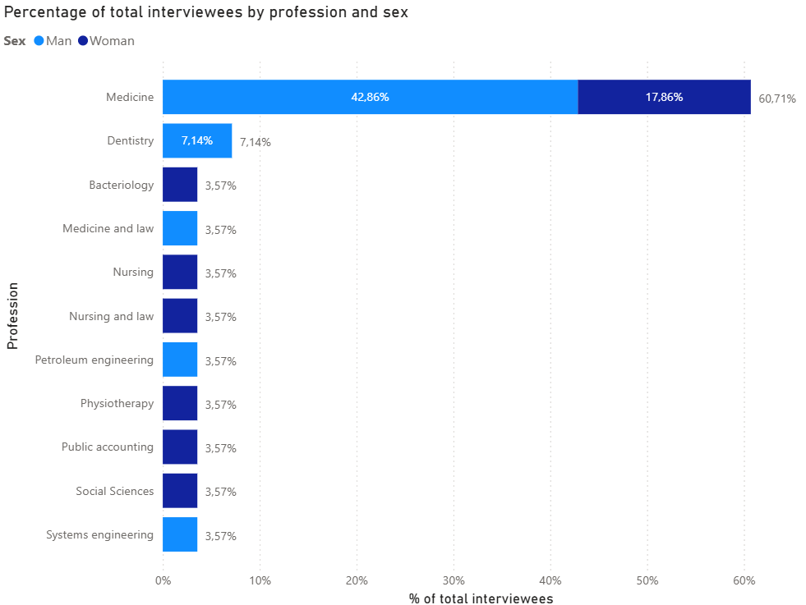

Figure C2. Percentage distribution of participants by department of the exercise of the position and sex
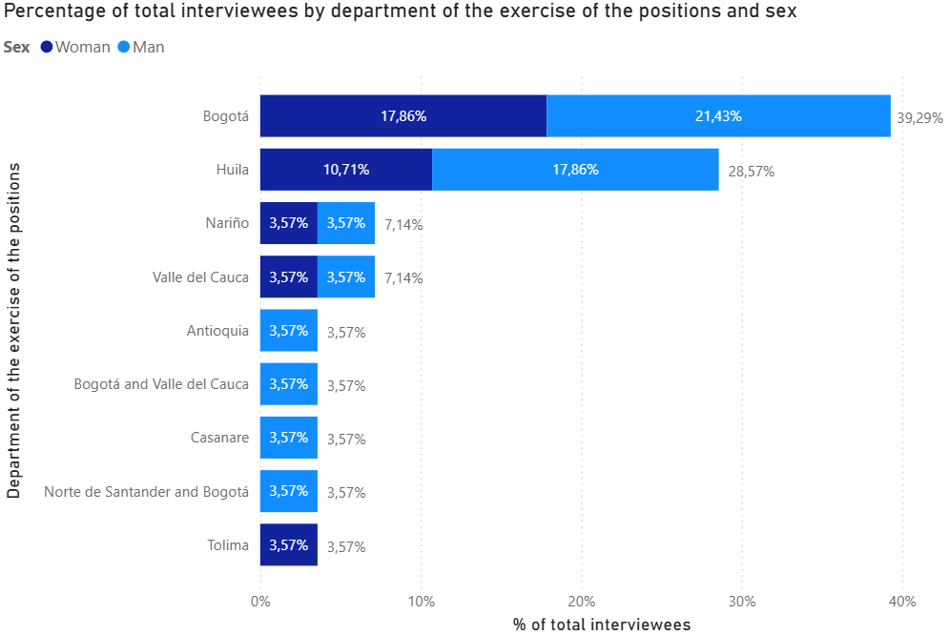

The following word clouds were generated from qualitative interviews conducted with key stakeholders.

Figure C3. Word cloud: Perceptions of financial fragmentation
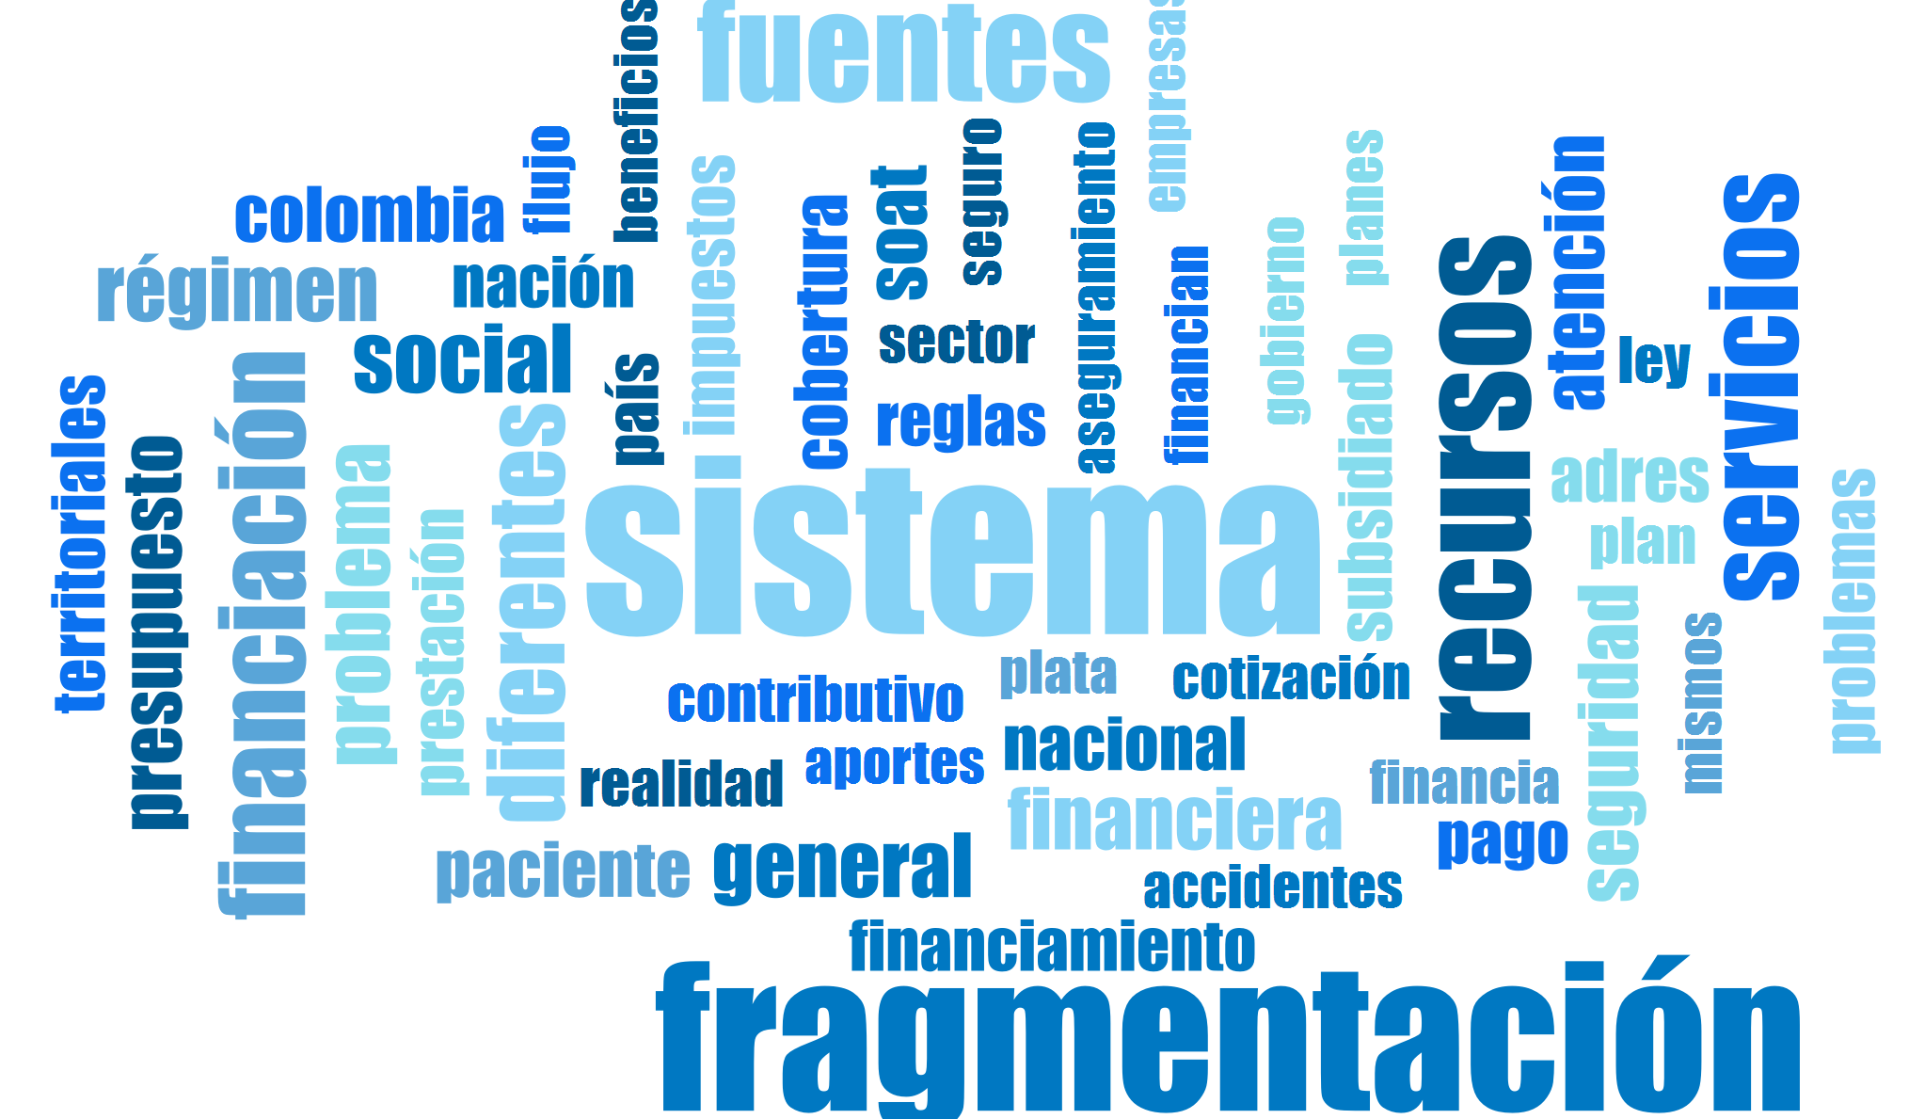

We show the most common words related to the perception of the stakeholders about the financial fragmentation. The most prominent words include “sistema” (system), “fragmentación” (fragmentation), “recursos” (resources), “fuentes” (sources), “servicios” (services), “financiación” (financing), “social” (social), and “general” (general).

Figure C4. Word cloud: Causes of the financial fragmentation of the Colombian health system
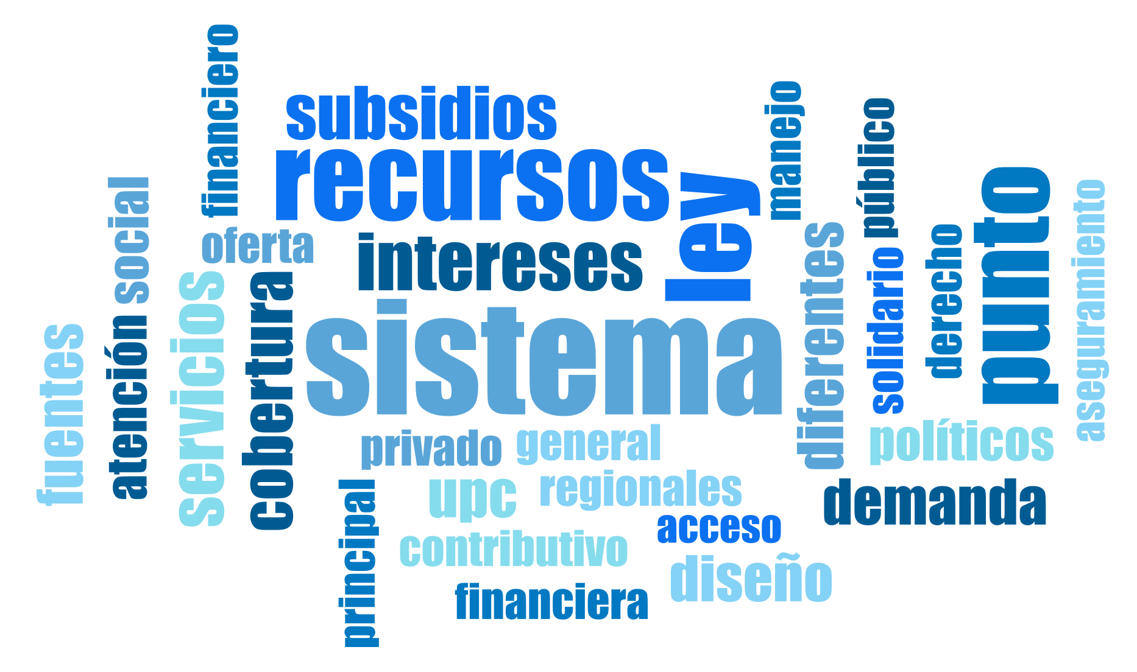
We show the most common words related to the perception of the stakeholders about the causes of financial fragmentation. The most prominent words include “sistema” (system), “recursos” (resources), “ley” (law), “intereses” (interests), “subsidios” (subsidies), “servicios” (services), and “cobertura” (coverage).

Figure C5. Word cloud: Political determinants of the financial fragmentation of the Colombian health system
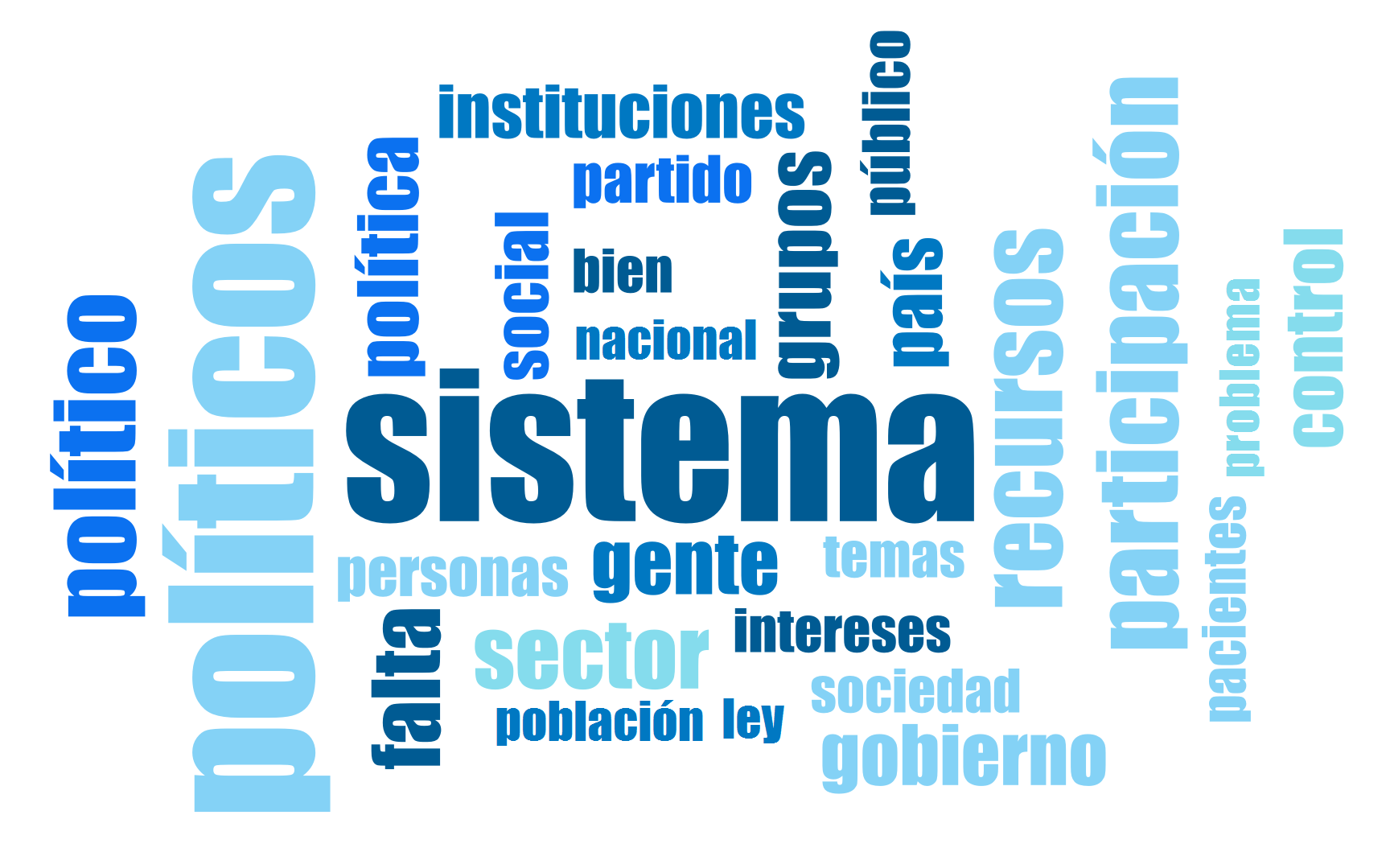
We show the most common words related to the perception of the stakeholders about the political determinants of financial fragmentation. The most prominent words include “sistema” (system), “políticos” (politicians), “participación” (participation), “recursos” (resources), “gente” (people), “sector” (sector), “gobierno” (government), and “instituciones” (institutions).

Figure C6. Word cloud: Institutional determinants of the financial fragmentation of the Colombian health system
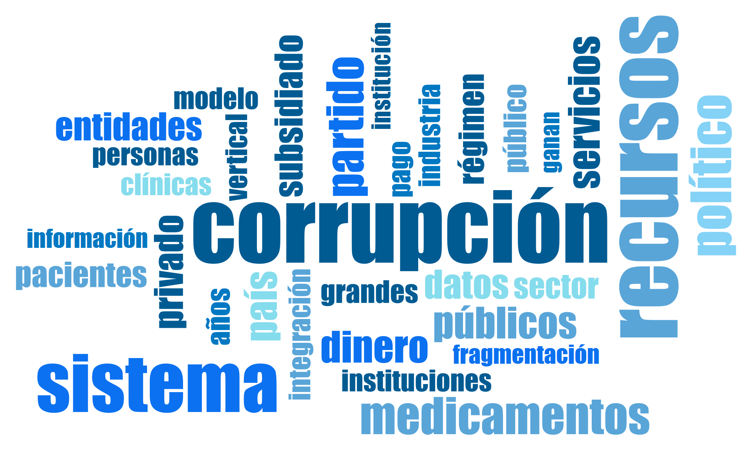
We show the most common words related to the perception of the stakeholders about the institutional determinants of financial fragmentation. The most prominent words include “corrupción” (corruption), “recursos” (resources), “sistema” (system), “medicamentos” (medicines), “dinero” (money), “partido” (political party), “servicios” (services), and “entidades” (entities).

Figure C7. Word cloud: consequences of the financial fragmentation of the Colombian health system

Negative consequences
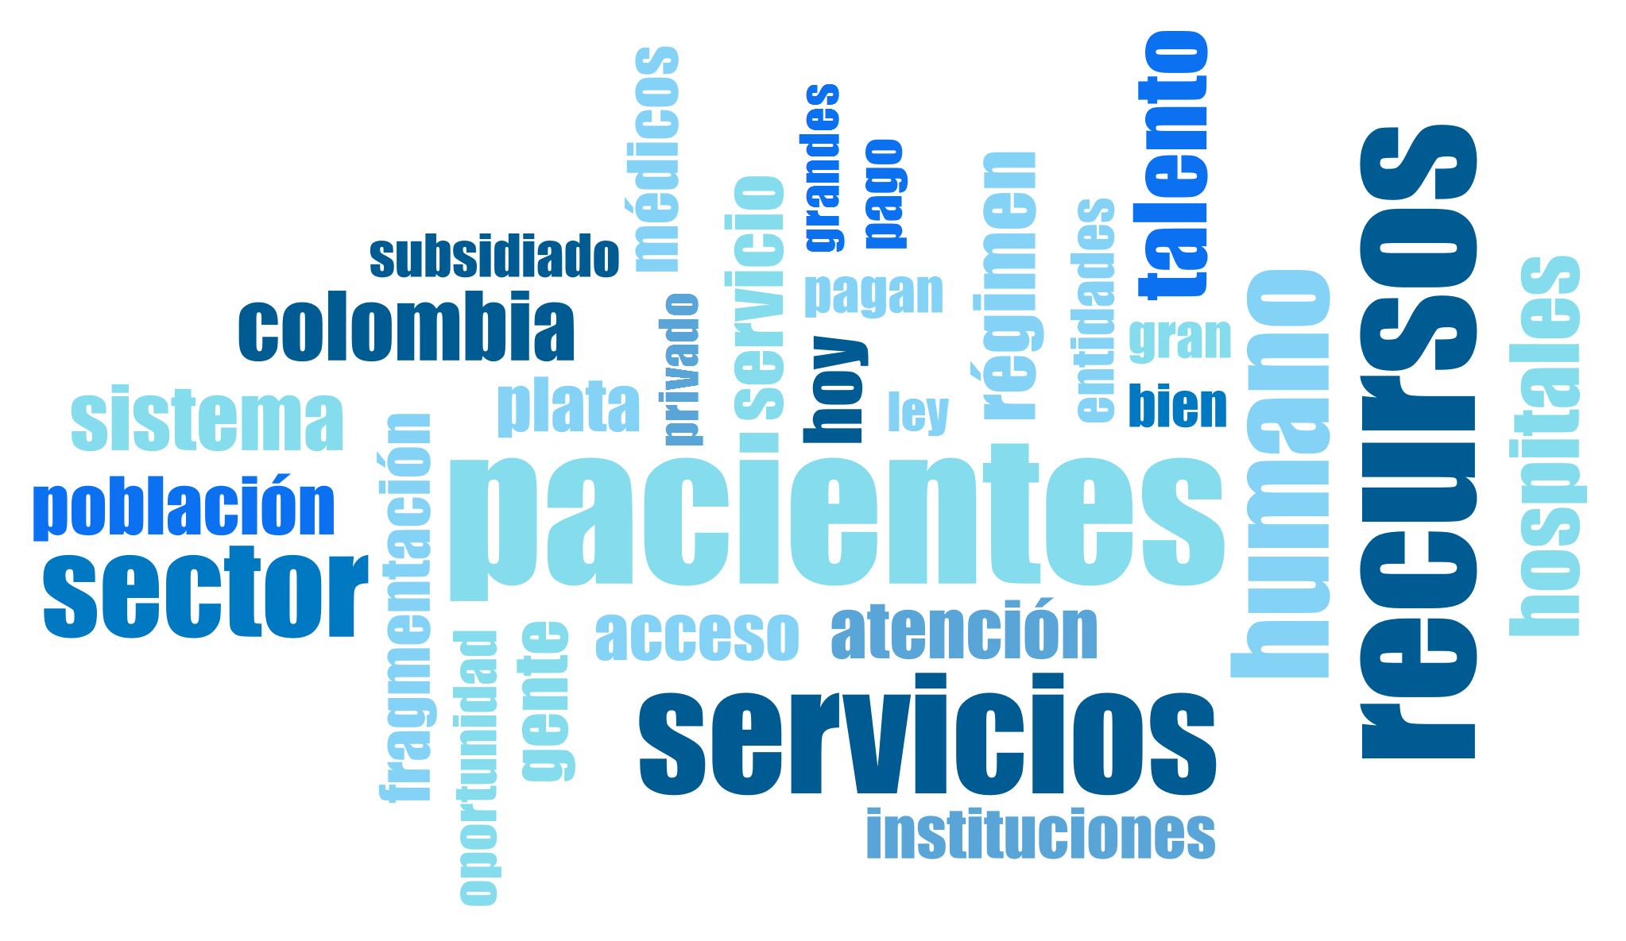
We show the most common words related to the perception of the stakeholders about the negative consequences of financial fragmentation. The most prominent words include “pacientes” (patients), “servicios” (services), “recursos” (resources), “talento humano” (human talent), “sector” (sector), “sistema” (system), and “acceso” (access).

Positive consequences
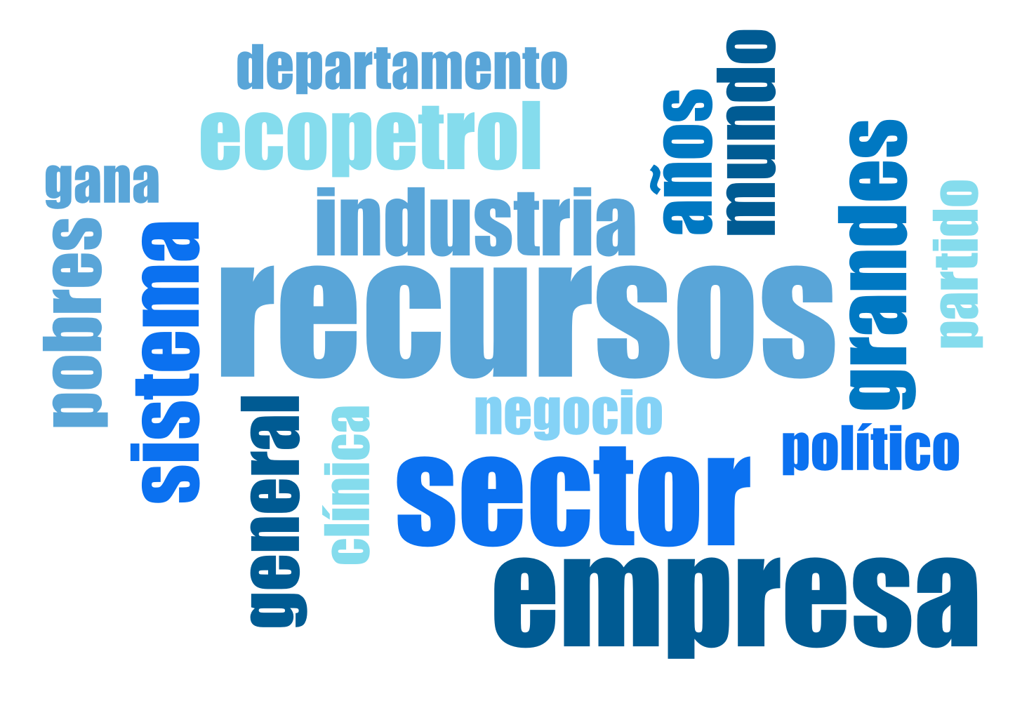
We show the most common words related to the perception of the stakeholders about the positive consequences of financial fragmentation. The most prominent words include “recursos” (resources), “sector” (sector), “empresa” (company), “industria” (industry), “ecopetrol” (Ecopetrol), “sistema” (system), and “grandes” (large)

Figure C8. Word cloud: solutions to overcome the financial fragmentation of the Colombian health system
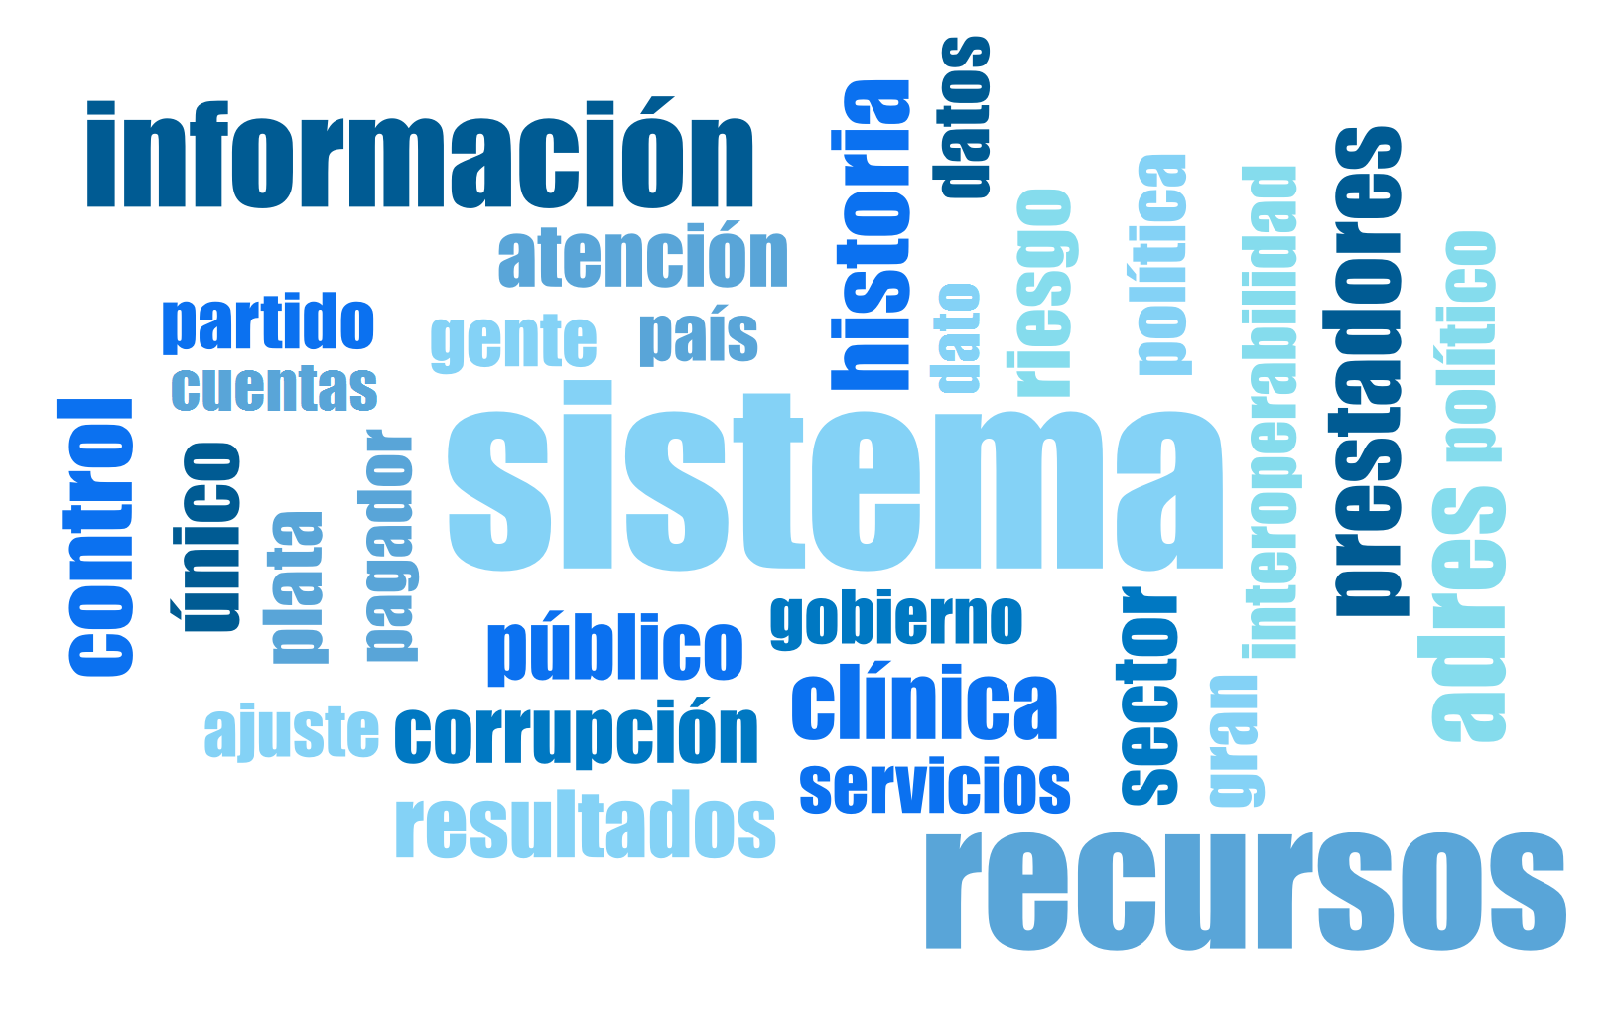
We show the most common words related to the perception of the stakeholders about the possible solutions to overcome financial fragmentation. The most prominent words include “sistema” (system), “información” (information), “recursos” (resources), “prestadores” (providers), “historia” (history), “clínica” (clinical), “control” (control), and “resultados” (results).

Figure C9. Word cloud: Barriers to overcoming the financial fragmentation of the Colombian health system
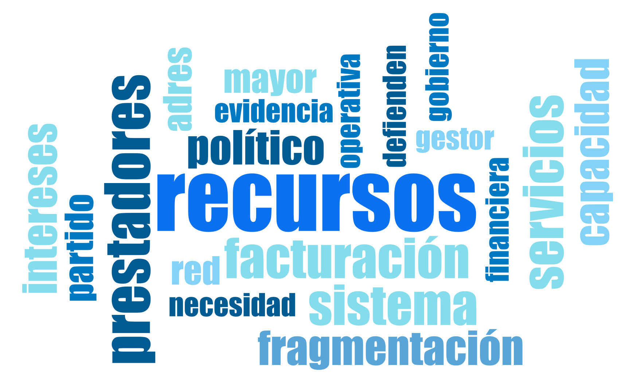
We show the most common words related to the perception of the stakeholders about the barriers to overcoming financial fragmentation. The most prominent words include “recursos” (resources), “prestadores” (providers), “facturación” (billing), “sistema” (system), “fragmentación” (fragmentation), “servicios” (services), “político” (political), and “capacidad” (capacity).

Figure C10. Word cloud: Facilitators to overcome the financial fragmentation of the Colombian health system
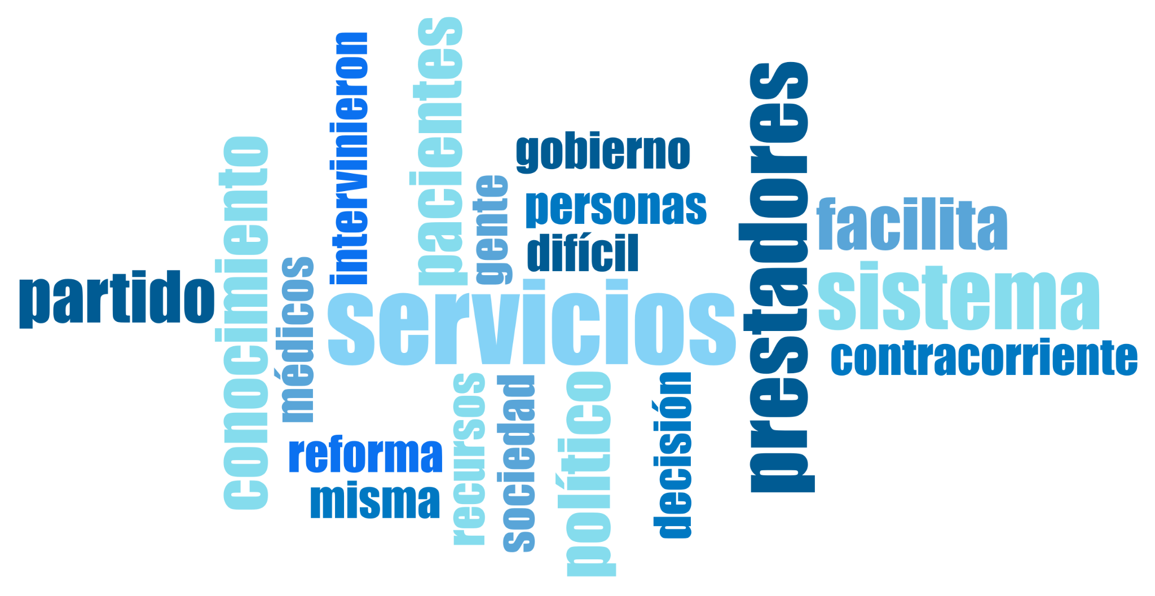
We show the most common words related to the perception of the stakeholders about the facilitators to overcome financial fragmentation. The most prominent words include “servicios” (services), “prestadores” (providers), “sistema” (system), “conocimiento” (knowledge), “pacientes” (patients), “político” (political), and “reforma” (reform).

Figure C11. Word cloud: all categories
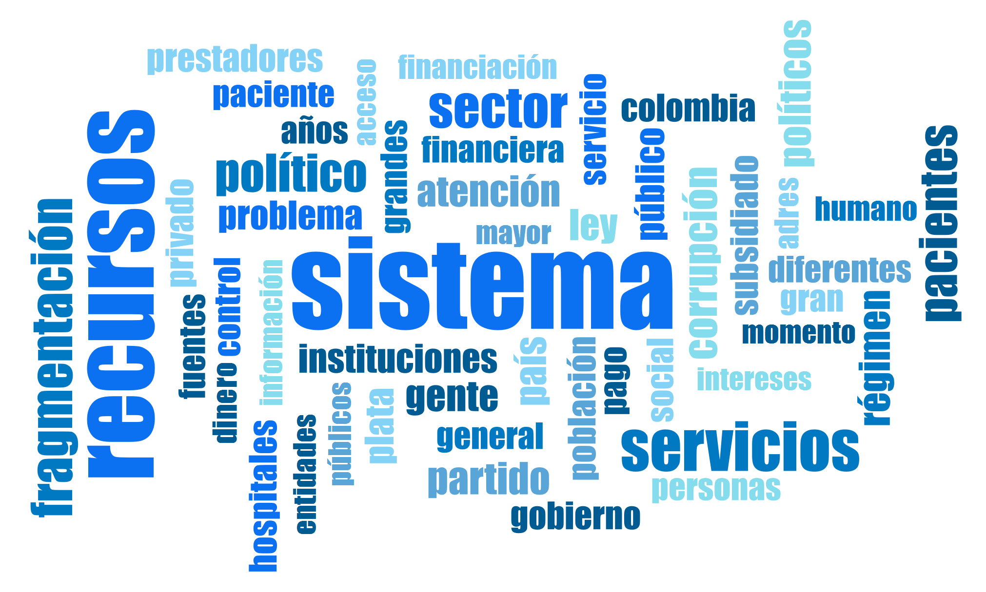
We show the most common words related to all the categories in the interviews. The most prominent words include “sistema” (system), “recursos” (resources), “servicios” (services), “sector” (sector), “político” (political), “pacientes” (patients), and “corrupción” (corruption). Other frequently mentioned terms such as “fragmentación”, “prestadores” (providers), “instituciones” (institutions), “financiación” (financing), and “público” (public) reflect the complexity and multidimensional nature of the financial fragmentation issue in the health system.

References

1. Bossert T, Blanchet N, Sheetz S, Pinto DM, Cali J, Perez-Cuevas R. Comparative Review of Health System Integration in Selected Countries in Latin America. IDB Publ. 2014 Jan 1. Located at: Chile. doi:10.18235/0009151
2. Etymonline. Etymonline [Internet]. 2025 [cited 2025 Jul 18]. Cause: Etymology, Origin & Meaning. Available from: https://www.etymonline.com/word/cause
3. Ottersen OP, Dasgupta J, Blouin C, Buss P, Chongsuvivatwong V, Frenk J, et al. The political origins of health inequity: prospects for change. The Lancet. 2014 Feb 15;383(9917):630–67. doi:10.1016/S0140-6736(13)62407-1 PubMed PMID: 24524782.
4. Duric P, Smith M, Collins P, Chen PR. Global definitions of political determinans of health: a sistematic review. Soc Sci Med. 2026 Mar 12;119191. doi:10.1016/j.socscimed.2026.119191
5. Greer SL, Wismar M, Figueras J, European Observatory on Health Systems and Policies, editors. Strengthening health system governance: better policies, stronger performance. Maidenhead, Berkshire: Open University Press; 2016. 272 p. (European observatory on health systems and policies series).
6. World Health Organization (WHO). World Health Organization (WHO) [Internet]. 2025. Health Systems Governance. Available from: https://www.who.int/health-topics/health-systems-governance#tab=tab_1
7. Monitor ciudadano de la corrupción. Corrupción. El Monitor Ciudadano de la Corrupción - Transparencia por Colombia [Internet]. 2025 [cited 2025 Jul 18]. Available from: https://www.monitorciudadano.co/about/
8. World Health Organization (WHO). World Health Organization - Regional Office for the Eastern Mediterranean [Internet]. 2025 [cited 2025 Jul 18]. Violence. Available from: http://www.emro.who.int/health-topics/violence/index.html
9. Trejos Rosero LF. Dos enfoques para entender mejor la violencia armada en Colombia. La Silla Vacía [Internet]. 2025 Apr 9 [cited 2025 Jul 18]. Available from: http://www.lasillavacia.com/red-de-expertos/red-de-la-paz/dos-enfoques-para-entender-mejor-la-violencia-armada-en-colombia/
10. Comisión de la verdad. Comisión de la verdad [Internet]. 2018 [cited 2025 Jul 18]. Acuerdo Final para la Terminación del Conflicto y la Construcción de una Paz Estable y Duradera​. Available from: https://www.comisiondelaverdad.co/acuerdo-final-para-la-terminacion-del-conflicto-y-la-construccion-de-una-paz-estable-y-duradera
11. Centro Nacional de Memoria Histórica. ¡Basta ya! Colombia: memorias de guerra y dignidad. Resumen [Internet]. Bogotá: Centro Nacional de Memoria Histórica; 2013 [cited 2025 Jul 18]. Available from: https://babel.banrepcultural.org/digital/collection/p17054coll2/id/89
12. Periódico Universidad Nacional de Colombia. Polarización política: claves para entender un fenómeno global [Internet]. 2025 [cited 2025 Jul 18]. Available from: https://www.periodico.unal.edu.co/articulos/polarizacion-politica-claves-para-entender-un-fenomeno-global
13. Fuentes ML. Sociedad civil, crisis e incertidumbre [Internet]. Universidad Nacional Autónoma de México; 2014. Available from: http://www.pued.unam.mx/export/sites/default/archivos/documentos-trabajo/012.pdf
14. ScienceDirect. Media Communication - an overview [Internet]. 2015 [cited 2025 Jul 18]. Available from: https://www.sciencedirect.com/topics/social-sciences/media-communication
15. IOM UN Migration. IOM UN Migration [Internet]. 2025. Key Migration Terms. Available from: https://www.iom.int/key-migration-terms
16. Melo-Becerra LA, Arango-Thomas LE, Ávila-Montealegre Ó, Ayala-García J, Bonilla-Mejía L, Botero-García JA, et al. Aspectos financieros y fiscales del sistema de salud en Colombia. Ens Sobre Política Económica. 2023 Oct 2;(106):1–92. doi:10.32468/espe106
17. Castro Figueroa AM, Malpica Zapata WA. Factores determinantes en la crisis de las instituciones prestadoras de servicios de salud en Colombia, un acercamiento desde la perspectiva financiera. Criterio Libre [Internet]. 2021 [cited 2025 Jul 18];19(34):84–94. Available from: https://dialnet.unirioja.es/servlet/articulo?codigo=8065780
18. Ingram RC, Scutchfield FD, Mays GP, Bhandari MW. The Economic, Institutional, and Political Determinants of Public Health Delivery System Structures. Public Health Rep. 2012 Mar 1;127(2):208–15. doi:10.1177/003335491212700210
19. Universidad Nacional Autónoma de México. Los sistemas de información [Internet]. 2025 [cited 2025 Jul 18]. Available from: https://programas.cuaed.unam.mx/repositorio/moodle/pluginfile.php/1101/mod_resource/content/15/uapa_Los_sistemas_de_informacion/index.html
20. Ministerio de Salud y Protección Social, Ministerio de Tecnologías de la Información y las Comunicaciones. Resolución Conjunta 866 de 2021 [Internet]. 2021 [cited 2025 Jul 18]. Available from: https://www.alcaldiabogota.gov.co/sisjur/normas/Norma1.jsp?i=114503
21. Congreso de la República de Colombia. Ley 100 de 1993 [Internet]. 1993 Dec 23. p. 132. Available from: https://www.minsalud.gov.co/sites/rid/Lists/BibliotecaDigital/RIDE/DE/DIJ/ley-100-de-1993.pdf
22. Bardey D, Buitrago G. Integración vertical en el sector colombiano de la salud. Desarro Soc. 2016 Jul 1;(77):77. doi:10.13043/dys.77.6
23. Méndez Castillo JA. Dinámicas del complejo médico industrial y financiero en la rehabilitación física en el Sistema General de Seguridad Social en salud (1993-2015) : El caso de las prótesis auditivas [Internet]. Universidad Nacional de Colombia; 2022. Available from: https://repositorio.unal.edu.co/handle/unal/83060
24. Relman AS. The New Medical-Industrial Complex. N Engl J Med. 1980 Oct 23;303(17):963–70. doi:10.1056/NEJM198010233031703
25. Diccionario de la Real Academia de la Lengua Española (RAE). «Diccionario de la lengua española (2001)» [Internet]. 2024 [cited 2025 Jul 18]. Consecuencia. Available from: https://www.rae.es/drae2001/consecuencia

