Supplementary files
Supplementary table 1 Dimensional and over all accessibility score of healthcare facilities in Bahir Dar City
Dimensions | No of indicators | Mean liker scale for an indicator | Total Accessibility score range | Total Mean Accessibility score | Cut off point | Accessibility Level (f/%) |  | Conclusion
 |  |  |  |  |  | High accessibility | Low accessibility | Conclusion
Universal design & accessibility | 39 | 0.31 | 0 – 39 | 11.9 | 12.5 | 4 (40) | 6 (60) | Unacceptable/ tolerable
Reasonable accommodation | 14 | 0.45 | 0 – 14 | 6.3 | 5.5 | 7 (70) | 3 (30) | Tolerable, but needs intervention
Capacity of facility staff | 13 | 0.38 | 0 – 13 | 5 | 4.5 | 6 (60) | 4 (40) | Tolerable, but needs intervention
Linkage to disability & rehabilitation services | 13 | 0.17 | 0 – 13 | 2.2 | 4.5 | 2 (20) | 8 (80) | Unacceptable/ tolerable
Over all accessibility | 79 | 0.34 | 0 - 79 | 26.6 | 29 | 5 (50) | 5 (50) | Unacceptable/ tolerable

Supplementary table 2 Comparison of accessibility score using Kruskal Wallis test across main dimensions
Dimensions | Accessibility Score | Mean Rank
Universal design & accessibility | 30.8 | 202
Reasonable accommodation | 46.5 | 267
Capacity of facility staff | 42.4 | 232.5
Linkage to specialized services | 7.7 | 118.5
X² |  | 8.894
Df |  | 3
p-value |  | 0.03

Supplementary table 3 Frequency and percentages of facilities met accessibility criteria in the Universal Design and Accessibility Dimensions.
Indicator | Facilities met the accessibility criteria
Indicator | Rural (f/%) | Urban (f/%) | Total (f/%)
Entrance to services
Public transport access for wheelchair < 1Km | 4 (100) | 6(100) | 10(100)
Clearly signed parking space for disabled | 0 | 0 | 0
Accessible compound for wheelchair/crunch user | 0 | 4(66.7) | 4 (40)
Width of ramp > 90 cm | 2 (50) | 5 (83) | 7 (70)
Hand rails present on ramp | 0 (0) | 1(16.7) | 1(10)
Texture of ramp - is non slippery | 1(25) | 5(83) | 6 (60)
Slope of ramp <= 5 ⁰ / (5-8%) | 0 | 0 | 0
Width of main facility entrance door (>90 cm) | 2 (50) | 0 | 0
Facility entrance door open easily with one hand | 1 (25) | 6 (100) | 7 (70)
Lip on door | 3 (75) | 1 (16.7) | 4 (40)
Entrance signage available in accessible format | 0 | 4 (66.7) | 4 (40)
Reception, corridors & waiting rooms
Reception have a regular full time staff | 0 | 1(16.7) | 1 (10)
Reception clearly marked/ signed | 1(25) | 1 (16.7) | 2 (20)
Reception near the main entrance and accessible | 1 (25) | 1 (16.7) | 2 (20)
Height of reception desk < 50 cm | 0 | 0 | 0
Triage has regular full-time staff | 4 (100) | 6 (100) | 10 (100)
Triage clearly marked or signed/labelled | 3 (75) | 5(83) | 8(80)
Triage near main entrance/accessible | 0 | 5(83) | 5(83)
Height of triage desk | 0 | 0 | 0
Usable width of corridors (150 cm) | 0 | 1(16.7) | 0
Non-slippery corridor/room floors | 0 | 1(16.7) | 0
Examination rooms, emergency evacuations and dispensing windows
Usable width of doorways (160 cm) | 0 | 1(16.7) | 1(16.7)
Width of other facility doors e.g. lab. >90 cm | 0 | 0 | 0
Description posted at top of door or side of wall in accessible formats | 4(40) | 6(60) | 10(100)
Direction in key areas in accessible formats like signposts | 3(75) | 0 | 3(30)
Emergency evacuation/exit wheelchair accessible | 0 | 0 | 0
Emergency evacuation/exit routes signed with pictures & braille | 0 | 0 | 0
Service rooms on the same level | 0 | 6(100) | 6(60)
Adjustable examination table height | 0 | 1(16.7) | 0
Accessible bed at the facility | 2(50) | 6(60) | 8(80)
Caretaker/support person welcoming | 2(50) | 6(100) | 8(80)
Window near main entrance & accessible | 0 | 6(100) | 6(60)
Height of lab/dispensing window (< 50 cm) | 0 | 0 | 0
Toilets
Clearly labelled disability toilet as accessible | 0 | 2(33) | 2(20)
Usable width of disability toilet door (>90cm) | 0 | 1(16.7) | 1(10)
Disability toilet has hand rails | 0 | 3(50) | 3(30)
Toilet seat is accessible/ user friendly | 0 | 3(50) | 3(30)
Toilet has enough space to manoeuvre a wheelchair | 1(25) | 3(50) | 4(40)
Wash points wheelchair user can reach (50-70 cm) | 0 | 1(16.7) | 0

Supplementary table 4 Frequency and percentages of facilities met accessibility criteria in the reasonable accommodation dimensions.
Indicator | Facilities met the accessibility criteria
Indicator | Rural (f/%) | Urban (f/%) | Total (f/%)
Information and communication
Alternative communication techniques e.g. braille | 0 | 6(100) | 6(60)
Health information provided in accessible format | 0 | 0 | 0
Simplified health information (including pictures) | 0 | 1(16.7) | 1(10)
Written informed consent sheets | 3(75) | 3(50) | 6(60)
Accessible formats for informed consent | 0 | 0 | 0
Facility provide information on medicines & where to access | 4(100) | 6(100) | 10(100)
Convenient dispensary information are accessible | 0 | 6(100) | 6(60)
Assistance and support
Functional AT for temporary use | 3(75) | 4 (66.7) | 7 (70)
Guiding services available e.g. assistant | 1 (25) | 5 (83.3) | 6(60)
Way in making complaints/ suggestions box | 2 (50) | 6 (100) | 8 (80)
Suggestion box accessible format | 0 | 2 (33.3) | 2(20)
Routine patient satisfaction survey | 4 (100) | 6 (100) | 10 (100)
Survey available in accessible format | 0 | 0 | 0
Clear signage indicating first in queues | 0 | 0 | 1 (10)

Supplementary table 5 Frequency and percentages of facilities met accessibility criteria in the capacity of facility staff dimensions.
Indicator | Facilities met the accessibility criteria
Indicator | Total (f/%) | Total (f/%) | Total (f/%)
Training on disability accessibility
Disability focal person | 2(50) | 4(66.7) | 6(60)
Focal person trained on disability & support | 1(25) | 4(66.7) | 5(50)
All cadres trained on disability etiquette/ sensitization | 0 | 6(100) | 6(60)
Training conducted on sign language interpretation and Braille signage | 1(25) | 6(100) | 7(70)
Educational material in accessible format | 0 | 3(50) | 3(30)
Training for HCW
Staff member trained on disability, accessibility | 3(75) | 6(100) | 9(90)
Training on how to screen/ identify disability | 0 | 1(16.7) | 1(10)
Training on how to refer rehabilitation/specialized services | 0 | 1(16.7) | 0
Training for HWs on awareness and use of AT | 0 | 1(16.7) | 1(10)
Other training and capacity building
Training conducted on supporting emergency evacuation | 0 | 0 | 0
Training on SRHR & GBV included disability | 3(75) | 5(83.3)) | 8(80)
PWDs participated in SRHR/GBV training | 1(25) | 2(33.3) | 3(30)
Protocol/ guideline incorporate need of/ disability issue | 0 | 1(16.7) | 1(10)

Supplementary table 6: Frequency and percentages of facilities met accessibility criteria in the linkage to disability and rehabilitation services dimensions.
Indicator | Facilities met the accessibility criteria
Indicator | Total (f/%) | Total (f/%) | Total (f/%)
Disability data capture
Health register capture disability status | 0 | 3(50) | 3(30)
Health register capture needed accommodations | 0 | 0 | 0
Disability screening tools available e.g. WG. | 0 | 1(16.7) | 0
Routine data summary include disability | 0 | 0 | 3(30)
Annually updated referral processes
Referral/ follow up monitoring tool | 0 | 3(50) | 3(30)
Annually updated referral process on disability services providing AT | 0 | 2(33.3) | 2(20)
Annually updated referral/ follow-up system on repairing AT | 0 | 1(16.7) | 1(10)
Annually updated referral process to rehabilitation/specialized medical services | 0 | 1(16.7) | 1(10)
Annually updated referral process to mental healthcare service accessibility | 0 | 3(50) | 3(30)
Disability specific service linkages
Updated directory/ list of organizations working on disability | 0 | 0 | 0
Linkages/ collaborations with OPDs | 0 | 3(50) | 3(30)
Linkages with rehabilitation outreach programme/ 6 months | 0 | 0 | 0
Linkages & referral to Home-Based or Community- Based Rehabilitation programmes | 0 | 0 | 0

Supplementary table 7: Comparison of accessibility score using Kruskal Wallis test in each facility
Healthcare facility | Accessibility Score |  |  | Mean Rank
Healthcare facility | Total | Urban | Rural | Total | Urban | Rural
01 | 48.1 | 48.1 | - | 112.5 | 57 | -
02 | 59.5 | 59.5 | - | 147.5 | 83.5 | -
03 | 32.9 | 32.9 | - | 80.5 | 28.5 | -
04 | 39.2 | 39.2 | - | 103 | 43.5 | -
05 | 45.6 | 45.6 | - | 112.5 | 51.5 | -
06 | 37.9 | 37.9 | - | 80.5 | 36 | -
07 | 13.9 | - | 13.9 | 29 | - | 23.5
08 | 22.8 | - | 22.8 | 62.5 | - | 43
09 | 21.5 | - | 21.5 | 50.5 | - | 38.5
10 | 15.2 | - | 15.2 | 41.5 | - | 31
X² |  |  |  | 22.836 | 9.419 | 2.509
df |  |  |  | 9 | 5 | 3
p-value |  |  |  | 0.0067 | 0.094 | 0.4736

Supplementary table 8: Comparison of accessibility score using Kruskal Wallis test in sub-dimensions
Sub-Dimensions | Accessibility Score | Mean Rank
Entrance to services | 36.4 | 754
Reception, corridors & waiting rooms | 25 | 573
Examination rooms, emergency evacuations and dispensing windows | 41.7 | 680
Toilets | 8.4 | 478.5
Information & communication | 42.9 | 789
Assistance & support | 50 | 876
Training on accessibility | 50 | 794
Training for HCW | 25 | 582.5
Other training and capacity building | 25 | 597
Disability data capture | 12.5 | 446.5
Annually updated referral processes | 0 | 394
Disability specific service linkages | 0 | 295.5
X² |  | 29.769
Df |  | 11
p-value |  | 0.0017

Supplementary table 9 Accessibility scores among all facilities in the audit by dimension and sub - dimension
Dimension | Sub-Dimension | Accessibility Score for facilities disaggregated by location (Anonymized)
Dimension | Sub-Dimension | Urban facilities |  |  |  |  |  | Rural facilities
Dimension | Sub-Dimension | 1 | 2 | 3 | 4 | 5 | 6 | 7 | 8 | 9 | 10
Universal design and accessibility | Entrance to services | 45.5 | 72.5 | 36.4 | 36.4 | 45.5 | 54.5 | 36.4 | 27.3 | 36.4 | 18.2
Universal design and accessibility | Reception, corridors and waiting rooms | 40 | 60 | 20 | 30 | 30 | 30 | 10 | 20 | 20 | 20
Universal design and accessibility | Examination rooms and emergency routes | 50 | 50 | 50 | 41.7 | 41.7 | 50 | 25 | 16.7 | 25 | 8.3
Universal design and accessibility | Toilets | 83.3 | 0 | 0 | 0 | 66.7 | 66.7 | 16.7 | 0 | 16.7 | 0
Universal design and accessibility | Domain total | 51.3 | 51.3 | 30.8 | 30.8 | 43.6 | 48.7 | 23.1 | 17.9 | 25.6 | 12.8
Reasonable accommodation of people with disabilities | Information and communication | 57.1 | 57.1 | 42.9 | 42.9 | 57.1 | 57.1 | 14.3 | 28.6 | 28.6 | 28.6
Reasonable accommodation of people with disabilities | Assistance and support | 57.1 | 71.4 | 42.9 | 57.1 | 57.1 | 57.1 | 14.3 | 57.1 | 28.6 | 42.9
Reasonable accommodation of people with disabilities | Domain total | 57.1 | 64.3 | 42.9 | 50 | 57.1 | 57.1 | 14.3 | 42.9 | 28.6 | 35.7
Capacity of facility staff to identify and support people with disabilities | Awareness and accessibility training (all) | 100 | 80 | 80 | 100 | 60 | 40 | 0 | 40 | 20 | 0
 | Healthcare worker training (at least some staff) | 25 | 75 | 25 | 25 | 50 | 25 | 0 | 25 | 25 | 25
 | Other training and support capacity | 50 | 50 | 25 | 25 | 50 | 0 | 0 | 50 | 25 | 25
 | Domain total | 61.5 | 69.2 | 46.2 | 53.8 | 53.8 | 23.1 | 0 | 38.5 | 23.1 | 15.4
Linkage to disability and rehabilitation services | Disability data capture | 25 | 50 | 25 | 50 | 50 | 0 | 0 | 0 | 0 | 0
Linkage to disability and rehabilitation services | Annually updated referral processes | 0 | 100 | 20 | 60 | 20 | 0 | 0 | 0 | 0 | 0
Linkage to disability and rehabilitation services | Disability specific service linkages | 25 | 50 | 0 | 0 | 25 | 0 | 0 | 0 | 0 | 0
Linkage to disability and rehabilitation services | Domain total | 15.4 | 69.2 | 15.4 | 38.5 | 30.8 | 0 | 0 | 0 | 0 | 0
Total Score |  | 48.1 | 59.5 | 32.9 | 39.2 | 45.6 | 37.9 | 13.9 | 22.8 | 21.5 | 15.2

Supplementary table 10 Correlation of patient volume and staff with accessibility score
 | Patient volume & accessibility |  | Staff & accessibility
 | Spearman correlation coefficient (ρ) | P-value | Spearman correlation coefficient (ρ) | P-value
Rural | -0.2 | 0.91 | -0.4 | 0.75
Urban | 0.6 | 0.24 | 0.6 | 0.24
Over all facilities | 0.8424 | 0.004 | 0.8303 | 0.005

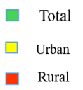

Supplementary figure 1 Accessibility score of facilities by rural/ urban stratification
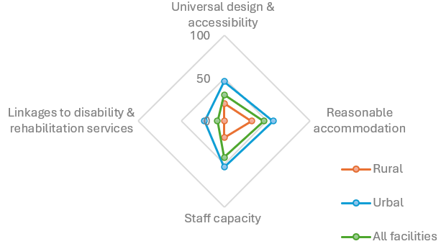
Supplementary figure 2 Median percentage score of accessibility accords dimensions and disaggregated by location of facilities.

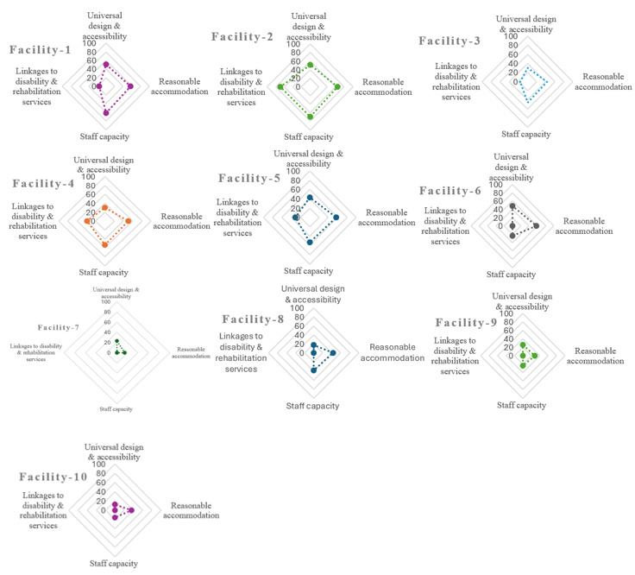
Supplementary figure 3 Facility-level accessibility score across each dimension

