Appendix 1 – Fig. A1 The distribution of sample after matching in China
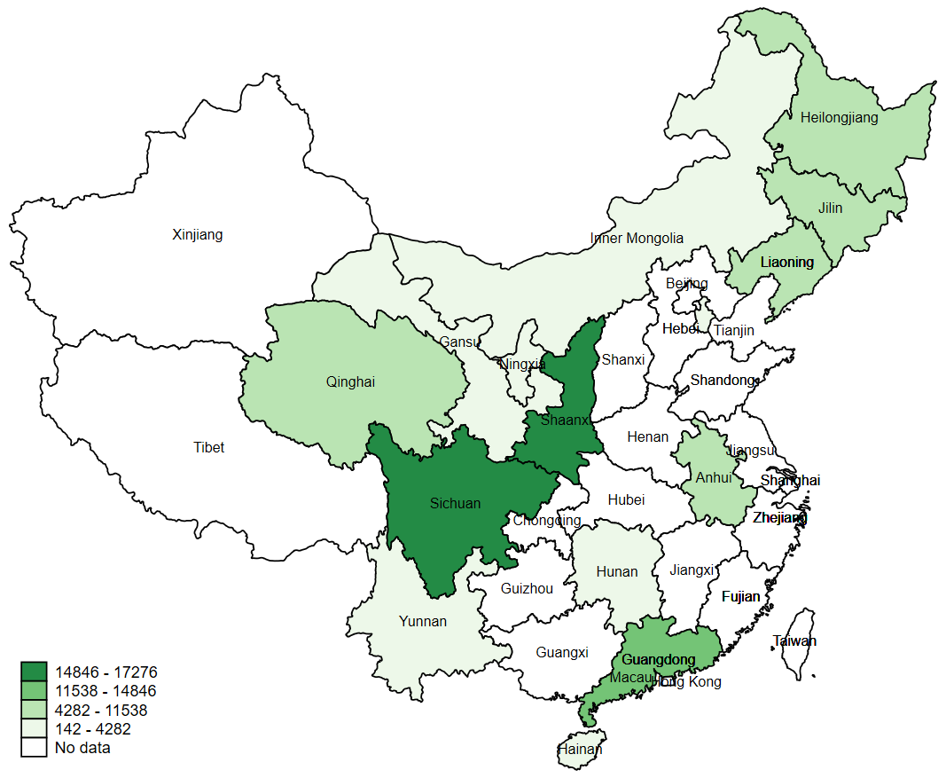
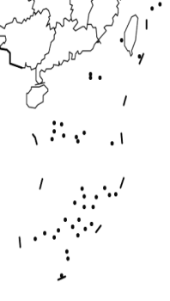
Fig. A1 The distribution of sample after matching in China

Appendix 2 – Table A1 Variables definitions
Variables | Types of variables | Description of variables
Independent variables
Group | Binomial variable | 0 = Control group;  1 = Treatment group
Year | Binomial variable | 0 = Pre-intervention; 1 = Post-intervention
Control variables
Provincial-level characteristics
Average social wages of urban workers (10 000 CNY) | Continuous variable | Continuous variable
Per Capita GDP | Continuous variable | Continuous variable
Number of Health Technical Personnel per 1,000 Population | Continuous variable | Continuous variable
Population Aged 65 and Over | Continuous variable | Continuous variable
CPI | Continuous variable | Continuous variable
Hospital-level characteristics
Hospital level | Categorical variable | 1 = Secondary hospital;  2 = Tertiary hospital
Hospital type | Categorical variable | 1 = General hospital;  2 = Traditional Chinese medicine hospital;  3 = Specialized hospital
ln(Total hospital revenue) | Continuous variable | Continuous variable
ln(Medical care revenue) | Continuous variable | Continuous variable
ln(Financial subsidy) | Continuous variable | Continuous variable
ln(Personnel expenditures) | Continuous variable | Continuous variable
ln(Number of health workers) | Continuous variable | Continuous variable
ln(Number of visits) | Continuous variable | Continuous variable
ln(Number of discharged patients) | Continuous variable | Continuous variable
ln(Physicians are responsible for the number of visits per day) | Continuous variable | Continuous variable
Individual-level characteristics
Education | Categorical variable | 1 = Junior College and Below;  2 = College;  3 = Master and above
Qualifications | Categorical variable | 1 = Practicing doctors/Assistant practicing doctors;  2 = Registered nurses;  3 = Others
Nature of employment | Categorical variable | 1 = Salaried staff;  2 = Contracted staff;  3 = Others
Length of service (years) | Continuous variable | Continuous variable
Departments | Categorical variable | 1 = Internal Medicine;  2 = Surgical department;  3 = Pediatrics obstetrics and gynecology;  4 = Medical laboratory;  5 = Emergency department;  6 = Administration and logistics department;  7 = Other departments
Job type | Categorical variable | 1 = Specialized technical job;  2 = Management job;  3 = Logistics job
Positions | Categorical variable | 1 = Ordinary staff;  2 = Department manager;  3 = Hospital manager
Outcome variables
The percentage of base salary (%) | Continuous variable | Continuous variable
The percentage of merit salary (%) | Continuous variable | Continuous variable
ln(Total compensation) (CNY) | Continuous variable | Continuous variable
ln(Annual base salary) (CNY) | Continuous variable | Continuous variable
ln(Annual merit salary) (CNY) | Continuous variable | Continuous variable
Notes: The salaries and benefits of the salaried staff were uniformly funded and allocated by the government, whereas the contracted staff or temporary staff were funded by hospitals.

Appendix 3 – Table A2 Descriptive statistics at baseline for control variables

Control variables | Treatment group  N. (%)  (n=29 318) | Control group  N. (%)  (n=26 284)
Provincial-level characteristics
Average social wages of urban workers, | 1.8 (0.1) | 1.8 (0.1)
Per Capita GDP | 49253.9 (63.8) | 53176.1 (118.6)
Number of Health Technical Personnel per 1,000 Population | 6.3 (0.0) | 5.9 (0.0)
Population Aged 65 and Over | 4194.9 (17.2) | 5352.9 (16.5)
CPI | 101.8 (0.0) | 101.5 (0.0)
Hospital-level characteristics
Hospital level
Secondary hospital | 7 727 (26.4) | 9 301 (35.4)
Tertiary hospital | 21 591 (73.6) | 16 983 (64.6)
Hospital type
General hospital | 27 138 (92.6) | 18 516 (70.5)
Traditional Chinese medicine hospital | 1 081 (3.7) | 3 762 (14.3)
Specialized hospital | 1 099 (3.7) | 4 006 (15.2)
Individual-level characteristics
Education ª
Junior college and below | 13 675 (48.0) | 13 397 (51.4)
College | 13 018 (45.7) | 10 974 (42.1)
Master and above | 1 780 (6.3) | 1 698 (6.5)
Qualifications ª
Practicing doctors/Assistant practicing doctors | 7 687 (33.0) | 8 807 (35.3)
Registered nurses | 11 319 (48.5) | 12 191 (48.9)
Others | 4 314 (18.5) | 3 946 (15.8)
Nature of employment ^{a b}
Salaried staff | 15 292 (52.2) | 14 784 (56.3)
Contracted staff | 13 715 (46.8) | 11 229 (42.7)
Others | 309 (1.1) | 271 (1.0)
Departments ª
Internal medicine | 7 457 (25.58) | 6 501 (24.87)
Surgical department | 5 359 (18.38) | 4 452 (17.03)
Pediatrics obstetrics and gynecology | 3 041 (10.43) | 2 929 (11.21)
Medical laboratory | 5 424 (18.60) | 5 115 (19.57)
Emergency department | 1 863 (6.39) | 1 354 (5.18)
Administration and logistics department | 4 594 (15.76) | 4 463 (17.07)
Other departments | 1 416 (4.86) | 1 324 (5.07)
Length of service, mean (SD), years | 12.35 (0.06) | 13.85 (0.06)
Job type ª
Specialized technical job | 24 931 (91.9) | 24 596 (94.0)
Management job | 539 (2.0) | 511 (2.0)
Logistics job | 1 673 (6.1) | 1 055 (4.0)
Positions
Ordinary staff ^{c} | 25 996 (88.7) | 23 015 (87.6)
Department manager | 3 070 (10.5) | 3 015 (11.5)
Hospital manager | 252 (0.9) | 254 (1.0)
Mean (SD) were performed for continuous variable. N. (%) were performed for categorical variable.
ª There were missing values. There were 1060 missing values in education, 7338 missing values in qualification, 2 missing values in nature of employment, 310 missing values in departments and 2297 missing values in job type.
^{b} Salaried staff belongs to the authorized size of a government body and have the fixed guarantee. The salaries and benefits of the salaried staff were uniformly funded and allocated by the government. Whereas the contracted staff or temporary staff mention the time period of employment and were funded by the hospitals.
^{c} Ordinary staff means the hospital workers who are not classified as executives, department managers, or any specifically listed employee or job description.

Appendix 4 – Table A3 Observed characteristics at baseline between final sample and data before cleaning
Control variables | Data before cleaning  (n=57 432)  N. (%) | Final sample  (n=55 602)  N. (%) | P value
Provincial-level characteristics
ln(Average social wages of urban workers), mean (SD),10 000 CNY | 1.8 (0.1) | 1.8 (0.1) | .46
Hospital-level characteristics
Hospital level
Secondary hospital | 17 776 (30.9) | 17 028 (30.6) | .23
Tertiary hospital | 39 656 (69.1) | 38 574 (69.4)
Hospital type
General hospital | 46 949 (81.7) | 45 654 (82.1) | .17
Traditional Chinese medicine hospital | 5 026 (8.8) | 4 843 (8.7)
Specialized hospital | 5 757 (9.5) | 5 105 (9.2)
Individual-level characteristics
Education ª
Junior college and below | 28 115 (49.9) | 27 072 (49.6) | .60
College | 24 726 (43.9) | 23 992 (44.0)
Master and above | 3 528 (6.2) | 3 478 (6.4)
Qualifications ª
Practicing doctors/Assistant practicing doctors | 17 101 (34.2) | 16 494 (34.2) | .10
Registered nurses | 24 136 (48.2) | 23 510 (48.7)
Others | 8 808 (17.6) | 8 260 (17.1)
Nature of employment ^{a b}
Salaried staff | 30 843 (53.71) | 30 076 (54.1) | .42
Contracted staff | 25 984 (45.24) | 24 944 (44.9)
Others | 603 (1.05) | 580 (1.0)
Departments ª
Internal medicine | 14 185 (24.8) | 13 958 (25.2) | .14
Surgical department | 9 989 (17.5) | 9 811 (17.7)
Pediatrics obstetrics and gynecology | 6 352 (11.1) | 5 970 (10.8)
Medical laboratory | 10 884 (19.1) | 10 539 (19.1)
Emergency department | 3 284 (5.7) | 3 217 (5.8)
Administration and logistics department | 9 623 (16.8) | 9 057 (16.4)
Other departments | 2 797 (4.9) | 2 740 (5.0)
Length of service, mean (SD), years | 13.1 (10.6) | 13.85 (10.6) | .46
Job type ª
Specialized technical job | 51 034 (92.4) | 49 527 (92.9) | .09
Management job | 1 119 (2.0) | 1 050 (2.0)
Logistics job | 2 973 (5.6) | 2 728 (5.1)
Positions
Ordinary staff ^{c} | 50 687 (88.3) | 49 011 (88.2) | .81
Department manager | 6 218 (10.8) | 6 085 (10.9)
Hospital manager | 527 (0.9) | 506 (0.9)
Mean (SD) were performed for continuous variable. N. (%) were performed for categorical variable.
ª There were missing values. There were 1063 and 1060 missing values in education for complete data and incomplete data, 7387 and 7338 missing values in qualification, 2 missing values in nature of employment for complete data and incomplete data,318 and 310 missing values in departments for complete data and incomplete data , and 2306 and 2297 missing values in job type for complete data and incomplete data.

Appendix 5– Table A4 Summary statistics for outcome variables

Outcome variables | Obs. | Mean | SD | Median | IQR
Pre-intervention (2016)
The percentage of base salary (%) | 55 602 | 31.7 | 17.0 | 27.6 | 20.1~38.8
The percentage of merit salary (%) | 55 602 | 47.6 | 22.8 | 50.8 | 31.6~66.7
Total compensation (CNY) | 55 602 | 91 417.2 | 50 956.8 | 82 464.5 | 55 851.0~115 896.3
Annual base salary (CNY) | 55 602 | 24 534.3 | 11 756.5 | 22 200.0 | 17 400.0~31 011.0
Annual merit salary (CNY) | 55 602 | 47 142.1 | 39 198.6 | 37 581.9 | 19 218.0~65 004.3
Post-intervention (2017)
The percentage of base salary (%) | 55 602 | 34.1 | 17.2 | 30.1 | 21.9~42.3
The percentage of merit salary (%) | 55 602 | 49.3 | 23.1 | 52.7 | 32.5~68.9
Total compensation (CNY) | 55 602 | 94 496.5 | 49 074.7 | 87 202.3 | 59 953.7~118 103.0
Annual base salary (CNY) | 55 602 | 28 063.2 | 12 958.6 | 25 140.0 | 19 720.8~35 052.0
Annual merit salary (CNY) | 55 602 | 50 358.8 | 39 899.7 | 41 348.0 | 20 520.0~70 953.6

Appendix 6 – Table A5 Results of the random selection test

Variables | Treatment group  Mean (SD) | Control group  Mean (SD) | t-statistic | P value
Provincial-level
ln(Average social wages of urban workers) | 1.8 (0.1) | 1.8 (0.1) | 0.6 | .25
ln(Per Capita GDP) | 10.7 (0.1) | 10.9 (0.2) | 1.3 | .09
ln(Number of Health Technical Personnel per 1,000 Population) | 1.7 (0.1) | 1.7 (0.1) | -0.1 | .48
ln(Population Aged 65 and Over) | 7.6 (0.1) | 7.9 (0.3) | -0.5 | .31
ln(CPI) | 4.6 (0.1) | 4.6 (0.1) | -1.1 | .15
Hospital-level
ln(Total hospital revenue) | 9.4 (1.4) | 9.4 (1.2) | -0.1 | .50
ln(Medical care revenue) | 9.3 (1.7) | 8.9 (1.5) | -0.3 | .36
ln(Financial subsidy) | 7.4 (1.0) | 7.4 (0.9) | -0.4 | .35
ln(Personnel expenditures) | 8.4 (1.4) | 8.3 (1.1) | -0.4 | .35
ln(Number of health workers) | 5.9 (1.1) | 5.9 (0.9) | -0.2 | .44
ln(Number of visits) | 11.9 (1.5) | 11.8 (1.6) | -0.3 | .37
ln(Number of discharged patients) | 9.0 (1.7) | 9.0 (1.4) | -0.1 | .47
ln(Physicians are responsible for the number of visits per day) | 2.8 (1.9) | 2.6 (1.8) | -0.4 | .35
Number of observations | 51 | 51 | 51 | 51
Notes: Because of the skewed distribution, we used natural logs of the values of these variables.
Appendix 7 – Fig. A2 The matching results between two groups
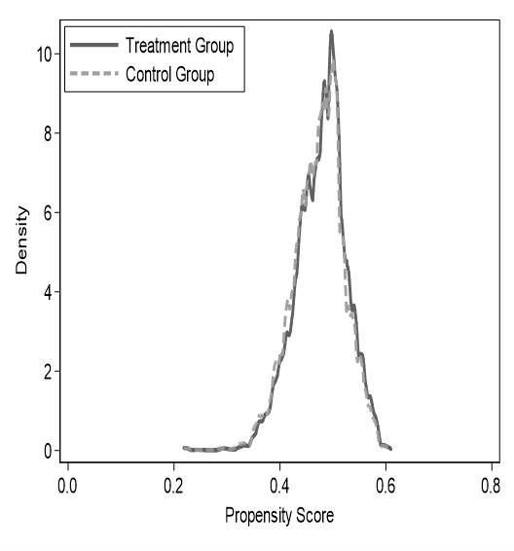
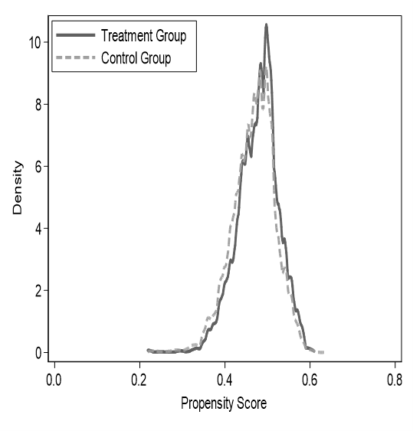
(a) Standardized % bias across covariates (b)the common support before matching (c)the common support after matching

Fig. A2 The matching results between two groups
Graph (a) shows the change of standardized % bias across covariates before and after matching. Graph (b) shows the common support graph of propensity scores before matching. Graph (c) shows the common support graph of propensity scores after matching.

Appendix 8 – Table A6 Balance diagnostics of the treatment and control group before and after matching

Variables | Before matching (N=55 606) |  |  | After matching(N=55 602)
Variables | Treatment group  Mean | Control group  Mean | P value | Treatment group  Mean | Control group  Mean | P value
Education | 1.6 | 1.5 | <.001 | 1.6 | 1.6 | .97
Qualifications | 2.5 | 2.4 | <.001 | 2.5 | 2.5 | .55
Nature of employment | 1.4 | 1.4 | .08 | 1.4 | 1.4 | .67
Departments | 3.0 | 3.3 | <.001 | 3.1 | 3.1 | .84
Length of service | 1.8 | 1.9 | <.001 | 1.8 | 1.8 | .93
Job type | 1.1 | 1.1 | .11 | 1.1 | 1.1 | .69
Positions | 1.1 | 1.1 | .41 | 1.1 | 1.1 | .83
Number of observations | 29 318 | 26 288 |  | 29 318 | 26 284
Appendix 9 – Table A7 sensitivity analysis
 | The percentage of base salary | The percentage of merit salary | ln (Total compensation) | ln (Annual base salary) | ln (Annual merit salary)
Change outcome variables-log transformation  RPHCS*Time | 0.14*** (0.01) | 0.01*** (0.01) | 1192.34*** (259.73) | 2592.96*** (55.36) | 1356.57*** (153.63)
Change outcome variables-fixed salary  RPHCS*Time | 3.77*** (0.10) | - | - | 0.11*** (0.01) | -
Delete sample  RPHCS*Time | 3.14** (0.08) | 0.84* (0.13) | 0.01 (0.01) | 0.10*** (0.01) | 0.03** (0.01)
Delete provincial control variables  RPHCS*Time | 1.40*** (0.070) | 0.58*** (0.10) | 0.01*** (0.01) | 0.06*** (0.01) | 0.06*** (0.01)

