Supplementary Material
Additional File 1
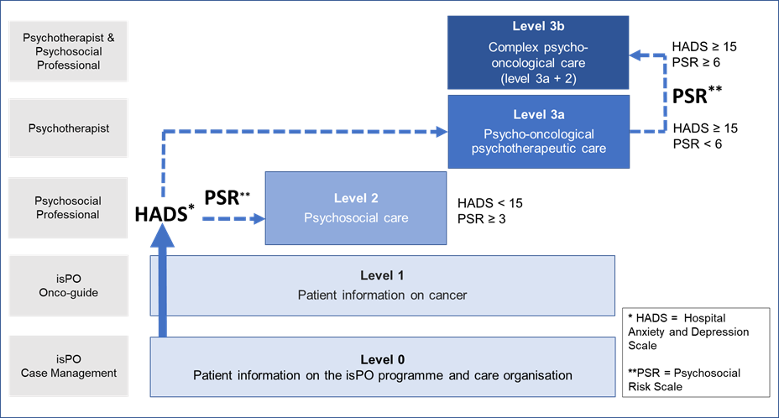
Figure A. The isPO programme’s stepped care concept. Adapted from Kusch et al. and Salm and Cecon et al.
Kusch M, Labouvie H, Schiewer V, Talalaev N, Cwik JC, Bussmann S, et al. Integrated, cross-sectoral psycho-oncology (isPO): a new form of care for newly diagnosed cancer patients in Germany. BMC Health Serv Res 2022. doi:10.1186/s12913-022-07782-0.
Salm S, Cecon N, Jenniches I, Pfaff H, Scholten N, Dresen A, Krieger T. Conducting a prospective evaluation of the development of a complex psycho-oncological care programme (isPO) in Germany. BMC Health Serv Res. 2022;22:531. doi:10.1186/s12913-022-07951-1.

Additional File 2
Table A. Overview and specifics on the scales and items used to assess contextual variables from the isPO service provider’s perspective.
Variable | Scale and item specifics | Answering scale | Example item
Sufficient resources for the isPO | Three items, self-developed, on human, time, and financial resources. | Four-point scale from ‘not at all’ to ‘totally’. | To what extent are the following resources in your care facility sufficient to implement the ispO concept?  - Financial resources
Information needs* | Three items, self-developed, on work tasks, care processes, and project goals. | Four-point scale from ‘does not apply’ to ‘applies’. | When working in the isPO programme, I would have liked more information about my work tasks / my role in the programme
Planning deficits [31] | Reduced to two items on planning deficiencies and impairments due to unclear responsibilities and requirements | Four-point scale from ‘does not apply’ to ‘applies’. | In my work in the isPO programme, I have to cope with planning shortcomings in other areas.
Organisational workload | One self-developed item. | Four-point scale from ‘do not agree at all’ to ‘totally agree’. | The organisational effort within the programme is high.
Restrictions through isPO* | One self-developed item. | Four-point scale from ‘do not agree at all’ to ‘totally agree’. | The work that falls to me within the programme limits me in my everyday work tasks.
Changes in work conditions through isPO | One self-developed item. | Five-point scale from ‘very much worsened’ to ‘very much improved’. | To what extent have your working conditions changed as a result of the project?
Work-related sense of coherence [32] | Nine items on work-related comprehensibility, manageability, and meaningfulness. | Seven-point scale with changing poles (e.g. from ‘structured’ to ‘chaotic’ or ‘predictable’ to ‘unpredictable’). | How do you personally feel about your current work or work situation in general?
Effort Reward Imbalance Scale [33] | Sixteen items with three subscales on overcommitment, effort, and reward. | Four-point scale from ‘do not agree at all’ to ‘totally agree’. | It often happens that I think about work problems when I wake up.  Due to the high workload, there is often great time pressure.  When I think of all the achievements and efforts made, I think the recognition I received is appropriate.
Cooperation [31] | Four items on within and between professions. | Four-point scale from ‘do not agree at all’ to ‘totally agree’ and one non-response category (‘I cannot judge’). | Cooperation within the narrower working area is good.
Trustful organisation [31] | Four items. | Four-point scale from ‘do not agree at all’ to ‘totally agree’. | In our institution, we have trust in each other.
Social backing [34] | Three items. | Five-point scale from ‘does not apply at all’ to ‘totally applies’. | I can rely on my colleagues when things get difficult at work.
Open communication [31] | Four items. | Four-point scale from ‘do not agree at all’ to ‘totally agree’. | In our institution, problems are addressed openly.
Organisational readiness to change [35] | Twelve items on change commitment and change efficacy.  Translated into German | Five-point scale from ‘do not agree at all’ to ‘totally agree’. | Persons who work here…  … are determined to implement this change.  … can get people invested in implementing this change.
Innovation climate [31] | Seven items. | Four-point scale from ‘do not agree at all’ to ‘totally agree’. | In our institution, we are motivated to bring in new ideas.
Resistance to change [36] | Nine items on routine seeking and short-term focus. | Six-point scale from ‘do not agree at all’ to ‘strongly agree’. | I generally consider change to be negative.  I often feel a bit uncomfortable about change, even if it may improve my life.
Personality traits [37] | Ten items on extraversion, agreeableness, conscientiousness, neuroticism, and openness. | Five-point scale from ‘does not apply at all’ to ‘totally applies’. | I am outgoing and sociable.  I am generally trusting and believe in the good in people.  I do a thorough job.  I get nervous easily.  I have an active imagination.
*these items which represent contextual factors, were measured in both, the main survey and the additional survey of medical staff

Additional File 3
Table B. Overarching guiding questions of the interview guidelines.
Guiding questions for the telephone interviews with the head psycho-oncologists
What is your task and role in isPO?
How do you evaluate the role of the clinical head of isPO?
How do you experience communication with the project staff involved in developing the care concept and the care processes?
How do you experience the exchange at the quality workshops?
How would you explain isPO to a colleague?
What distinguishes isPO from other psycho-oncological care programmes?
How do you assess the maturity of the care concept for the respective care levels?
Care level 3* in the treatment manual is important for your work.
How would you rate the isPO treatment manual specifically developed for care level 3?
How do you experience the utilisation of CAPSYS²⁰²⁰ in your daily work?
How do you assess the changes that have taken place through isPO?
Considering the isPO programme as a whole, how would you end the following sentence?
I find isPO ...
In your opinion, what would still have to be changed in the care concept or the care processes in order to be able to implement the programme nationwide in Germany?
What would you wish for isPO from your profession’s point of view?
Is there anything else striking / problematic / good / important that you would like to tell us about the isPO project that has not come up?
Guiding questions for the two focus groups*
What do you associate with isPO?
How would you rate isPO in the course of the project so far?
Note: participants were asked to answer regarding different project phases (normalisation phase, Corona and status quo)
How do you experience the implementability of isPO in your care network in regard to facilitating factors?
Note: participants were asked to answer regarding the normalisation phase)
How do you experience the implementability of isPO in your care network in regard to hindering factors?
Note: participants were asked to answer regarding the normalisation phase)
How do you experience the implementability of isPO in your care network throughout Corona?
Note: participants were asked to answer regarding facilitating and hindering factors.
What would it take for isPO to be transferred to routine care?
Note: participants were asked to answer regarding different perspectives (patients, isPO service providers, biomedical oncological service providers, administration, isPO-designers, society)
*The questions were also used for the virtual interview of one person that could not attend one of the focus groups.

Additional File 4
Figure B. Head codes of the coding system for interviews with isPO head psycho-oncologists.
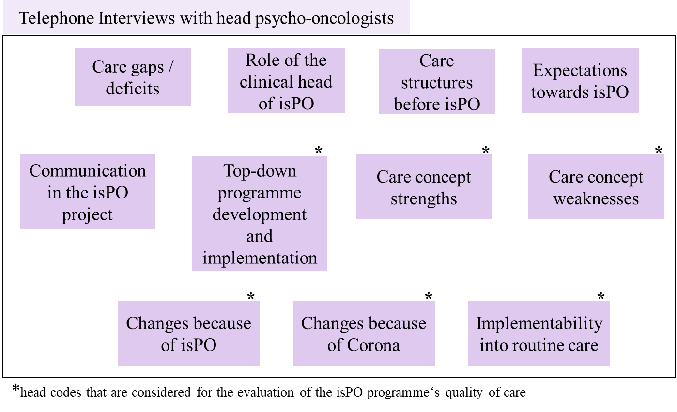

Table C. Coding system (of relevant codes) for the telephone interviews with the head psycho-oncologists.
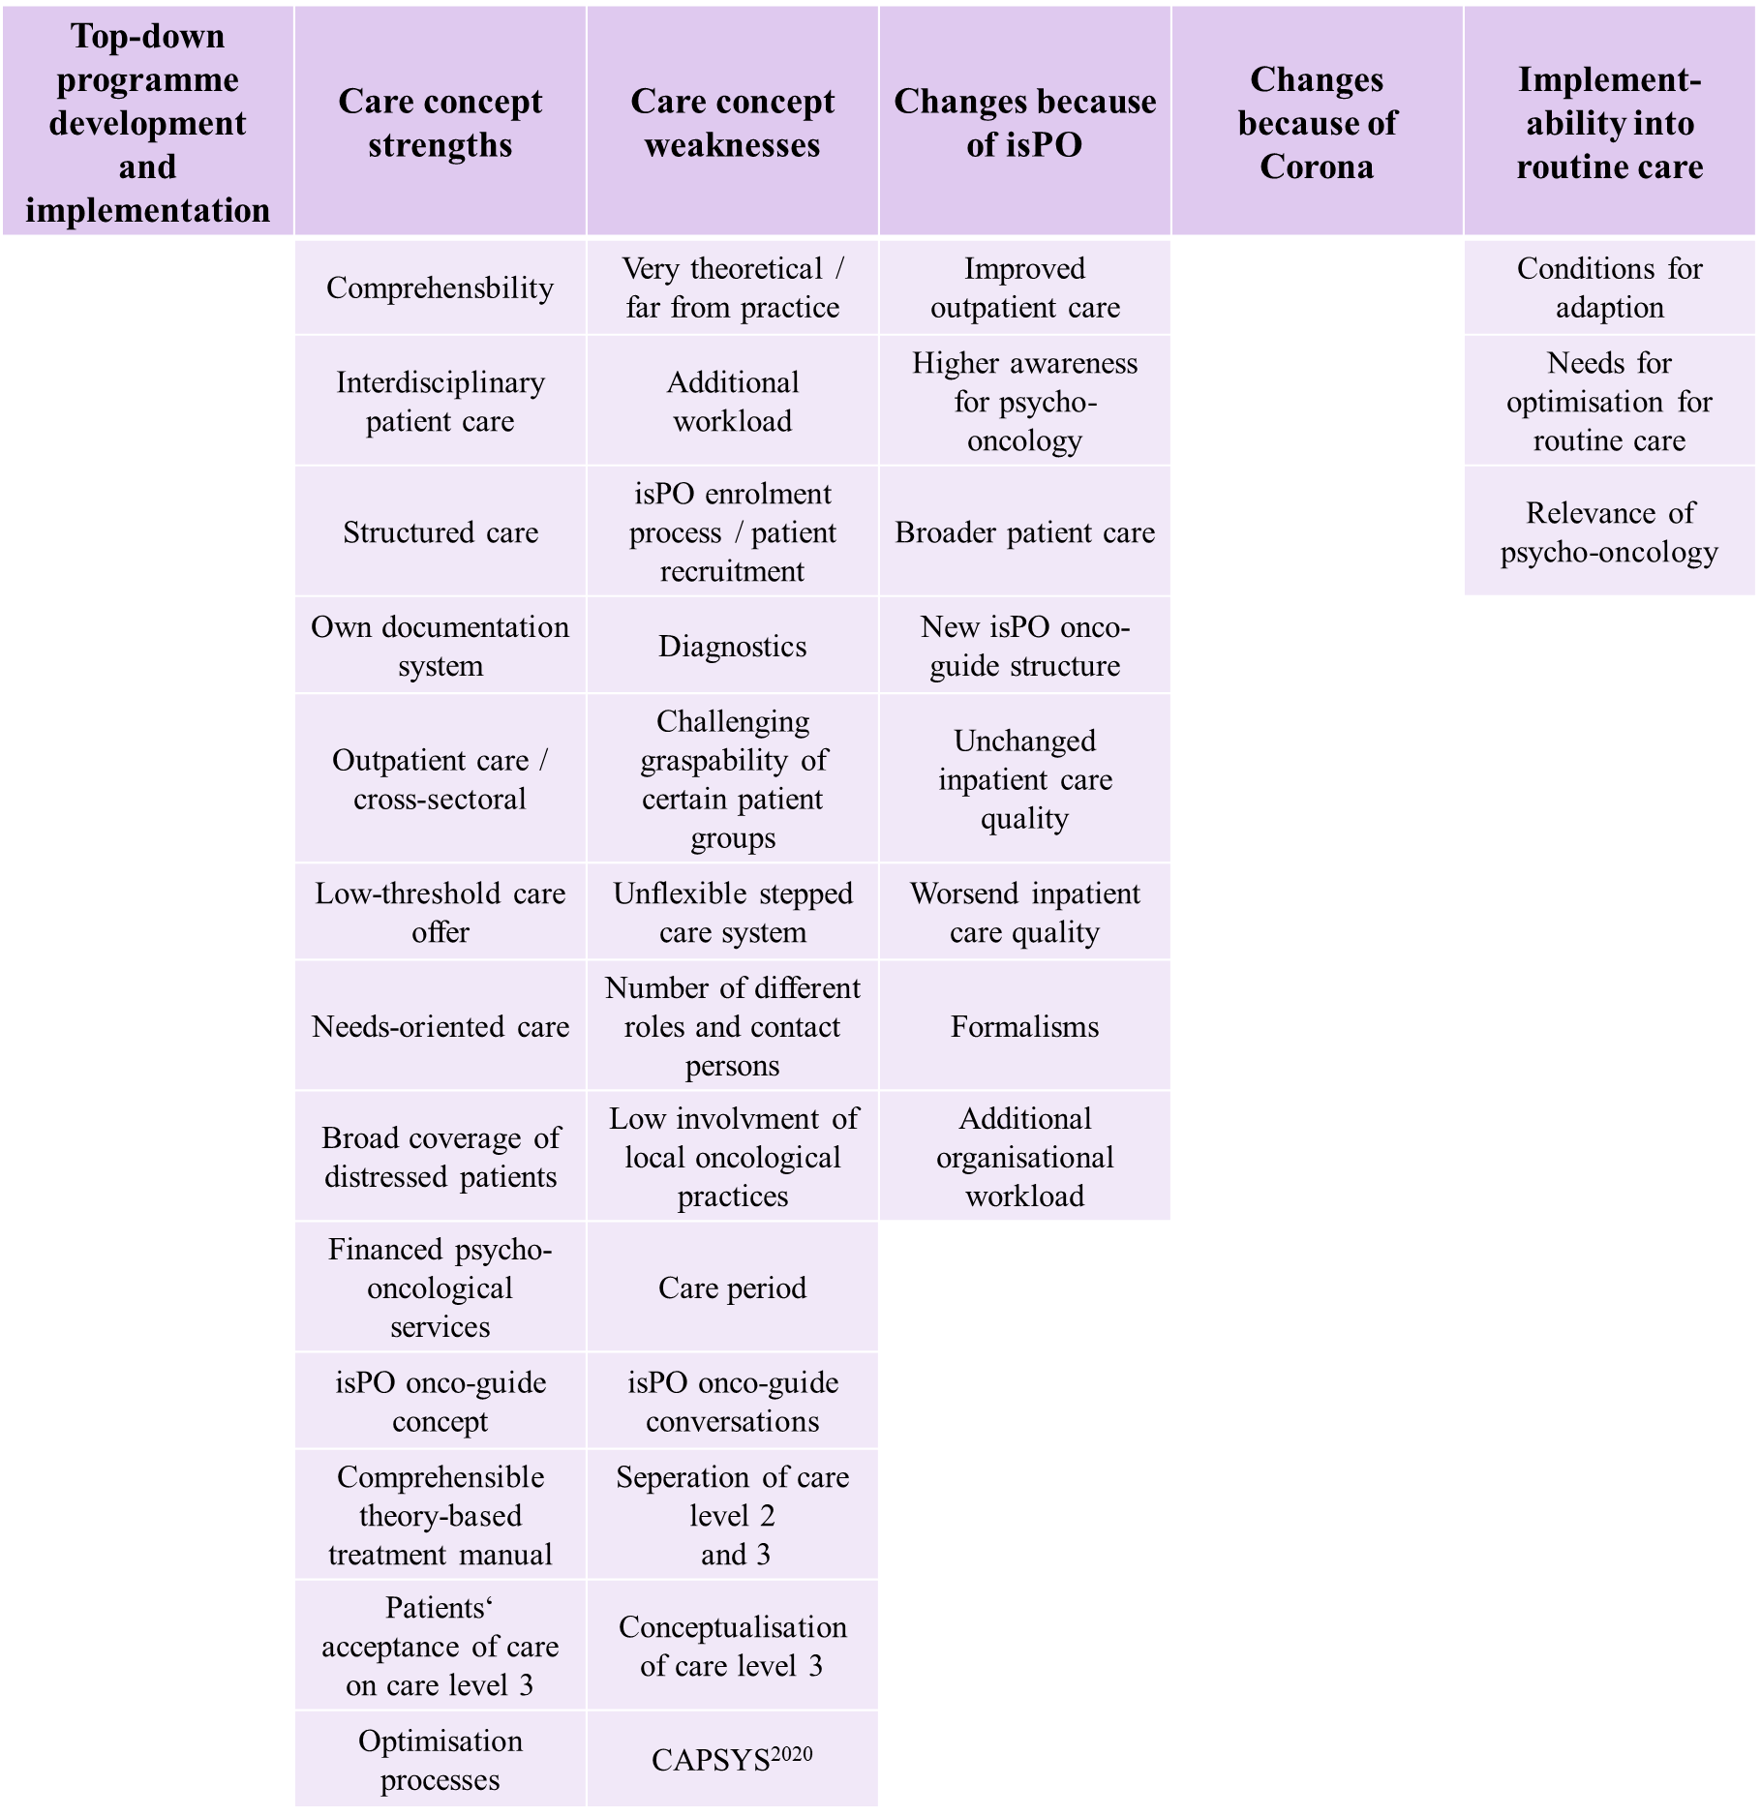
Additional File 5
Table D. Coding system for Focus Group 1.
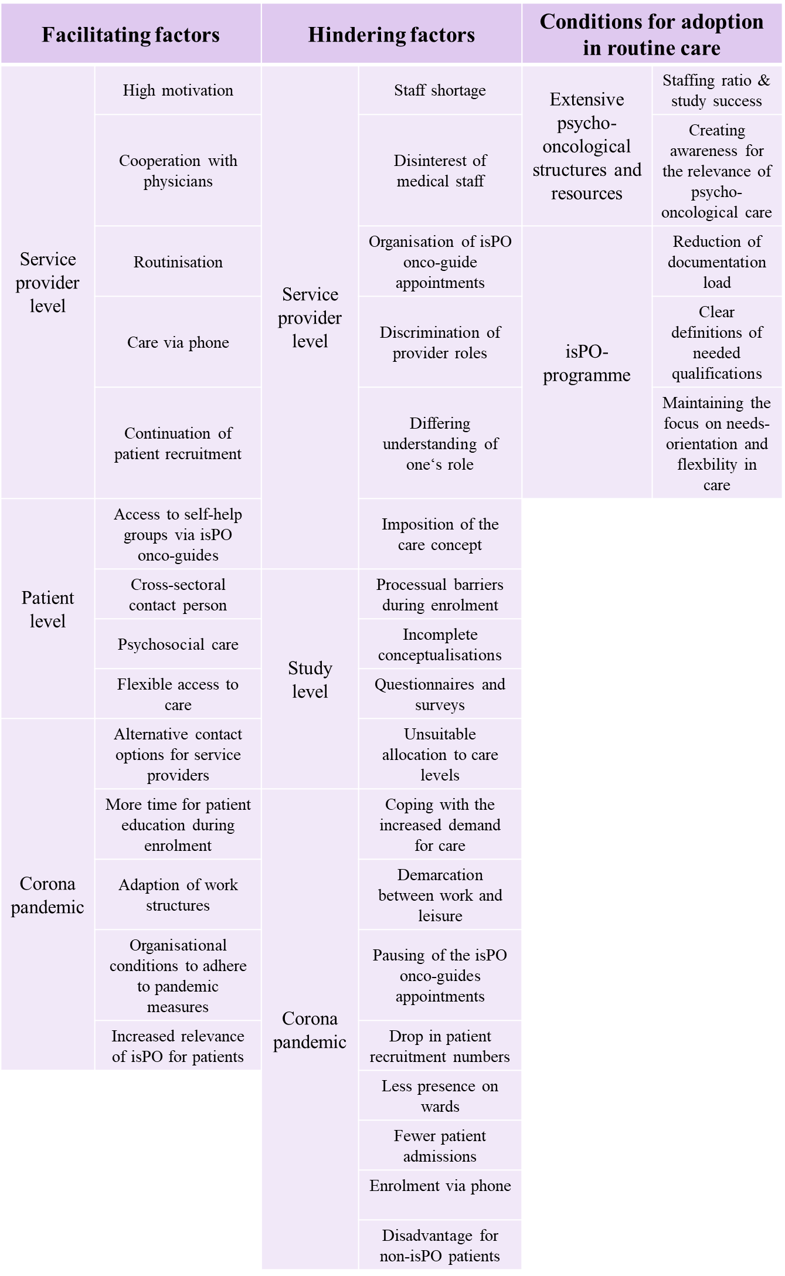
Table E. Coding system for Focus Group 2.
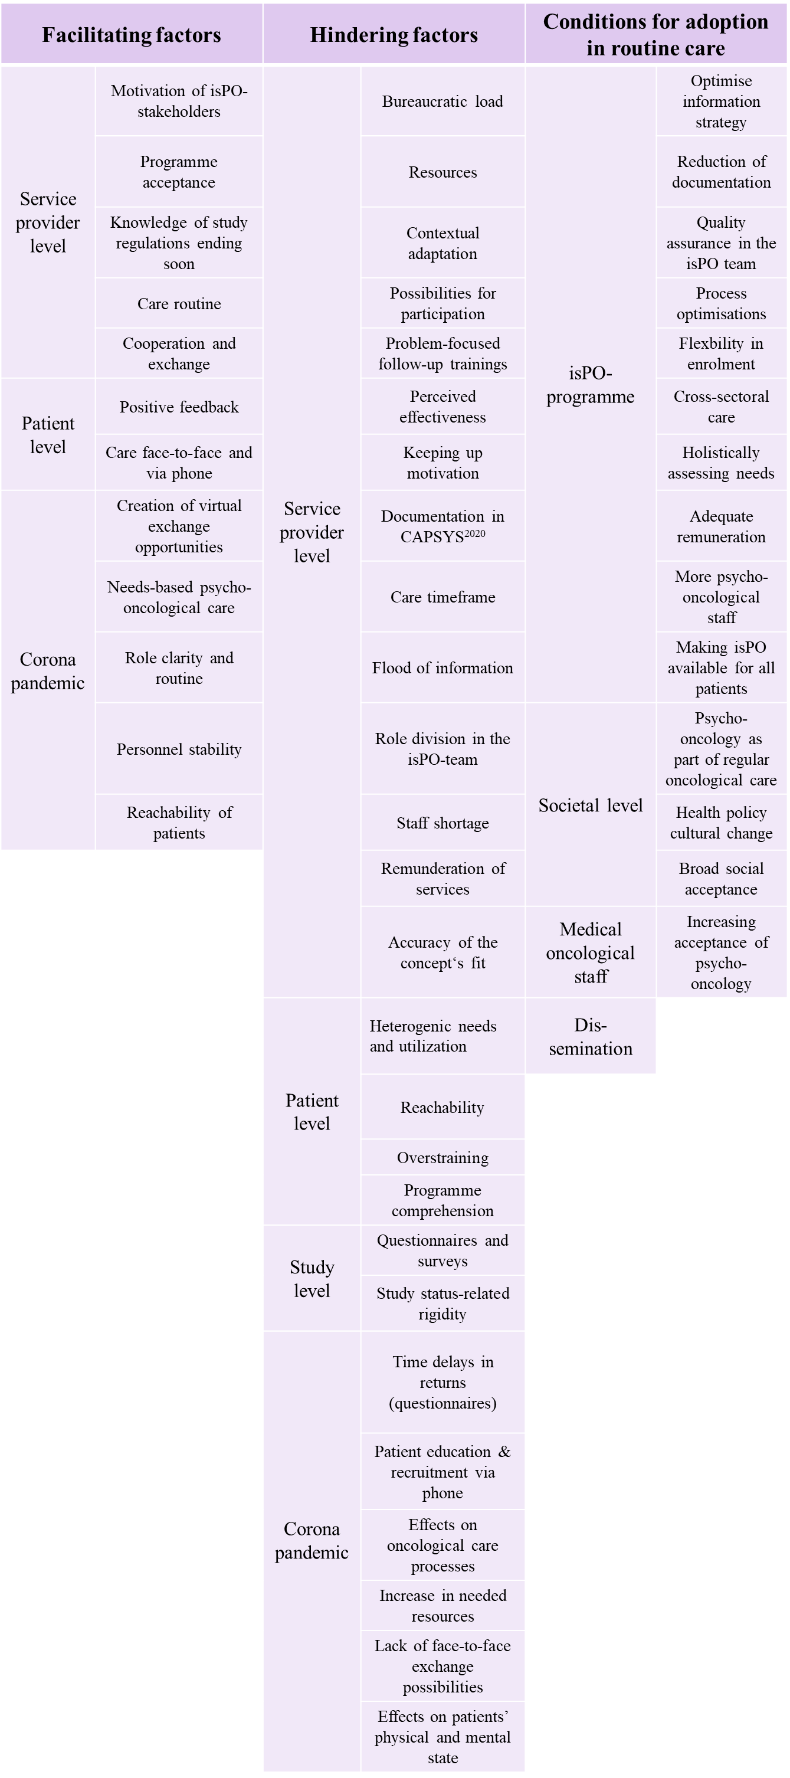

Continuation of Table D – Subcodes of hindering factors.

Additional File 6
Figure C. Observed relationships between the complex interventions programme isPO, implementation strategies, feasibility, programme acceptance, contextual and individual factors, quality management, perceived challenges, and patient benefits.
