Supplementary Figure S1. Age Distribution of Pneumococcal Vaccination by Dose Number and Vaccine Type.
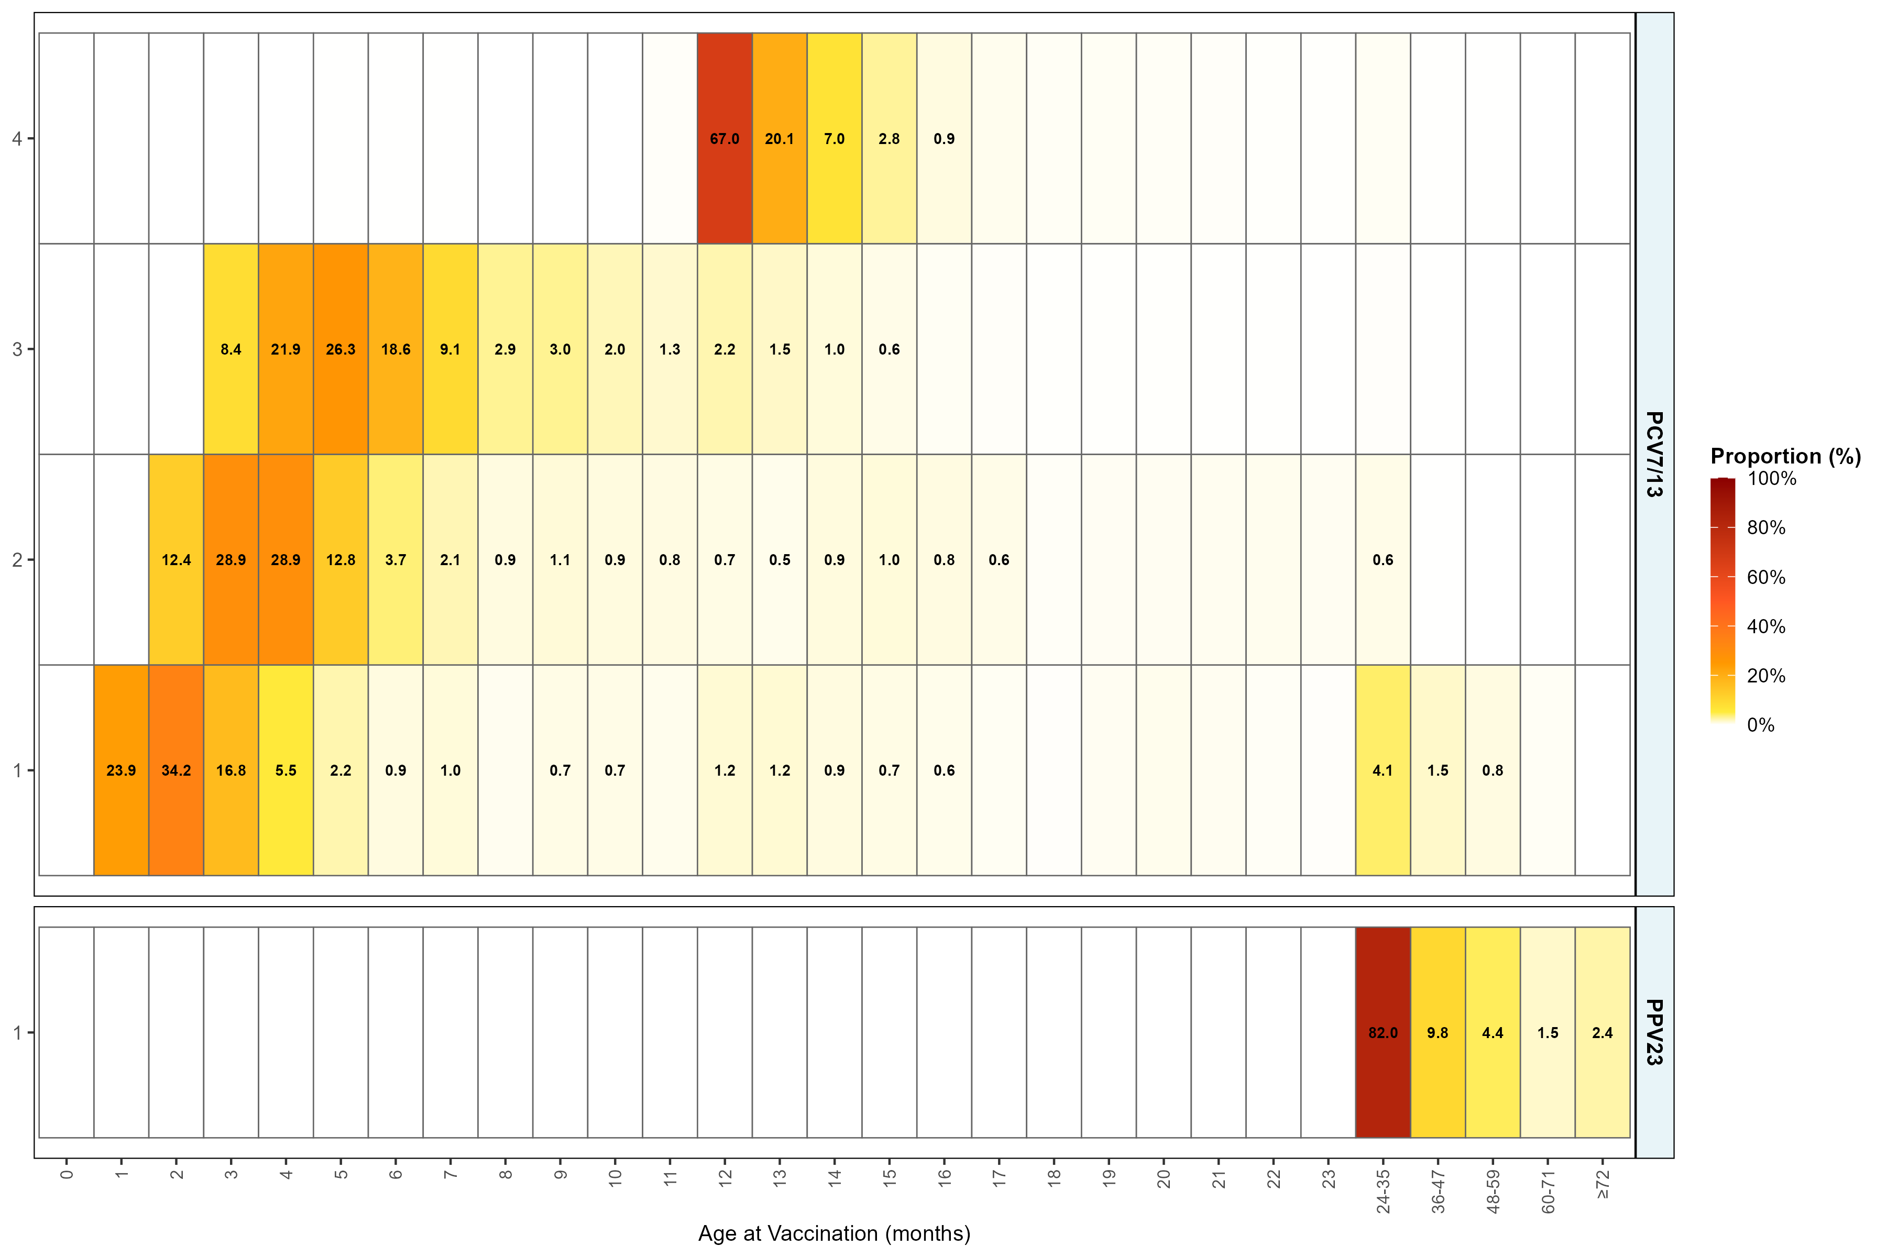
Note: White cells indicate no vaccinations recorded for the corresponding age-dose combination. Labels are displayed only for bins with proportions exceeding 0.5%. PCV7/13, 7- and 13-valent pneumococcal conjugate vaccines; PPV23, 23-valent pneumococcal polysaccharide vaccine.

