Financial impact of participating in oncology clinical trials in a tertiary hospital in Spain

Sergio Mosquera-Ferrer¹, Emilio Vargas-Castrillón², Macarena Torrego-Ellacuría³

¹Clinical Pharmacology; Hospital Clínico San Carlos, Madrid, Spain
²Clinical Pharmacology; Pharmacology and Toxicology; Hospital Clínico San Carlos; Universidad Complutense de Madrid; Instituto de Investigación Sanitaria San Carlos (IdISSC), Madrid, Spain
³Innovation Unit, Hospital Clinico San Carlos, IdISSC, Madrid, Spain.

Corresponding author
Sergio Mosquera-Ferrer, PhD
Clinical Pharmacology
Hospital Clínico San Carlos
Calle del Prof Martín Lagos, S/N
28040 Madrid
Phone: +34913303000
e-mail: sergiomosqueraferrer@gmail.com

Additional file
Supplementary Table 1. Resource use: diagnostic tests
Complementary tests* | In-house | External | Total
Laboratory test | 11,427 | - | 11,427
Computed tomography | 565 | 2,112 | 2,677
Gammagraphy | 461 | - | 461
Radiography | 427 | - | 427
Echography | 240 | - | 240
PET-CT | 183 | - | 183
Magnetic resonance | 180 | 167 | 347
Catheterism | 115 | - | 115
Biopsy | 42 | - | 42
Densitometry | 28 | - | 28
Other | 136 | - | 136
*All figures represent the number of tests.
Unit costs can be found in reference #19. However, note that diagnostic tests are presented in aggregated categories (e.g., laboratory tests and radiography). However, within each category, individual tests have different unit costs (for example, a hand radiograph and a chest radiograph have different prices). Therefore, reporting a single unit cost or an average cost for these aggregated categories would not be representative and could be misleading.
PET-CT positron emission tomography‒computed tomography

Supplementary Table 2. Resource use: medical visits
Visits* | Number of visits | Unit cost (€)
Chemotherapy day unit visits | 13,499 | 150,00
Nursing visits | 5,195 | 21,00
Follow-up medical oncologist visit | 1,284 | 79,00
Telephone medical oncologist visit | 644 | 56,00
Follow-up genetic counseling | 335 | 212,00
First-visit genetic counseling | 15 | 212,00
First medical oncologist visit | 9 | 132,00
Hospital ward | 4 | 79,00
*All figures represent the number of visits.

Supplementary Table 3. Drug cost avoidance by tumor site
Type of tumor | Overall | Per patient
Non-small cell lung cancer | 5,698,206.43 | 53,254.27
Ovarian cancer | 5,283,720.03 | 92,696.84
Breast cancer | 4,379,542.17 | 27,895.17
Renal cancer | 3,289,467.16 | 99,680.82
Prostate cancer | 1,905,517.83 | 32,296.91
Bladder cancer | 1,632,627.94 | 15,698.35
Solid tumors | 829,347.92 | 10,238.86
Liver cancer | 755,942.91 | 94,492.86
Other | 701,310.57 | 14,610.64
Melanoma | 505,875.00 | 45,988.64
Colorectal cancer | 451,658.66 | 18,066.35
Uterine cancer | 350,307.67 | 29,192.31
Small cell lung cancer | 89,149.12 | 5,943.27
Gastric cancer | 22,649.51 | 3,774.92
Gallbladder cancer | 3,824.66 | 956.17

Supplementary Figures
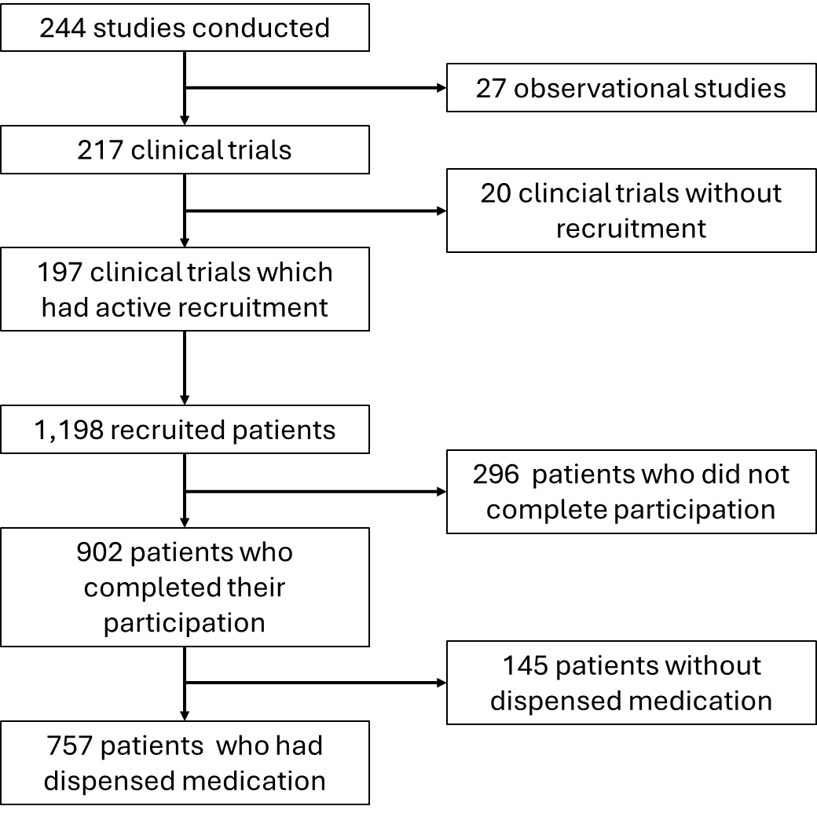
Supplementary Figure 1. Clinical trials and patient disposition

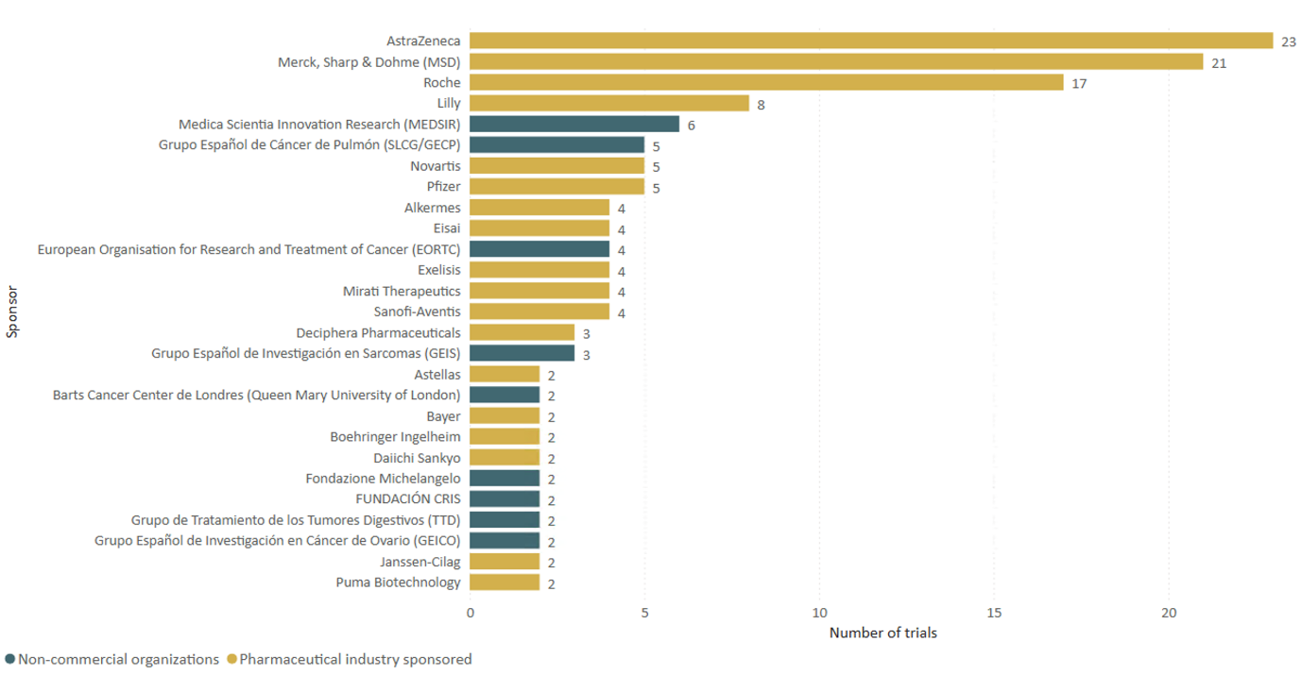
Supplementary Figure 2. Distribution of trials by sponsors
The figure shows only sponsors who have conducted more than one trial.

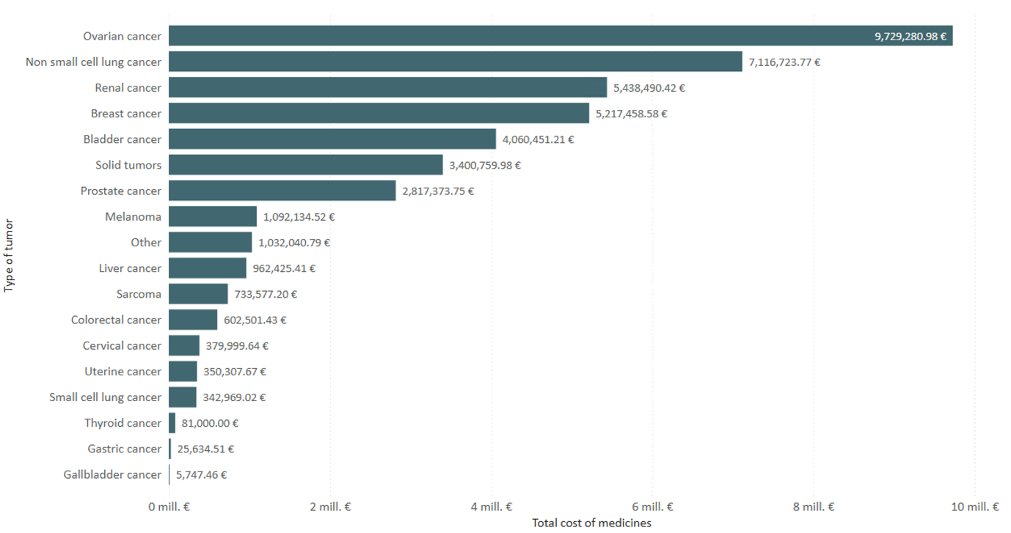
Supplementary Figure 3. Cost of dispensed medications by tumor type

