Supplementary Information

Additional file 1: Methods

Coverage rate
The inclusion of clinics in the NNRR has been ongoing since the registry was established in 2012 (1). Since 2016, outpatient clinics at the four largest hospitals in Oslo, Bergen, Trondheim, and Tromsø have provided data for the NNRR. In 2020, three more outpatient clinics affiliated with the NNRR contributed data for parts of the year. Moreover, 15 other outpatient clinics were identified as potential contributors to the registry, although they had not yet commenced data contributions. Outpatient clinics not affiliated with the NNRR were excluded from coverage calculations. From 2016 to 2020, the national coverage rates in the NNRR were 48%, 56%, 63%, 56% and 42%, respectively. From 2016 to 2019, the coverage rate was determined by averaging the respective coverage rates of the outpatient clinics included (1). In 2020, the coverage rate was calculated by dividing the total number of registrations by the total number of relevant patients in the included outpatient clinics. Technical difficulties in scanning patient-reported forms partially explained the lower coverage rate observed. Additionally, the reduced coverage in 2020 was influenced by challenges facilitating form completion due to the COVID-19 pandemic, especially at the largest hospitals (1).

Categorization into location of pain groups
Other clinical variables specifying pain location from the healthcare provider form were variables indicating whether radiculopathy radiated from the back or neck and whether unspecific pain was related to the back or neck. The question “Where is your pain?” involves checking for the body regions that have experienced pain for the last 14 days and covers 16 body regions on the front side and 16 body regions on the back side of the body. Patients were asked to identify and indicate any areas within the regions where they had experienced pain. Patients who selected “low back” and “chest back (upper part of the back)” on the back side of the body were categorized into the “back pain” group. Patients who indicated “neck” on the back side or front side of the body were classified into the “neck pain group.” Patients who were categorized into both the “back pain” and “neck pain” groups based on the pain question, were classified into the “back & neck pain” group. When the location of pain was still lacking, categorization employed the Oswestry Disability Index (ODI) for “back pain” and the Neck Disability Index (NDI) for “neck pain”. Patients who reported both scores were classified as having “back & neck pain”.

Outcomes
Patients were classified into mutually exclusive groups based on the following recommendations for further treatment provided by healthcare providers at the index consultation: 1) follow-up in primary care, 2) follow-up in specialist care, 3) follow-up in both primary and specialist care, or 4) no further follow-up. Recommended follow-up in primary care included consultations with physicians, physical therapists, chiropractors, and others (including psychologists, municipal follow-up, or work-related follow-up). Specialist care follow-up included treatment in one's specialist service, referral to another rehabilitation centre, referral for evaluation by other specialists, or assessment for surgical intervention. This encompassed individual and group multidisciplinary interventions, ranging from simple follow-ups to comprehensive treatments. We investigated actual care by identifying patients’ first, second, and third consultations within six months after the index consultation. Consultations with physicians, physical therapists, and chiropractors were considered in primary care, while all outpatient and inpatient consultations were categorized as specialist care. Patients were subsequently classified into the following groups: primary care, specialist care, both primary and specialist care, or no follow-up.
Additional file 2: Diagnostic codes with categorization into back pain and neck pain.
Diagnostic codes | Term
Back pain
M413 | Thoracogenic scoliosis
M4195 | Scoliosis, thoracolumbar region
M4215 | Adult osteochondrosis of spine, thoracolumbar region
M4306 | Spondylolysis, lumbar region
M4316 | Spondylolisthesis, lumbar region
M4317 | Spondylolisthesis, lumbosacral region
M4726 | Other spondylosis with radiculopathy, lumbar region
M4728 | Other spondylosis with radiculopathy, sacral and sacrococcygeal region
M4784 | Other spondylosis, thoracic region
M4786 | Other spondylosis, lumbar region
M4787 | Other spondylosis, lumbosacral region
M4806 | Spinal stenosis, lumbar region
M4854 | Collapsed vertebra, not elsewhere classified, thoracic region
M510 | Thoracic, thoracolumbar and lumbosacral intervertebral disc disorders with myelopathy
M511 | Thoracic, thoracolumbar and lumbosacral intervertebral disc disorders with radiculopathy
M512 | Other thoracic, thoracolumbar and lumbosacral intervertebral disc displacement
M513 | Other thoracic, thoracolumbar and lumbosacral intervertebral disc degeneration
M518 | Other thoracic, thoracolumbar and lumbosacral intervertebral disc disorders
M519 | Unspecified thoracic, thoracolumbar and lumbosacral intervertebral disc disorder
M533 | Sacrococcygeal disorders, not elsewhere classified
M5385 | Other specified dorsopathies, thoracolumbar region
M5416 | Radiculopathy, lumbar region
M5417 | Radiculopathy, lumbosacral region
M543 | Sciatica
M544 | Lumbago with sciatica
M5446 | Lumbago with sciatica, lumbar region
M545 | Low back pain
M5456 | Low back pain, lumbar region
M5457 | Low back pain, lumbosacral region
M5458 | Low back pain, sacral and sacrococcygeal region
M546 | Pain in thoracic spine
M5464 | Pain in thoracic spine, thoracic region
M5468 | Pain in thoracic spine, sacral and sacrococcygeal region
M548 | Other dorsalgia
M5485 | Other dorsalgia, thoracolumbar region
M5486 | Other dorsalgia, lumbar region
M5487 | Other dorsalgia, lumbosacral region
M549 | Dorsalgia, unspecified
M5494 | Dorsalgia, thoracic region
M5495 | Dorsalgia, thoracolumbar region
M5496 | Dorsalgia, lumbar region
M5497 | Dorsalgia, lumbosacral region
M5498 | Dorsalgia, sacral and sacrococcygeal region
G834 | Cauda equina syndrome
*Ryggplager | Low back pain
*Thorakale ryggsmerter | Pain in thoracic spine
*Uspesifikke ryggsmerter | Low back pain
Neck pain
M4302 | Spondylolysis, cervical region
M4712 | Other spondylosis with myelopathy, cervical region
M4722 | Other spondylosis with radiculopathy, cervical region
M4782 | Other spondylosis, cervical region
M4792 | Spondylosis, cervical region
M4802 | Spinal stenosis, cervical region
M500 | Cervical disc disorder with myelopathy
M501 | Cervical disc disorder with radiculopathy
M503 | Other cervical disc degeneration
M509 | Cervical disc disorder, unspecified
M530 | Cervicocranial syndrome
M531 | Cervicobrachial syndrome
M5392 | Dorsopathy, cervical region
M5412 | Radiculopathy, cervical region
M5413 | Radiculopathy, cervicothoracic region
M542 | Cervicalgia
M5421 | Cervicalgia, occipito-atlanto-axial region
M5422 | Cervicalgia, cervical region
M5423 | Cervicalgia, cervicothoracic region
*Nakke | Cervicalgia
*Nakkeplager | Cervicalgia
*Nakkesmerter | Cervicalgia
*Uspesifikke nakkeplager | Cervicalgia
*Diffuse nakkeplager | Cervicalgia
*Generaliserte nakkeplager | Cervicalgia
Spinal diagnostic codes without reference to the location of pain
M411 | Juvenile and adolescent idiopathic scoliosis
M418 | Other forms of scoliosis
M419 | Scoliosis, unspecified
M420 | Juvenile osteochondrosis of spine
M430 | Spondylolysis
M431 | Spondylolisthesis
M471 | Other spondylosis with myelopathy
M472 | Other spondylosis with radiculopathy
M478 | Other spondylosis
M480 | Spinal stenosis
M540 | Panniculitis affecting regions of neck and back
M541 | Radiculopathy
*Skoliose | Scoliosis
The same person may have more than one diagnostic code. *Diagnoses written with the term in the diagnosis variable are included because the location of pain is defined.
Additional file 3: Number of participants categorized into pain location groups based on criteria for categorization
 | ICD-10 codes | ICD-10 codes+ diagnostic variables | ICD-10 codes + diagnostic variables + pain question | ICD-10 codes + diagnostic variables + pain question + ODI/NDI
Back, n (%) | 5 174 (54.8) | 5 409 (57.2) | 5 616 (59.4) | 5 827 (61.9)
Neck, n (%) | 2 349 (24.9) | 2 420 (25.6) | 2 506 (26.5) | 2 514 (26.7)
Back & Neck, n (%) | 412 (4.4) | 412 (4.4) | 683 (7.2) | 975 (10.4)
Spinal diagnostic codes without reference to location of pain, n (%) | 257 (2.7) | 68 (0.7) | 17 (0.2) | 3 (0.03)
Other diagnoses, n (%) | 294 (3.1) | 232 (2.5) | 45 (0.5) | 17 (0.2)
Missing, n (%) | 926 (9.8) | 871 (9.2) | 545 (5.8) | 76 (0.8)

Additional file 4: Diagnostic codes used to define cause-specific consultations from KUHR and NPR
Data source | Back | Neck
KUHR (ICPC) | L02 L03 L84 L85 L86 | L01 L83
NPR (ICD-10) | G544 G551 G552 G553 G558 G834 M400/M405 M412 M415 M418/M419 M430/M432 M435 M438/M439 M471/M472 M478/M484 M488 M489 M498 M510/M514 M518/M519 M532/M533 M538 M539 M541 M543/M546 M548/M549 M960/M961 M963/M964 M966 M968/M969 M991 M993/M997 | G999 M500/M503 M508/M509 M530/M531

Additional file 5: All-cause healthcare utilization across pain location groups and healthcare services.
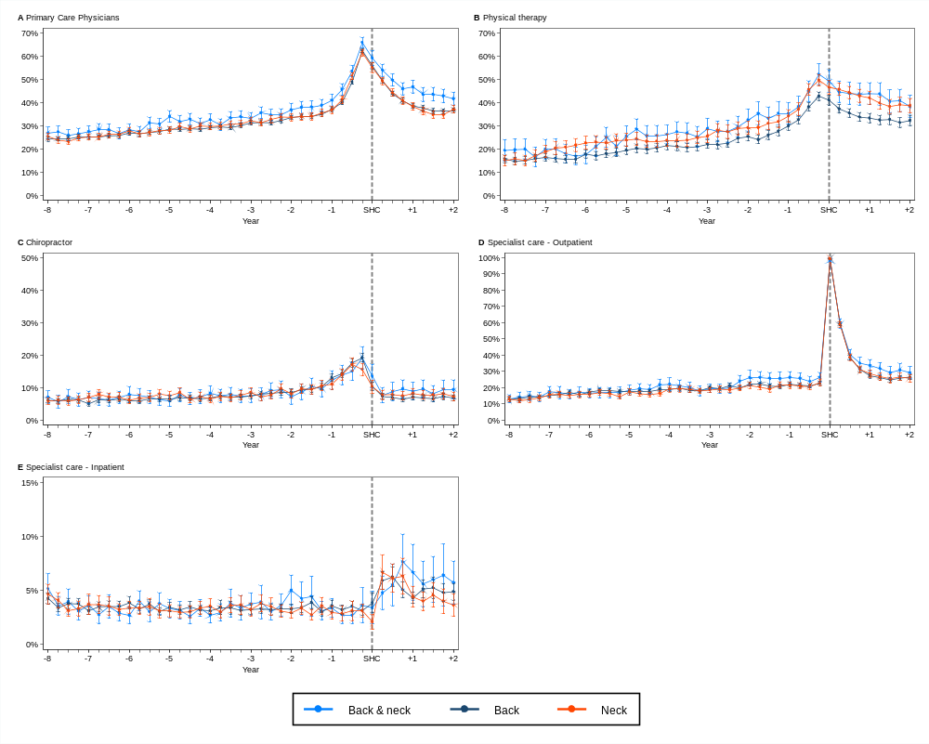
SHC: Specialist healthcare indicates the time point for index consultation.
The y-axis shows the proportion of participants with at least one consultation per quarter.
Additional file 6: Differences in healthcare utilization between pain location groups
 | First-year post period |  | Second-year post period
 | Percentage (95% CI)* | Percentage points difference (95% CI)*† | Percentage (95% CI)* | Percentage points difference (95% CI)*†
Primary care
Physicians
Back & neck | 48.8 (46.7, 50.9) |  | 42.6 (40.3, 44.9)
Back | 43.0 (42.2, 43.9) | -5.8 (-8.0, -3.6) | 36.6 (35.8, 37.5) | -6.0 (-8.4, -3.5)
Neck | 43.5 (42.3, 44.7) | -5.3 (-7.7, -2.9) | 36.1 (34.9, 37.4) | -6.5 (-9.1, -3.9)
Physical therapy
Back & neck | 43.9 (39.8, 48.1) |  | 40.7 (36.3, 45.2)
Back | 34.8 (33.2, 36.4) | -9.1 (-13.5, -4.6) | 32.1 (30.3, 33.9) | -8.6 (-13.4, -3.9)
Neck | 44.1 (41.8, 46.4) | 0.2 (-4.6, 4.9) | 39.3 (36.6, 42.0) | -1.4 (-6.6, 3.8)
Chiropractor
Back & neck | 8.6 (6.4, 10.8) |  | 9.0 (6.8, 11.2)
Back | 6.9 (6.3, 7.5) | -1.7 (-4.1, 0.6) | 6.8 (6.1, 7.5) | -2.2 (-4.5, 0.1)
Neck | 7.9 (6.9, 8.9) | -0.7 (-3.2, 1.7) | 7.8 (6.7, 8.9) | -1.2 (-3.7, 1.3)
Specialist care
Outpatient
Back & neck | 42.4 (40.0, 44.8) |  | 29.7 (26.7, 32.7)
Back | 40.6 (39.7, 41.5) | -1.8 (-4.3, 0.8) | 25.7 (24.5, 26.8) | -4.0 (-7.3, -0.8)
Neck | 41.0 (39.6, 42.4) | -1.4 (-4.2, 1.4) | 26.3 (24.5, 28.1) | -3.4 (-6.9, 0.0)
Inpatient
Back & neck | 6.2 (5.0, 7.5) |  | 5.9 (4.5, 7.3)
Back | 5.4 (4.9, 5.8) | -0.8 (-2.2, 0.5) | 5.0 (4.4, 5.6) | -0.9 (-2.4, 0.7)
Neck | 5.9 (5.1, 6.8) | -0.3 (-1.8, 1.2) | 4.1 (3.5, 4.7) | -1.8 (-3.3, -0.3)
The table presents data on all-cause consultations across all pain location groups and healthcare services.
*The percentage (95% CI) of participants in the pain location groups, adjusted for age, sex, and calendar month.
†Difference estimates (in percentage points) represent the mean values (95% CI) from quarterly analyses within the respective time periods using back pain vs neck pain as reference groups in separate analyses.
Additional file 7: Cause-specific inpatient healthcare utilization across pain location groups
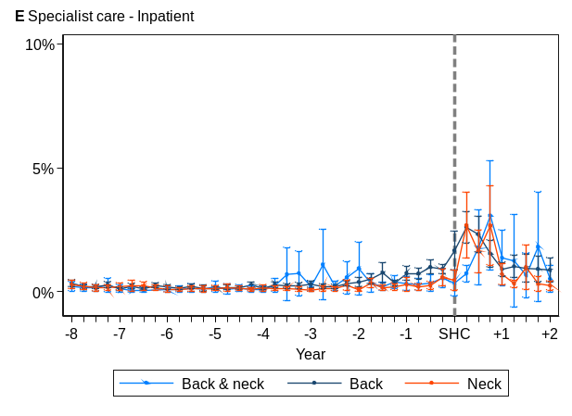

References
1. The Norwegian Neck and Back Registry 2024 [updated 14.03.2024; cited 02.01.2025. Available from: https://www.unn.no/fag-og-forskning/medisinske-kvalitetsregistre/norsk-nakke-og-ryggregister.

