Supplementary material: Mapping system dynamics shaping neonatal infection prevention and antimicrobial stewardship in Botswana
File 1 – COREQ CHECKLIST
COREQ (COnsolidated criteria for REporting Qualitative research) Checklist
Topic | Item No. | Guide Questions/Description | Page No.
Domain 1: Research team and reﬂexivity
Personal characteristics
Interviewer/facilitator | 1 | Which author/s conducted the interview or focus group? | 7
Credentials | 2 | What were the researcher’s credentials? E.g. PhD, MD | 7
Occupation | 3 | What was their occupation at the time of the study? | 7
Gender | 4 | Was the researcher male or female? | 7
Experience and training | 5 | What experience or training did the researcher have? | 7
Relationship with
participants
Relationship established | 6 | Was a relationship established prior to study commencement? | 6 -7
Participant knowledge of  the interviewer | 7 | What did the participants know about the researcher? e.g. personal goals, reasons for doing the research | 6 -7
Interviewer characteristics | 8 | What characteristics were reported about the interviewer/facilitator? e.g. Bias, assumptions, reasons and interests in the research topic | 6 -7
Domain 2: Study design
Theoretical framework
Methodological orientation and Theory | 9 | What methodological orientation was stated to underpin the study? e.g. grounded theory, discourse analysis, ethnography, phenomenology, content analysis | 4 - 6
Participant selection
Sampling | 10 | How were participants selected? e.g. purposive, convenience,  consecutive, snowball | 6 -7
Method of approach | 11 | How were participants approached? e.g. face-to-face, telephone, mail, email | 6 -7
Sample size | 12 | How many participants were in the study? | 9
Non-participation | 13 | How many people refused to participate or dropped out? Reasons? | 6 -7
Setting
Setting of data collection | 14 | Where was the data collected? e.g. home, clinic, workplace | 7 - 8
Presence of non-  participants | 15 | Was anyone else present besides the participants and researchers? | 7 - 8
Description of sample | 16 | What are the important characteristics of the sample? e.g. demographic, data, date | 9, Suppl. File 5
Data collection
Interview guide | 17 | Were questions, prompts, guides provided by the authors? | Suppl. File 3
Repeat interviews | 18 | Were repeat interviews carried out? If yes, how many? | 7 - 8
Audio/visual recording | 19 | Did the research use audio or visual recording to collect the data? | 7 - 8
Field notes | 20 | Were ﬁeld notes made during and/or after the interview or focus group? | 7 - 8
Duration | 21 | What was the duration of the interviews or focus group? | 7 - 8
Data saturation | 22 | Was data saturation discussed? | 7 - 8
Transcripts returned | 23 | Were transcripts returned to participants for comment or correction? | N/A
Domain 3: analysis and findings
Data analysis
Number of data coders | 24 | How many data coders coded the data? | 8 - 9
Description of the coding tree | 25 | Did authors provide a description of the coding tree? | 8 - 9
Derivation of themes | 26 | Were themes identiﬁed in advance or derived from the data? | 8 - 9
Software | 27 | What software, if applicable, was used to manage the data? | 8 - 9
Participant checking | 28 | Did participants provide feedback on the ﬁndings? | N/A
Reporting
Quotations presented | 29 | Were participant quotations presented to illustrate the themes/ﬁndings? Was each quotation identiﬁed? e.g. participant number | 9 - 19
Data and findings consistent | 30 | Was there consistency between the data presented and the ﬁndings? | 9 - 19
Clarity of major themes | 31 | Were major themes clearly presented in the ﬁndings? | 9 - 19
Clarity of minor themes | 32 | Is there a description of diverse cases or discussion of minor themes? | 9 - 19
Table S1: COREQ Checklist
Developed from: Tong A, Sainsbury P, Craig J. Consolidated criteria for reporting qualitative research (COREQ): a 32-item checklist for interviews and focus groups. International Journal for Quality in Health Care. 2007. Volume 19, Number 6: pp. 349 – 357

FILE 2 – STRESS GUIDELINES
Strengthening the Reporting of Empirical Simulation Studies (STRESS) checklist

Section/Subsection | Item | Recommendation | Page No.
- Objectives
Purpose of the model | 1.1 | Explain the background and objectives for the model. | 4 - 5
Model Outputs | 1.2 | Define all quantitative performance measures that are reported, using equations where necessary. Specify how and when they are calculated during the model run along with how any measures of error such as confidence intervals are calculated. | N/A
Experimentation Aims | 1.3 | If the model has been used for experimentation, state the objectives that it was used to investigate. | N/A
- Logic
Base model overview diagram | 2.1 | Describe the base model using appropriate diagrams and description. This could include one or more process flow, activity cycle or equivalent diagrams sufficient to describe the model to readers. Avoid complicated diagrams in the main text. The goal is to describe the breadth and depth of the model with respect to the system being studied. | 9 – 19, Suppl. Files 6, 7
Base model logic | 2.2 | Give details of the base model logic. Give additional model logic details sufficient to communicate to the reader how the model works. | N/A
Scenario logic | 2.3 | Give details of the logical difference between the base case model and scenarios (if any). | N/A
Algorithms | 2.4 | Provide further detail on any algorithms in the model that (for example) mimic complex or manual processes in the real world. | N/A
Components | 2.5 | Detail on entities, activities, resources, queues, entry/exit points | N/A
- Data
Data sources | 3.1 | List and detail all data sources. Sources may include:  - Interviews with stakeholders,  - Samples of routinely collected data,  - Prospectively collected samples for the purpose of the simulation study,  - Public domain data published in either academic or organisational literature. Provide, where possible, the link and DOI to the data or reference to published literature.  All data source descriptions should include details of the sample size, sample date ranges and use within the study. | 5 - 9
Pre-processing | 3.2 | Provide details of any data manipulation that has taken place before its use in the simulation, e.g. interpolation to account for missing data or the removal of outliers. | 5 - 9
Input parameters | 3.3 | List all input variables in the model. Provide a description of their use and include parameter values. | 9 – 19, Suppl. Files 6, 7
Assumptions | 3.4 | Where data or knowledge of the real system is unavailable what assumptions are included in the model? This might include parameter values, distributions or routing logic within the model. | N/A
- Experimentation |  |  | N/A
- Implementation |  |  | N/A
- Code Access |  |  | N/A
Table S2: STRESS checklist
Developed from: Monks, T., Currie, C. S. M., Onggo, B. S., Robinson, S., Kunc, M., & Taylor, S. J. E. (2019). Strengthening the reporting of empirical simulation studies: Introducing the STRESS guidelines. Journal of Simulation, 13(1), 55–67. https://doi.org/10.1080/17477778.2018.1442155

FILE 3 – SEMI-STRUCTURED INTERVIEW GUIDE (HCWs)
Introduction:
Please could describe your role?
As it relates to/influences hospitalised neonates? What specific tasks and functions do you perform? Give example of what your day look like in neonatal unit.
As it relates to IPC within the unit/hospital?
How will you describe the current situation of IPC in PMH? And in the neonatal unit?
What are the main IPC problems you experience at Princess Marina Hospital? In the neonatal unit?

Use the following probes:
[WHO Core Component Multimodal Strategy]
Education and training:
What are the key IPC practices for preventing hospital-acquired infections in the neonatal unit?
Probe: Hand hygiene, multi-use equipment, environmental cleaning, more specific practices around: umbilical catheter placement, isolette and radiant warmer use, preparation and storage of breast milk/infant formula, kangaroo care

What education and training is provided to doctors, nurses, and healthcare workers for IPC?
Probe: What is the content of the training?
When are you trained on the new guidelines? As a student?
What percentage of staff have received training? What about cleaners and other personnel?
How frequently do you receive training regarding IPC? Is it regularly renewed? Who gives the training?
Is there any specific training or information shared with patients’ family members on IPC and preventing HAIs?

Monitoring infrastructures, practices, processes, outcomes, and providing data feedback

Could you describe your perception of hand-hygiene practices and compliance?
Probe: Is this monitored?
Are there programs/initiatives in place?

Reminders in the workplace/communications
Are there reminders in the unit?
Probe: What are they? For hand-hygiene? Aseptic techniques? Multi-use equipment? Environmental cleaning?
Where are they?
Do you think they are effective?

Culture of safety
Is there a performance management system in place for you and your team?
Probe: Who are you accountable to? Who employs you?

System - Built environment, materials, and equipment for IPC:
Are there hand-hygiene stations
Probe: alcohol-based handrub solution or soap and water and clean single-use towels) available at all points of care?
Is there functioning environmental ventilation in the ward?
Is there an accessible record of cleaning for floors and work surfaces? Is it signed by the cleaners each day?
Do you have single patient rooms or rooms for cohorting patients with similar pathogens?
Is PPE available at all times and in sufficient quantity for all uses for all health workers?
Do you reliably have sterile and disinfected equipment ready for use?

System - Workload, staffing, and bed occupancy:
Are staffing levels appropriate to patient load in the unit? If not, what is it like?
What is bed occupancy like in the unit? Throughout the year?
What is the spacing between patient beds? Is a minimum space ensured?

Policy:
What IPC guidelines are available at PMH? In your view, what guidelines/documents do you feel have affected the way you practice at PMH?
Do you have an IPC team? When did they last meet?

Overall:
Overall, what aspects of the system work well in relation to IPC and HAI prevention in neonates?
Why?
Overall, what aspects of the system do not work/cope well in relation to IPC and HAI prevention in neonates?
Why?
What do you see as key policies or interventions that need to be put in place to prevent HAI in neonates?
Which ones already exist but need to be improved, which are proposed new solutions?
Internal?
External? (ie MoHW)

Is there anything else you’d like to tell me that I haven’t asked about?

Who are other key individuals who I should interview/should be involved or interviewed in this study?

FILE 4 – GMB WORKSHOP SCRIPTS
Objectives of workshop:
- To gain insight on the systems factors influencing sustainable infection prevention and control in the NNU.
- To understand the mental models of stakeholders who influence IPC in the NNU.
- To inform strategic planning that strengthens and sustains implementation of IPC at the NNU but also wider relevant settings.
Workshop principles: Guidelines for participation
- Everyone’s input is equally valued.
- This is a learning exercise: no idea is bad.
- Share your experiences and perspectives.
- No finger-pointing – we are here to address an issue, not individuals.
- Have fun.

- Hopes and fears
What are your hopes and fears for today’s workshop?
- Hopes on green post-its
- Fears on pink post-its
- 1 per paper, keep colours separate
Rank your hopes and fears with the most important at the top of each pile.
Please share your top hope, and top fear.
- Variable elicitation
What are key variables (influencing factors) affecting or influencing IPC in the NNU?
- Write as many as you can
- Nominate a member to record on flipchart
Each group has to choose their top 15 variables – either by consensus or voting.
Record them on flipchart paper (can * or circle)
- Connection circles
Draw a big circle on flipchart paper. Put your group’s top 15 variables around the circle.
Choose 2 variable and draw an arrow indicating the direction of influence.
- Variables can influence each other
- You can add/change/remove variables
- Can be based on data or your personal experience
Rank the top 5 connections. Nominate someone who will present the Connection Circle.
- Action Ideas
Look at your connection circle and individually identify as many actions as possible that could impact/improve the system. Record on sticky notes.
Opportunities to intervene in the system:
- Variables
- Connections
- Rules that govern the connections
- Goals in the system
- Mindset
As a group: Draw the prioritisation matrix on flipchart:
- Low workability High workability
- Low priority High priority
Place your action ideas in the matrix.
Discuss the most important ones as a group.
Nominate someone to present.

FILE 5 – SUMMARY PROFILE OF PARTICIPANTS
Stakeholder group/role | Number of participants interviewed | Health System Levels
Clinicians | 14 | Unit
Nurses | 12 | Unit
Support staff | 3 | Unit
Cleaning Staff | 9 | Unit, Hospital
Equipment and Maintenance | 1 | Hospital
Hospital IPC | 3 | Hospital
Supplies | 1 | Hospital
Microbiology | 5 | Hospital
Pharmacy | 2 | Hospital
Hospital management | 1 | Hospital
Policy (Ministry of Health and Wellbeing) | 1 | National
Mothers | 15 | Unit
Total: | 67
Table S3: Summary profile of study participants

FILE 6 – THEMATIC SEED CLDs
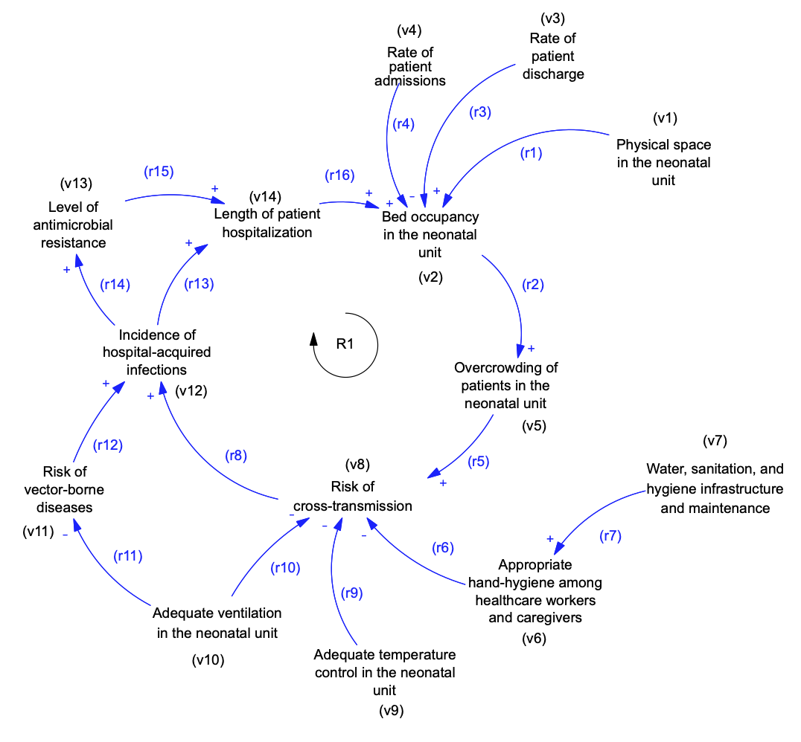
Figure S1: Causal Loop Diagram for Built Environment:

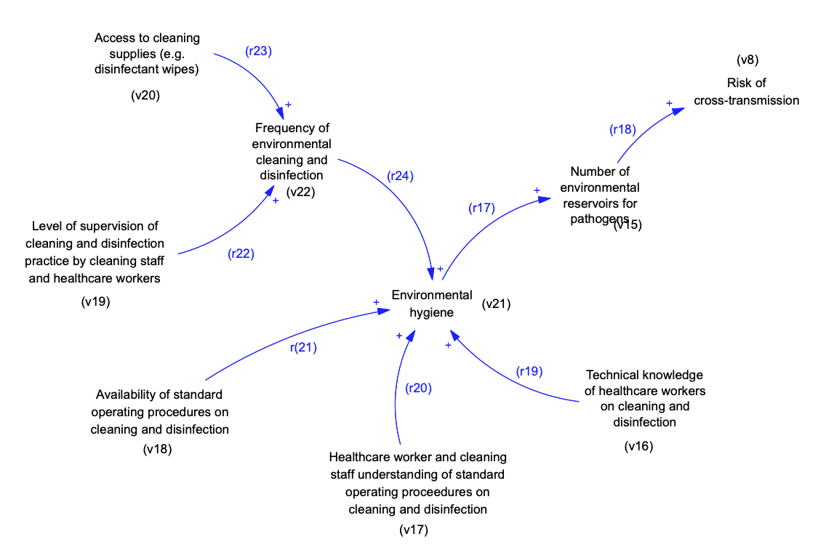
Figure S2: Causal Loop Diagram for Cleanliness of Environment

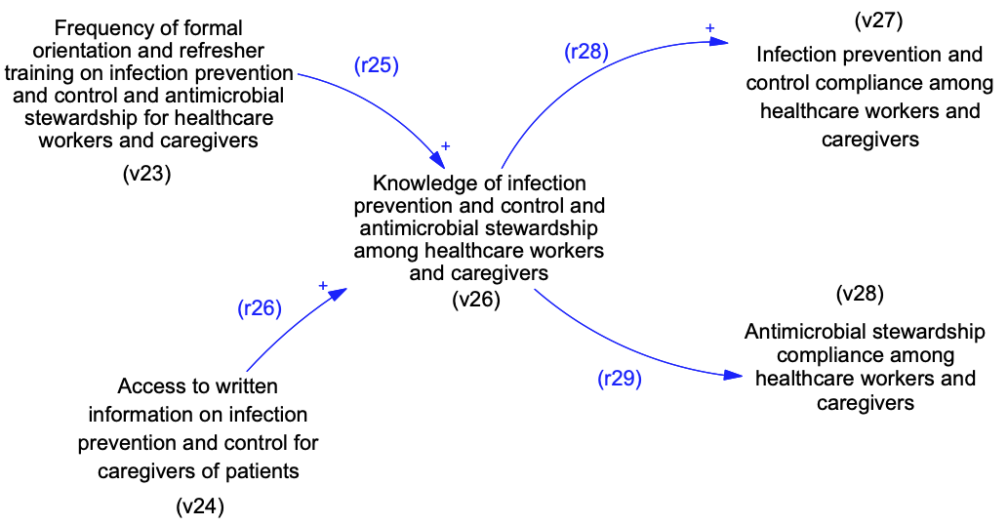
Figure S3: Causal Loop Diagram for Education and Training

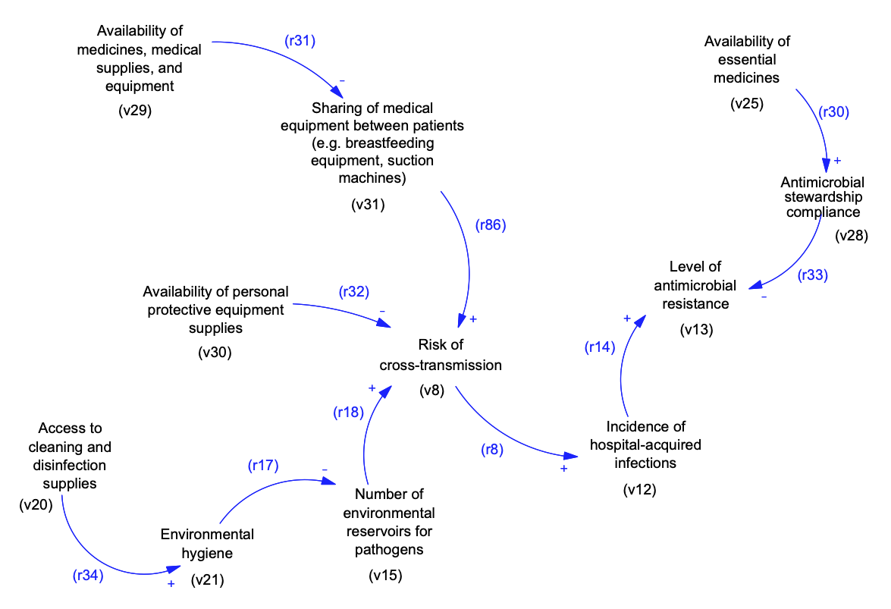
Figure S4: Causal Loop Diagram for Equipment, medicines, and medical supplies

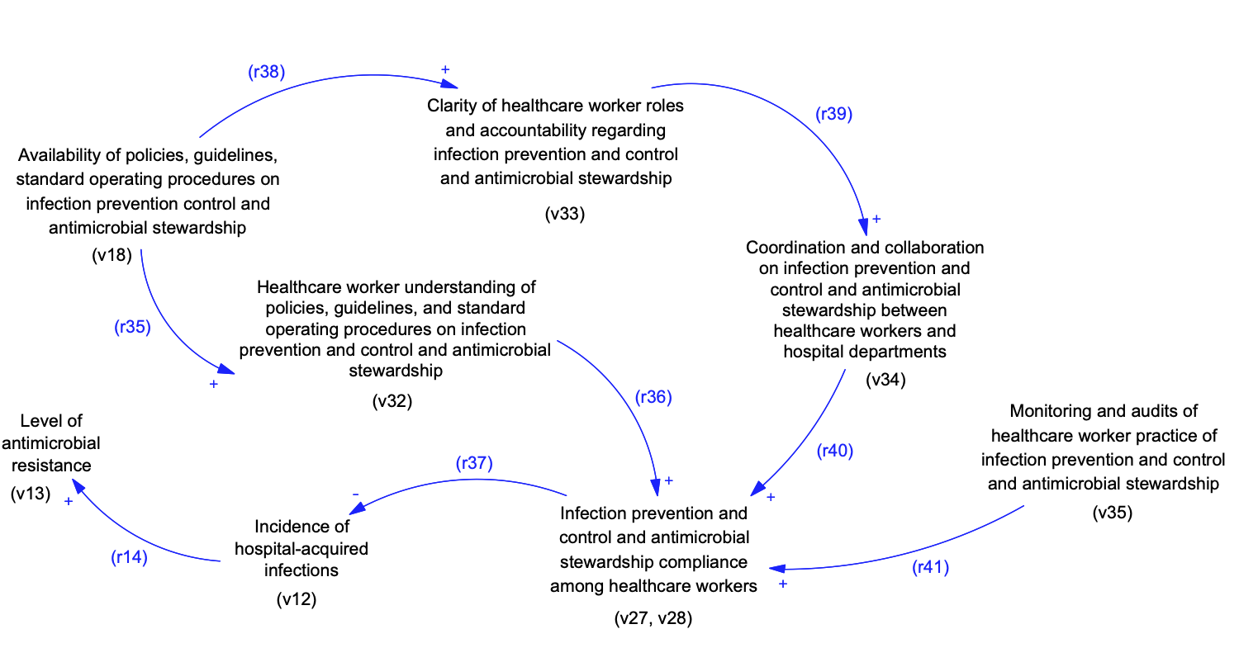
Figure S5: Causal Loop Diagram for Governance and Management

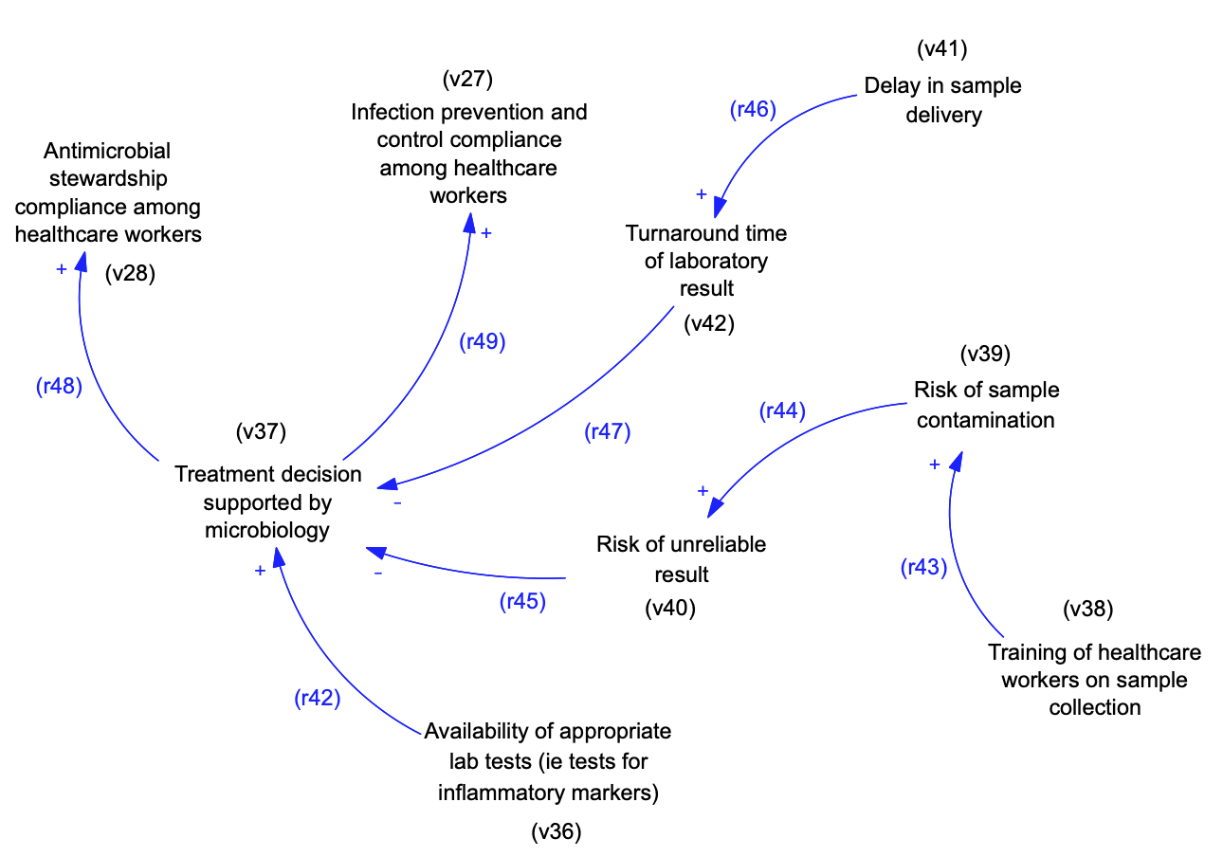
Figure S6: Causal Loop Diagram for Laboratory Testing

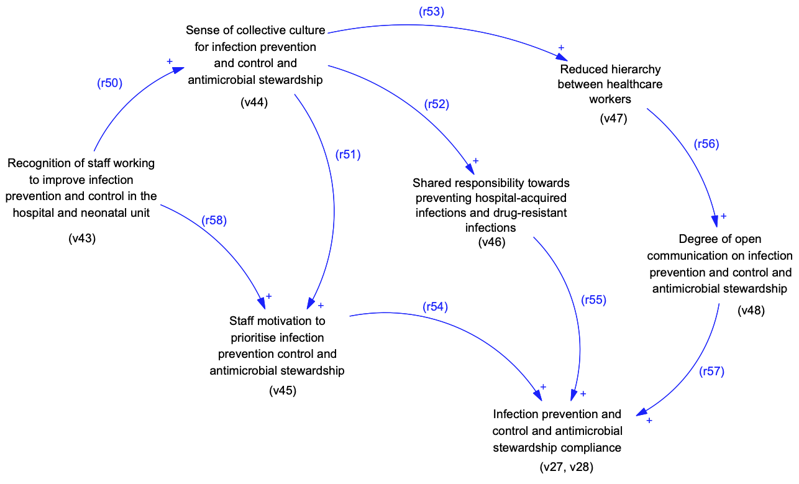
Figure S7: Causal Loop Diagram for Organizational Culture and Patient Safety Climate

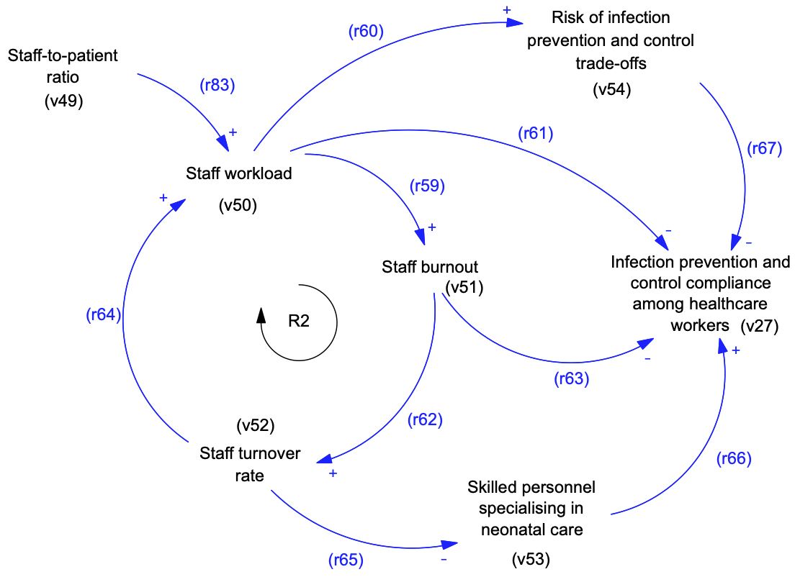
Figure S8: Causal Loop Diagram for Workload, Workforce, and Staffing

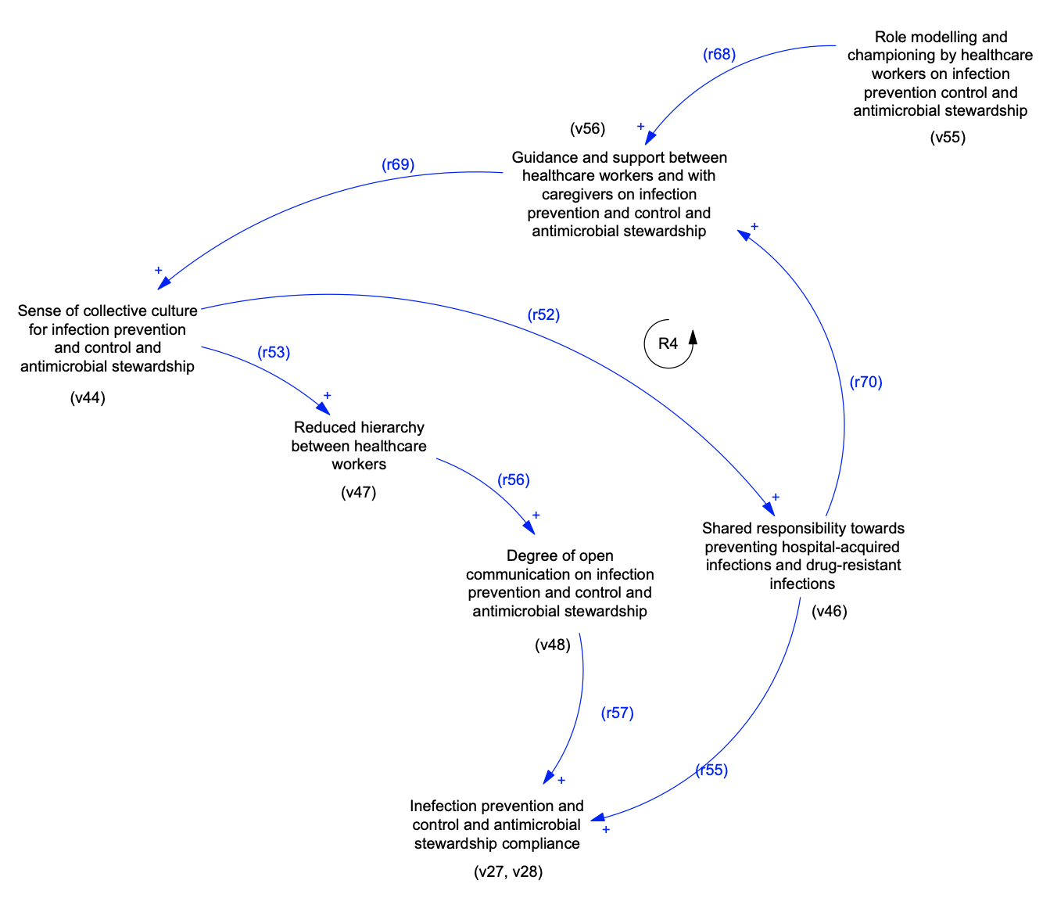
Figure S9: Causal Loop Diagram for Enablers and Facilitators

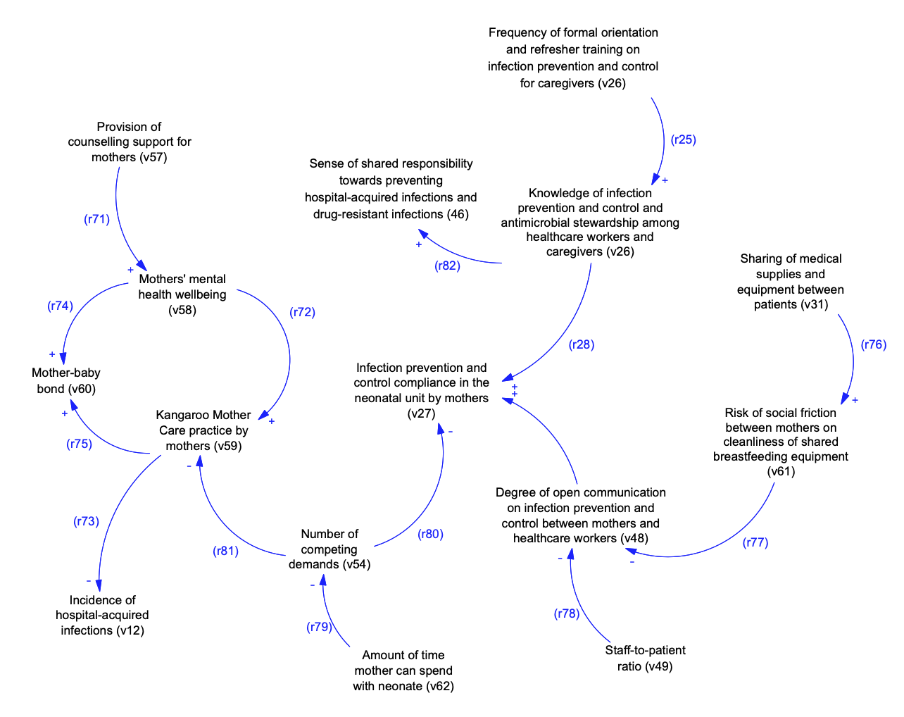
Figure S10: Causal Loop Diagram of factors influencing IPC from Mothers' perspectives

FILE 7 – INTEGRATED CAUSAL LOOP DIAGRAM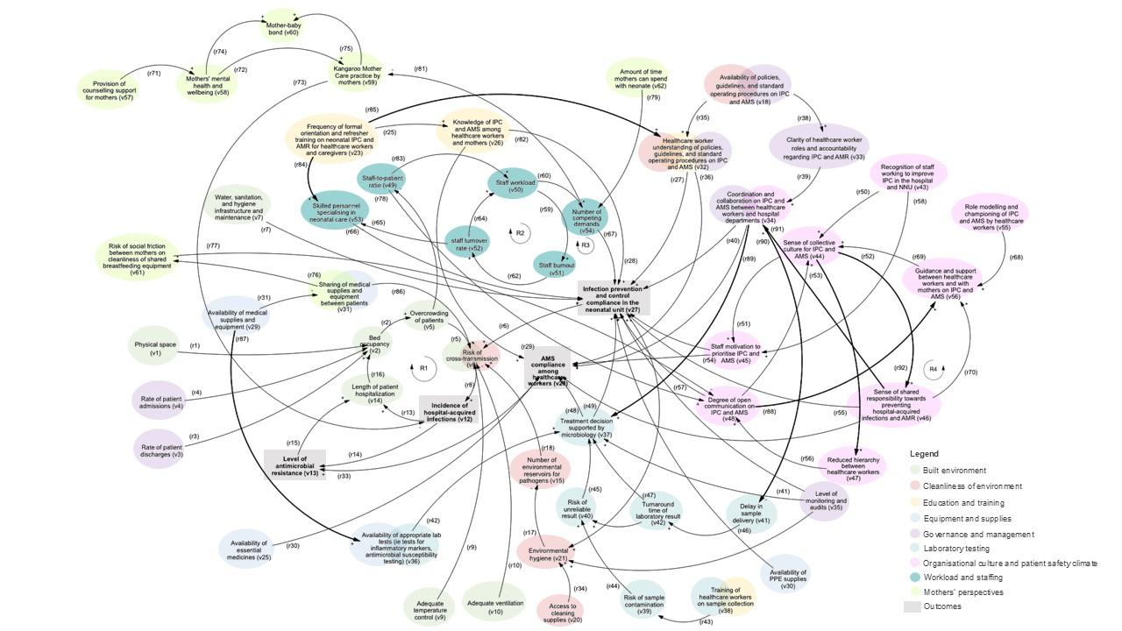
Figure S11: Integrated causal loop diagram on system dynamics shaping neonatal infection prevention and antimicrobial stewardship in Botswana

