Supplementary Material 3
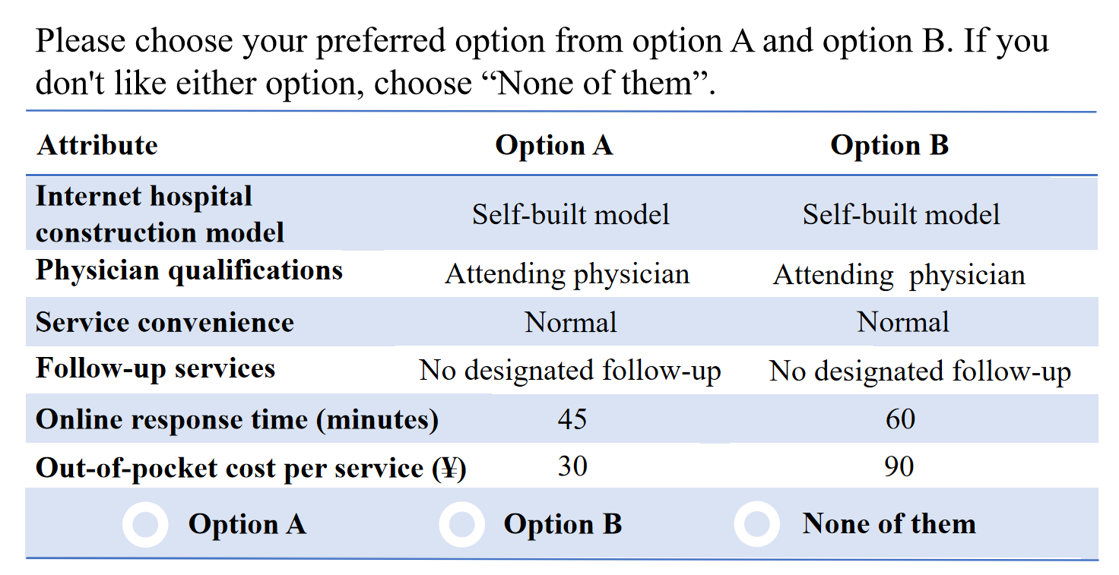
Figure S1. The choice set of bait question. Respondents were asked to select the most attractive option.US $1 =CNY ¥7.20.

