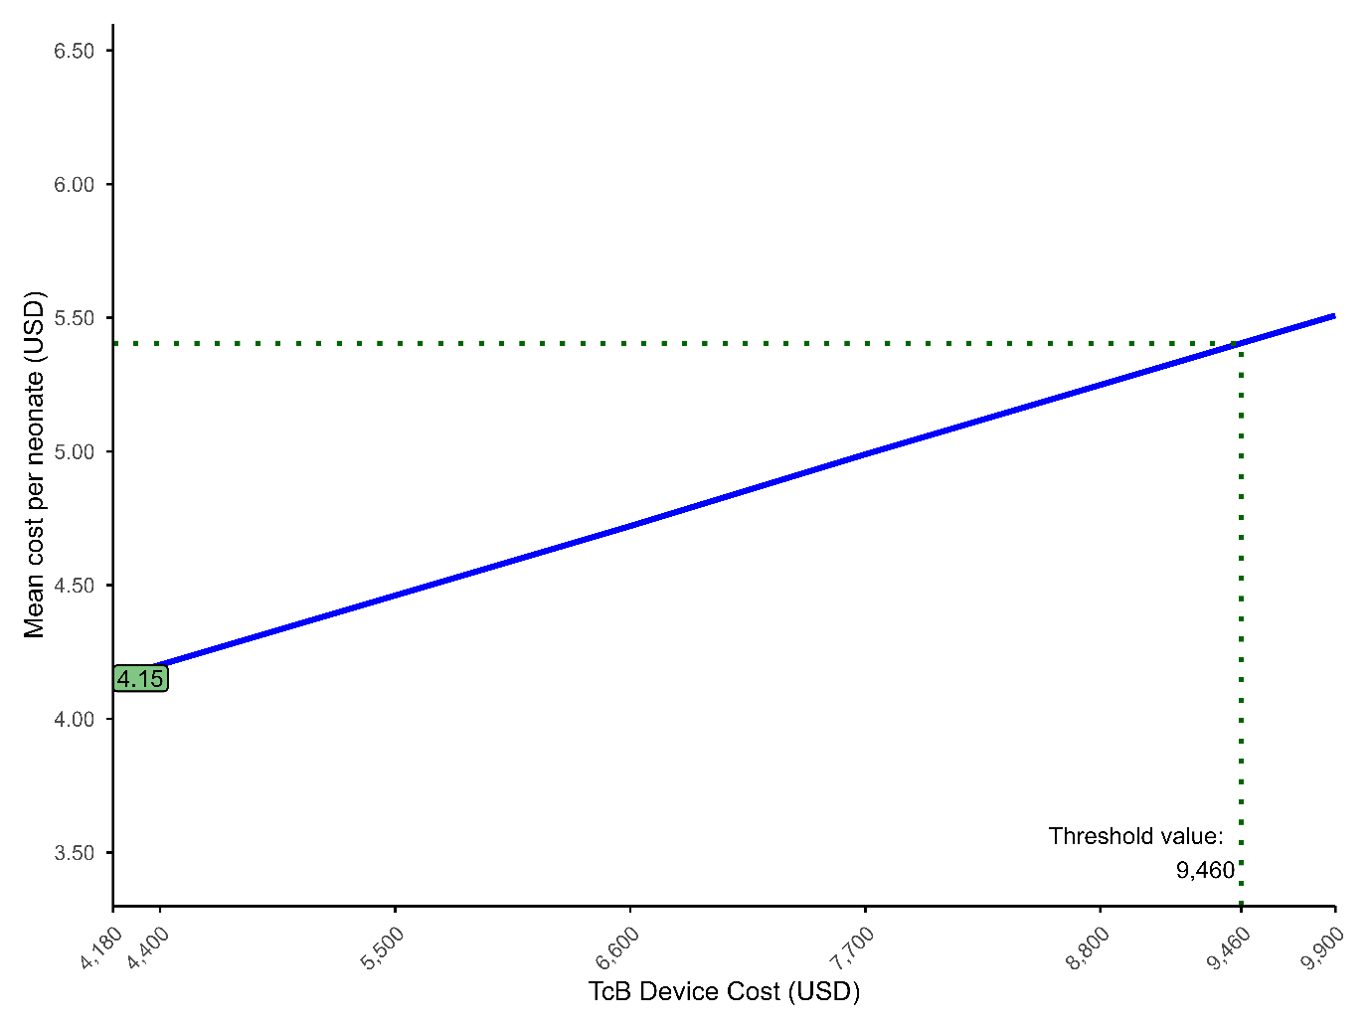
eFigure 1. Threshold analysis of TcB device capital cost.
Model-based threshold analysis identifying the maximum allowable TcB device capital cost at which the total mean costs per neonate of the KR-TcB-TSB and KR-TSB screening strategies are cost-equivalent, indicating a cost-neutral decision point.
USD: US Dollar; TcB: Transcutaneous bilirubin

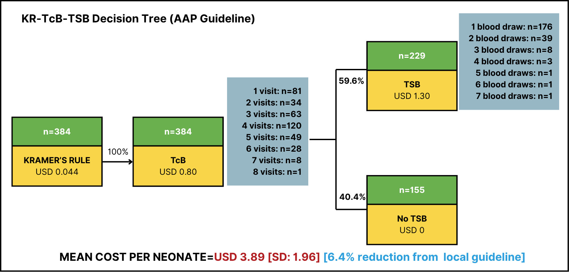
eFigure 2. Decision tree for KR–TcB–TSB strategy using American Academy of Pediatrics (AAP) recommendations.
Scenario analysis identifying the total mean costs of the KR-TcB-TSB with AAP. The number of KR-TcB screening episodes reflects the total number of follow-up screening visits completed by each neonate. The number of blood draws indicates the cumulative number of TSB performed per neonate throughout follow-up.
AAP: American Academy of Pediatrics; USD: US Dollar; TcB: Transcutaneous bilirubin; TSB: Total serum bilirubin; SD: Standard Deviation

eTable 1. Direct medical costs for KR assessment, TcB measurement and TSB testing

 | USD
Identified cost parameters | Min | Max | Weighted Cost | Total costs
Kramer’s rule (KR)
Personnelª
- performed KR | 0.0374 | 0.0740 | 0.0440 | 0.0440
Total KR costs |  |  |  | 0.0440
Transcutaneous bilirubin (TcB)
- Personnelª |  |  |  | 0.2970
- performed KR | 0.0902 | 0.1056 | 0.0968
- review result & gave plan | 0.099 | 0.3168 | 0.2002
- Equipment^{b}
- device and maintenance | 0.3366 | 0.7172 | 0.5016 | 0.5016
Total TcB costs |  |  |  | 0.7986
Total serum bilirubin (TSB)
- Personnelª |  |  |  | 0.6754
- performed KR | 0.0396 | 0.2222 | 0.1056
- performed lab analysis | 0.0748 | 0.3366 | 0.2288
- review result & gave plan | 0.2134 | 0.5852 | 0.3410
- Equipment^{b}
- device and maintenance | 0.0462 | 0.0792 | 0.0594 | 0.0594
- Consumables^{c} | 0.5654 | 0.5698 | 0.5676 | 0.5676
Total TSB costs |  |  |  | 1.3024

ª Personnel costs were calculated using a weighted average across all participating clinics, reflecting the mean salary of all potential staff members involved in performing each specific process within the respective activities.
^{b} Equipment costs were calculated using a weighted average across all participating clinics, incorporating the relevant capital costs and associated maintenance expenses. Discounting was applied based on the expected useful life of the equipment as recommended by the manufacturer.
^{c} Consumables costs were calculated using a weighted average across all participating clinics, encompassing all relevant items required for blood collection procedures.
KR: Kramer’s rule; TcB: Transcutaneous bilirubin; TSB: Total serum bilirubin; USD: US Dollar

eTable 2: Comparative Scenario Analysis of NNJ Management: KR-TcB-TSB Model Using Local vs. AAP Guidelines
Scenario | Total cost (USD) | Mean (SD) cost per neonate (USD) | Blood draws | Missed severe hyperbilirubinemia cases*
Base Case (Local Guidelines) | 1602.44 | 4.15 (SD 2.33) | 386 | 0
AAP Guideline | 1492.31 | 3.89 (SD 1.96) | 308 | 0
*Defined as infants exceeding severe hyperbilirubinemia thresholds not receiving TSB testing
NNJ: Neonatal jaundice; AAP: American Academy of Pediatrics; USD: US Dollar; SD: Standard Deviation

