Supplementary Materials
Supplementary File S1. In-depth Interview Guide

Study title: Exploring Conflict Dynamics in Healthcare Teams: Insights from Healthcare Staff
- Welcome and Introduction
- Explain the purpose of the interview and assure confidentiality.
- Obtain informed consent from the participant.

Participant Background:
Gender: [Male/Female/Prefer not to say] Age: ______ (in completed years)
Role: Doctors/ nurses/others ___________ Years of Experience in Healthcare: ______
Designation/Department/Hospital: _______________________________________________

Questions guide (use probes wherever necessary):
- What are your responsibilities within the healthcare team? (start with rapport building)
- How do you define conflict within the healthcare team?
- What is the severity and frequency of conflicts in your work environment?
- What are the different types, sources and triggers of conflicts you have encountered within the healthcare team? (Ask to recall/describe few examples in detail)
- How did you resolve conflicts? (different conflict resolution approaches can be negotiation, mediation, or escalation to higher authorities.)
- How did the conflicts influence team productivity, morale, and patient outcomes?
- What other individual and team-level factors contribute to conflict within the healthcare team? (Prompts: communication, hierarchy, personal differences, workload).
- How can health care team conflicts be better managed in your opinion?
(Prompts:
    - any strategies employed to promote a positive team culture
    - learning and growth from conflicts within the healthcare team.
    - positive changes or improvements in team dynamics or processes.
    - support systems and resources for managing conflict
    - training or interventions to address conflict)

Conclusion:
- Give Closing Remarks (Briefly summarize the interview and ask participant to add any missing points)
- Thank the participant for their time and valuable insights.
- Provide contact information for further questions or clarifications.
Supplementary Figure S1. Participant-Generated Thematic Mind-Map of Conflict Factors in Indian Hospital Settings
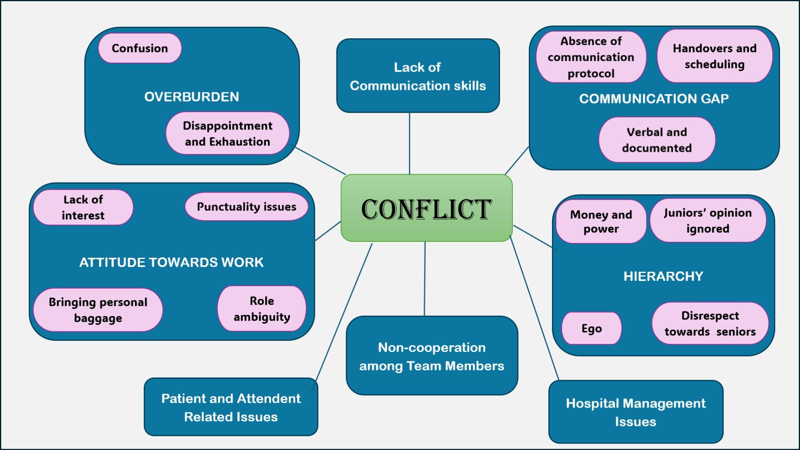
Note. This mind-map was constructed from participant accounts during inductive open coding (Phase 2 analysis) and depicts the full range of conflict antecedents identified across all 19 interviews. It complements the six-theme reflexive framework by illustrating additional contextual domains including non-cooperation among team members, patient- and attendant-related issues, hospital management constraints, scheduling problems, and individual attitude-related factors that, while analytically subordinate to the primary themes, were consistently reported across sites. Seven broad domains are represented: (1) Lack of Communication Skills; (2) Communication Gap; (3) Hierarchy; (4) Attitude Towards Work; (5) Overburden; (6) Non-cooperation Among Team Members; and (7) Hospital Management Issues. Sub-nodes represent specific categories identified within each domain through inductive coding.

Supplementary Table S1. Extended Illustrative Quotations by Thematic Domain (N = 19)
Thematic Domain | Category / Sub-theme | Illustrative Quotations
1. Attitude Towards Work | Roles & Responsibilities  Role Ambiguity  Personal Factors  Lack of Interest  Protocol Non-adherence  Personal Baggage | "a doctor has to be a clinician, an educator, a professional, a leader sometimes, a manager sometimes and also be a student sometimes." (OBG Professor, Rajasthan)  "confusion about who was responsible for updating the treatment plan and conveying important information." (Nursing Staff, Rajasthan)  "Making roles clear prevents confusion." (Anaesthetist, Gujarat)  "Everyone should spend 10 minutes completing their charts before leaving." (Nursing Officer, Telangana)  "People must be willing to listen and understand, not just wait for their turn to argue their point." (Orthopaedic Surgeon, Gujarat)  "People bring personal baggage to work. I had a colleague who was irritable every morning. Later we found she was caring for a sick parent at home." (Staff Nurse, Female, 32 yrs)
2. Scheduling Issues | Schedule Issues  Handovers  Shift Disputes | "disagreeing with a surgeon about scheduling planned versus emergency surgeries — balancing theatre time is tricky in a private hospital." (Anaesthetist, Gujarat)  "A conflict about patient handovers in the recovery room led to a new, clearer process that improved communication." (Anaesthetist, Gujarat)  "Misunderstandings often happen during handovers." (Nursing Officer, Telangana)  "Conflicts also happen among nurses about shifts or feeling like the workload isn't fair." (Nursing Superintendent, Gujarat)
3. Communication Gap & Misunderstanding | Lack of Formal Channels  Verbal-Only Orders  Personal Communication Skills | "In government setups with overburdened staff, verbal orders dominate. That leads to frequent confusion." (SR, Female, 35 yrs)  "Communication is everything. I remember a case where a patient was to be prepped for surgery, but apparently no one told the family about the fasting protocol." (JR, Female, 27 yrs)  "The main issue was a lack of clear communication channels between the nursing staff and the physicians." (Nursing Staff, Rajasthan)  "Communication, I believe, is not one tool among many — it is the only effective tool which can overcome conflict." (Assistant Professor, Telangana)  "So many issues come from poor communication. Double-checking orders given by doctors is good." (Staff Nurse, Female, 32 yrs)
4. Hierarchy | Silencing of Juniors  Doctor–Nurse Relations  Tone & Manner  Money and Power | "I once wanted to clarify a dosing query with a senior consultant, but my resident warned me: 'He doesn't like juniors questioning his orders.' That fear stopped me." (JR, Female, 27 yrs)  "Basically, seniors are like: 'whatever we say, you listen.' So, at some particular point of time, if you even find it weird, you still have to listen to them." (Orthopaedics JR, Telangana)  "Sometimes nurses feel their opinions aren't valued as much as doctors' opinions because of the hierarchy." (Nursing Superintendent, Gujarat)  "The senior consultant corrected a resident sharply in front of everyone. It made the whole room uncomfortable. Later, I overheard the SR say she would never ask that consultant for help again." (JR, Female, 27 yrs)  "Their power comes from money, our power comes from knowledge, and that's a classic recipe for conflict." (Orthopaedic Surgeon, Gujarat)
5. Overburden | Stressful Schedules  Workload Fatigue  Staff Shortages | "There is work! There is a lot of work." (Orthopaedics JR, Telangana)  "Conflict is inevitable when you work in an overburdened system like ours." (Senior Consultant, Male, 53 yrs)  "Conflict is a daily reality in a high-pressure environment. You can't have so many dedicated, stressed-out people working together and not have disagreements." (Orthopaedic Surgeon, Gujarat)  "Heavy workload is a big one; tired staff are more likely to clash." (Nursing Superintendent, Gujarat)  "Misunderstandings often happen due to a lack of staff and the high flow of patients." (Nursing Officer, Telangana)
6. Hospital Management Issues | Equipment Failures  Budget Constraints  New Procedures | "Sometimes issues arise due to malfunctioning BP operators or inadequate indent supplies." (Nursing Officer, Telangana)  "They were pushing for a more budget-friendly supplier to cut costs. I insisted on using a different brand, which had a proven track record of better patient outcomes." (Orthopaedic Surgeon, Gujarat)  "But getting approval from the hospital administration, who controlled the budget, was difficult." (Nursing Superintendent, Gujarat)  "Some of our experienced staff, used to older ways from the district hospital days, had disagreements about how to do things." (Nursing Superintendent, Gujarat)
7. Interpersonal Relationships | Doctor–Nurse Coordination  Lack of Respect  Ego Clashes | "The conflict between a doctor and nurse starts when nurses do not follow instructions and treatment given in the case sheets." (Ophthalmology SR, Telangana)  "Between nurses and doctors, the main issues arise when nurses are ordered around with no context or courtesy." (Nurse In-Charge, Female, 59 yrs)  "The nursing officers were too much; they used to not listen to us." (Assistant Professor, Telangana)
Note. Quotations are verbatim with minor grammatical corrections for readability. The thematic domains in this table derive from an independent inductive coding pass on participant accounts and are presented as an empirical complement to the six-theme reflexive framework in Table 2 of the main manuscript. Minor overlap between domains reflects the interrelated nature of conflict antecedents. Participant descriptors follow the anonymisation conventions of Table 1. SR = Senior Resident; JR = Junior Resident; OBG = Obstetrics and Gynaecology; RMO = Resident Medical Officer; PG = Postgraduate.

