Data Access Proof
The HMIS data for the study was downloaded from the HMIS portal of the Ministry of Health and Family Welfare, Govt of India, using the URL: https://www.hmis.mohfw.gov.in/#!/standardReports
Below are the screenshots of the portal page where the performance indicators related to maternal and child health were located. Block-level data are available in ZIP files.

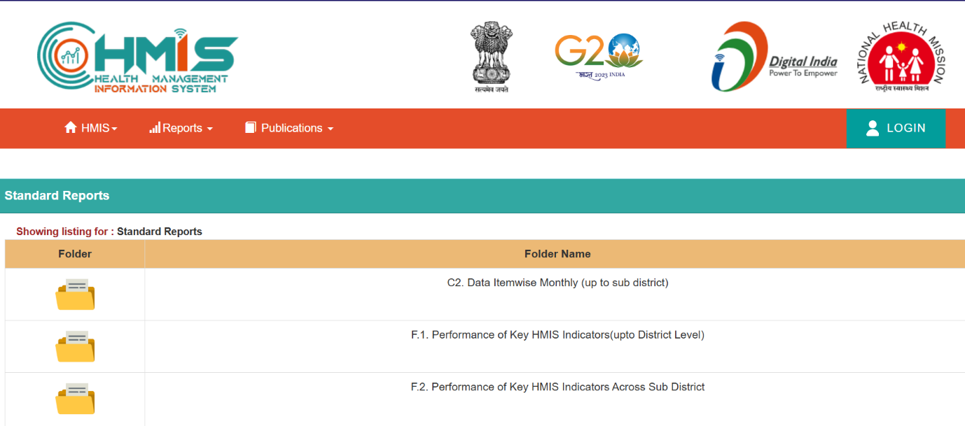

The zip file contains Microsoft Excel format files, the screenshot of which is shown below. Each Excel file contains reports from each health block for the time unit.

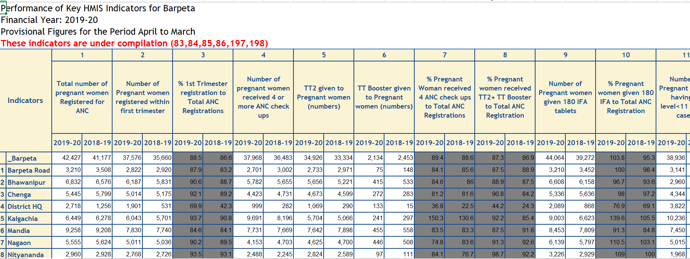

The files were scraped for the relevant values using the R programming environment. Attached below is the snapshot of the final HMIS dataset created using R.

> head(hmis_mch)
Facility ANC ANC 1st 4 ANC TT2 TT Booster IFA Anemia Test
1 zone1 GMSH-16 15079 5370 17829 5428 5428 1472 7532
2 zone2 CHC-22 7008 1957 9313 3872 3872 2411 5115
3 zone3 Mani-Majra 5674 2400 3525 4303 4303 2813 2082
4 zone4 Polyclinic 45 6543 2640 4166 4030 4030 2258 2589
5 Balod 2310 1864 1915 1942 1942 1869 395
7 Dondi 2652 1877 2389 2444 2444 2490 1166
Anemia Treated Facility Del Total Rep.Delivery PNC Rep.Live birth
1 247 19635 19680 15720 19379
2 80 2637 2854 2974 2883
3 0 375 1020 1423 1018
4 3 477 945 1833 928
5 0 1210 1345 1020 1325
7 1 949 1245 1088 1217
Still birth Weighted Weight below 2.5 Breastfed 1 hour OPV BCG DPT
1 744 19037 4943 12559 18410 18149 5915
2 6 2840 438 2695 2933 3139 3528
3 11 1004 69 942 844 1633 4228
4 11 814 97 878 1382 1558 4599
5 20 1266 91 1268 1749 1779 1898
7 28 1197 143 1203 1910 2142 2316
DPT3 Penta Penta3 Measles File Year index
1 4096 NA NA 3871 102.xls 2012 1
2 3474 NA NA 3676 102.xls 2012 2
3 4257 NA NA 4305 102.xls 2012 3
4 4463 NA NA 4423 102.xls 2012 4
5 1839 NA NA 1693 103.xls 2012 5
7 2241 NA NA 2278 103.xls 2012 7

