Subject number:
Date:

Demographic Questionnaire

This questionnaire is to collect the demographic information of the participant. All information is strictly confidential. Please fill in the information or put a tick at the appropriate place.

Part 1: Background Information
- Experience in clinical practice (from the time you obtained your RN Certificate)
_____ years _____ months
- Hospital： □ PWH □ AHNH □ NDH
- Unit： □ OT □ Medicine □ ICU
□ Pediatric □ Other (Please specify) : _____________
- Experience in current unit
_____ years _____ months

Perception Questionnaire

Model of infusion pump being evaluated (Circle one)
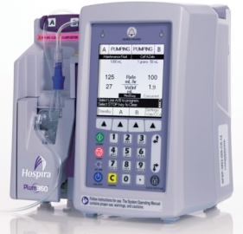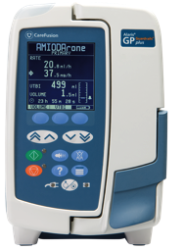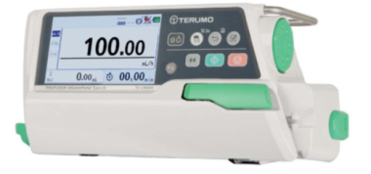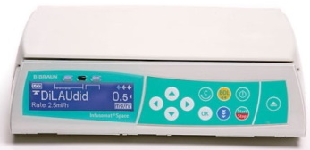

□Pump 1 □Pump 2 □Pump 3 □Pump 4

The following questions ask about your feeling of using infusion pump in doing drug administration. To describe your feeling, please respond by stating one of the numbers, or the words that go with the numbers, on the scale.

Part I
 | Very Strongly Disagree | Strongly Disagree | Disagree | Neutral | Agree | Strongly Agree | Very Strongly Agree
- The set is easy to prime and load. | 1 | 2 | 3 | 4 | 5 | 6 | 7
- It is easy to titrate flow rates. | 1 | 2 | 3 | 4 | 5 | 6 | 7
- It is easy to turn the pump on and off. | 1 | 2 | 3 | 4 | 5 | 6 | 7
- It is easy to load and unload a set. | 1 | 2 | 3 | 4 | 5 | 6 | 7
- It is easy to program a basic infusion. | 1 | 2 | 3 | 4 | 5 | 6 | 7
- It is easy to program a drug infusion from scratch. | 1 | 2 | 3 | 4 | 5 | 6 | 7

 | Very Strongly Disagree | Strongly Disagree | Disagree | Neutral | Agree | Strongly Agree | Very Strongly Agree
- It is easy to program a drug infusion from the drug libraries. | 1 | 2 | 3 | 4 | 5 | 6 | 7

Part II
 | Not at all | A little | Some | A moderate amount | Pretty much | Quite a lot | A great deal
- How much mental effort is required when setting up and programming the infusion pump? | 1 | 2 | 3 | 4 | 5 | 6 | 7
- To what extent does the overall setup and the programming of the infusion pump require concentration? | 1 | 2 | 3 | 4 | 5 | 6 | 7
- How likely is it that you would make programming errors due to the complex design of the pump? | 1 | 2 | 3 | 4 | 5 | 6 | 7
- How much confidence do you have in your ability to set up the infusion pump correctly? | 1 | 2 | 3 | 4 | 5 | 6 | 7
- To what extent do you think the use of drug libraries helps to prevent medication errors? | 1 | 2 | 3 | 4 | 5 | 6 | 7
- How likely do you think it is that the pump can identify a problem and give an appropriate alarm? | 1 | 2 | 3 | 4 | 5 | 6 | 7
- How much confidence do you have in your ability to correct the error you make when using the pump? | 1 | 2 | 3 | 4 | 5 | 6 | 7

Part III
 | Very Strongly Disagree | Strongly Disagree | Disagree | Neutral | Agree | Strongly Agree | Very Strongly Agree
- The pump allows me to work fast. | 1 | 2 | 3 | 4 | 5 | 6 | 7
- The pump allows tasks to be performed in a straightforward manner. | 1 | 2 | 3 | 4 | 5 | 6 | 7
- The pump functions as I expect it to. | 1 | 2 | 3 | 4 | 5 | 6 | 7

Part IV
 | Very Strongly Disagree | Strongly Disagree | Disagree | Neutral | Agree | Strongly Agree | Very Strongly Agree
- It is easy to understand how to set an infusion pump. | 1 | 2 | 3 | 4 | 5 | 6 | 7
- It is easy to remember how to set an infusion pump. | 1 | 2 | 3 | 4 | 5 | 6 | 7
- It is easy to explore new features by trial and error. | 1 | 2 | 3 | 4 | 5 | 6 | 7
- It is easy to remember names of commands and the use of commands. | 1 | 2 | 3 | 4 | 5 | 6 | 7

