Supplementary Material

Appendix 1: Course Lecture Topics

Lecture Topics
ABCDE Approach
Primary Survey
Secondary Survey
Obtaining a History

Appendix 2: Skills Stations Supply List

Trauma Skills | Supplies Needed*
Wound Management (Circulation) | *May vary based on local context/availability
Direct pressure | gloves for PPE practice, mannikin arm/homemade wound simulator/demonstrate on instructor/participant
Deep wound packing | gloves for PPE practice, gauze, clean fabric, elastic bandage if available
Tourniquet | strong stick/piece of metal for windlass, fabric that is NOT elastic, may also show commercial tourniquet if available
General wound management | gauze, clean fabric, water for wound irrigation, elastic bandage if available
Burn management | *general wound mgmt supplies + non-adherent dressing material
Extended Exam
AVPU | printed AVPU chart
Primary Survey | stethoscope (if participants use in daily practice)
Secondary Survey | none
Immobilization
Cervical spine immobilization | commercial c-collar if available, sheet/towel, cardboard, tape
Full spinal immobilization | backboard if available
Log roll | backboard if available
Basic fracture immobilization | sticks/cardboard of various lengths for arm/leg splinting, fabric to secure splint, gauze/other padding, Sam splint if available, elastic bandage if available
Pelvic binding | sheet, commercial pelvic binder if available
Positioning of the pregnant trauma patient | sheet/towel/locally available material to ramp patient
Snake bite management | *same as fracture immobilization + pressure dressing supplies (gauze/fabric/elastic bandage)
Breathing
Three-sided occlusive dressing | mannikin/box or other object to simulate chest wall, tape, gauze, dressing/plastic
Handbook Review | Pictorial Trauma Handbook for each participant

Appendix 3: Course Schedule

Day 1 |  | Nepal Rural Trauma Course Schedule
Time |  | Item/ Activity
9:30 | 11:00 | Participants’ arrival and welcome
10:00 | 10:30 | Pre-test
10:30 | 11:00 | About the Trauma Course (Intro)
11:00 | 12:15 | ABCDE + Primary Survey Lecture
12:15 | 12:45 | Lunch
12:45 | 14:05 | Skills Station 1  (c-spine, log-roll+full spine, direct pressure + wound, tourniquet)
14:05 | 14:20 | Break
14:20 | 15:40 | Skills Station 2  (AVPU/Primary/Secondary talk station, 3-sided dressing, fx immob, pelvic binding)
15:40 | 16:00 | Questions/Review
16:00 | 16:15 | Wrap Up / Closing remarks
DAY 2
Time |  | Item/ Activity
9:00 | 9:30 | Participants’ arrival and welcome
9:30 | 10:00 | Secondary Survey + Brief History Lecture
10:30 | 11:15 | Skills Station 3  (Snake bite, pregnant position, handbook review)
11:15 | 12:00 | Leader and communication lecture: with the example simulation
12:00 | 12:50 | Lunch
13:00 | 14:15 | Group Trauma Scenario Simulation
14:15 | 15:00 | Post-course exam
15:00 | 15:30 | Wrap Up/Role in Study / Closing remarks
15:30 | 16:00 | Diploma Ceremony
Appendix 4: Course Confidence Survey – Modified from WHO BEC Survey

NEPAL TRAUMA COURSE SURVEY FOR PARTICIPANTS
[ ] Pre-Course [ ] Post-Course

Name: _________________________________________________________

What is your job title? _____________________________________________

What municipality do you work in? ___________________________________

What did you receive your education/training in? ________________________

How long have you worked at your current job? _________________________

Please indicate how strongly you disagree or agree with the following statements by crossing the response that best describes you now. Check a box by crossing it.
Question | Strongly Disagree | Disagree | Agree | Strongly Agree
1. I feel comfortable handling any patient requiring trauma care in the community.
2. I feel nervous about seeing patients with traumatic injuries.
3. I feel that I lack the skills to provide care in most prehospital trauma emergencies.
4. I feel confident seeing very ill patients with traumatic injuries.
5. I feel that I understand the ABCDE’s of basic trauma care.
6. . I feel I have an organized approach that allows me to be prepared for all emergency trauma patients in the prehospital settings.
7. I do not feel confident in my knowledge of emergency trauma care in the prehospital settings.
8. I believe that prehospital trauma care trainings for community health workers are important.

How would you rate your confidence in the following?

 | Not confident at all | Slight confidence | Confident | Very confident
Applying a cervical spine collar for patient with concern for spine injury
Pre-hospital management of the injured adult
Prehospital management of the injured child
Positioning of a pregnant patient with trauma prior to transport
Pre hospital management of the patient with sucking chest wound
Have the skills to apply a tourniquet
Have skills to apply a pelvic binder for an unstable pelvis
Have the skills to pad and splint a limb after a snake bite
Have skills to stop a bleeding after trauma by applying pressure
Have the skills to immobilize patients on a spinal board before transport of patient

Appendix 5: Flow Chart of RA Data Collection
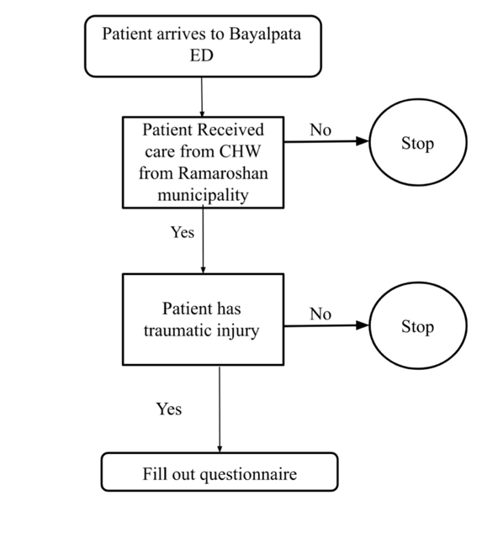
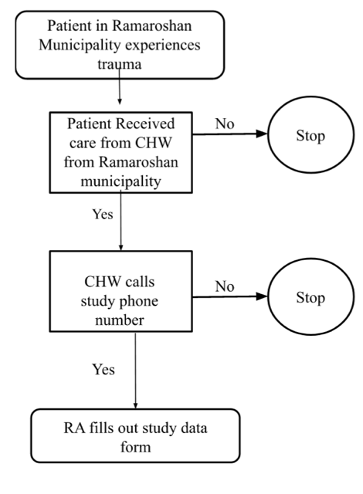

Appendix 6: Patient Process Indicators Data Collection Tool

Study Serial Number: _______

Demographics Transport Data Trauma Mechanism
Age: _______  Gender: _________  Pregnant more than 20 weeks? (circle): Y N U  Weight (kg): ______________  Height (cm): ______________ | Date: ____________  Transport Time: __________  Arrival Time: ___________  Pre-hospital care provided by (CHW type):  ______________________  Transported from (municipality)  ______________________ | Car/Bus Accident  Pedestrian vs. Automobile  Motorcycle Accident  Fall  Burn  Snake Bite  Assault  Animal attack  Natural Disaster  Other:___________________  ________________________  ________________________
Transport Mechanism:
Private car/jeep (rented)
Ambulance
Police Car
Air Transport
Local bus or passenger van/jeep

Motorcycle

Other:_________________________________________

Transfer from another hospital?  If yes, from where? _____________________________ | Yes (Y) |  | No (N)
Neck immobilization/cervical collar indicated?  Neck immobilization/cervical collar in place?  If yes, describe the cervical collar: ________________________  ________________________________________________________  If no, but it was indicated, describe why not placed: ________  _______________________________________________________ | Y  Y |  | N  U (Unknown)  N
Backboard (full spinal immobilization) indicated?  Backboard (full spinal immobilization) done?  If yes, describe the backboard: ______________________________  ________________________________________________________  If no, but indicated, describe why not placed? _________________  _______________________________________________________ | Y  Y |  | N U  N
Was there a concern for fracture?  If yes, describe where the fracture concern is, and how does the fracture look?: _____________________________________  _________________________________________________________  If yes, was the fracture immobilized?  If immobilized, describe the immobilization. _____________ ________________________________________________________  If fracture present, and not immobilization not applied, describe why not? _________________________________  _______________________________________________________ | Y |  | N U
 | Y | N
Pelvic binder indicated?  Pelvic binder applied?  If yes, describe: ____________________________________  ________________________________________________________  If no, but indicated, describe why not placed? __________________  ________________________________________________________ | Y  Y |  | N U  N
If a patient is pregnant more than 20 weeks, were they placed in the left lateral decubitus position? | Y | N |  | U
Was any active bleeding present?  If yes, bleeding site and description: ____________________  ________________________________________________________  Direct pressure?  If direct pressure applied, describe for how long before the bleeding was controlled or torniquet was required? _____  Wound cleaned?  If wound cleaned, how was it cleaned? ________  Pressure dressing?  Tourniquet Applied?  If yes, please describe where the tourniquet was placed, what was used for the tourniquet, what time it was placed, and did the bleeding stop?  If pressure and/or tourniquet was indicated,, but not applied, describe why not? ___________  ________________________________________________________ | Y  Y  Y  Y  Y |  | N U  N  N  N  N
Snake bite present?  If yes, location: ____________________________________  Limb immobilized?  Dressing applied?  Tourniquet applied?  Wound Sucked?  Other care provided? Describe. _________________  ________________________________________________________  If no, but indicated, describe why not? __________________  ________________________________________________________ | Y  Y  Y  Y  Y |  | N U  N  N  N  N
Sucking chest wound present?  If yes, was a three-sided dressing applied?  If no, but indicated, describe why not? __________________  ________________________________________________________ | Y |  | N U
 | Y | N |  | N/A

Additional Notes: _____________________________________________________________________
_____________________________________________________________________________________

_____________________________________________________________________________________

Appendix 7: Course Feedback - Modified from WHO BEC Course Feeback

Nepal CHW Trauma Training Participant Course Feedback

Name: ________________________________________________________

What is your job title? ________________________________________________

What municipality do you work in? ______________________________________

What did you receive your education/training in? _____________________________

How long have you worked at your current job? _____________________________

We would like to know you what you thought about this course; what parts were good and what parts need to be changed.

- Regarding the course as a whole, what did you think of level of the content of the modules?
Very Somewhat Somewhat Inappropriate
Appropriate Appropriate Inappropriate

- Regarding the course as a whole, how appropriate do you feel the content of the modules were to your setting?
Very Somewhat Somewhat Inappropriate
Appropriate Appropriate Inappropriate

- Please let us know what you thought of the lectures for this course.

  - How did you feel about the clarity and language of the text on the slides?
Very clear Somewhat clear Somewhat unclear Unclear

  - What did you think about the overall quality of the lectures?
Excellent Good Poor Unacceptable

- Please let us know what you thought about the case scenarios for this course.

  - Did you feel that the clarity and language of the case scenario text was?
Very clear Somewhat clear Somewhat unclear Unclear

  - What did you think about the overall quality of the case scenarios?
Excellent Good Poor Unacceptable

- Please let us know what you thought about the hands-on skills stations of this course?

- Did you get to practice all the skills in the skill station? Yes_____ No ______

- Do you think it was clear to understand the procedures?
Very clear Somewhat clear Somewhat unclear Unclear

- What did you think about the overall quality of the skills station?
Excellent Good Poor Unacceptable
- Please let us know what you thought about the multiple-choice questions for this course assessment.

- Did you feel that the clarity and language of the multiple-choice text was?
Very clear Somewhat clear Somewhat unclear Unclear

- What did you think about the overall quality of the multiple choice questions?
Excellent Good Poor Unacceptable

- I believe that the trauma course was a productive use of my time.
Strongly Agree Agree Neutral Disagree Strongly Disagree

- I believe I will use these skills in the pre-hospital settings in my community?
Strongly Agree Agree Neutral Disagree Strongly Disagree

- I would recommend the trauma course to other community health workers.
Strongly Agree Agree Neutral Disagree Strongly Disagree

- How effective do you feel your instructors were in teaching this course?
Excellent Good Poor Unacceptable

Please explain:
- What specific things did you like about this course?

- What would you change about this course?

Appendix 8: Pictorial Trauma Reference Handbook examples
