Additional file 2
Table S1. Primary analysis including deaths. Health utilities for the 3 groups at baseline, at 6 months, 12 months and 18 months follow-up
 | Usual care |  |  |  | PRO-based telephone consultation |  |  |  | PRO-based remote follow-up
Utilities | Baseline | 6 months | 12 months | 18 months | Baseline | 6 months | 12 months | 18 months | Baseline | 6 months | 12 months | 18 months
Mean | 0,782 | 0,701 | 0,689 | 0,699 | 0,860 | 0,830 | 0,799 | 0,811 | 0,814 | 0,744 | 0,697 | 0,707
SD | 0,185 | 0,289 | 0,323 | 0,303 | 0,207 | 0,234 | 0,250 | 0,210 | 0,200 | 0,314 | 0,357 | 0,321
Median | 0,830 | 0,812 | 0,823 | 0,812 | 0,912 | 0,911 | 0,878 | 0,887 | 0,858 | 0,832 | 0,865 | 0,819
25th | 0,699 | 0,548 | 0,577 | 0,593 | 0,819 | 0,806 | 0,793 | 0,747 | 0,758 | 0,736 | 0,532 | 0,674
75th | 0,952 | 0,928 | 0,942 | 0,918 | 1,000 | 1,000 | 0,952 | 0,952 | 0,952 | 0,959 | 0,952 | 0,917
N | 47 | 47 | 47 | 47 | 53 | 53 | 53 | 53 | 51 | 51 | 51 | 51
Note: QALY; Quality-adjusted life-years; SD: Standard deviation.

Additional file 3
Table S2. Secondary analysis for complete cases. Incremental costs, effect and cost-effectiveness ratio based on complete case observations
 | Incremental costs |  |  | Incremental effect |  |  | Costs/Effect | CE planes
 | Cost (€) | CI low | CI high | Effect | CI low | CI high | ICER | NE (%) | NW (%) | SE (%) | SW (%)
PRO-tele vs Usual Care
QALY | -2242 | -9926 | 5442 | 0,06 | -0,06 | 0,18 | -37181 | 24 | 2 | 62 | 11
Non-inferiority eGFR | 464 | -8320 | 9249 | -0,24 | -0,41 | -0,06 | -1958 | 0 | 46 | 0 | 54
PRO-remote vs Usual Care
QALY | -3148 | -7198 | 901 | -0,01 | -0,13 | 0,11 | 379277 | 3 | 3 | 41 | 53
Non-inferiority eGFR | -315 | -5750 | 5120 | -0,16 | -0,36 | 0,05 | 2006 | 2 | 46 | 3 | 48
PRO-remote vs PRO-tele
QALY | -3832 | -11004 | 3339 | -0,09 | -0,19 | 0,02 | 44558 | 1 | 16 | 4 | 79
Non-inferiority eGFR | -3083 | -14353 | 8186 | 0,07 | -0,13 | 0,27 | -44681 | 32 | 13 | 43 | 12
Note: Cost-effectiveness adjusted for age, sex, Charlson index and respectively baseline eGFR, QALY and pre-period costs. Including only patients with complete reporting. CI, Confidence interval (95%); CE, cost-effectiveness; eGFR, estimated Glomerular Filtration Rate; ICER, incremental cost-effectiveness ratio; NE, north-east, NW, north-west; SE, south-east, SW, south-west QALY, quality-adjusted life-year.

Additional file 4
Figure S1. Complete case analysis – Cost-effectiveness planes
 | PRO-tele vs usual care | PRO-remote vs usual care | PRO-remote vs PRO-tele
QALY | A  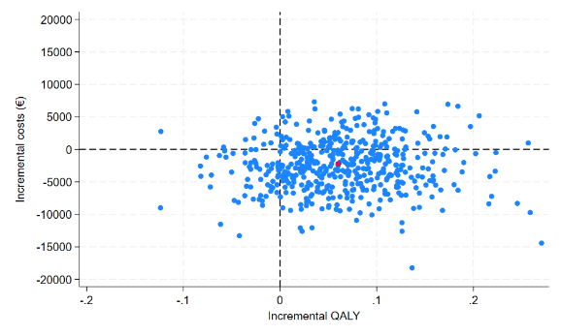 | B  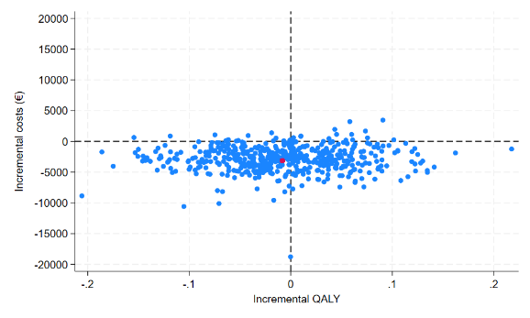 | C  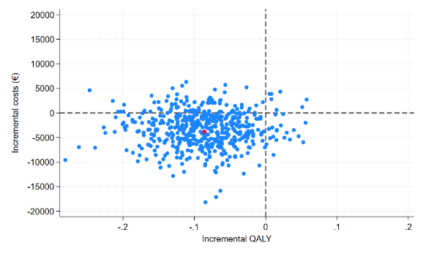
eGFR | D  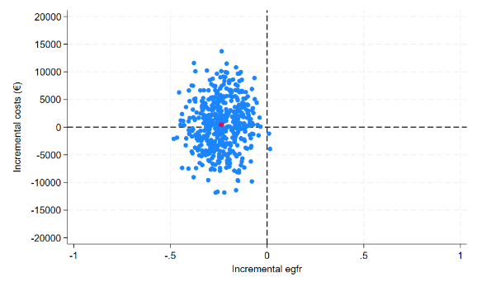 | E  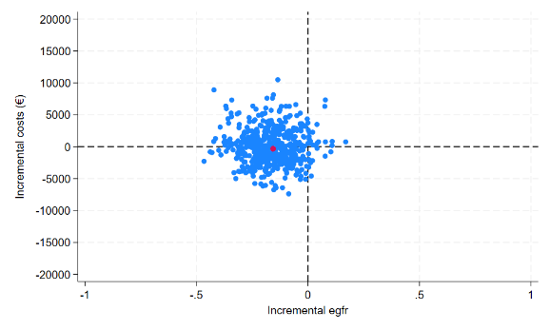 | F  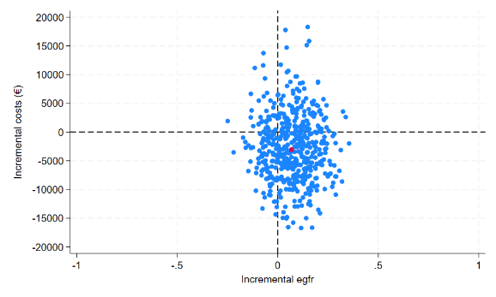

The cost-effectiveness planes of cost per QALY adjusted for age, sex and respectively baseline QALY, eGFR and pre-period costs. Including only patients with complete reporting. Based on 500 bootstrap replications. A-C) ICER planes for costs per QALY. D-F) ICER planes of costs per person reached non-inferiority eGFR. A & D) PRO-tele vs Usual care, B) PRO-remote vs Usual care, C & E) PRO-remote vs PRO-tele, D & F) PRO-tele vs Usual care. ICER; incremental cost-effectiveness ratio, QALY; quality-adjusted life-year, eGFR; estimated Glomerular Filtration Rate.

Additional file 5
Table S3. Secondary analysis excluding deaths. Incremental costs, effect and cost-effectiveness ratio
 | Incremental costs |  |  | Incremental effect |  |  | Costs/Effect | CE planes
 | Cost (€) | CI low | CI high | Effect | CI low | CI high | ICER | NE (%) | NW (%) | SE (%) | SW (%)
PRO-tele vs Usual Care
QALY | 1868 | -6401 | 10137 | 0,001 | -0,07 | 0,07 | 2075556 | 35 | 34 | 18 | 14
Non-inferiority eGFR | 1868 | -6401 | 10137 | -0,23 | -0,42 | -0,05 | -7983 | 1 | 68 | 0 | 31
PRO-remote vs Usual Care
QALY | -105 | -5830 | 5620 | -0,01 | -0,09 | 0,06 | 8015 | 21 | 34 | 23 | 22
Non-inferiority eGFR | -105 | -5830 | 5620 | -0,17 | -0,37 | 0,04 | 633 | 3 | 53 | 2 | 43
PRO-remote vs PRO-tele
QALY | -3804 | -14912 | 7303 | -0,02 | -0,09 | 0,06 | 209011 | 5 | 19 | 25 | 51
Non-inferiority eGFR | -3804 | -14912 | 7303 | 0,05 | -0,16 | 0,26 | -71774 | 15 | 9 | 54 | 22
Note: Cost-effectiveness adjusted for age, sex, Charlson index and respectively baseline eGFR, QALY and pre-period costs. Excluding patients that died during the intervention period. CI, Confidence interval (95%); CE, cost-effectiveness; eGFR, estimated Glomerular Filtration Rate; ICER, incremental cost-effectiveness ratio; NE, north-east, NW, north-west; SE, south-east, SW, south-west QALY, quality-adjusted life-year.

Additional file 6
Figure S2. Cost-effectiveness planes - Excluding deaths
 | PRO-tele vs usual care | PRO-remote vs usual care | PRO-remote vs PRO-tele
QALY | A  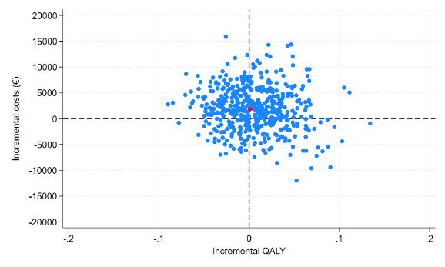 | B  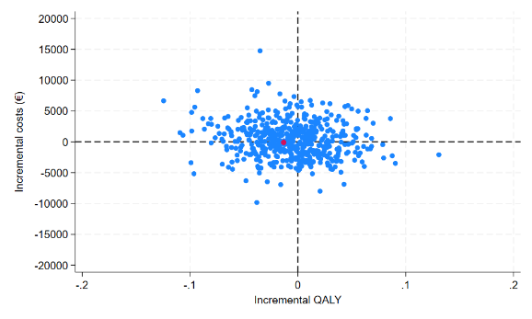 | C  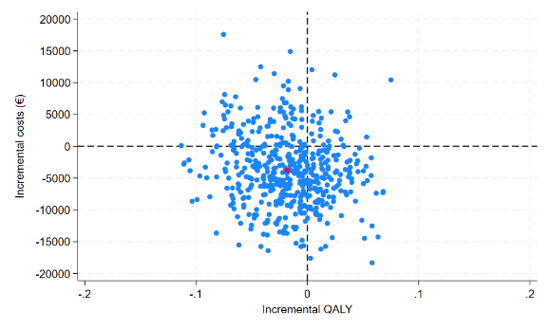
eGFR | D  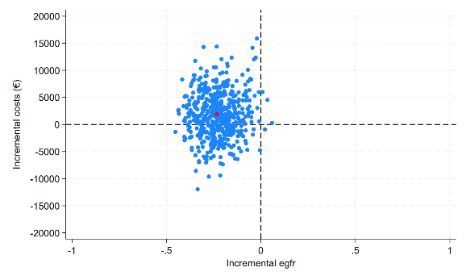 | E  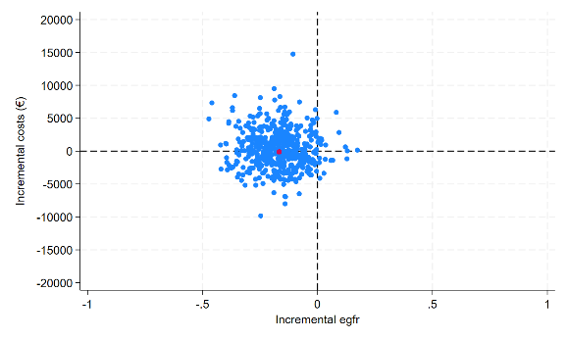 | F  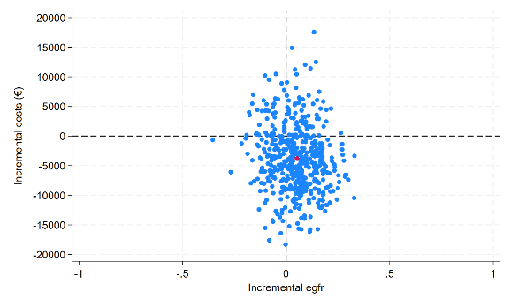
The cost-effectiveness planes of cost per QALY adjusted for age, sex and respectively baseline QALY, eGFR and pre-period costs. Excluding patients that died during the intervention period. Based on 500 bootstrap replications. A-C) ICER planes for costs per QALY. D-F) ICER planes of costs per person reached non-inferiority eGFR. A & D) PRO-tele vs Usual care, B) PRO-remote vs Usual care, C & E) PRO-remote vs PRO-tele, D & F) PRO-tele vs Usual care. ICER; incremental cost-effectiveness ratio, QALY; quality-adjusted life-year, eGFR; estimated Glomerular Filtration Rate.

Additional file 7
Table S4. Secondary analysis unadjusted. Incremental costs, effect and cost-effectiveness ratio
 | Incremental costs |  |  | Incremental effect |  |  | Costs/Effect | CE planes
 | Cost (€) | CI low | CI high | Effect | CI low | CI high | ICER | NE (%) | NW (%) | SE (%) | SW (%)
PRO-tele vs Usual Care
QALY | 1239 | -6891 | 9369 | 0,08 | -0,03 | 0,19 | 15966 | 58 | 4 | 35 | 3
Non-inferiority eGFR | 1239 | -6891 | 9369 | -0,17 | -0,37 | 0,03 | -7288 | 2 | 59 | 1 | 37
PRO-remote vs Usual Care
QALY | -501 | -5862 | 4859 | 0,001 | -0,13 | 0,13 | -556667 | 21 | 19 | 35 | 25
Non-inferiority eGFR | -501 | -5862 | 4859 | -0,11 | -0,31 | 0,10 | 4682 | 7 | 33 | 12 | 48
PRO-remote vs PRO-tele
QALY | -2195 | -13843 | 9453 | -0,07 | -0,17 | 0,03 | 30276 | 3 | 29 | 8 | 60
Non-inferiority eGFR | -2195 | -13843 | 9453 | 0,06 | -0,13 | 0,26 | -35984 | 27 | 5 | 58 | 10
Note: Cost-effectiveness adjusted only for baseline eGFR, QALY and pre-period costs. CI, Confidence interval (95%); CE, cost-effectiveness; eGFR, estimated Glomerular Filtration Rate; ICER, incremental cost-effectiveness ratio; NE, north-east, NW, north-west; SE, south-east, SW, south-west QALY, quality-adjusted life-year.

Additional file 8
Figure S3. Cost-effectiveness planes - Crude analysis
 | PRO-tele vs usual care | PRO-remote vs usual care | PRO-remote vs PRO-tele
QALY | A  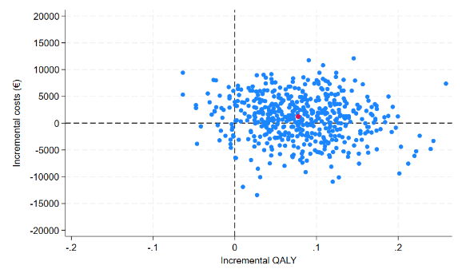 | B  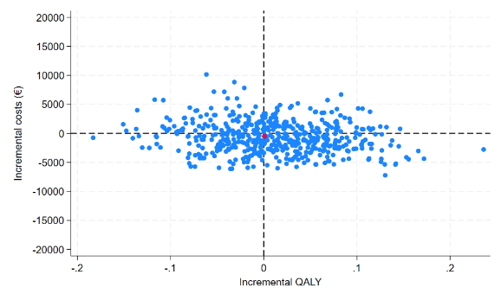 | C  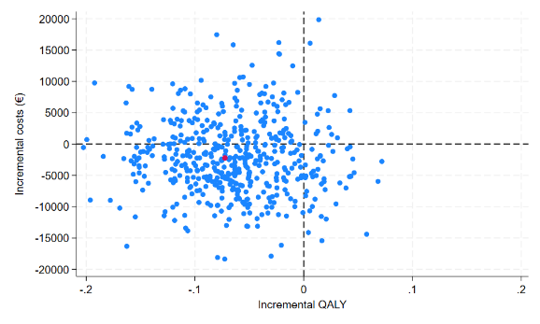
eGFR | D  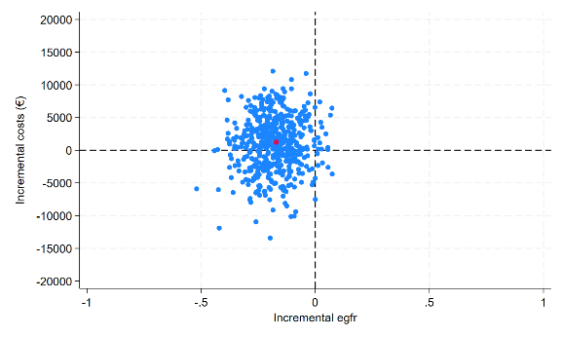 | E  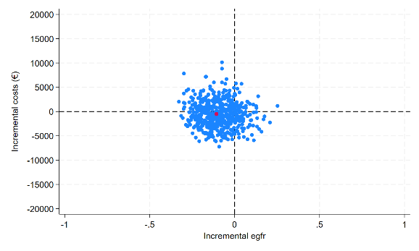 | F  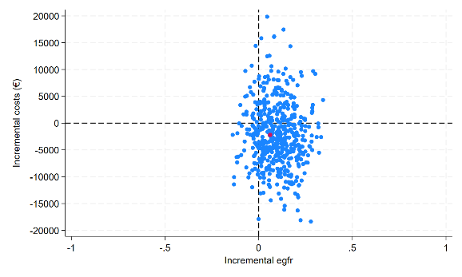
The cost-effectiveness planes of cost per QALY adjusted only for respectively baseline QALY, eGFR and pre-period costs. Based on 500 bootstrap replications. A-C) ICER planes for costs per QALY. D-F) ICER planes of costs per person reached non-inferiority eGFR. A & D) PRO-tele vs Usual care, B) PRO-remote vs Usual care, C & E) PRO-remote vs PRO-tele, D & F) PRO-tele vs Usual care. ICER; incremental cost-effectiveness ratio, QALY; quality-adjusted life-year, eGFR; estimated Glomerular Filtration Rate

