Appendix
Appendix Table A1. Prior labor migration and subsequent changes in provincial population and health resources
Panel | Outcome: subsequent change | Pooled coefficient (SE) | Pooled p-value | Province-FE coefficient (SE) | FE p-value | N: pooled / FE
A. Population | Change in log provincial population | -0.0033 (0.0006) | 0.000 | -0.0001 (0.0001) | 0.479 | 189 / 186
B. Raw counts | Change in log provincial staff count | 0.0039 (0.0117) | 0.740 | 0.0255 (0.0469) | 0.588 | 189 / 186
B. Raw counts | Change in log district staff count | -0.0014 (0.0044) | 0.760 | 0.0049 (0.0097) | 0.617 | 189 / 186
B. Raw counts | Change in log commune staff count | -0.0022 (0.0030) | 0.479 | -0.0071 (0.0085) | 0.407 | 189 / 186
B. Raw counts | Change in log medical staff count | -0.0008 (0.0025) | 0.736 | 0.0053 (0.0069) | 0.439 | 189 / 186
B. Raw counts | Change in log pharmaceutical staff count | 0.0014 (0.0043) | 0.741 | 0.0094 (0.0090) | 0.305 | 189 / 186
B. Raw counts | Change in log female health staff count | -0.0014 (0.0032) | 0.664 | 0.0021 (0.0075) | 0.777 | 189 / 186
B. Raw counts | Change in log provincial bed count | -0.1651 (0.1251) | 0.192 | -0.3622 (0.3330) | 0.281 | 189 / 186
B. Raw counts | Change in log district bed count | -0.0054 (0.0045) | 0.236 | -0.0001 (0.0122) | 0.995 | 189 / 186
B. Raw counts | Change in log commune bed count | 0.0100 (0.0156) | 0.522 | 0.0322 (0.0358) | 0.372 | 189 / 186
C. Densities | Change in provincial staff per 10,000 | -0.0620 (0.0705) | 0.383 | -0.1102 (0.1635) | 0.503 | 189 / 186
C. Densities | Change in district staff per 10,000 | 0.0428 (0.0528) | 0.420 | 0.0843 (0.1411) | 0.553 | 189 / 186
C. Densities | Change in commune staff per 10,000 | 0.0138 (0.0289) | 0.635 | -0.0401 (0.0870) | 0.646 | 189 / 186
C. Densities | Change in medical staff per 10,000 | 0.0309 (0.0639) | 0.630 | 0.0928 (0.1770) | 0.602 | 189 / 186
C. Densities | Change in pharmaceutical staff per 10,000 | 0.0092 (0.0096) | 0.342 | 0.0100 (0.0260) | 0.701 | 189 / 186
C. Densities | Change in female health staff per 10,000 | 0.0131 (0.0706) | 0.854 | 0.0021 (0.1568) | 0.989 | 189 / 186
C. Densities | Change in provincial beds per 10,000 | -0.2759 (0.1521) | 0.075 | -0.3960 (0.3559) | 0.270 | 189 / 186
C. Densities | Change in district beds per 10,000 | 0.0126 (0.0455) | 0.782 | 0.0369 (0.1056) | 0.728 | 189 / 186
C. Densities | Change in commune beds per 10,000 | 0.0549 (0.0384) | 0.158 | 0.0497 (0.0860) | 0.565 | 189 / 186
Notes: The explanatory variable is the prior provincial labor-migration rate, scaled so that coefficients represent a one-percentage-point higher prior migration rate. Pooled models include period fixed effects and province-clustered standard errors. Province-FE models additionally absorb province fixed effects and control for changes in log GRDP per capita and the unemployment rate. Raw-count outcomes are log changes; density outcomes are changes in resources per 10,000 population. These regressions are diagnostic tests of dynamic feedback. A statistically insignificant coefficient supports, but does not prove, the absence of reverse causality because the tests may have limited statistical power.

Appendix Table A2. Alternative service-use and diagnostic-capacity measures
Alternative measure | Full analysis sample | Work migrants vs. non-movers
Inpatient cases | 0.991 (0.057) | 0.987 (0.058)
Inpatient service days | 1.018 (0.040) | 1.020 (0.040)
Public laboratory tests | 0.949 (0.036) | 0.948 (0.036)
Public ultrasound examinations | 1.019 (0.026) | 1.021 (0.026)
Public CT/MRI scans | 1.001 (0.010) | 1.002 (0.010)
Private laboratory tests | 0.996 (0.016) | 0.996 (0.017)
Private ultrasound examinations | 0.999 (0.016) | 1.000 (0.017)
Private CT/MRI scans | 1.009 (0.009) | 1.009 (0.009)
Public/private laboratory-test ratio | 1.000 (0.000) | 1.000 (0.000)
Public/private ultrasound ratio | 1.000 (0.000) | 1.000 (0.000)
Public/private CT/MRI ratio | 1.000 (0.000) | 1.000 (0.000)
Observations | 9,321 | 8,639
LR test vs. single-level logit, p-value | <0.001 | <0.001
Notes: Odds ratios and delta-method standard errors correspond to a 10% increase in the original count or public/private ratio. The models include all alternative measures jointly, the same covariates as Table 4, and province and household random intercepts. Column 2 excludes individuals who migrated for marriage, education, household separation, family-related, or other non-labor reasons. Because the alternative indicators have incomplete coverage across province-years, the sample is smaller than in the main analysis; the results should be interpreted as complementary sensitivity evidence rather than direct measures of overall healthcare quality. * p<0.10, ** p<0.05, *** p<0.01.

Exploratory interaction figures

These eight figures are supplementary exploratory analyses. Each graph reports average marginal effects with 95% confidence intervals. Formal interaction p-values test differences across moderator levels. Benjamini-Hochberg q-values control the false-discovery rate across these eight appendix tests.

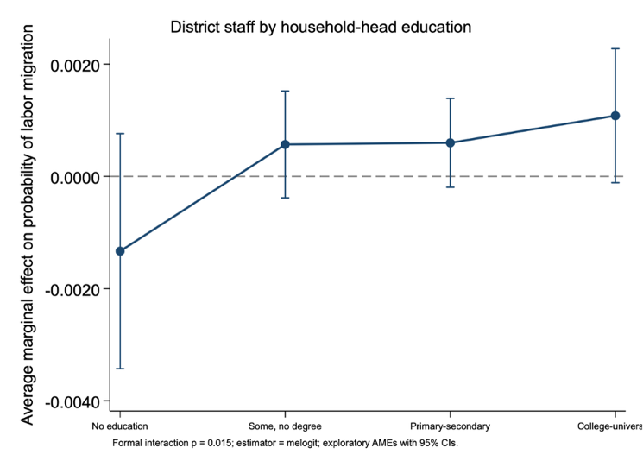 | 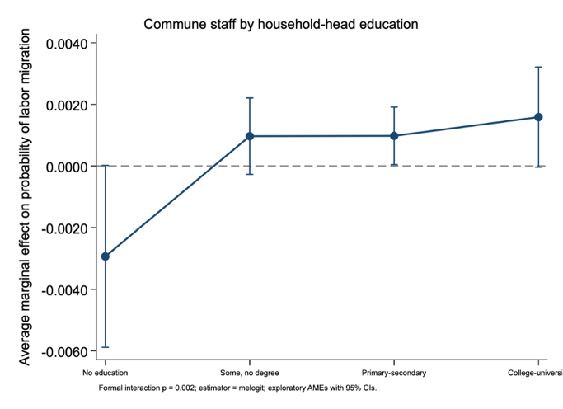
Figure A1. District-staff density by household-head education | Figure A2. Commune-staff density by household-head education

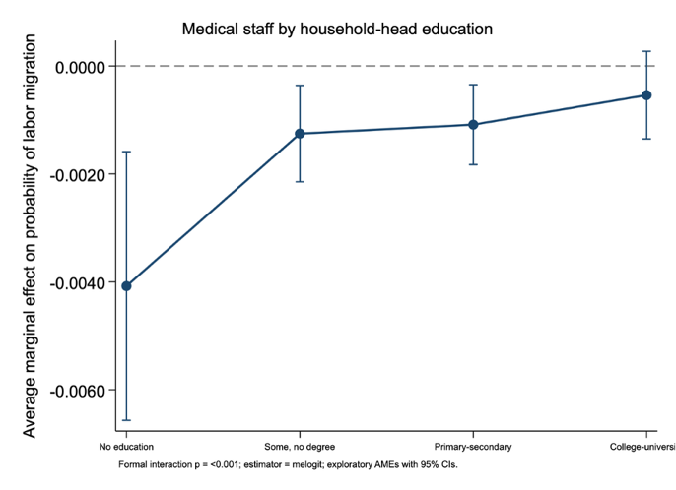 | 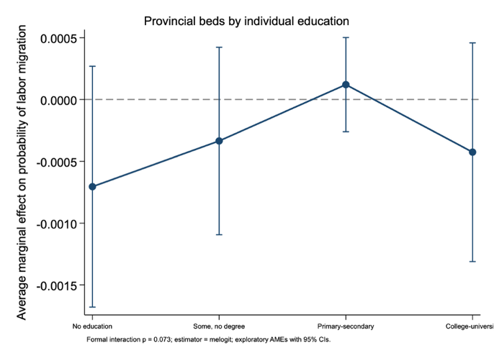
Figure A3. Medical-staff density by household-head education | Figure A4. Provincial-bed density by individual education

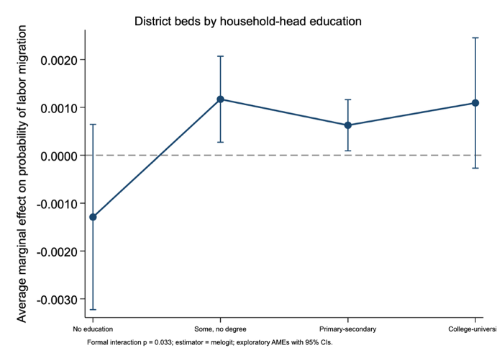 | 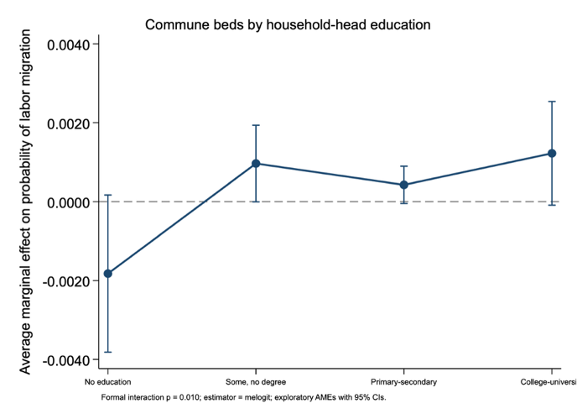
Figure A5. District-bed density by household-head education | Figure A6. Commune-bed density by household-head education
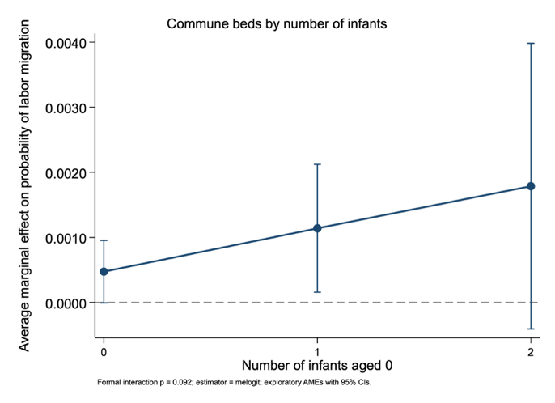 | 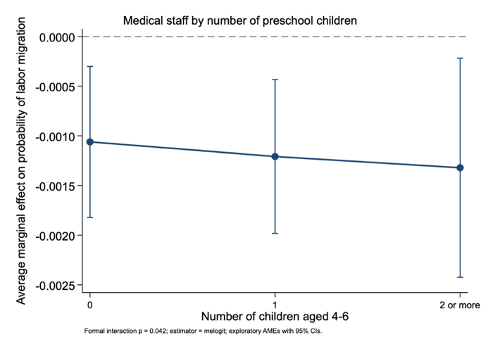
Figure A7. Commune-bed density by number of infants | Figure A8. Medical-staff density by number of preschool children

Formal interaction tests
Figure | Interaction | p-value | BH q-value | N | Estimator
Fig. A1 | District-staff density x household-head education | 0.015 | 0.030 | 41,344 | melogit
Fig. A2 | Commune-staff density x household-head education | 0.002 | 0.008 | 41,344 | melogit
Fig. A3 | Medical-staff density x household-head education | <0.001 | 0.002 | 41,344 | melogit
Fig. A4 | Provincial-bed density x individual education | 0.073 | 0.083 | 41,344 | melogit
Fig. A5 | District-bed density x household-head education | 0.033 | 0.052 | 41,344 | melogit
Fig. A6 | Commune-bed density x household-head education | 0.010 | 0.026 | 41,344 | melogit
Fig. A7 | Commune-bed density x number of infants | 0.092 | 0.092 | 41,344 | melogit
Fig. A8 | Medical-staff density x number of preschool children | 0.042 | 0.056 | 41,344 | melogit
Notes: BH = Benjamini-Hochberg. The adjustment is applied across the eight exploratory appendix interactions in this report. The old graph treating age6 as a fractional household proportion is not reproduced because age6 is a count variable. Occupation, household-head age, adolescent, and malaria interactions are omitted because their theoretical relevance was weaker and the malaria main estimate was not robust.

