Sexual conflict maintains variation at an insecticide resistance allele. Rostant et al.
Supplementary Materials
Table S1: Calculating the contribution of each kind of mated pair to each genotype of adult offspring. Red font indicates DDT-R fitness effects. Note that pupal viability, P, is a function of offspring genotype whereas other fitness effects shown here are derived solely from a maternal effect. The numbers to the right are the proportions of offspring from each cross that have a particular genotype (in columns RR, RS, SS).

 |  |  | RR | RS | SS
Cross  ♀ × ♂ | Frequency | DDT-R fitness  effects | P |  | none
RR × RR | λ_{RRRR} | F = f×e×l | 1
RR × RS | λ_{RRRS} | F = f×e×l | ½ | ½
RR × SS | λ_{RRSS} | F = f×e×l |  | 1
RS × RR | λ_{RSRR} | F = f×e×l | ½ | ½
RS × RS | λ_{RSRS} | F = f×e×l | ¼ | ½ | ¼
RS × SS | λ_{RSSS} | F = f×e×l |  | ½ | ½
SS × RR | λ_{SSRR} | none |  | 1
SS × RS | λ_{SSRS} | none |  | ½ | ½
SS × SS | λ_{SSSS} | none |  |  | 1

Supplementary Information on explicit solutions for all internal equilibria in the model.
Where,
And, (S1)

From these the expected equilibria for the default parameter values (Table 1, main text) that satisfy inequalities (1) and (2) can be calculated (see main text).

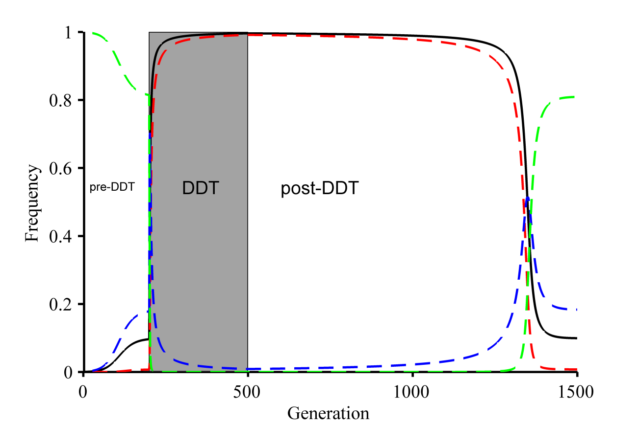

Figure S1: The effect of DDT selection on DDT-R genotype and allele trajectories in a hypothetical background where the sexually antagonistic effects are conservatively set to be weaker than our empirical data suggest. In this case hypothetical low equilibrium fitness parameters (m = 0.5, F = 1.5, P = 1.05, D = 5) were used, starting from initial genotype frequencies x_{RR} = 0, x_{RS} = 0.001, x_{SS} = 0.999. The red line is the frequency of x_{RR} , the blue line is x_{RS} , the green line is x_{SS} , and the black line is DDT-R. The internal equilibrium of 9.9% in the absence of DDT selection is achieved within the first 200 generations (in the ‘pre-DDT’ period). As with Fig. 1C in the main text, DDT selection (shaded area) starts at generation 201 and ends at generation 500 at which time DDT-R has acquired a frequency of greater than 99%. More than 1000 generations are required ‘post-DDT’ selection for the stable internal equilibrium to be regained (c.f. Fig. 1C, main text).

Figure S2: McCart et al. (2005) show that Canton-S females have higher fitness when carrying the DDT-R allele, here we show a similar fitness advantage to DDT-R females in another background - the WC genetic background of Smith et al. (2011). Shown here are fitness (fecundity) and viability measures for resistant (RR) and susceptible (SS) females (means ± s.e.). (a) Female fecundity: Full fecundity data was obtained for 115 mated females, laying for 3 days – this is a good approximation of lifetime offspring production (fitness) (Taylor et al. 2008a,b) and is a proxy for the intrinsic rate of increase of the genotypes (Hunt & Hodgson 2010). Model simplification of a GLM of fecundity against male genotype (RR, SS), female genotype and female size (and all interactions) revealed a significant effect of female resistance genotype on number of eggs laid (F_{1,113} =15.45, p < 0.001) with resistant females (mean eggs laid = 23.92, standard error interval = (22.06, 25.93)) laying more eggs than susceptible females (mean eggs laid = 14.06, standard error interval = (12.56,15.72)). To test if the elevated fecundity of DDT-R females could be eroded by survival costs, we tested egg and larval viability, and found that DDT-R females did not differ from wild-type in these attributes, and hence their fitness would be greater. (b) Egg viability: egg viability data was obtained for 81 females, and simplification of the GLM of egg viability against the same explanatory variables yielded a null minimum adequate model, with no significant effect of female genotype (F_{1,79} = 0.5234, p = 0.47). (c) Combined larval and pupal viability: larvae were collected from 82 females and there was no significant effect of female genotype on combined larval-pupal viability (F_{1,80} = 2.34, p = 0.13). Together these results show that the increased fecundity of DDT-R females is not “lost” through poorer egg or larval viability and hence like DDT-R in Canton-S, WC females carrying the DDT-R allele have higher fitness.

References for Supplementary Materials
Hunt, J. & Hodgson, D. J. In Evolutionary Behavioral Ecology (eds D.F. Westneat & C.W. Fox) 46-70 (Oxford University Press, 2010).
McCart, C., Buckling, A. & ffrench-Constant, R. H. DDT resistance in flies carries no cost. Curr. Biol. 15, R587-R589 (2005).
Smith, D. T. et al. DDT resistance, epistasis and male fitness in flies. J. Evol. Biol. 24, 1351-1362 (2011).
Taylor, M.L. et al. Sexual selection and female fitness in Drosophila simulans. Behav. Ecol. Sociobiol. 62:721-728 (2008a).
Taylor, M.L. et al. Multiple mating increases female fitness in Drosophila simulans. Anim. Behav. 76:963-970 (2008b).

