- Adjusting the rate of NADH:O₂ turnover in AOX-SMPs
As the rate of NADH:O₂ turnover in AOX-SMPs can exceed that of the natural respiratory chain, rate-matching experiments of AOX-SMPs and SMPs were performed to ensure that the substrate is not exhausted in AOX-SMPs on the timescale of the EPR sample preparation:

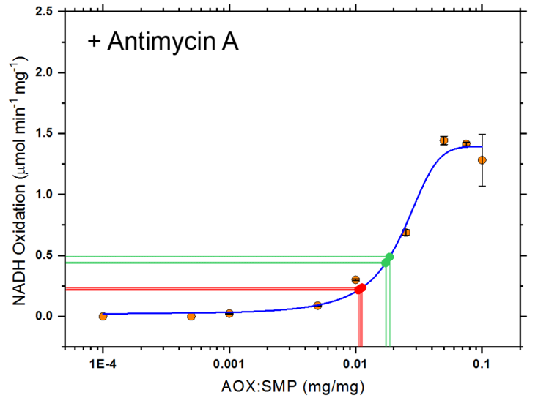
Figure S1: Rate matching of AOX-SMPs to SMP NADH:O₂ turnover. SMPs were incubated with AOX at the ratios specified. Activity assays were performed with 20 µg/mL SMP and 200 µM NADH. Antimycin A (2 µM) was added to the assay mixture to inhibit electron flux through the canonical electron transport chain. The triplicate red lines indicate the amount of AOX required to match the rate of uninhibited SMPs in this experiment. The green lines indicate the amount of AOX required to match the rate of uncoupled (+ 4 μM CCCP) SMPs. Error bars indicate standard deviation of triplicate measurements.

