- Comparison of EPR signals of reduced SMPs and isolated complex I
The EPR spectra in the figure below shows that most of the EPR signals in SMPs originate from complex I, but that a contribution from complex II is significant.
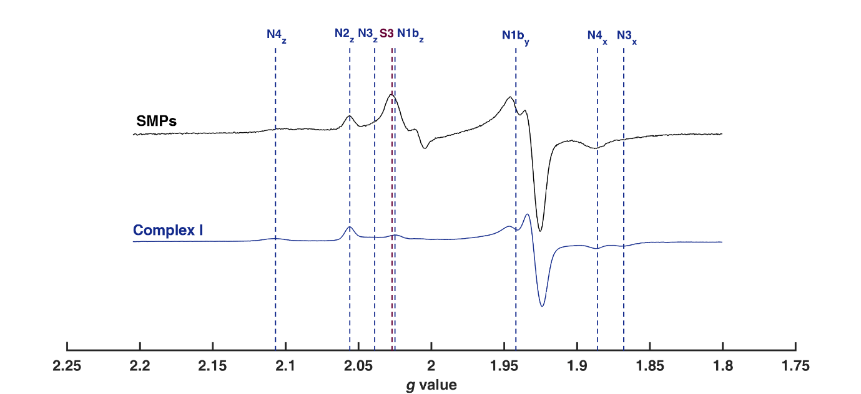
Figure S3: X-band CW EPR spectra of reduced SMPs and isolated complex I. SMPs (25 mg/mL) and complex I (25 mg/mL) were reduced with 15 mM NADH under aerobic conditions (atmospheric O₂). Measurements were carried out at 16 K with 2.02 mW microwave power and 7 G modulation amplitude. Vertical blue lines correspond to the g values of the Fe-S clusters in complex I. Species not arising from complex I are indicated in maroon (S3 of complex II at g = 2.027). Spectra are normalised to the height of the N2 g_{z} signal (g = 2.054).

