- Complete HYSCORE spectrum of the g ~ 2 signal in complex II inhibited SMPs
The absence of any significant amounts of N1b in the complex II inhibited SMP sample lends further evidence to the ‘backbone ¹⁴N’ couplings originating from the g ~ 2 SQ species.
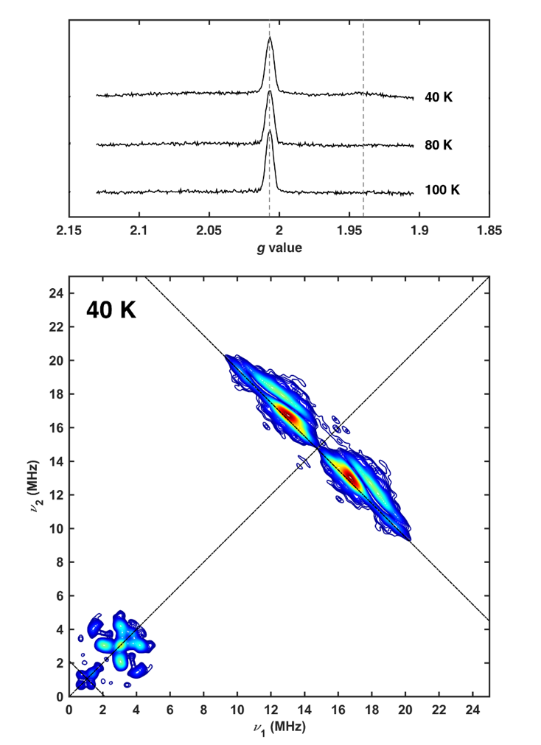
Figure S7: Echo-detected field sweep and HYSCORE spectroscopy of oxygen supplemented SMPs treated with carboxin. (Top) Temperature dependence of echo-detected field sweeps of SMPs. Measurements performed with a two-pulse sequence (π/2–τ–π–echo) with π/2 = 16 ns, π = 32 ns, τ = 200 ns. Shot repetition times and shots per point were kept constant across the temperature range at 2 ms and 50, respectively. Vertical lines indicate the maximum intensity of the semiquinone signal (g = 2.00) and the N1b signal (g = 1.94) (Bottom) 40 K (+,+) quadrant of the g = 2.006 signal of carboxin inhibited SMPs with oxygen supplementation. HYSCORE measurement conditions as in Figure 7.

