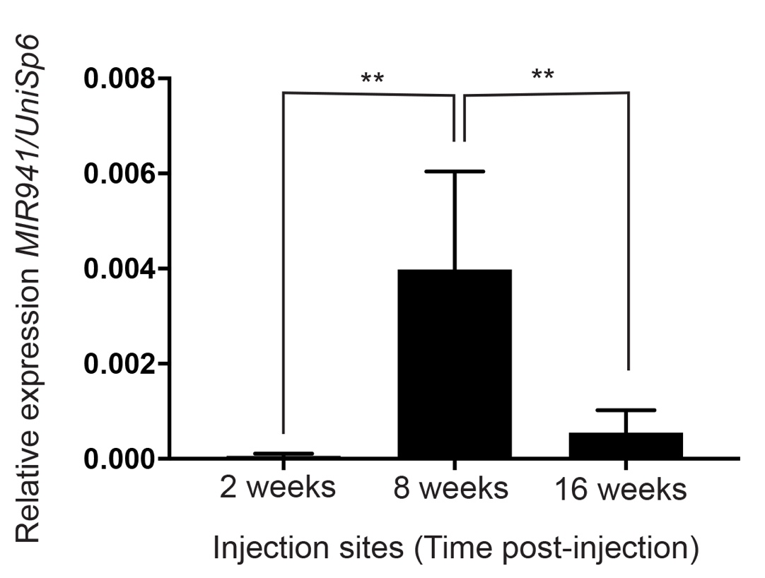

Additional File 11: Fig. S10. Higher overall expression of MIR941 expression in the injected sites of 8 week animals compared to both 2 and 16 weeks. A UniSp6 spike-in control was used to normalize expression.

