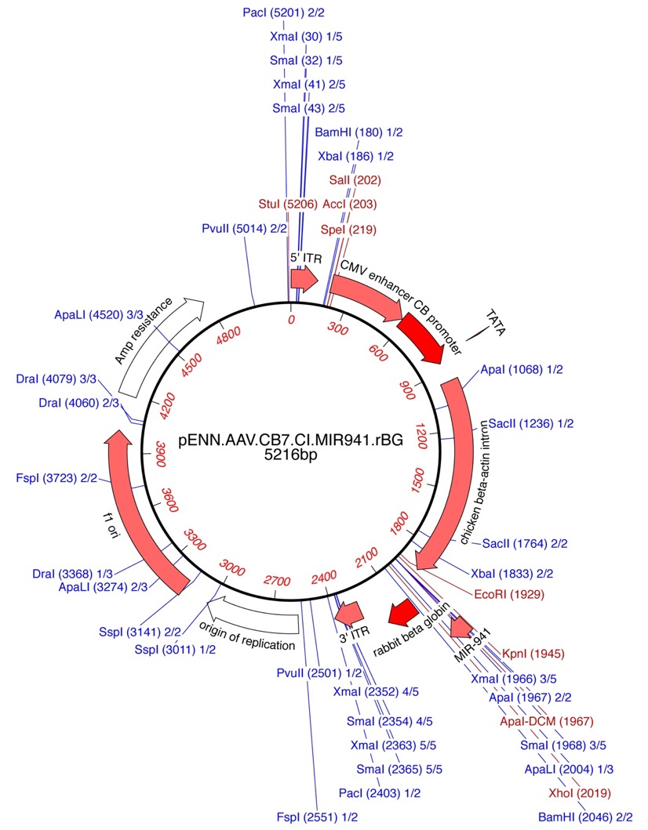

Additional File 1: Fig. S1. pENN.AAV.CB7.CI.MIR941.rBG. Plasmid produced for viral vector production by Penn Vector Core.

