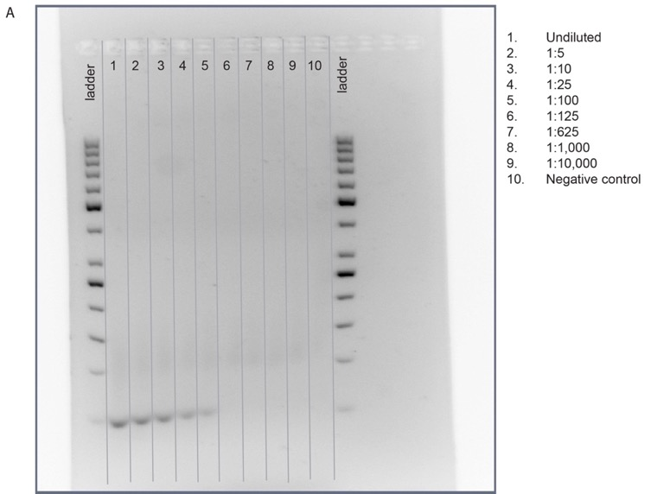

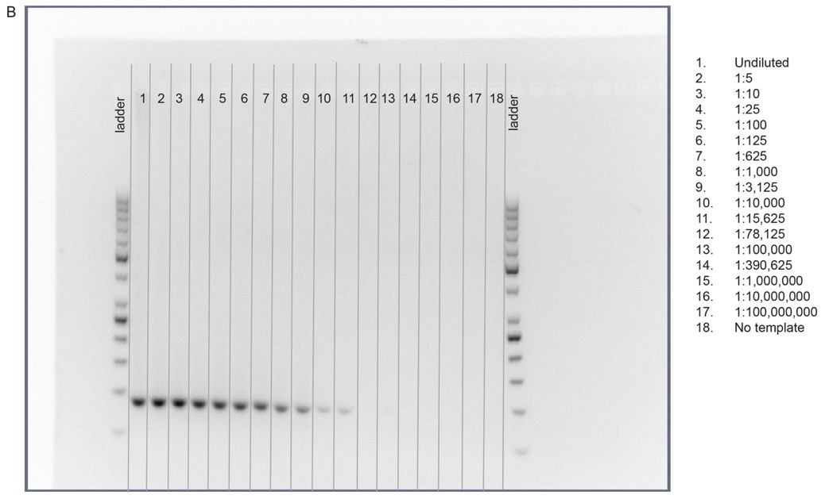

Additional File 2: Fig. S2. Detection of (A) MIR941 and (B) a rabbit β-globin fragment in treated adult male mice. Positive control striatal injection sites from adult male mice were used to detect single bands using a gene-specific locked nucleic acid (LNA) quantitative PCR (qPCR) system.

