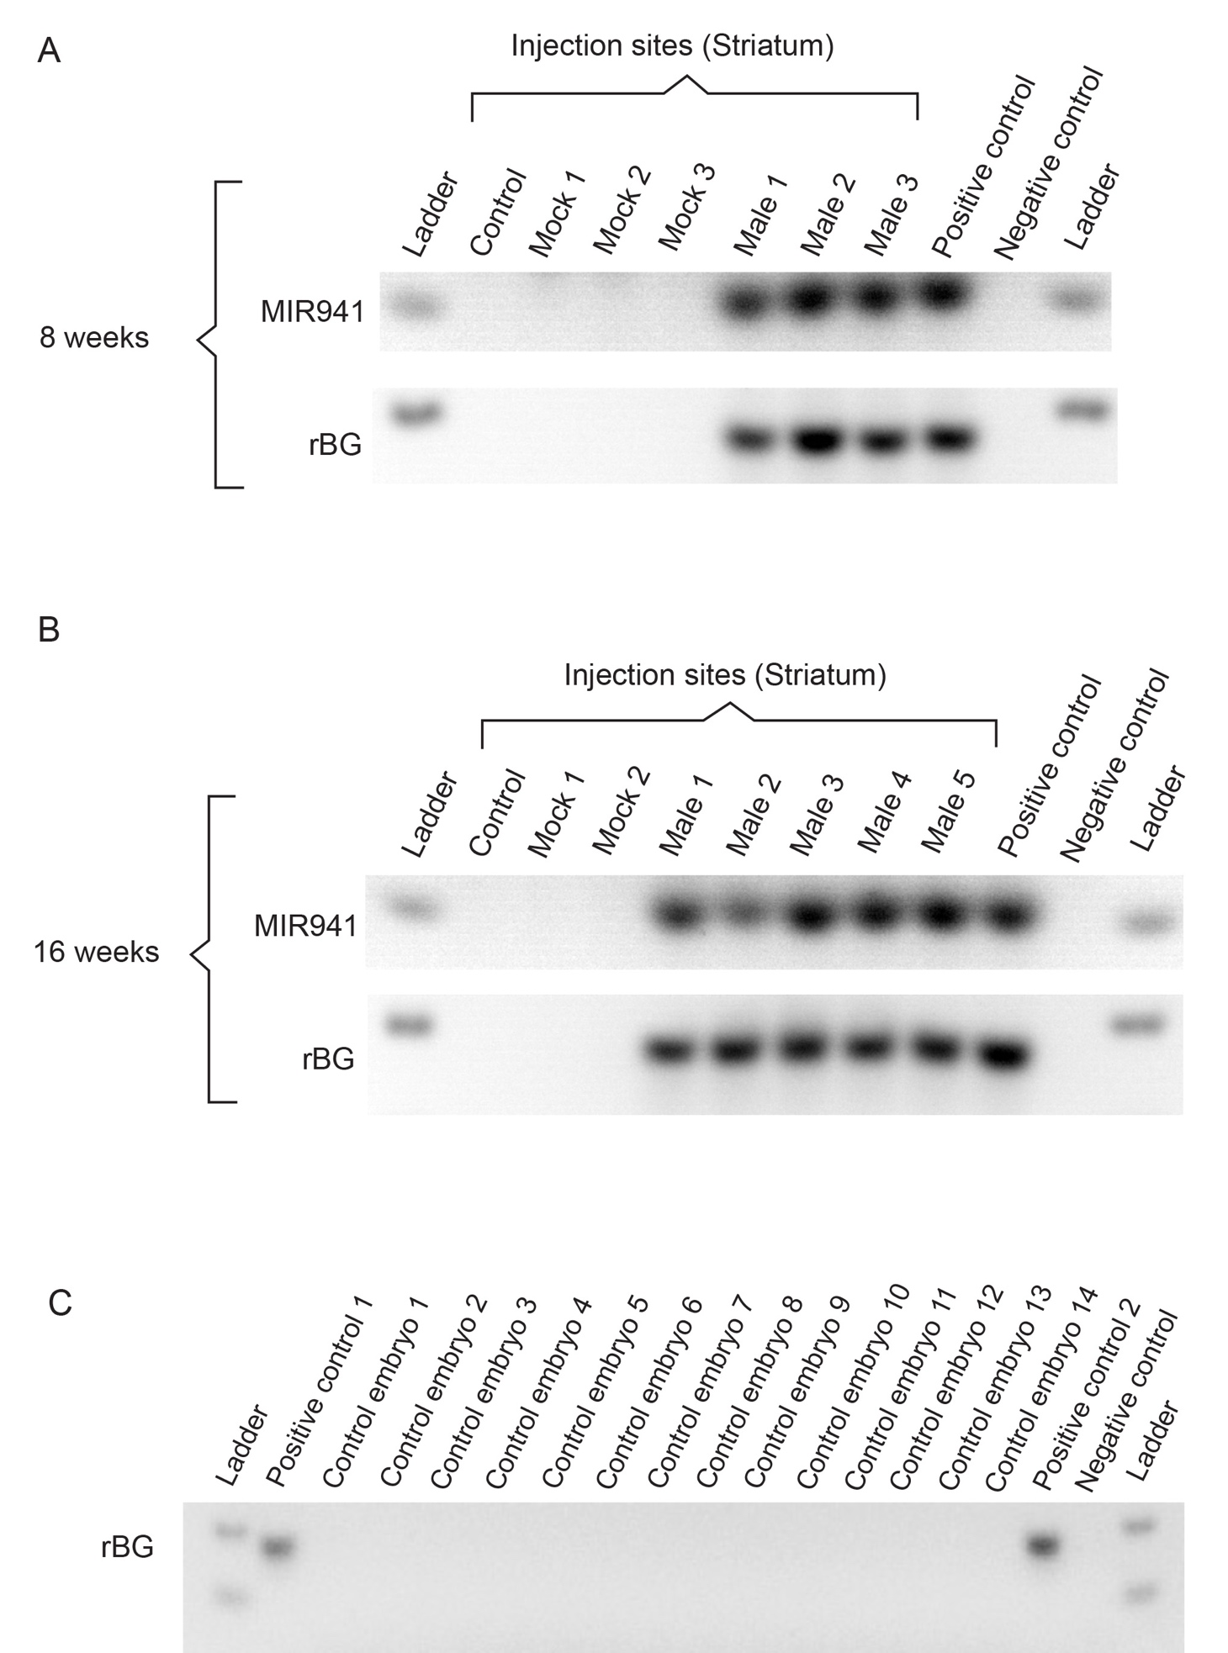

Additional File 3: Fig. S3. No detection of MIR941 or rabbit β-globin fragment in control (uninjected) or mock-treated (saline-injected) animals at either (A) 8 weeks or (B) 16 weeks post-injection. Additionally, no presence of rabbit β-globin fragment was found in control embryos, collected from 3 separate litters, from uninjected parents (C); positive control 1- MDA cells, positive control 2 – HEK cells; negative control – no template control).

