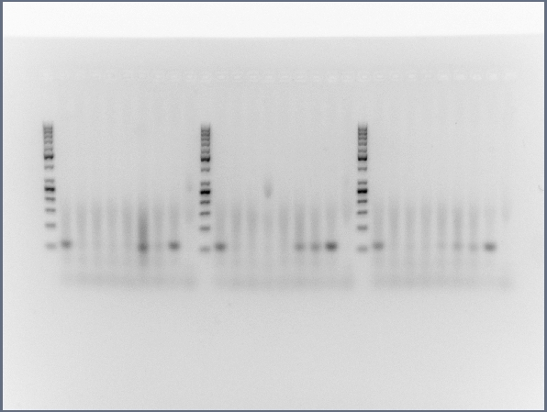

Additional File 4: Fig. S4. Full size, unedited gels used for Figure 1 in the main text.

