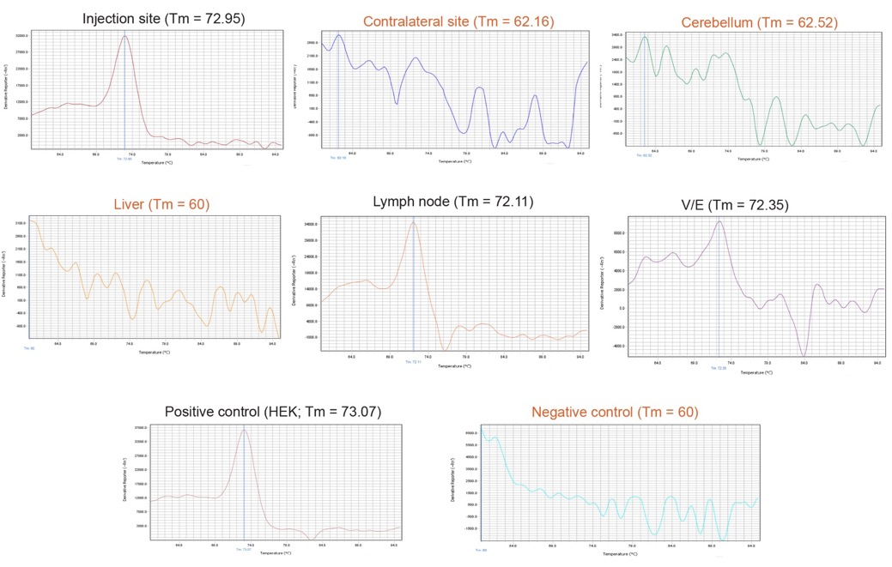

Additional File 6: Fig. S5. Representative full panel of melt curves for Week 2, Male 1 showing MIR941 LNA qPCR. Positive (black writing) and negative (red writing) melt curves and associated melting temperatures (T_{m}) are shown and correspond to the bands in Figure 1. We have used an asterix (*) to denote a positive band of correct size on the gel that also had positive melt curves and T_{m} values as shown in this figure.

