A
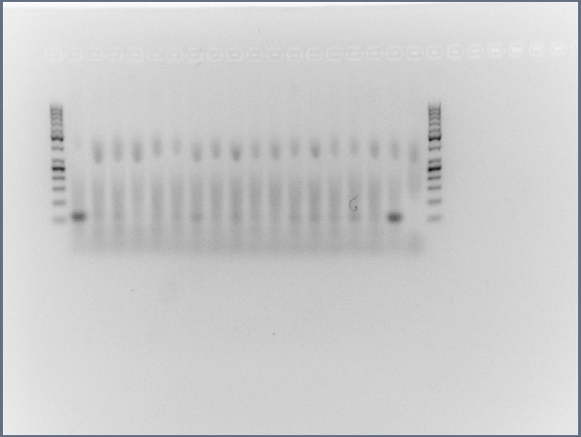

B
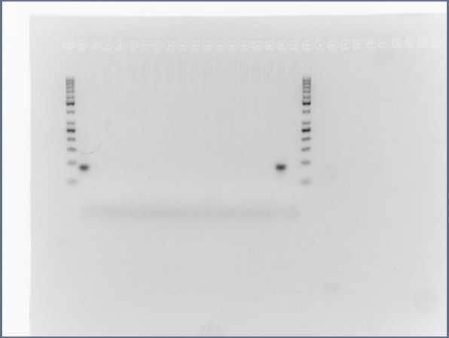

C
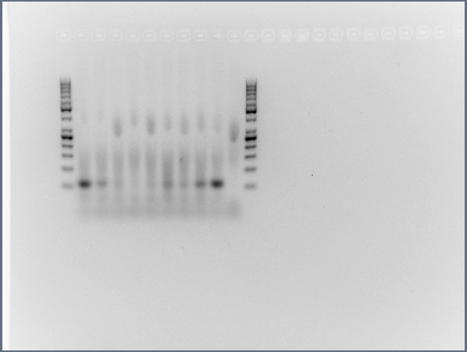]

D
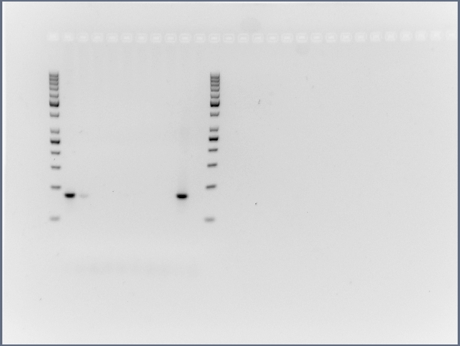

E

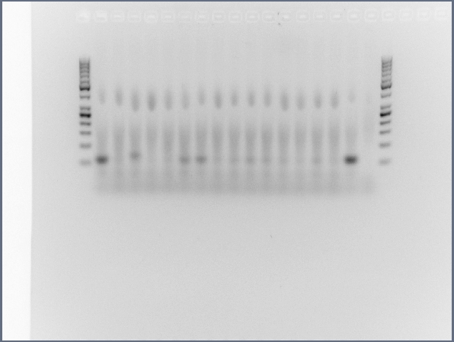

F

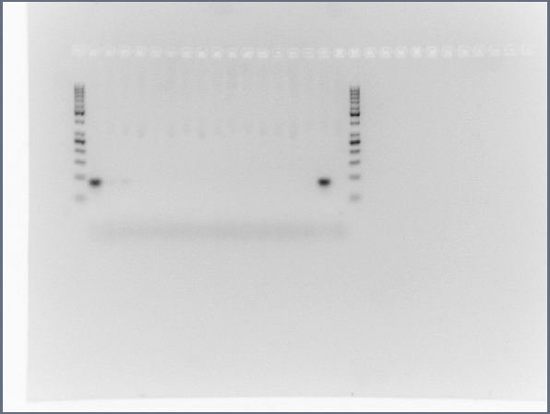

Additional File 7: Fig. S6. Full size, unedited gels used for Figure 2 in the main text. (A) MIR941-Male 1, (B) Rabbit β-globin fragment - Male 1, (C) MIR941-Male 2, (D) Rabbit β-globin fragment - Male 2, (E) MIR941-Male 3, (F) Rabbit β-globin fragment - Male 3.

