A
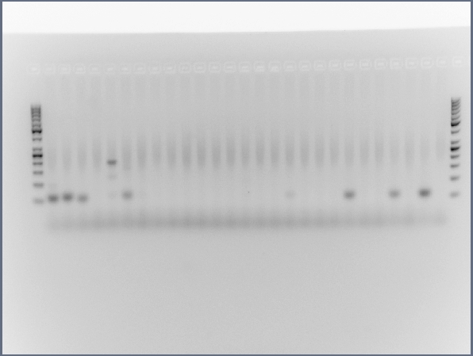

B
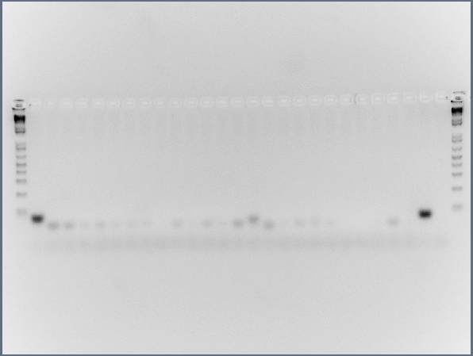

C
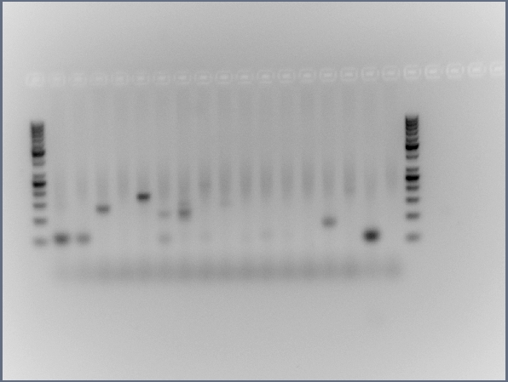

D
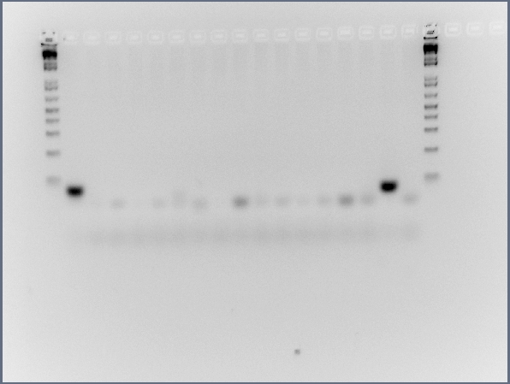

E
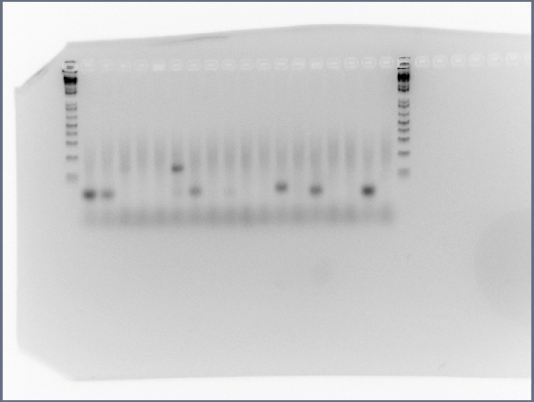

F
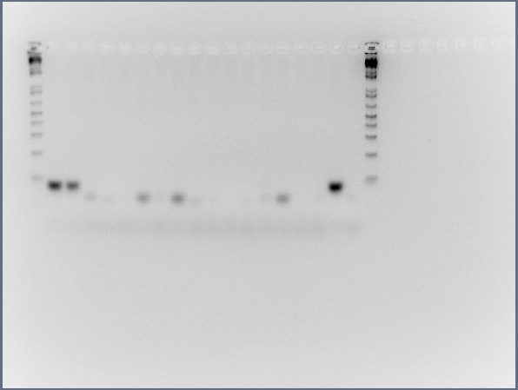

G
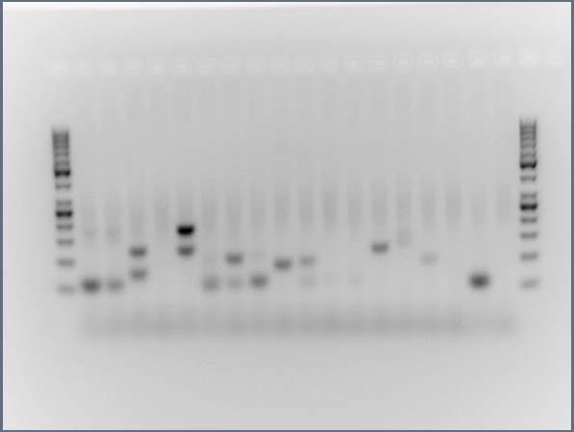

H
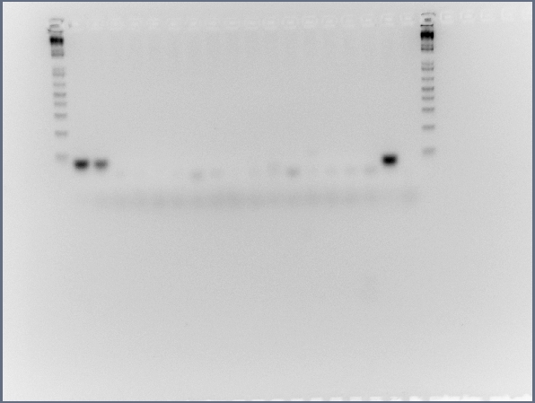

I
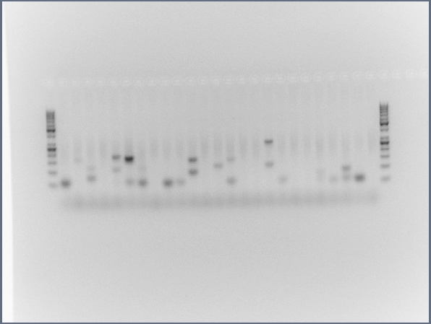

J
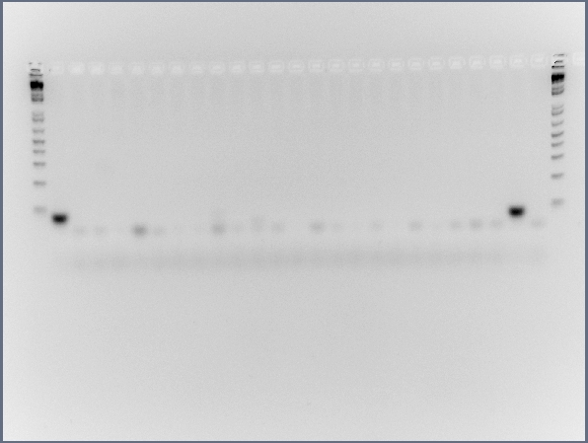

Additional File 9: Fig. S8. Full size, unedited gels used for Figure 4 in the main text. (A) MIR941-Male 1, (B) Rabbit β-globin fragment - Male 1, (C) MIR941-Male 2, (D) Rabbit β-globin fragment - Male 2, (E) MIR941-Male 3, (F) Rabbit β-globin fragment - Male 3, (G) MIR941-Male 4, (H) Rabbit β-globin fragment - Male 4, (I) MIR941-Male 5, (J) Rabbit β-globin fragment - Male 5.

